**Task8**

Case In Select

select

ST_Id as [Id],

ST_Name as [Full Name],

PROF_ID as [PROF ID],

P.Prof_FName + ' ' + P.Prof_LName as [PROF Full Name],

GRADE as [GRADE],

Birthday as Birthday,

case

when DATEDIFF(year,s.Birthday,GETDATE()) <= 17 then 'Teenage : ' + cast(DATEDIFF(year,s.Birthday,GETDATE()) as varchar(20))

else 'Adults : ' + cast(DATEDIFF(year,s.Birthday,GETDATE()) as varchar(20)) end as Age

from Students as s join Professors as p on s.PROF_Id = p.Id;

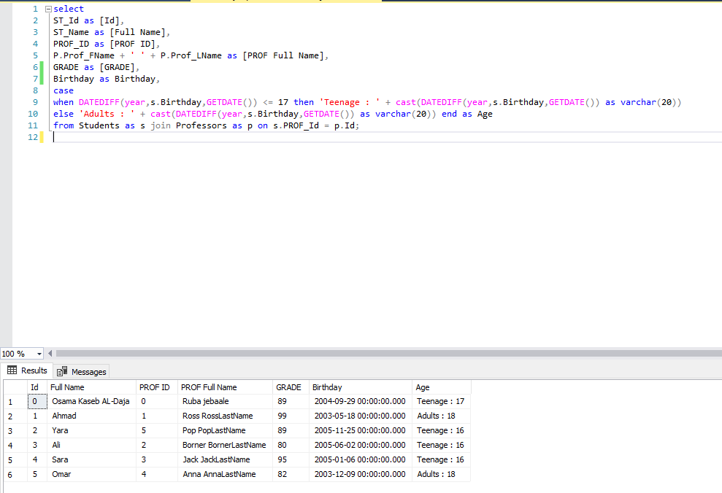

**Q3 :**

allows you to access and manipulate database information using procedural schema objects called PL/SQL program units.

Procedures, functions, and packages are all examples of PL/SQL program units

Procedures and functions are created in a user's schema and stored in a database for continued use.

access-control mechanisms and data-validation, may return result sets, can be used parameter and without.