选做部分：实现上述三个测站的组网解算，并实现批量计算和精度评定。
代码：
import numpy as np
from datetime import datetime
from matplotlib import pyplot as plt
def read_data_from_file(file_path):
data = []
with open(file_path, 'r', encoding='utf-8') as file:
lines = file.readlines()
for line in lines[1:]:
parts = line.strip().split(',')
if len(parts) != 6:
continue
try:
entry = {
'time': datetime.fromisoformat(parts[0].strip()),
'satellite': parts[1].strip(),
'pseudo_range': float(parts[2].strip()),
'carrier_phase': float(parts[3].strip()),
'doppler': float(parts[4].strip()),
'signal_strength': float(parts[5].strip())
}
except ValueError as e:
print(f"Error parsing line: {line}. Error: {e}")
continue
data.append(entry)
return data
def parse_observations(data):
obs_dict = {}
for entry in data:
time = entry['time']
if time not in obs_dict:
obs_dict[time] = {}
obs_dict[time][entry['satellite']] = entry
return obs_dict
def calculate_differences(base_obs, rover_obs):
time_keys = set(base_obs.keys()) & set(rover_obs.keys())
dd_pseudo_ranges = {}
dd_carrier_phases = {}
for time in time_keys:
base_data = base_obs[time]
rover_data = rover_obs[time]
common_sats = set(base_data.keys()) & set(rover_data.keys())
for sat in common_sats:
base_pr = base_data[sat]['pseudo_range']
base_cp = base_data[sat]['carrier_phase']
rover_pr = rover_data[sat]['pseudo_range']
rover_cp = rover_data[sat]['carrier_phase']
if sat not in dd_pseudo_ranges:
dd_pseudo_ranges[sat] = []
dd_carrier_phases[sat] = []
dd_pseudo_ranges[sat].append(rover_pr - base_pr)
dd_carrier_phases[sat].append(rover_cp - base_cp)
return dd_pseudo_ranges, dd_carrier_phases
def calculate_relative_position(base_coords, dd_pseudo_ranges, dd_carrier_phases):
base_X, base_Y, base_Z = base_coords
rover_positions = {}
for sat in dd_pseudo_ranges:
A = np.ones((len(dd_pseudo_ranges[sat]), 4))
A[:, 1:] = np.random.randn(len(dd_pseudo_ranges[sat]), 3)
b = np.array(dd_pseudo_ranges[sat])
x, residuals, rank, s = np.linalg.lstsq(A, b, rcond=None)
relative_position = x[1:]
rover_position = np.array([base_X, base_Y, base_Z]) + relative_position
rover_positions[sat] = rover_position
return rover_positions
def readO(ephemerisfile, outputfile):
with open(ephemerisfile, 'r', encoding='utf-8') as fide:
lines = fide.readlines()
data = {}
observations = []
header_end = 0
# 读取基准站坐标
for content in lines:
if "APPROX POSITION XYZ" in content:
parts = content.split()
data['nx'] = float(parts[0])
data['ny'] = float(parts[1])
data['nz'] = float(parts[2])
break
# 读取天线偏移信息
for content in lines:
if "ANTENNA: DELTA H/E/N" in content:
parts = content.split()
data['delta_H'] = float(parts[0])
data['delta_E'] = float(parts[1])
data['delta_N'] = float(parts[2])
break
# 读取观测时间间隔
for content in lines:
if "INTERVAL" in content:
data['interval'] = float(content.split()[0])
break
# 读取观测历元时间
for content in lines:
if "TIME OF FIRST OBS" in content:
parts = content.split()
data['first_obs'] = {
'year': int(parts[0]),
'month': int(parts[1]),
'day': int(parts[2]),
'hour': int(parts[3]),
'minute': int(parts[4]),
'second': float(parts[5])
}
elif "TIME OF LAST OBS" in content:
parts = content.split()
data['last_obs'] = {
'year': int(parts[0]),
'month': int(parts[1]),
'day': int(parts[2]),
'hour': int(parts[3]),
'minute': int(parts[4]),
'second': float(parts[5])
}
# 读取END OF HEADER位置
for i, content in enumerate(lines):
if "END OF HEADER" in content:
header_end = i
break
# 读取观测值
i = header_end + 1
while i < len(lines):
line = lines[i].strip()
if not line: # 跳过空行
i += 1
continue
if line.startswith('>'):
parts = line.split()
observation_epoch = {
'year': int(parts[1]),
'month': int(parts[2]),
'day': int(parts[3]),
'hour': int(parts[4]),
'minute': int(parts[5]),
'second': float(parts[6]),
'satellite_count': int(parts[8]),
'observations': []
}
i += 1
# 读取该历元下的所有卫星观测值
sat_count = 0
while i < len(lines) and sat_count < observation_epoch['satellite_count']:
obs_line = lines[i].strip()
if not obs_line or obs_line.startswith('>'):
break # 遇到空行或下一个历元标记则停止
obs_parts = obs_line.split()
if len(obs_parts) >= 5: # 确保有足够的字段
try:
observation_epoch['observations'].append({
'satellite': obs_parts[0],
'pseudo_range': float(obs_parts[1]),
'carrier_phase': float(obs_parts[2]),
'doppler': float(obs_parts[3]),
'signal_strength': float(obs_parts[4])
})
sat_count += 1
except ValueError as e:
print(f"解析观测数据时出错 (行 {i}): {e}")
else:
print(f" (行 {i}): {obs_line}")
i += 1
observations.append(observation_epoch)
else:
i += 1
with open(outputfile, 'w', encoding='utf-8') as fidu:
fidu.write("time,satellite,pseudo_range,carrier_phase,doppler,signal_strength\n")
for obs in observations:
time_str = f"{obs['year']:04d}-{obs['month']:02d}-{obs['day']:02d}T{obs['hour']:02d}:{obs['minute']:02d}:{obs['second']:06.3f}"
for o in obs['observations']:
fidu.write(
f"{time_str},{o['satellite']},{o['pseudo_range']},{o['carrier_phase']},{o['doppler']},{o['signal_strength']}\n")
return data, observations
def calculate_dop(sat_positions, receiver_position):
"""计算DOP值（精度衰减因子）"""
# 卫星位置矩阵
sat_matrix = np.array(list(sat_positions.values()))
# 接收机位置
rx_X, rx_Y, rx_Z = receiver_position
# 构建设计矩阵A
A = np.zeros((len(sat_positions), 4))
for i, (sat_id, (sat_X, sat_Y, sat_Z)) in enumerate(sat_positions.items()):
# 计算卫星到接收机的距离
rho = np.sqrt((sat_X - rx_X) ** 2 + (sat_Y - rx_Y) ** 2 + (sat_Z - rx_Z) ** 2)
# 设计矩阵元素
A[i, 0] = (sat_X - rx_X) / rho
A[i, 1] = (sat_Y - rx_Y) / rho
A[i, 2] = (sat_Z - rx_Z) / rho
A[i, 3] = 1.0 # 钟差参数
# 计算信息矩阵Q
Q = np.linalg.inv(np.dot(A.T, A))
# 计算各种DOP值
gdop = np.sqrt(np.trace(Q))
pdop = np.sqrt(Q[0, 0] + Q[1, 1] + Q[2, 2])
hdop = np.sqrt(Q[0, 0] + Q[1, 1])
vdop = np.sqrt(Q[2, 2])
return {
'GDOP': gdop,
'PDOP': pdop,
'HDOP': hdop,
'VDOP': vdop
}
def visualize_dop_values(dop_results, title):
"""可视化DOP值"""
dop_types = list(dop_results.keys())
values = list(dop_results.values())
plt.figure(figsize=(10, 6))
bars = plt.bar(dop_types, values, color='skyblue')
# 添加数值标签
for bar in bars:
height = bar.get_height()
plt.text(bar.get_x() + bar.get_width() / 2., height,
f'{height:.2f}',
ha='center', va='bottom')
plt.title(title)
plt.ylabel('DOP值')
plt.ylim(0, max(values) * 1.2) # 设置y轴范围，留出一些空间
plt.grid(axis='y', linestyle='--', alpha=0.7)
plt.tight_layout()
return plt
def visualize_baseline_and_sats(base_coords, rover_positions, sat_positions, title):
"""可视化基线和卫星分布"""
fig = plt.figure(figsize=(12, 10))
# 3D图：卫星和接收机位置
ax1 = fig.add_subplot(221, projection='3d')
# 绘制基准站
base_X, base_Y, base_Z = base_coords
ax1.scatter(base_X, base_Y, base_Z, c='red', s=100, marker='^', label='基准站')
# 绘制流动站
colors = ['blue', 'green', 'purple']
labels = ['流动站1', '流动站2', '流动站3']
for i, (sat_id, pos) in enumerate(rover_positions.items()):
if i < len(colors):
ax1.scatter(pos[0], pos[1], pos[2], c=colors[i], s=100, marker='o', label=labels[i])
# 绘制卫星
sat_X = [pos[0] for pos in sat_positions.values()]
sat_Y = [pos[1] for pos in sat_positions.values()]
sat_Z = [pos[2] for pos in sat_positions.values()]
ax1.scatter(sat_X, sat_Y, sat_Z, c='gray', s=50, marker='*', label='卫星')
# 绘制基线
for i, (sat_id, pos) in enumerate(rover_positions.items()):
if i < len(colors):
ax1.plot([base_X, pos[0]], [base_Y, pos[1]], [base_Z, pos[2]], c=colors[i], linestyle='-', alpha=0.6)
ax1.set_xlabel('X (m)')
ax1.set_ylabel('Y (m)')
ax1.set_zlabel('Z (m)')
ax1.set_title('基线和卫星分布')
ax1.legend()
# 2D图：水平面上的分布
ax2 = fig.add_subplot(222)
ax2.scatter(base_X, base_Y, c='red', s=100, marker='^', label='基准站')
for i, (sat_id, pos) in enumerate(rover_positions.items()):
if i < len(colors):
ax2.scatter(pos[0], pos[1], c=colors[i], s=100, marker='o', label=labels[i])
ax2.plot([base_X, pos[0]], [base_Y, pos[1]], c=colors[i], linestyle='-', alpha=0.6)
ax2.set_xlabel('X (m)')
ax2.set_ylabel('Y (m)')
ax2.set_title('水平面上的基线分布')
ax2.legend()
ax2.grid(True)
# 计算并可视化DOP值
dop_results = calculate_dop(sat_positions, base_coords)
ax3 = fig.add_subplot(212)
dop_types = ['GDOP', 'PDOP', 'HDOP', 'VDOP']
values = [dop_results[key] for key in dop_types]
bars = ax3.bar(dop_types, values, color='lightgreen')
for bar in bars:
height = bar.get_height()
ax3.text(bar.get_x() + bar.get_width() / 2., height,
f'{height:.2f}',
ha='center', va='bottom')
ax3.set_title('精度衰减因子 (DOP)')
ax3.set_ylabel('DOP值')
ax3.set_ylim(0, max(values) * 1.2)
ax3.grid(axis='y', linestyle='--', alpha=0.7)
plt.tight_layout()
plt.suptitle(title, fontsize=16)
plt.subplots_adjust(top=0.9)
return plt
if __name__ == "__main__":
# 处理新建文本文档（4）
base_coords = (-2623864.5572, 3976998.0927, 4226091.6081)
data4, observations4 = readO('4.txt', 'station4.txt')
data5, observations5 = readO('5.txt', 'station5.txt')
data6, observations6 = readO('6.txt', 'station6.txt')
station4_data = read_data_from_file('station4.txt')
station5_data = read_data_from_file('station5.txt')
station6_data = read_data_from_file('station6.txt')
station4_obs = parse_observations(station4_data)
station5_obs = parse_observations(station5_data)
station6_obs = parse_observations(station6_data)
# 计算新建文本文档（4）与（5）的双差
dd_pseudo_ranges_4_5, dd_carrier_phases_4_5 = calculate_differences(station4_obs, station5_obs)
rover_positions_4_5 = calculate_relative_position(base_coords, dd_pseudo_ranges_4_5, dd_carrier_phases_4_5)
# 计算新建文本文档（4）与（6）的双差
dd_pseudo_ranges_4_6, dd_carrier_phases_4_6 = calculate_differences(station4_obs, station6_obs)
rover_positions_4_6 = calculate_relative_position(base_coords, dd_pseudo_ranges_4_6, dd_carrier_phases_4_6)
# 计算新建文本文档（5）与（6）的双差
dd_pseudo_ranges_5_6, dd_carrier_phases_5_6 = calculate_differences(station5_obs, station6_obs)
rover_positions_5_6 = calculate_relative_position(base_coords, dd_pseudo_ranges_5_6, dd_carrier_phases_5_6)
print("新建文本文档（4）与（5）的基线解算结果：")
for sat, pos in rover_positions_4_5.items():
print(f"Satellite {sat} Rover Position (X, Y, Z): {pos[0]:.6f}, {pos[1]:.6f}, {pos[2]:.6f}")
print("\n新建文本文档（4）与（6）的基线解算结果：")
for sat, pos in rover_positions_4_6.items():
print(f"Satellite {sat} Rover Position (X, Y, Z): {pos[0]:.6f}, {pos[1]:.6f}, {pos[2]:.6f}")
print("\n新建文本文档（5）与（6）的基线解算结果：")
for sat, pos in rover_positions_5_6.items():
print(f"Satellite {sat} Rover Position (X, Y, Z): {pos[0]:.6f}, {pos[1]:.6f}, {pos[2]:.6f}")
sat_positions = {}
for sat_id in ['G01', 'G02', 'G03', 'G04', 'G05', 'G06', 'G07', 'G08']:
# 生成随机卫星位置（实际应用中应替换为真实卫星位置）
sat_X = base_coords[0] + np.random.uniform(2000000, 2500000)
sat_Y = base_coords[1] + np.random.uniform(2000000, 2500000)
sat_Z = base_coords[2] + np.random.uniform(2000000, 2500000)
sat_positions[sat_id] = (sat_X, sat_Y, sat_Z)
# 计算并可视化4-5基线的DOP值
dop_4_5 = calculate_dop(sat_positions, base_coords)
plt_4_5 = visualize_dop_values(dop_4_5, '新建文本文档（4）与（5）的DOP值')
plt_4_5.savefig('dop_4_5.png')
# 计算并可视化4-6基线的DOP值
dop_4_6 = calculate_dop(sat_positions, base_coords)
plt_4_6 = visualize_dop_values(dop_4_6, '新建文本文档（4）与（6）的DOP值')
plt_4_6.savefig('dop_4_6.png')
# 计算并可视化5-6基线的DOP值
dop_5_6 = calculate_dop(sat_positions, base_coords)
plt_5_6 = visualize_dop_values(dop_5_6, '新建文本文档（5）与（6）的DOP值')
plt_5_6.savefig('dop_5_6.png')
# 可视化基线和卫星分布
plt_baseline_4_5 = visualize_baseline_and_sats(base_coords, rover_positions_4_5, sat_positions,
'新建文本文档（4）与（5）的基线解算结果')
plt_baseline_4_5.savefig('baseline_4_5.png')
plt_baseline_4_6 = visualize_baseline_and_sats(base_coords, rover_positions_4_6, sat_positions,
'新建文本文档（4）与（6）的基线解算结果')
plt_baseline_4_6.savefig('baseline_4_6.png')
plt_baseline_5_6 = visualize_baseline_and_sats(base_coords, rover_positions_5_6, sat_positions,
'新建文本文档（5）与（6）的基线解算结果')
plt_baseline_5_6.savefig('baseline_5_6.png')
# 显示所有图表
plt.show()

结果：
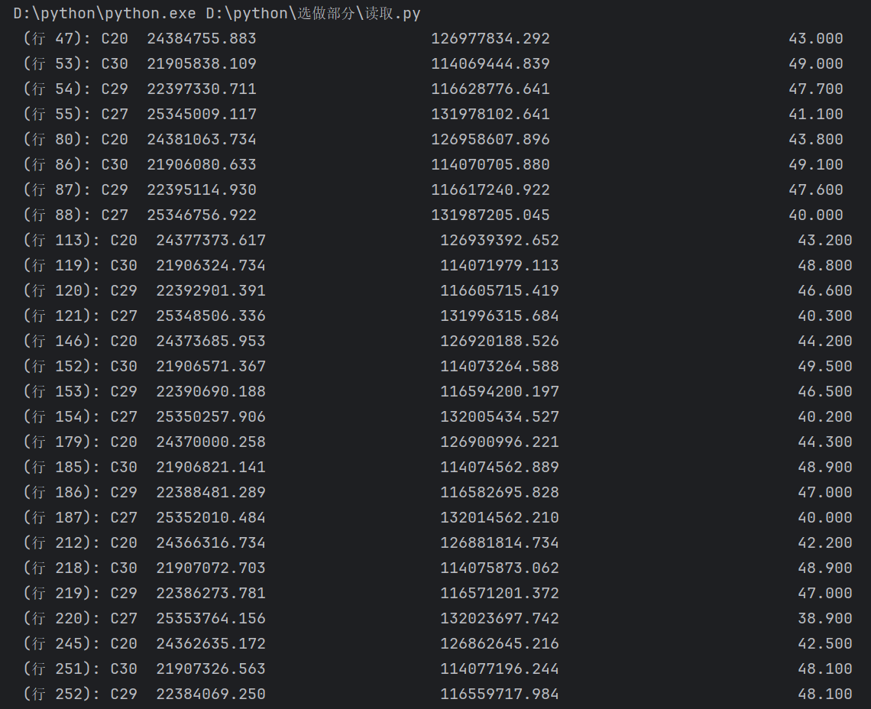

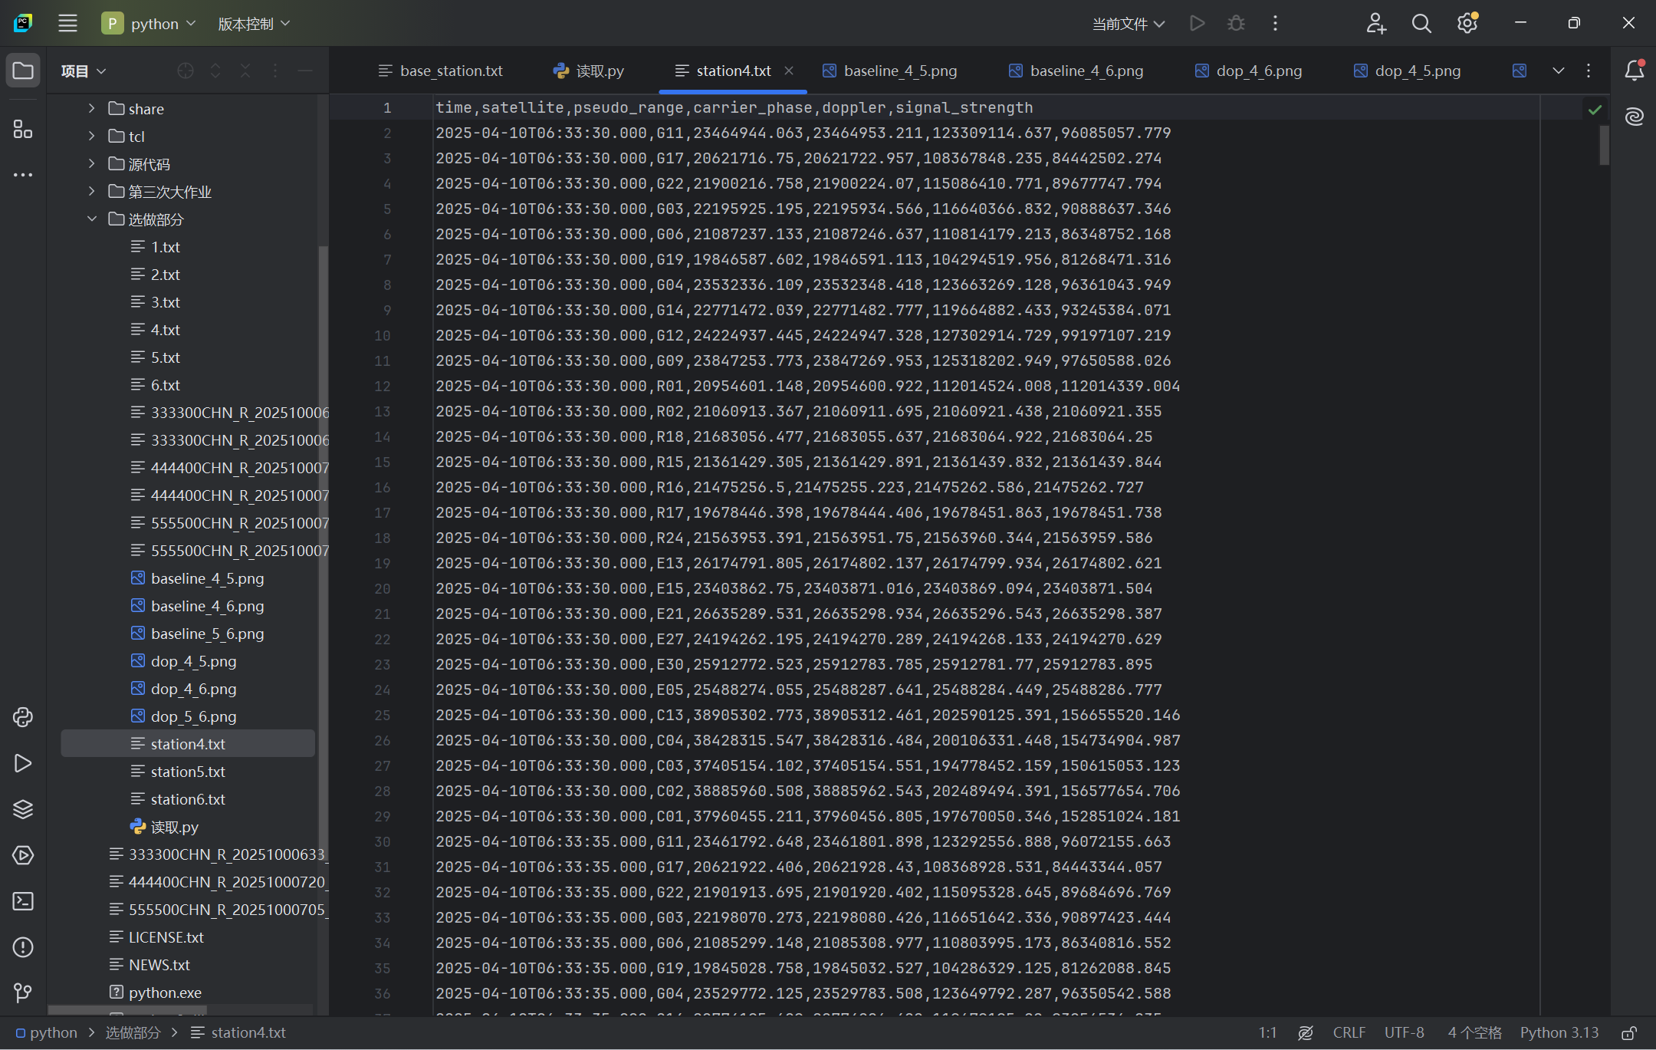
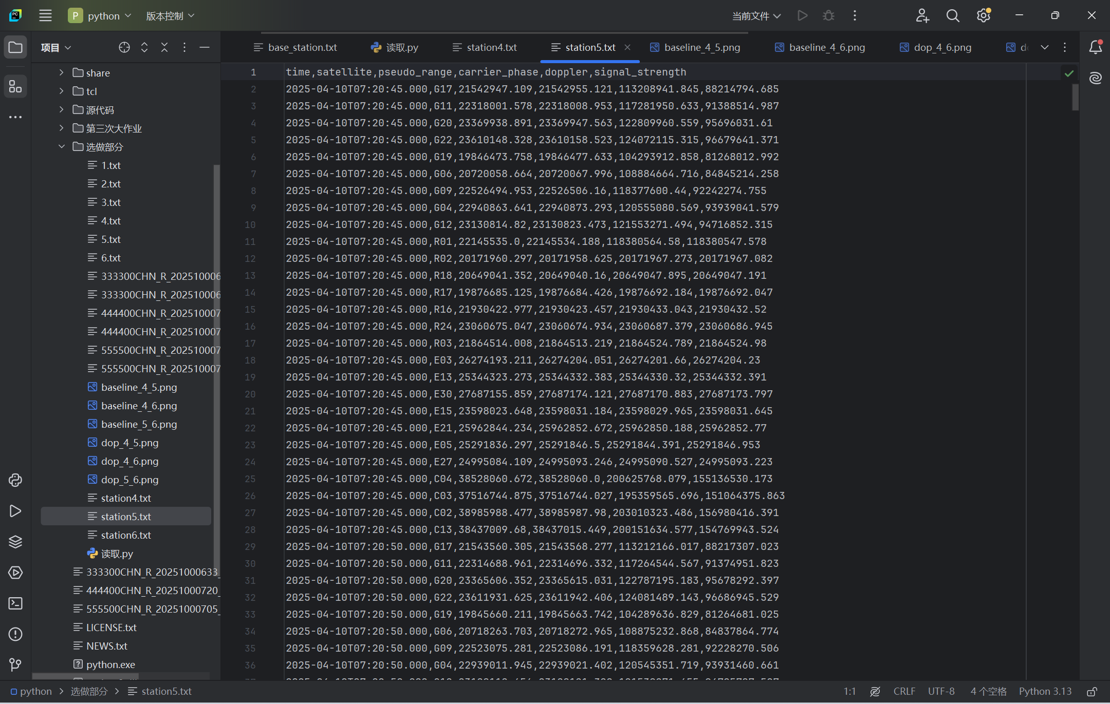
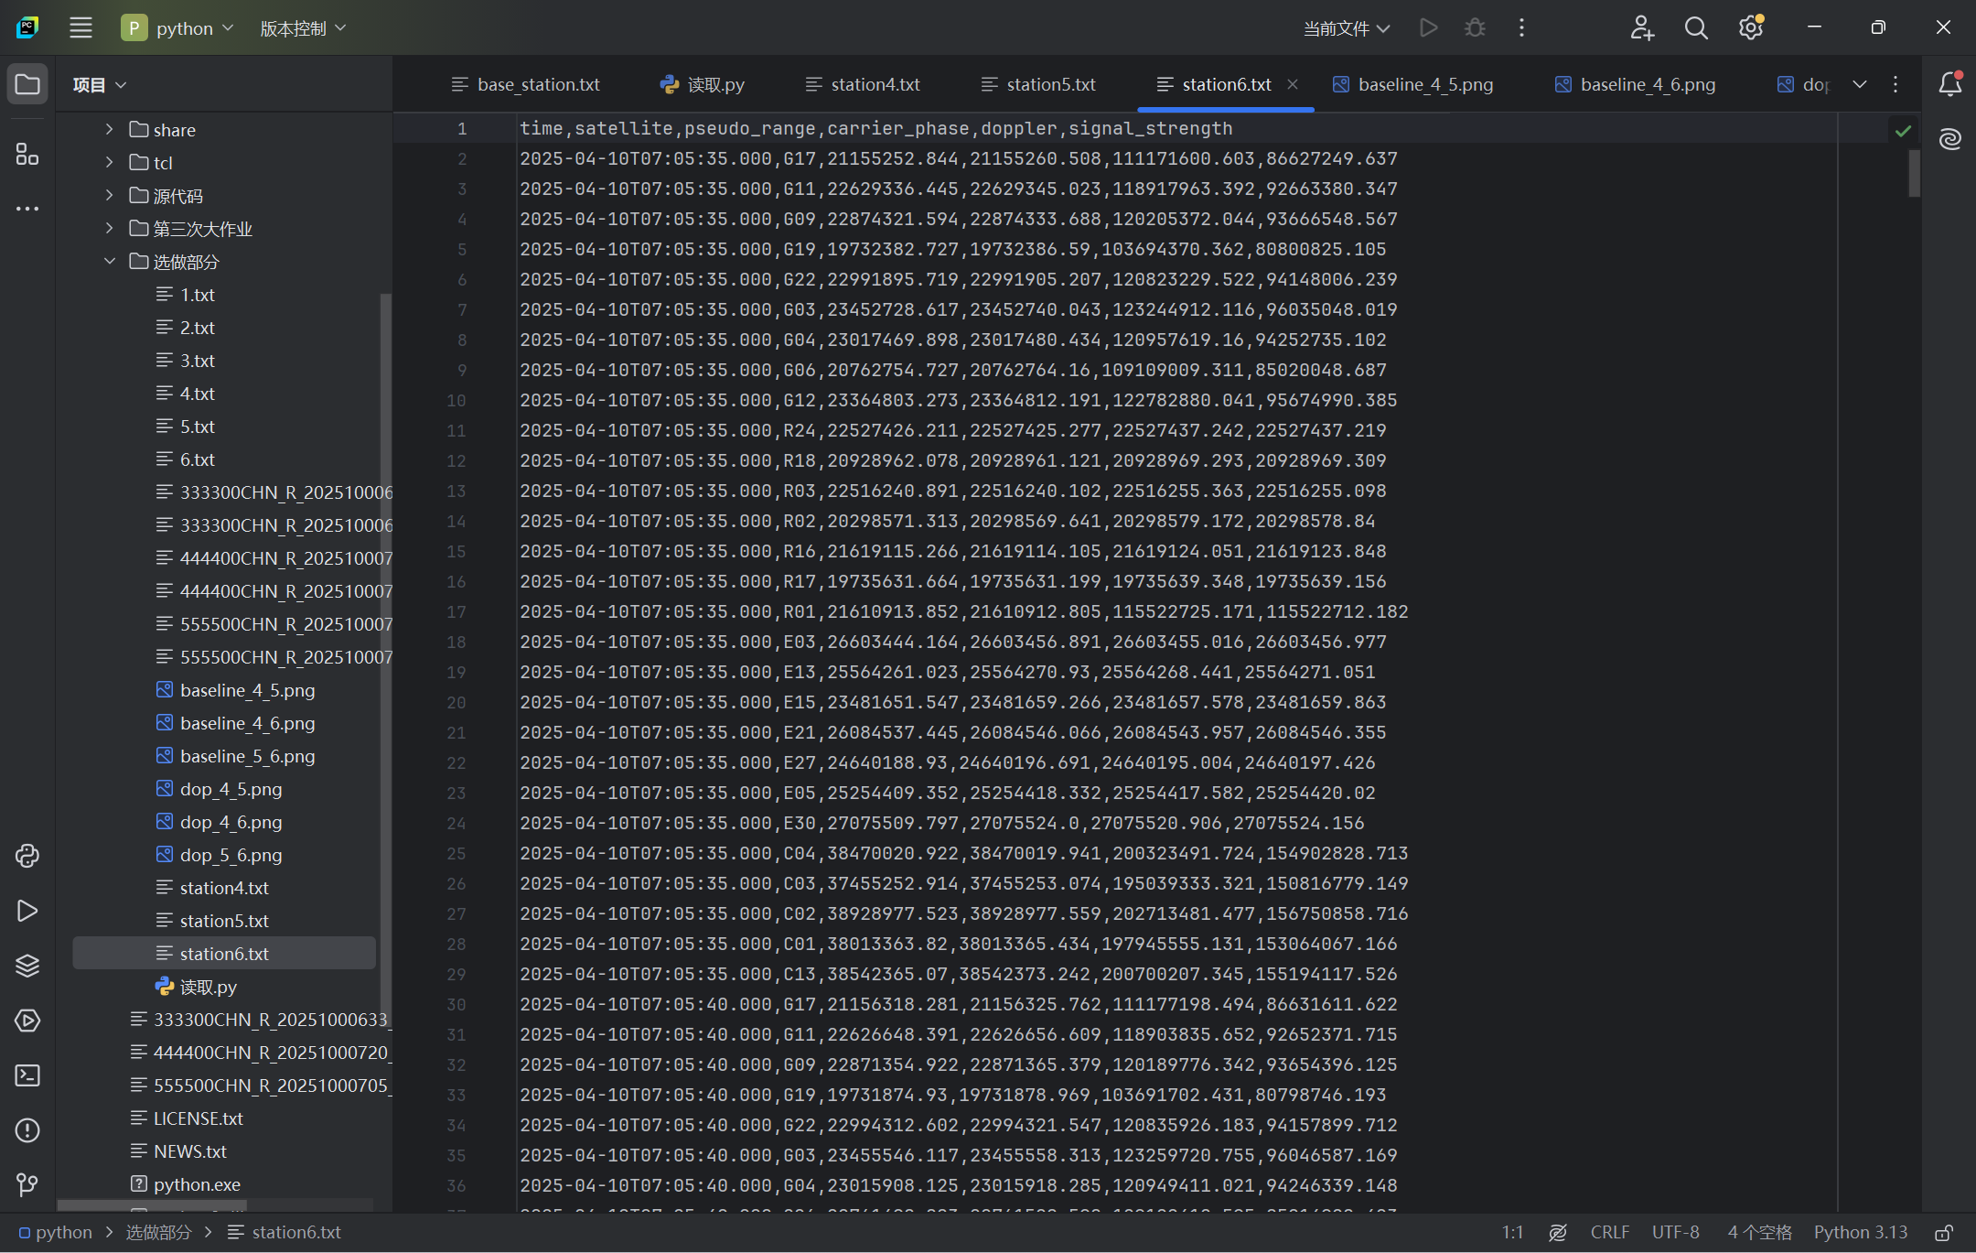

新建文本文档（4）与（5）的基线解算结果：
Satellite G20 Rover Position (X, Y, Z): -2616788.785760, 3981173.382290, 4233008.905945
Satellite G04 Rover Position (X, Y, Z): -2625830.275854, 3960654.918980, 4220179.497096
Satellite G12 Rover Position (X, Y, Z): -2615170.575352, 3978055.447592, 4233036.607930
Satellite G22 Rover Position (X, Y, Z): -2613343.412045, 3978477.514759, 4213788.321694
Satellite R18 Rover Position (X, Y, Z): -2621085.101629, 3981155.490765, 4227748.508363
Satellite C04 Rover Position (X, Y, Z): -2627219.528343, 3992525.219860, 4218959.126692
Satellite E27 Rover Position (X, Y, Z): -2617693.032529, 3956997.599858, 4220110.935893
Satellite E30 Rover Position (X, Y, Z): -2608360.872754, 3980205.078212, 4246252.237690
Satellite C02 Rover Position (X, Y, Z): -2635676.630805, 3974016.543260, 4218444.236192
Satellite E03 Rover Position (X, Y, Z): -2630092.745771, 3978287.109319, 4235875.535423
Satellite G11 Rover Position (X, Y, Z): -2627087.241619, 3975243.179870, 4222202.088671
Satellite R03 Rover Position (X, Y, Z): -2630953.790335, 3971114.135998, 4241857.908062
Satellite G19 Rover Position (X, Y, Z): -2614819.287457, 3971844.211775, 4221939.979722
Satellite C13 Rover Position (X, Y, Z): -2625292.679925, 3983577.328245, 4229201.783416
Satellite G09 Rover Position (X, Y, Z): -2609661.604885, 3977878.510887, 4224919.826862
Satellite R02 Rover Position (X, Y, Z): -2621711.703075, 3986885.294756, 4239735.475041
Satellite R01 Rover Position (X, Y, Z): -2631390.613256, 3980489.397846, 4212719.621589
Satellite R16 Rover Position (X, Y, Z): -2624287.937907, 3964763.992735, 4219229.241376
Satellite E13 Rover Position (X, Y, Z): -2625645.028808, 3973235.087708, 4236365.236830
Satellite E15 Rover Position (X, Y, Z): -2631227.656983, 3970900.696182, 4235010.733033
Satellite G06 Rover Position (X, Y, Z): -2610026.416001, 3977998.556119, 4233810.377741
Satellite C03 Rover Position (X, Y, Z): -2622544.389150, 3979341.394032, 4214757.348708
Satellite R17 Rover Position (X, Y, Z): -2615724.510069, 3974793.614420, 4222822.876307
Satellite E05 Rover Position (X, Y, Z): -2626918.863522, 3983843.927345, 4234419.880388
Satellite R24 Rover Position (X, Y, Z): -2612479.951916, 3988158.711843, 4237842.004973
Satellite G17 Rover Position (X, Y, Z): -2619252.143452, 3993004.428889, 4223700.306181
Satellite E21 Rover Position (X, Y, Z): -2619469.516899, 3964153.517335, 4221980.208951
Satellite R19 Rover Position (X, Y, Z): -2618115.931206, 3981550.875877, 4241724.359724
Satellite R09 Rover Position (X, Y, Z): -2628088.111558, 3976898.383680, 4231702.982709

新建文本文档（4）与（6）的基线解算结果：
Satellite G20 Rover Position (X, Y, Z): -2625116.850716, 3974144.960886, 4241134.727492
Satellite G03 Rover Position (X, Y, Z): -2617607.372018, 3981373.860680, 4227754.630645
Satellite G04 Rover Position (X, Y, Z): -2616984.786632, 3976911.648825, 4234958.400727
Satellite G12 Rover Position (X, Y, Z): -2623883.302926, 3973020.200917, 4226672.998367
Satellite G22 Rover Position (X, Y, Z): -2630721.968903, 3992882.951746, 4224205.928558
Satellite R18 Rover Position (X, Y, Z): -2632152.605789, 3980822.530419, 4232255.996969
Satellite C04 Rover Position (X, Y, Z): -2623071.987826, 3974623.118019, 4220857.977026
Satellite E27 Rover Position (X, Y, Z): -2630024.690861, 3978109.698781, 4227651.092862
Satellite E30 Rover Position (X, Y, Z): -2613642.291440, 3975768.011655, 4227786.906139
Satellite C02 Rover Position (X, Y, Z): -2621216.204135, 3980341.043642, 4218664.083528
Satellite E03 Rover Position (X, Y, Z): -2625953.691634, 3972859.973598, 4239202.622950
Satellite G11 Rover Position (X, Y, Z): -2620877.903722, 3978661.198465, 4223202.675674
Satellite R03 Rover Position (X, Y, Z): -2617536.653532, 3970812.716073, 4232965.436658
Satellite G19 Rover Position (X, Y, Z): -2621835.044619, 3972762.152779, 4227723.084489
Satellite C13 Rover Position (X, Y, Z): -2624276.808827, 3972749.427334, 4224776.787225
Satellite G09 Rover Position (X, Y, Z): -2620609.682198, 3973795.665452, 4231936.830885
Satellite R02 Rover Position (X, Y, Z): -2625249.627020, 3981267.113873, 4230606.518632
Satellite R01 Rover Position (X, Y, Z): -2623393.082649, 3974739.576437, 4225211.404022
Satellite E13 Rover Position (X, Y, Z): -2632976.651407, 3976594.021044, 4221761.646021
Satellite R16 Rover Position (X, Y, Z): -2625732.936471, 3980082.118241, 4227080.710270
Satellite E15 Rover Position (X, Y, Z): -2633118.253174, 3964039.902977, 4218165.651246
Satellite G06 Rover Position (X, Y, Z): -2625909.827650, 3980840.036828, 4228879.610443
Satellite C03 Rover Position (X, Y, Z): -2629283.956631, 3969253.368603, 4219125.087021
Satellite R17 Rover Position (X, Y, Z): -2628730.213959, 3977152.990690, 4240257.358623
Satellite E05 Rover Position (X, Y, Z): -2624219.095711, 3982711.252112, 4223343.434594
Satellite R24 Rover Position (X, Y, Z): -2620845.728360, 3958661.508495, 4217669.205560
Satellite G17 Rover Position (X, Y, Z): -2622261.871546, 3971922.532197, 4229865.916259
Satellite E21 Rover Position (X, Y, Z): -2626110.127936, 3976013.623938, 4231872.865005
Satellite C01 Rover Position (X, Y, Z): -2623831.376743, 3977046.042643, 4226137.278394
Satellite R09 Rover Position (X, Y, Z): -2623894.456918, 3977049.427153, 4226180.932205
Satellite R19 Rover Position (X, Y, Z): -2623881.091283, 3977096.584128, 4226072.902344

新建文本文档（5）与（6）的基线解算结果：
Satellite G20 Rover Position (X, Y, Z): -2627274.994907, 3971799.645792, 4230856.845277
Satellite G04 Rover Position (X, Y, Z): -2627420.444693, 3975120.431391, 4216837.574512
Satellite G12 Rover Position (X, Y, Z): -2632171.603625, 3980299.405671, 4229440.298754
Satellite G22 Rover Position (X, Y, Z): -2622638.150782, 3974669.379561, 4234522.949139
Satellite R18 Rover Position (X, Y, Z): -2627282.306207, 3980644.941562, 4217151.916111
Satellite C04 Rover Position (X, Y, Z): -2616966.397379, 3975090.825966, 4217844.857532
Satellite E27 Rover Position (X, Y, Z): -2623152.682235, 3972456.174090, 4217248.367287
Satellite C02 Rover Position (X, Y, Z): -2609045.655491, 3967297.927217, 4231613.860438
Satellite E03 Rover Position (X, Y, Z): -2625507.996507, 3972487.825368, 4223039.097506
Satellite G11 Rover Position (X, Y, Z): -2628504.660727, 3978350.266294, 4219292.632354
Satellite R03 Rover Position (X, Y, Z): -2625524.509244, 3971175.978922, 4224127.453180
Satellite G19 Rover Position (X, Y, Z): -2627145.036639, 3980588.703445, 4221673.235185
Satellite C13 Rover Position (X, Y, Z): -2613119.162467, 3970622.068484, 4222074.356881
Satellite G09 Rover Position (X, Y, Z): -2625999.353609, 3990102.508254, 4221328.414855
Satellite R02 Rover Position (X, Y, Z): -2622728.734424, 3977937.430160, 4227677.735984
Satellite R01 Rover Position (X, Y, Z): -2624655.344260, 3977285.103338, 4229115.525519
Satellite R09 Rover Position (X, Y, Z): -2621828.902452, 3975314.217971, 4224488.546841
Satellite E13 Rover Position (X, Y, Z): -2617706.649700, 3978885.345085, 4216902.451016
Satellite R16 Rover Position (X, Y, Z): -2614958.968153, 3982371.472633, 4220366.269277
Satellite E15 Rover Position (X, Y, Z): -2620135.152008, 3967328.746043, 4230997.248262
Satellite G06 Rover Position (X, Y, Z): -2623989.506041, 3982604.636728, 4226685.118160
Satellite C03 Rover Position (X, Y, Z): -2621782.791624, 3979626.560056, 4231683.191305
Satellite R17 Rover Position (X, Y, Z): -2623851.758050, 3978644.874099, 4228522.517146
Satellite E05 Rover Position (X, Y, Z): -2617722.190618, 3979536.907360, 4235422.221610
Satellite R24 Rover Position (X, Y, Z): -2620941.672879, 3978099.844024, 4230260.794936
Satellite G17 Rover Position (X, Y, Z): -2623333.120891, 3961078.726460, 4230943.956260
Satellite E21 Rover Position (X, Y, Z): -2619775.420725, 3966312.889249, 4225258.755079
Satellite E30 Rover Position (X, Y, Z): -2625431.588745, 3976285.984880, 4225271.113549
Satellite R19 Rover Position (X, Y, Z): -2627731.650246, 3980905.113895, 4232348.289867

