东北大学资源与土木工程学院
作 业 报 告

课程名称:_ _测绘专业英语 _ __

学生专业: 测绘工程 学生班级:测绘2301
学 号: 20232444 学生姓名:闻子博
指导教师: 魏恋欢、敖萌 作业成绩:
教师评语:
评阅人: 评阅时间:

目录
2.1 INTRODUCTION（引言） 1
2.2 EARLY HISTORY OF AERIAL PHOTOGRAPHY 2
2.3 PHOTOGRAPHIC BASICS（摄影基础） 5
The Simple Camera（简单的相机） 5
Focus（对焦） 6
Exposure（曝光） 7
EXAMPLE 2.1（例2.1） 8
Solution（解决方案） 8
EXAMPLE 2.2（例2.2） 10
Solution（解决方案） 10
Geometric Factors Influencing Exposure（影响曝光的几何因素） 10
Filter(过滤器) 14
2.4 FILM PHOTOGRAPHY（胶片摄影） 19
Film Density and Characteristic Curves(薄膜密度和特性曲线) 20

2.1 INTRODUCTION（引言）
One of the most common, versatile, and economical forms of remote sensing is aerial photography. Historically, most aerial photography has been film-based. In recent years, however, digital photogra -phy has become the most dominant form of newly collected photographic imagery. In this chapter, unless otherwise specified, when we use the term “aerial photography,” we are referring to both film and digital aerial photography. The basic advantages that aerial photography affords over on-the-ground observation include:
航空摄影是最常见、最通用和最经济的遥感方式之一。历史上，大多数航空摄影都是基于胶片的。然而，近年来，数码摄影已经成为新收集的摄影图像中最主要的形式。在本章中，除非另有说明，当我们使用“航空摄影”时，我们指的是胶片和数字航空摄影。与地面观测相比，航空摄影的基本优势包括：

1.Improved vantage point. Aerial photography gives a bird’s-eye view of large areas, enabling us to see earth surface features in their spatial con- text. In short, aerial photography permits us to look at the “big picture” in which objects of interest reside. It is often difficult, if not impossible, to obtain this view of the environment through on-the-ground observation. With aerial photography, we also see the “whole picture” in that all observable earth surface features are recorded simultaneously. Completely different information might be extracted by different people looking at a photograph. The hydrologist might concentrate on surface water bodies, the geologist on bedrock structure, the agricu -lturalist on soil orcrop type, and so on.
1.改进的有利位置。航空摄影提供了大面积的鸟瞰图，这使得我们能够在空间环境下看到地球表面的特征。简而言之，航空摄影允许我们看到感兴趣的物体所在的“大局”。如果不是不可能的话，通过地面观察获得对环境的这种认知通常是困难的。通过航空摄影，我们还可以看到“全貌”，因为所有可观测的地球表面特征都被同时记录下来。不同的人看一张像片可能会提取出完全不同的信息。水文学家可能专注于地表水体，地质学家可能专注于基岩结构，农学家可能专注于土壤或作物类型，等等。

2.Capability to stop action. Unlike the human eye, photographs can give us a “stop action”view of dynamic conditions. For example, aerial photographs are very useful in studying dynamic phenome-na such as floods, moving wildlife populations, traffic, oil spills, and forest fires.
2.定格能力。与人眼不同，像片可以给我们一个动态条件的定格视图。例如，航空像片在研究洪水、移动的野生动物种群、交通、石油泄漏和森林等动态现象时非常有用。

3.Permanent recording. Aerial photographs are virtually permanent records of existing conditions. As such, these records can be studied at leisure, under office rather than field conditions. A single image can be studied by a large number of users. Airphotos can also be conveniently compared against similar data acquired at previous times, so that changes over time can be monitored easily.
3.永久记录。航空像片实际上是现有条件的永久记录。因此，这些记录可以在办公室而不是野外条件下进行研究。一个图像可以被大量用户研究。航拍照片还可以方便地与以前获取的类似数据进行比较，以便于监测时序变化。

4.Broadened spectral sensitivity. With photography, invisible UV and near-IR energy can be detect-ed and subsequently recorded in the form of a visible image; hence with photography we can see cer- tain phenomena the eye cannot.
4.光谱灵敏度变宽。通过摄影，可以检测不可见的紫外线和近红外能量，并随后以可见图像的形式记录下来；因此，通过摄影，我们可以看到某些肉眼看不到的现象。

5.Increased spatial resolution and geometric fidelity. With the proper selection of camera, sensor, and flight parameters, we are able to record more spatial detail on a photograph than we can see with the unaided eye. With proper ground reference data, we can also obtain accurate measurements of positions, distances, directions, areas, heights, volumes, and slopes from airphotos.
5.提高了空间分辨率和几何保真度。通过正确选择相机、传感器和飞行参数，我们能够在照片上记录比肉眼看到的更多的空间细节。有了适当的地面参考数据，我们还可以从航拍照片中获得位置、距离、方向、面积、高度、体积和坡度的精确测量值。

This and the following chapter detail and illustrate the above characteristics of aerial photographs. In this chapter, we describe the various materials and methods used to acquire aerial photographs. In Chapter 3 we examine various aspects of measuring and mapping with airphotos (photogrammetry).
本章和下一章详细说明并说明了航空照片的上述特征。在这一章中，我们描述了用于获取航空像片的各种材料和方法。在第三章中，我们研究了用航空像片（摄影测量）测量和制图的各个方面。

2.2 EARLY HISTORY OF AERIAL PHOTOGRAPHY
（航空摄影的早期历史）
Photography was born in 1839 with the public disclosure of the pioneering photographic processes of Nicephore Niepce, William Henry Fox Talbot, and Louis Jacques Mande Daguerre. As early as 1840, Argo, Director of the Paris Observatory, advocated the use of photography for topographic survey-ing. The first known aerial photograph was taken in 1858 by a Parisian photographer named Gaspard-félix Tournachon. Known as “Nadar,” he used a tethered balloon to obtain the photograph over Val de Bievre, near Paris.
摄影诞生于1839年，随着尼塞福尔·尼普斯、威廉·亨利·福克斯·塔尔博特和路易·雅克·曼德·达盖尔的开创性摄影过程的公开披露。早在1840年，巴黎天文台台长阿尔戈就提倡用摄影技术进行地形测量。已知的第一张航拍照片是1858年由一位名叫加斯帕德-费利克斯·图尔纳雄的巴黎摄影师拍摄的。他用一个热气球在巴黎附近的Val de Bievre上空拍摄了这张照片。

As an outgrowth of their use in obtaining meteorological data, kites were used to obtain aerial photographs beginning in about 1882. The first aerial photograph taken from a kite is credited to an English meteorologist, E. D. Archibald.
大约从1882年开始，风筝被用来获取气象数据，这是风筝在获取气象数据方面的一个副产品。英国气象学家E.D.阿奇博尔德拍摄的第一张风筝航拍照片。

By 1890, A. Batut of Paris had published a textbook on the latest state of the art. In the early 1900s the kite photography of an American, G. R. Lawrence, brought him worldwide attention. On May 28, 1906, he photographed San Francisco approximately six weeks after the great earthquake and fire (Figure 2.1a).
直到1890年，巴黎的A.Batut出版了一本关于最新艺术水平的教科书。20世纪初，美国人G.R.劳伦斯的风筝摄影引起了全世界的关注。1906年5月28日，他拍摄了大地震和大火大约六周后的旧金山（图2.1 a）。
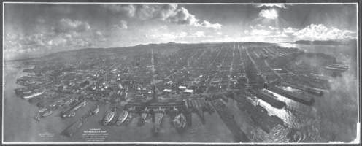
(a)
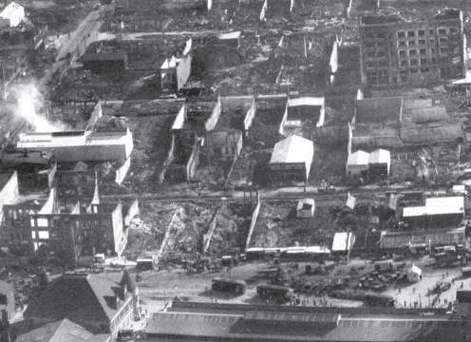
(b)
Figure 2.1 “San Francisco in Ruins,” photographed by G. R. Lawrence on May 8, 1906, approximately six weeks after the great earthquake and fire. (a) Note the backlighting provided by the low sun angle when the image was taken (sun in upper right of photograph). (b) This enlargement includes a small area located in the center-left of (a) approximately 4.5 cm from the left edge and 1.9 cm from the bottom of the photograph. (A bright smoke plume is included in this area.) The damage to the various buildings present in this area is readily observable in this enlargement. (Courtesy Library of Congress.)
图2.1“废墟中的旧金山”，由G.R.劳伦斯于1906年5月8日拍摄，大约在大地震和火灾发生六周后。（a）注意拍摄图像时低太阳角度提供的背光（照片右上角的太阳）。（b）该放大图包括位于（a）左中心的一个小区域，距离照片的左边缘约4.5 cm，距离照片的底部约1.9 cm。（这个区域有一股明亮的烟羽。）在这次放大中，可以很容易地观察到该地区各种建筑的损坏。（由国会图书馆提供。）

He hoisted his personally constructed panoramic camera, which had a field of view of approximately 130°, some 600 m above San Francisco Bay using a train of 17 kites flown from a naval ship. He also designed a stabilizing mechanism for his large camera, which reportedly weighed 22 kg and employ-ed celluloid-film plate negatives about 0.5 by 1.2 m in size (Baker, 1989). The impressive amount of detail recorded by his camera can be seen in Figure 2.1 b.
他使用从一艘海军舰艇上放飞的17只风筝，在旧金山湾上空约600米处悬挂了他个人建造的全景相机，该相机的视野约为130°。他还为他的大型相机设计了一个稳定机制，据报道，该相机重22公斤，采用了尺寸约为0.5×1.2米的赛璐珞底片（Baker ,1989）。在图2.1 b中可以看到他的相机记录下的大量细节。

The airplane, which had been invented in 1903, was not used as a camera plat- form until 1908, when a photographer accompanied Wilbur Wright and took the first aerial motion pictures (over Le Mans, France). Obtaining aerial photographs became a much more practical matter with the airplane than it had been with kites and balloons. Photography from aircraft received heightened attention in the interest of military reconnaissance during World War I, when more than one million aerial reconnaissance photographs were taken. After World War I, former military photographers founded aerial survey companies, and widespread aerial photography of the United States began. In 1934, the American Society of Photogrammetry (now the American Society for Photogrammetry and Remote Sensing) was founded as a scientific and professional organization dedicated to advancing this field.
这架飞机发明于1903年，直到1908年才被用作摄影平台，当时一名摄影师陪同威尔伯·赖特拍摄了第一部空中电影（在法国勒芒上空）。与风筝和气球相比，用飞机获取航拍照片变得更加实际了。在第一次世界大战期间，为了军事侦察的利益，飞机摄影受到了高度关注，当时拍摄了超过100万张航空侦察照片。第一次世界大战后，前军事摄影师成立了航空测量公司，开始了对美国的广泛航空摄影。1934年，美国摄影测量学会（现美国摄影测量和遥感学会）作为一个致力于推进这一领域的科学和专业组织成立。

In 1937, the U.S. Department of Agriculture’s Agricultural Stabilization and Conservation Service (USDA-ASCS) began photographing selected counties of the United States on a repetitive basis.
1937年，美国农业部农业稳定保护局（USDA-ASCS）开始重复拍摄本土被选定的县。

During World War II, in a facility located 56 km from London, a team of some 2000 trained interpreters analyzed tens of millions of stereoscopic aerial photographs to discover German rocket launch sites and analyze the damage of Allied bombing raids. They used a stereoplotter (Section 3.10) to make accurate measurements from the aerial photographs.
第二次世界大战期间，在距离伦敦56公里的一个设施中，一个由大约2000名训练有素的口译员组成的团队分析了数千万张立体航空照片，以发现德国火箭发射场并分析盟军轰炸袭击的损失。他们使用立体绘图仪（第3.10节）从航空照片中进行精确测量。

The film-based archives of aerial photographs begun in the United States (and elsewhere) in the 1930s are now recognized as an invaluable record for monitoring landscape change. This record continues to build, but increasingly, digital cameras are being used to accomplish this purpose. The transition from the use of film-based to digital aerial cameras took approximately a decade. Development of digital cameras in the civil sector began during the 1990s. The first widely available digital aerial cameras were unveiled at the 2000 International Society for Photogrammetry and Remote Sensing (ISPRS) Congress held in Amsterdam, The Netherlands. Currently, nearly a dozen manufacturers of digital aerial cam- eras exist, and digital acquisition procedures overwhelmingly dominate those that are film-based. However, we treat both film-based and digital photographic sys- tems in the following discussion for a number of reasons, including the facts that many film-based aerial photographic systems are still in use and many historical film photographs are now being converted to a digital format by means of scanning the film using a scanning densitometer to enable further digital analysis. Hence, it is important to understand the basic characteristics of such imagery in many applications.
20世纪30年代在美国（和其他地方）开始的基于电影的航空照片档案现在被认为是监测景观变化的无价记录。这一记录仍在继续，但越来越多的数码相机被用来实现这一目的。从使用胶片相机到数字航空相机的转变花了大约十年的时间。民用领域数码相机的发展始于20世纪90年代。2000年在荷兰阿姆斯特丹举行的国际摄影测量和遥感学会（ISPRS）大会上，第一批广泛使用的数字航空相机亮相。目前，存在近十几家数字航空摄像机制造商，数字采集程序压倒性地主导了那些基于胶片的程序。然而，由于许多原因，我们在下面的讨论中同时处理基于胶片和数字的摄影系统，包括许多基于胶片的航空摄影系统仍在使用，并且许多历史胶片照片现在正在通过使用扫描密度计扫描胶片以实现进一步的数字分析而转换为数字格式。因此，理解这种图像在许多应用中的基本特征是很重要的。

2.3 PHOTOGRAPHIC BASICS（摄影基础）
The basics of photography using both film and digital cameras are similar in many ways. In this section, we describe the simple camera, focus, exposure, geometric factors influencing exposure, and filters.
使用胶片和数码相机的摄影基础在许多方面是相似的。在本节中，我们将描述简单的相机、对焦、曝光、影响曝光的几何因素和滤镜。

The Simple Camera（简单的相机）
The cameras used in the early days of photography were often no more than a light- tight box with a pinhole at one end and the light-sensitive material to be exposed positioned against the opposite end (Figure 2.2 a). The amount of exposure of the film was controlled by varying the time the pinhole was allowed to pass light. Often, exposure times were in hours because of the low sensitivity of the photographic materials available and the limited light-gathering capability of the pinhole design. In time, the pinhole camera was replaced by the simple lens camera, shown in Figure 2.2 b. By replacing the pinhole with a lens, it became possible to enlarge the hole through which light rays from an object were collected to form an image, thereby allowing more light to reach the film in a given amount of time. In addition to the lens, an adjustable diaphragm and an adjustable shutter were introduced. The diaphragm controls the diameter of the lens opening during film exposure, and the shutter controls the duration of exposure.
摄影早期使用的相机通常只不过是一个不透光的盒子，一端有一个针孔，待曝光的感光材料靠在另一端（图2.2 a）。通过改变允许光通过针孔的时间来控制膜的曝光量。通常，由于可用照相材料的低灵敏度和针孔设计的有限聚光能力，曝光时间以小时为单位。随着时间的推移，针孔相机被简单的透镜相机所取代，如图2.2 b所示。通过用透镜代替针孔，可以扩大收集来自物体的光线以形成图像的孔，从而允许更多的光在给定的时间内到达膜。除了镜头，还引入了可调光圈和可调快门。光圈控制胶片曝光时镜头开口的直径，快门控制曝光的持续时间。

The design and function of modern adjustable cameras is conceptually identical to that of the early simple lens camera. To obtain sharp, properly exposed photo- graphs with such systems, they must be focused and the proper exposure settings must be made. We describe each of these operations separately.
现代可调相机的设计和功能在概念上与早期的简单镜头相机相同。为了用这样的系统获得清晰的、适当曝光的照片，它们必须被聚焦并且必须进行适当的曝光设置。我们分别描述这些操作中的每一个。
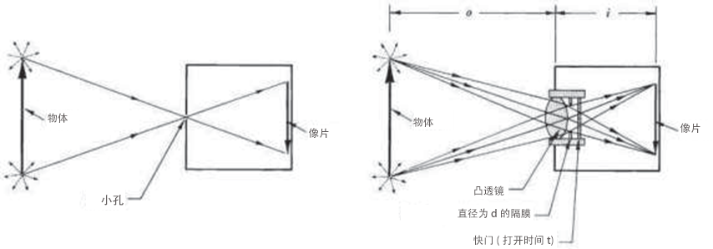
Figure 2.2 Comparison between (a) pinhole and (b) simple lens cameras.
图2.2（a）针孔相机和（b）简单镜头相机之间的比较。

Focus（对焦）
Three parameters are involved in focusing a camera: the focal length of the camera lens, f, the dis- tance between the lens and the object to be photographed, o, and the distance between the lens and the image plane, i. The focal length of a lens is the distance from the lens at which parallel light rays are focused to a point. (Light rays coming from an object at an infinite distance are parallel.) Object distance o and image distance i are shown in Figure 2.2 b. When a camera is properly focused, the relationship among the focal length, object distance, and image distance is
相机对焦涉及三个参数：相机镜头的焦距f、镜头与被摄物的距离o、镜头与像面的距离i。透镜的焦距是平行光线聚焦到一点的距透镜的距离。（来自无穷远物体的光线是平行的。）物距o和像距i如图2.2 b所示。当相机正确对焦时，焦距、物距和像距之间的关系为
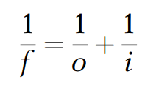 (2.1)

Because f is a constant for any given lens, as object distance o for a scene changes, image distance i must change. This is done by moving the camera lens with respect to the image plane (film or electronic sensor). When focused on an object at a discrete distance, a camera can image over a range just beyond and in front of this distance with acceptable focus. This range is commonly referred to as the depth of field.
因为f对于任何给定的镜头都是常数，所以当场景的物距o改变时，像距i必须改变。这是通过相对于图像平面(胶片或电子传感器)移动相机镜头来完成的。当聚焦在一个离散距离的物体上时，相机可以在这个距离之外和前面的范围内以可接受的焦点成像。这个范围通常被称为景深。

In aerial photography the object distances involved are effectively infinite. Hence the 1/o term in Eq. 2.1 goes to zero and i must equal f. Thus, most aerial cameras are manufactured with their image plane precisely located at a fixed distance f from their lens.
在航空摄影中，所涉及的物体距离实际上是无限的。因此等式中的1/o项。2.1式变为零，i必须等于f。因此，大多数航空相机被制造成使得它们的像平面精确地位于离它们的透镜固定距离f处。

Exposure（曝光）
The exposure at any point in the image plane of a camera is determined by the irradiance at that point multiplied by the exposure time, expressed by
相机图像平面中任何点的曝光1由该点的辐照度乘以曝光时间确定，由下式表示
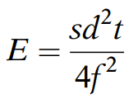 (2.2)
Where
其中

E = exposure, J mm⁻²
s = scene brightness, J mm⁻² sec⁻¹
d = diameter of lens opening, mm
t = exposure time, sec
f = lens focal length, mm
E=暴露量，J mm⁻²
s=场景亮度，J mm⁻² sec⁻¹
d=透镜开口直径，mm
t=暴露时间，秒
f=镜头焦距，mm

It can be seen from Eq. 2.2 that, for a given camera and scene, the exposure can be varied by changing the camera shutter speed t and/or the diameter of the lens opening d. Various combinations of d and t will yield equivalent exposures.
从等式2.2可以看出，对于给定的相机和场景，可以通过改变相机快门速度t和/或镜头开口直径d来改变曝光。d和t的各种组合将产生等效的曝光。

EXAMPLE 2.1（例2.1）
A camera with a 40-mm-focal-length lens is producing properly exposed images with a lens opening diameter of 5 mm and an exposure time of 1/125 sec (condition 1). If the lens opening is increased to 10 mm and the scene brightness does not change, what exposure time should be used to maintain proper exposure (condition 2)?
125
具有40mm焦距镜头的相机产生适当曝光的图像，镜头开口直径为5mm，曝光时间为1/125秒（条件1）。如果镜头开口增加到10 mm，场景亮度不变，应该使用什么曝光时间来保持适当的曝光（条件2）？
125

Solution（解决方案）
We wish to maintain the same exposure for conditions 1 and 2. Hence,
我们希望对条件1和条件2保持相同的暴露程度。因此，
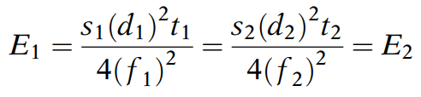
Canceling constants, we obtain
约掉常数，我们得到
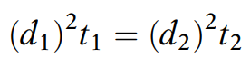
or
或
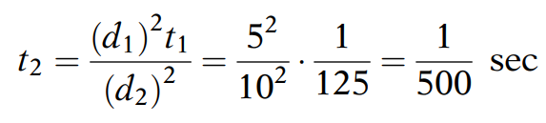
The diameter of the lens opening of a camera is determined by adjusting the diaphragm to a particular aperture setting, or f-stop. This is defined by
相机镜头开口的直径是通过将光圈调整到特定的光圈设置或光圈来确定的。这是由
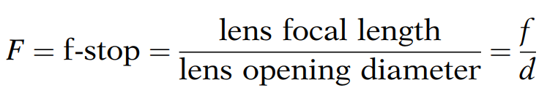 (2.3)

As can be seen in Eq. 2.3, as the f-stop number increases, the diameter of the lens opening decreases and, accordingly, the image exposure decreases. Because the area of the lens opening varies as the square of the diameter, the change in exposure with f-stop is proportional to the square root of the f-stop. Shutter speeds are normally established in sequential multiples of 2 ( 1/125 sec, 1/250 sec, 1/500 sec, 1/1000 sec, …). Thus, f-stops vary as the square root of 2 (f/1.4, f/2, f/2.8, f/4,…). Note, for example, that when the value of the f-stop is 2, it is written as f/2.
从等式2.3中可以看出，随着光圈数的增加，透镜开口的直径减小，并且相应地，图像曝光减小。因为镜头开口的面积随着直径的平方而变化，所以使用光圈的曝光变化与光圈的平方根成正比。快门速度通常以2的连续倍数（1/125秒、1/250秒、1/500秒、1/1000秒……）建立。因此，光圈随着2的平方根而变化（f/1.4、f/2、f/2.8、f/4…）。注意，例如，当f-stop的值为2时，它被写成f/2。

The interplay between f-stops and shutter speeds is well known to photographers. For constant exposure, an incremental change in shutter speed setting must be accompanied by an incremental change in f-stop setting. For example, the exposure obtained at 1/500 sec and f/1.4 could also be obtained at 1/250 sec and f/2. Short exposure times allow one to “stop action” and prevent blurring when photographing moving objects (or when the camera is moving, as in the case of aerial photo- graphy). Large lens-opening diameters (small f-stop numbers) allow more light to reach the image plane and are useful under low-light conditions. Small lens-opening diameters (large f-stop numbers) yield greater depth of field. The f-stop corresponding to the largest lens opening diameter is called the lens speed. The larger the lens-opening diameter (smaller f-stop number), the “faster” the lens is.
光圈和快门速度之间的相互作用是摄影师所熟知的。对于恒定曝光，快门速度设置的增量变化必须伴随着光圈设置的增量变化。例如，在1/500秒和f/1.4获得的曝光也可以在1/250秒和f/2获得。短曝光时间允许人们在拍摄移动物体时（或当相机移动时，如在航空摄影的情况下）“静止”并防止模糊。大的镜头开口直径（小的光圈数）允许更多的光到达图像平面，并且在弱光条件下是有用的。小的镜头开口直径（大光圈数）产生更大的景深。与最大镜头开口直径相对应的光圈称为镜头速度。镜头孔径越大（光圈数越小），镜头的速度越快。

Using f-stops, Eq. 2.2 can be simplified to
使用光圈，等式2.2可以简化为
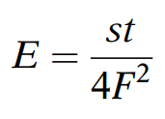 (2.4)
Where（其中） F = f-stop = f/d.

Equation 2.4 is a convenient means of summarizing the interrelationship among exposure, scene brightness, exposure time, and f-stop. This relationship may be used in lieu of Eq. 2.2 to determine various f-stop and shutter speed settings that result in identical exposures.
公式2.4是总结曝光、场景亮度、曝光时间和光圈之间相互关系的方便方法。该关系可以代替等式2.2用于确定导致相同曝光的各种光圈和快门速度设置。

EXAMPLE 2.2（例2.2）
A camera is producing properly exposed images when the lens aperture setting is f/8 and the expo-sure time is 1/125 sec (condition 1). If the lens aperture setting is changed to f/4, and the scene brightness does not change, what exposure time should be used to yield a proper exposure (condition 2)? (Note that this is simply a restatement of the condition of Example 2.1.)
125
当镜头光圈设置为f/8且曝光时间为1/125秒（条件1）时，相机正在产生正确曝光的图像。如果镜头光圈设置更改为f/4，而场景亮度没有变化，应该使用什么曝光时间来产生适当的曝光（条件2）？（注意，这只是例2.1的条件的重述。）
125

Solution（解决方案）
We wish to maintain the same exposure for conditions 1 and 2. With the scene brightness the same in each case,
我们希望对条件1和条件2保持相同的暴露。在每种情况下场景亮度相同的情况下，
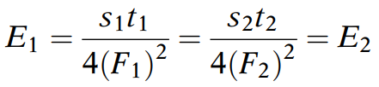
Canceling constants,
约掉常数，
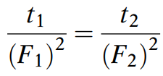
and
和
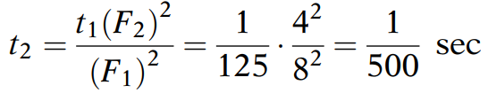

Geometric Factors Influencing Exposure（影响曝光的几何因素）
Images are formed because of variations in scene brightness values over the area photographed. Ideally, in aerial photography, such variations would be related solely to variations in ground object type and/or condition. This assumption is a great oversimplification because many factors that have nothing to do with the type or condition of a ground feature can and do influence exposure. Because these factors influence exposure measurements but have nothing to do with true changes in ground cover type or condition, we term them extraneous effects. Extraneous effects are of two general types: geometric and atmospheric. Atmospheric effects were introduced in Sections 1.3 and 1.4; here we discuss the major geometric effects that influence film exposure.
由于拍摄区域上的场景亮度值的变化而形成图像。理想地，在航空摄影中，这种变化将仅与地面物体类型和/或条件的变化有关。这个假设过于简单化，因为许多与地面特征的类型或条件无关的因素可以而且确实会影响暴露。因为这些因素影响暴露测量，但与地面覆盖类型或条件的真实变化无关，我们称之为外来影响。外来效应有两种一般类型：几何效应和大气效应。第1.3节和第1.4节介绍了大气效应；在这里，我们讨论影响胶片曝光的主要几何效应。

Probably the most important geometric effect influencing exposure is exposure fall off. This extraneous effect is a variation in focal plane exposure purely associated with the distance an image point is from the image center. Because of fall off, a ground scene of spatially uniform reﬂectance does not produce spatially uniform exposure in the focal plane. Instead, for a uniform ground scene, exposure at the focal plane is at a maximum at the center of the image and decreases with radial distance from the center.
影响曝光的最重要的几何效应可能是曝光衰减。这种无关效应是焦平面曝光的变化，它纯粹与图像点距图像中心的距离相关联。由于衰减，空间均匀反射的地面场景不会在焦平面中产生空间均匀的曝光。相反，对于均匀的地面场景，焦平面处的曝光在图像的中心处最大，并且随着距中心的径向距离而减小。

The factors causing falloff are depicted in Figure 2.3, which shows an image being acquired over a ground area assumed to be of uniform brightness. For a beam of light coming from a point directly on the optical axis, exposure E₀ is directly proportional to the area, A, of the lens aperture and inversely proportional to the square of the focal length of the lens, f ². However, for a beam exposing a point at an angle y off the optical axis, exposure E_{y} is reduced from E₀ for three reasons:
引起衰减的因素如图2.3所示，图2.3示出了在假定具有均匀亮度的地面区域上采集的图像。对于直接来自光轴上的点的光束，曝光E₀与透镜孔径的面积A成正比，并且与透镜焦距的平方f²成反比。然而，对于以偏离光轴的角度y曝光点的光束，曝光E_{y}从E₀减小，原因有三：

1. The effective light-collecting area of the lens aperture, A, decreases in pro- portion to cosy when imaging off-axis areas (A_{y} = A cosy).
2. The distance from the camera lens to the focal plane, f_{y}, increases as 1/cosy for off-axis points, f_{y} = f/cosy. Because exposure varies inversely as the square of this distance, there is an exposure reduction of cos²y.
3. The effective size of an image area element, dA, projected perpendicular to the beam decreases in proportion to cosy when the element is located off-axis, dA_{y} = dA cosy.
1.当对离轴区域成像时，透镜孔径A的有效集光面积与cosy成比例减小（Ay=A cosy）。
2.对于离轴点，从相机镜头到焦平面的距离fy随着1/cosy而增加，fy=f/cosy。因为曝光与该距离的平方成反比，所以cos2y的曝光减少。
3.当元件离轴时，垂直于光束投影的图像区域元件dA的有效尺寸与cosy成比例地减小，dAy=dA cosy。

Combining the above effects, the overall theoretical reduction in exposure for an off-axis point is
结合上述影响，离轴点的曝光的总体理论减少为
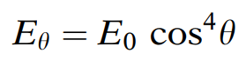 (2.5)

Where(其中)
y = angle between the optical axis and the ray to the off-axis point
E_{y} = exposure at the off-axis point
E₀ = exposure that would have resulted if the point had been located at the optical axis
y=光轴和光线到离轴点的角度
Ey=离轴点的曝光
E₀=如果该点位于光轴处将导致的曝光

The systematic effect expressed by the above equation is compounded by differential transmittance of the lens and by vignetting effects in the camera optics. Vignetting refers to internal shadowing resulting from the lens mounts and other aperture surfaces within the camera. The effect of vignetting varies from camera to camera and varies with aperture setting for any given camera.
由上述方程表示的系统效应由透镜的差分透射率和相机光学中的渐晕效应复合。渐晕是指由相机内的镜头支架和其他光圈表面产生的内部阴影。渐晕的效果因相机而异，并且因任何给定相机的光圈设置而异。
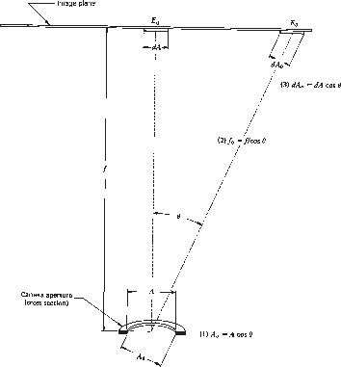
Figure 2.3 Factors causing exposure falloff.
图2.3导致暴露下降的因素。

Falloff and vignetting are normally mitigated at the time of exposure by using antivignetting filters. When such filters are not used, or when they fail to negate the exposure variations completely, it is appropriate to correct off-axis exposure values by normalizing them to the value they would possess had they been at the center of the photograph. This is done through the application of a correction model that is determined (for a given f-stop) by a radiometric calibration of the camera. This calibration essentially involves photographing a scene of uniform brightness, measuring exposure at various y locations, and identifying the relationship that best describes the falloff. For most cameras this relationship takes on the form
衰减和渐晕通常在曝光时通过使用抗渐晕滤光片来减轻。当不使用这样的滤光片时，或者当它们不能完全消除曝光变化时，适当地通过将离轴曝光值归一化为它们在照片中心时将具有的值来校正离轴曝光值。这是通过应用校正模型来完成的，该校正模型由相机的辐射校准确定(对于给定的f光圈)。这种校准本质上涉及拍摄均匀亮度的场景，测量不同y位置的曝光，并识别最能描述衰减的关系。对于大多数相机来说，这种关系的形式是
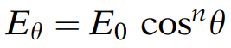 (2.6)

Because modern cameras are normally constructed in such a way that their actual falloff character- istics are much less severe than the theoretical cos⁴falloff, n in the above equation is normally in the range 1.5 to 4. All exposure values measured off- axis are then corrected in accordance with the falloff characteristics of the particular camera in use.
因为现代相机通常以这样的方式构造，即它们的实际衰减特性远没有理论cos⁴衰减严重，所以上述方程中的n通常在1.5至4的范围内。然后，根据使用中的粒子相机的衰减特性来校正离轴测量的所有曝光值。

Unique to digital cameras is yet another source of focal plane exposure variation, pixel vignetting. This results from the fact that most digital camera sensors are angle-dependent at the individual pixel level. Light striking such sensors at a right angle results in a signal that is greater than the same illumination striking the sensor at an oblique angle. Most digital cameras have an internal image–processing capability to apply corrections for this and the other natural, optical, and mechanical vignetting effects. These corrections are normally applied during the process of converting the raw sensor data to a standard format such as TIFF or JPEG.
数码相机独有的是焦平面曝光变化的另一个来源，像素渐晕。这是由于大多数数码相机传感器在单个像素水平上依赖于角度所造成的。以直角照射这种传感器的光产生的信号大于以斜角照射传感器的相同照明。大多数数码相机都具有内部图像处理能力，可以对这种和其他自然、光学和机械渐晕效果进行校正。这些校正通常在将原始传感器数据转换为诸如TIFF或JPEG的标准格式的过程中应用。

The location of an object within a scene can also affect the resulting exposure, as was discussed in Section 1.4.
场景中物体的位置也会影响最终的曝光，如1.4节所述。

Filter(过滤器)
Through the use of filters, we can be selective about which wavelengths of energy reflected from a scene we allow to reach the image plane (film or electronic). Filters are transparent (glass or gelatin) materials that, by absorption or reflection, eliminate or reduce the energy reaching the image plane in selected portions of the photographic spectrum. They are placed in the optical path of a camera in front of the lens.
通过使用滤光片，我们可以选择从场景反射的能量的那些波长到达图像平面（胶片或电子）。滤光片是透明（玻璃或明胶）材料，通过吸收或反射，消除或减少在摄影光谱的选定部分中到达图像平面的能量。它们被放置在镜头前面的照相机的光路中。

Aerial camera filters consist mainly of organic dyes suspended in glass or in a dried gelatin film. Filters are most commonly designated by Kodak Wratten filter numbers. They come in a variety of forms having a variety of spectral transmittance properties. The most commonly used spectral filters are absorption filters. As their name indicates, these filters absorb and transmit energy of selected wavelengths. A “yellow” filter, for example, absorbs blue energy incident upon it and transmits green and red energy. The green and red energy combine to form yellow—the color we would see when looking through the filter if it is illuminated by white light (see Plate 3 b).
航空相机滤光片主要由悬浮在玻璃或干燥明胶膜中的有机染料组成。滤光片通常由柯达Wratten滤光片编号指定。它们有多种形式，具有多种光谱透射率特性。最常用的光谱滤光片是吸收滤光片。顾名思义，这些滤波器吸收和透射选定波长的能量。例如，“黄色”滤光器吸收入射到其上的蓝色能量并透射绿色和红色能量。绿色和红色能量结合形成黄色——如果被白光照亮，我们通过滤光器看到的颜色（见图3 b）。

Absorption filters are often used to permit differentiation of objects with nearly identical spectral response patterns in major portions of the photographic spectrum. For example, two objects may appear to reflect the same color when viewed only in the visible portion of the spectrum but may have different reflection characteristics in the UV or near-IR region.
吸收滤光片通常用于区分在摄影光谱的主要部分中具有几乎相同的光谱响应模式的物体。例如，当仅在光谱的可见部分观察时，两个物体可能看起来反射相同的颜色，但在UV或近红外区域中可能具有不同的反射特性。

Figure 2.4 illustrates generalized spectral reflectance curves for natural grass and artificial turf. Because the artificial turf is manufactured with a green color to visually resemble natural grass, the reflectance in blue, green, and red is similar for both surfaces. However, the natural grass reflects very highly in the near IR whereas the artificial turf does not. In Figure 2.5, we illustrate disting-uishing between natural grass and artificial turf using photography in selected bands. Illustrated in (a) is an image in the visible part of the spectrum (0.4 to 0.7 mm) that records natural grass (outside the stadium) and artificial turf (inside the stadium) with a similar tone. Illustrated in (b) is an image where the scene reflectance is filtered such that only wavelengths longer than 0.7 mm are recorded, with the result that the natural grass has a light tone (high IR reflectance) and the artificial turf a very dark tone (low IR reflectance). The filter used in such photography, which selectively absorbs energy below a certain wavelength, is referred to as a short wavelength blocking filter or a high pass filter.
图2.4显示了天然草和人造草皮的广义光谱反射率曲线。因为人造草皮是用绿色制造的，以在视觉上类似于天然草，所以两个表面的蓝色、绿色和红色的反射率是相似的。然而，天然草在近红外反射非常高，而人造草皮则没有。在图2.5中，我们使用选定波段的照片来说明天然草和人造草皮之间的区别。（a）中所示的是光谱可见部分（0.4至0.7 mm）的图像，其记录了具有相似色调的天然草（体育场外）和人造草皮（体育场内）。在（b）中示出了这样的图像，其中场景反射率被过滤，使得仅记录长于0.7 mm的波长，结果是天然草具有浅色调（高红外反射率），而人造草皮具有非常暗的色调（低红外反射率）。在这种摄影中使用的选择性地吸收低于某个波长的能量的滤光片被称为短波长阻挡滤光片或高通滤光片。
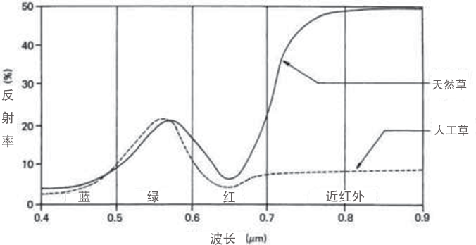
Figure 2.4 Generalized spectral reflectance curves for natural grass and artificial turf.
图2.4天然草和人造草皮的广义光谱反射率曲线

When one is interested in sensing the energy in only an isolated narrow portion of the spectrum, a bandpass filter may be used. Wavelengths above and below a specific range are blocked by such a filter. The spectral transmittance curves for a typical high pass filter and a bandpass filter are illustrated in Figure 2.6. Several high pass and bandpass filters may be used simultaneously to selectively photo- graph various wavelength bands as separate images.
当人们对仅在光谱的孤立的狭窄部分感兴趣时，可以使用带通滤波器。高于和低于特定范围的波长被这种滤光器阻挡。典型的高通滤波器和带通滤波器的光谱透射率曲线如图2.6所示。可以同时使用几个高通和带通滤波器来选择性地将各种波长带拍摄成单独的图像。

There is a large selection of filters from which to choose for any given application. Manufacturers’ literature describes the spectral transmittance properties of each available type (e.g., Eastman Kodak Company, 1990). It should be noted that low pass absorption filters are not available. Interference filters must be used when short wavelength transmittance is desired. These filters reflect rather than absorb unwanted energy. They are also used when extremely narrow bandpass characteristics are desired.
对于任何给定的应用，都有大量的过滤器可供选择。制造商的文献描述了每种可用类型的光谱透射率特性(例如，Eastman Kodak Company，1990)。应该注意的是，低通吸收滤波器不可用。当需要短波长透射率时，必须使用干涉滤光片。这些过滤器反射而不是吸收不需要的能量。当需要极窄的带通特性时，也使用它们。

Antivignetting filters are often used to improve the uniformity of exposure throughout an image. As described earlier in this section, there is a geometrically based decrease in illumination with increasing distance from the center of a photograph. To negate the effect of this illumination falloff, antivignetting filters are designed to be strongly absorbing in their central area and progressively transparent in their circumferential area. To reduce the number of filters used, and thereby the number of between-filter reflections possible, antivignetting features are sometimes built into haze and other absorption filters.
抗渐晕滤光片通常用于提高整个图像的曝光均匀性。如本节前面所述，随着距照片中心距离的增加，照明会出现基于几何的减少。为了抵消这种照明衰减的影响，抗渐晕滤光片被设计成在其中心区域具有强吸收性并且在其圆周区域逐渐透明。为了减少所使用的滤光片的数量，从而减少滤光片之间可能的反射的数量，有时在雾度和其他吸收滤光片中内置防晕影特征。

Polarizing filters are sometimes used in photography. Unpolarized light vibrates in all directions perpendicular to the direction of propagation. As shown in Figure 2.7, a linear polarizing filter transmits only light vibrating in one plane. Unpolarized light striking various natural surfaces can be reflected with at least partial polarization. The amount of polarization depends on the angle of inci- dence of the incoming light (see Figure 1.13), the nature of the surface, and the viewing angle. It also depends on the azimuth angle (see Figure 1.14). Polarizing filters can be used to reduce reflections in photographs of smooth surfaces (e.g., glass windows and water bodies). The effect of polarization is the greatest when the angle of reflection is approximately 35%. This often limits the use of polarizing filters in vertical aerial photography.
偏振滤光片有时用于摄影。非偏振光在垂直于传播方向的所有方向上振动。如图2.7所示，线性偏振滤光片只透射在一个平面内振动的光。撞击各种自然表面的非偏振光可以至少部分偏振地反射。偏振量取决于入射光的入射角（见图1.13）、表面的性质和视角。它还取决于方位角（见图1.14）。偏振滤光片可用于减少光滑表面(例如，玻璃窗和水体)照片中的反射。当反射角约为35%时，偏振的影响最大。这通常限制了偏振滤光片在垂直航空摄影中的使用。
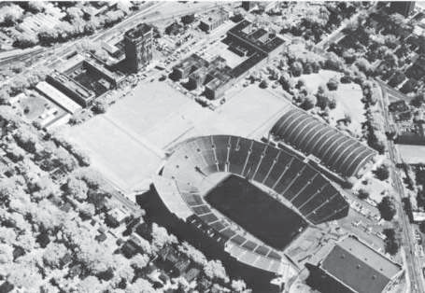
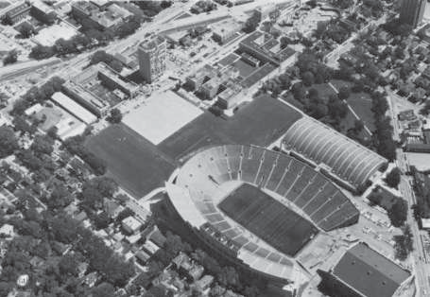
(b)
(a)
Figure 2.5 Simultaneous oblique aerial photographs showing the effect of filtration on discrimination of ground objects. Illustrated in (a) is an image in the visible part of the spectrum (0.4 to 0.7 mm) that records natural grass (outside the stadium) and artificial turf (inside the stadium) with a similar tone. Illustrated in (b) is an image in which the scene reflectance is filtered such that only wavelengths longer than 0.7 mm are recorded, with the result that the natural grass has a light tone and the artificial turf a very dark tone. (Author-prepared figure.)
图2.5显示过滤对区分地面物体的影响的同时倾斜航空照片。（a）中所示的是光谱可见部分（0.4至0.7 mm）的图像，其记录了具有相似色调的天然草（体育场外）和人造草皮（体育场内）。在（b）中示出了其中场景反射率被过滤使得仅记录大于0.7 mm的波长的图像，其结果是天然草具有浅色调并且人造草皮具有非常深的色调。（作者准备的图。）
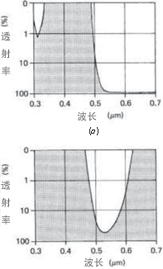
Figure 2.6 Typical transmission curves for filter types commonly used in aerial photography: (a) typical high pass filter (Kodak Wratten No. 12); (b) typical bandpass filter (Kodak Wratten No. 58). (Adapted from Eastman Kodak Company, 1992.)
图2.6航空摄影常用滤光片类型的典型透射曲线：（a）典型高通滤光片（柯达Wratten No. 12）；(b)典型的带通滤波器(Kodak Wratten No. 58)。（改编自伊士曼柯达公司，1992年。）

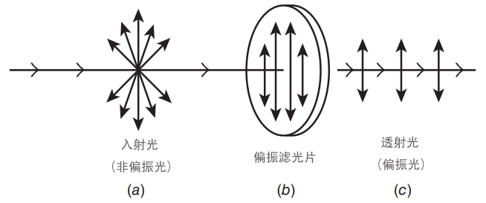
Figure 2.7 Process of using a polarizing filter to polarize light. (Adapted from American Society of Photogrammetry, 1968.)
图2.7使用偏振滤光片使光偏振的过程。（改编自美国摄影测量学会，1968年）

2.4 FILM PHOTOGRAPHY（胶片摄影）
In film photography, the resulting images can be either black and white or color, depending on the film used. Black and white photographs are typically exposed on negative film from which positive paper prints are made. Color images are typically recorded directly on film, which is processed to a positive transparency (although color negative films exist as well).
在胶片摄影中，产生的图像可以是黑白的，也可以是彩色的，这取决于所用的胶片。黑白照片通常在负片上曝光，正片由负片制成。彩色图像通常直接记录在胶片上，胶片被处理成正透明(尽管也存在彩色负片)。

In black and white photography using negative film and positive prints, each of these materials consists of a light-sensitive photographic emulsion coated onto a base. The generalized cross sections of black-and-white film and print paper are shown in Figure 2.8 a and b. In both cases, the emulsion consists of a thin layer of light-sensitive silver halide crystals, or grains, held in place by a solidified gelatin.
在使用负片和正片的黑白摄影中，这些材料中的每一种都由涂在基底上的感光照相乳剂组成。黑白胶片和打印纸的广义截面如图2.8 a和b所示。在这两种情况下，乳液都由一薄层光敏卤化银晶体或颗粒组成，由固化的明胶固定。
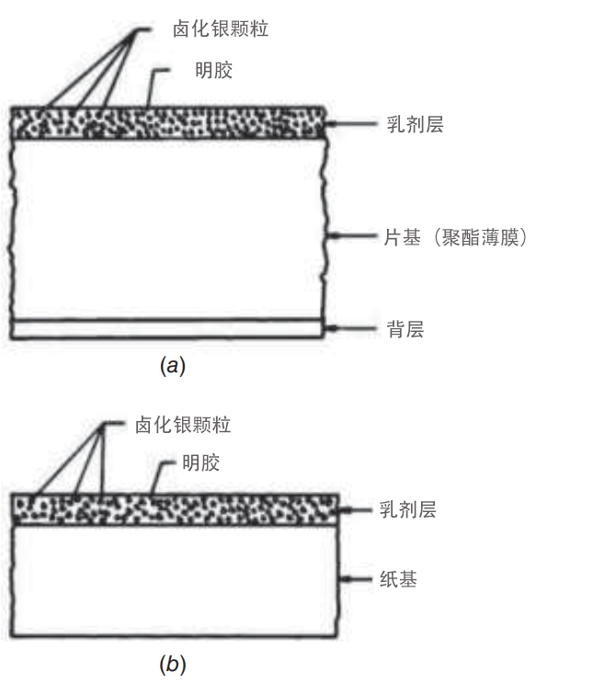
Figure 2.8 Generalized cross section of black-and-white photographic materials: (a) film and (b) print paper. (Adapted from Eastman Kodak Company, 1992.)
图2.8黑白照相材料的广义横截面：(a)胶片和(b)打印纸。（改编自伊士曼柯达公司，1992年。）
Paper is the base material for paper prints. Various plastics are used for film bases. When exposed to light, the silver halide crystals within an emulsion undergo a photochemical reaction, forming an invisible latent image. Upon treatment with suitable agents in the development process, these exposed silver salts are reduced to silver grains that appear black, forming a visible image. The number of black crystals at any point on the film is proportional to the exposure at that point. Those areas on the negative that were not exposed are clear after processing because crystals in these areas are dissolved as part of the development process. Those areas of the film that were exposed become various shades of gray, depending on the amount of exposure. Hence a “negative” image of reversed tonal rendition is produced.
纸是纸质印刷品的基础材料。各种塑料用于薄膜基底。当暴露在光下时，乳液中的卤化银晶体发生光化学反应，形成不可见的潜像。在显影过程中用合适的试剂处理后，这些暴露的银盐被还原成呈现黑色的银颗粒，形成可见的图像。胶片上任何一点的黑色晶体的数量与该点的曝光成正比。底片上那些未曝光的区域在处理后是清晰的，因为这些区域中的晶体作为显影过程的一部分被溶解。根据曝光量的不同，胶片中曝光的区域会变成不同深浅的灰色。因此，它会产生反向色调再现的”负片”图像。

Most aerial photographic paper prints are produced using the negative-to- positive sequence and a contact printing procedure. Here, the film is exposed and processed as usual, resulting in a negative of reversed scene geometry and bright- ness. The negative is then placed in emulsion-to-emulsion contact with print paper. Light is passed through the negative, thereby exposing the print paper. When processed, the image on the print is a positive representation of the original ground scene at the size of the negative.
大多数航空相纸打印是使用负片到正片顺序和接触打印程序生产的。在这里，胶片照常曝光和处理，产生场景几何形状和亮度颠倒的底片。然后将底片置于与打印纸乳液对乳液接触的状态。光穿过底片，从而使打印纸曝光。处理后，印刷品上的图像是底片大小的原始地面场景的正面表示。

Film Density and Characteristic Curves(薄膜密度和特性曲线)
The radiometric characteristics of aerial photographs determine how a specific film—exposed and processed under specific conditions—responds to scene energy of varying intensity. Knowledge of these characteristics is often useful, and sometimes essential, to the process of photographic image analysis. This is particularly true when one attempts to establish a quantitative relationship between the tonal values on an image and some ground phenomenon. For example, one might wish to measure the darkness, or optical density, of a transparency at various image points in a cornfield and correlate these measurements with a ground-observed parameter such as crop yield. If a correlation exists, the relationship could be used to predict crop yield based on photographic density measurements at other points in the scene. Such an effort can be successful only if the radiometric properties of the particular film under analysis are known. Even then, the analysis must be undertaken with due regard for such extraneous sensing effects as differing levels of illumination across a scene, atmospheric haze, and so on. If these factors can be sufficiently accounted for, considerable information can be extracted from the tonal levels expressed on a photograph. In short, image density measurements may sometimes be used in the process of determining the type, extent, and condition of ground objects. In this section, we discuss the inter- relationships between film exposure and film density, and we explain how characteristic curves (plots of film density versus log exposure) are analyzed.
航空照片的辐射特性决定了在特定条件下曝光和处理的特定胶片如何响应不同强度的场景能量。这些特征的知识对于摄影图像分析过程通常是有用的，有时是必不可少的。当人们试图在图像上的色调值和一些地面现象之间建立定量关系时，尤其如此。例如，人们可能希望测量玉米田中各个图像点处的透明度的暗度或光密度，并将这些测量与地面观测参数（例如作物产量）相关联。如果存在相关性，则该关系可以用于基于场景中其他点的照相密度测量来预测作物产量。只有当被分析的特定薄膜的辐射特性是已知的时，这种努力才能成功。即便如此，在进行分析时也必须适当考虑诸如整个场景的不同照明水平、大气雾霾等无关的传感效应。如果能够充分考虑这些因素，则可以从照片上表达的色调级别中提取相当多的信息。简而言之，图像密度测量有时可以用于确定地面物体的类型、范围和状况的过程中。在本节中，我们讨论了胶片曝光和胶片密度之间的相互关系，并解释了如何分析特征曲线（胶片密度与对数曝光的关系图）。

A photograph can be thought of as a visual record of the response of many small detectors to energy incident upon them. The energy detectors in a photo- graphic record on film are the silver halide grains in the film emulsion, and the energy causing the response of these detectors is referred to as a film’s exposure. During the instant that a photograph is exposed, the different reflected energy levels in the scene irradiate the film for the same length of time. A scene is visible on a processed film only because of the irradiance differences that are caused by the reflectance differences among scene elements. Thus, film exposure at a point in a photograph is directly related to the reﬂectance of the object imaged at that point. Theoretically, film exposure varies linearly with object reﬂectance, with both being a function of wavelength.
照片可以被认为是许多小型探测器对入射到它们上的能量的响应的视觉记录。胶片上的照相记录中的能量检测器是胶片乳剂中的卤化银颗粒，并且引起这些检测器响应的能量被称为胶片的曝光。在照片曝光的瞬间，场景中不同的反射能级照射胶片相同的时间长度。仅由于场景元件之间的反射率差异引起的辐照度差异，场景在处理过的胶片上是可见的。因此，照片中某一点的胶片曝光与在该点成像的物体的反射率直接相关。理论上，胶片曝光随物体反射率线性变化，两者都是波长的函数。

There are many ways of quantifying and expressing film exposure. Most photographic literature uses units of the form meter-candle-second (MCS) or ergs/cm². The student first “exposed” to this subject might feel hopelessly lost in under- standing unit equivalents in photographic radiometry. This comes about because many exposure calibrations are referenced to the sensitivity response of the human eye, through definition of a “standard observer.” Such observations are termed photometric and result in photometric, rather than radiometric, units. To avoid unnecessary confusion over how exposure is measured and expressed in absolute terms, we will deal with relative exposures and not be directly concerned about specifying any absolute units.
有许多方法可以量化和表达胶片曝光。大多数摄影文献使用米-烛-秒（MCS）或ergs/cm²形式的单位。第一次“接触”这个主题的学生可能会在理解照相辐射测量中的等效单位时感到震惊。这是因为通过“标准观察者”的定义，许多曝光校准参考了人眼的灵敏度响应。这种观测被称为光度测量，并产生光度测量单位，而不是辐射测量单位。为了避免在如何以绝对术语测量和表达风险方面出现不必要的混乱，我们将处理相对风险，而不直接关注指定任何绝对单位。
The result of exposure at a point on a film, after development, is a silver deposit whose darkening, or light-stopping, qualities are systematically related to the amount of exposure at that point. One measure of the “darkness” or “lightness” at a given point on a film is opacity O. Because most quantitative remote sensing image analyses involve the use of negatives or diapositives, opacity is determined through measurement of film transmittance T. As shown in Figure 2.9, transmittance T is the ability of a film to pass light. At any given point p, the transmittance is
显影后，在胶片上某一点曝光的结果是银沉积物，其变暗或遮光质量与该点的曝光量系统地相关。在胶片上给定点处的“暗度”或“明度”的一个量度是不透明度O。因为大多数定量遥感图像分析涉及使用底片或幻灯片，所以通过测量胶片透射率T来确定不透明度。如图2.9所示，透射率T是薄膜透过光的能力。在任一给定点p处，透射率为
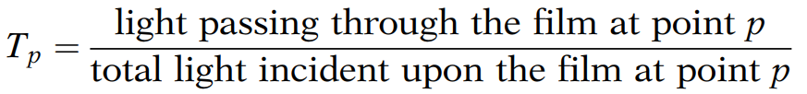 (2.7)
Opacity O at point p is
点p处的不透明度O为
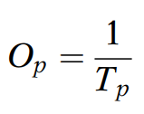 (2.8)
Although transmittance and opacity adequately describe the “darkness” of a film emulsion, it is often convenient to work with a logarithmic expression, density. This is an appropriate expression, because the human eye responds to light levels nearly logarithmically. Hence, there is a nearly linear relation-ship between image density and its visual tone. Density D at a point p is defined as the common logarithm of film opacity at that point:
尽管透射率和不透明度充分描述了胶片乳剂的”暗度”，但通常使用对数表达式密度进行工作是方便的。这是一个适当的表达式，因为人眼对光水平的反应几乎是对数的。因此，在图像密度和其视觉色调之间存在几乎线性关系。点p处的密度D定义为该点处膜不透明度的公共对数：
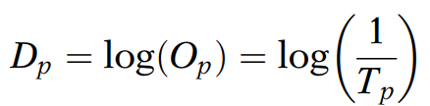 (2.9)
Instruments designed to measure density by shining light through film transparencies are called transmission densitometers. Density measurements may also be made from paper prints with a reﬂectance densitometer, but more precise measurements can be made on the original film material. When analyzing density on a transparency, the process normally involves placing the film in a beam of light that passes through it. The darker an image is, the smaller the amount of light that is allowed to pass, the lower the transmittance, the higher the opacity, and the higher the density. Some sample values of transmittance, opacity, and density are indicated in Table 2.1.
设计用于通过照射光穿过薄膜透明物来测量密度的仪器称为透射密度计。密度测量不仅可以用反射密度计从纸质印刷品进行，还可以在原始薄膜材料上进行更精确的测量。当分析透明胶片上的密度时，该过程通常包括将胶片置于穿过它的光束中。图像越暗，允许通过的光量越少，透射率越低，不透明度越高，密度越高。透射率、不透明度和密度的一些样品值如表2.1所示。

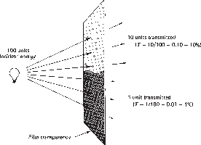
Figure 2.9 Film transmittance. To measure transmittance, a negative or positive transparency is illuminated from one side and the light transmitted through the image is measured on the other. Shown is a section of an image having a transmittance of 0.10 (or 10%) at one image point and 0.01 (or 1%) at another.
图2.9薄膜透射率。为了测量透射率，从一侧照射负或正透明度，并在另一侧测量透射通过图像的光。该图表示出了在一个图像点处具有0.10(或10%)的透射率和在另一个图像点处具有0.01(或1%)的透射率的图像的区段。

TABLE 2.1 Sample Transmittance, Opacity, and Density Values
表2.1样品透射率、不透明度和密度值
透射率  百分比 | T | O | O
100 | 1.0 | 1 | 0.00
50 | 0.50 | 2 | 0.30
25 | 0.25 | 4 | 0.60
10 | 0.1 | 10 | 1.00
1 | 0.01 | 100 | 2.00
0.1 | 0.001 | 1000 | 3.00

