姓名： 张洋 学号： 20232411 d
《卫星导航定位基础》课后作业（三）
GNSS双差相对定位及LAMBDA整周模糊度解算
任务部分：每位同学登陆网址（ftp://igs.gnsswhu.cn/pub/gps/data/daily/2025/doy/24d）下载WUHN与WUH2两个测站的RINEX观测值crx文件，进行双差相对定位解算并利用LAMBDA算法计算整周模糊度，然后进行精度评定。
- 每位同学下载的数据年积日（网址路径中的doy）不能相同；
- 利用crx2rnx.exe将.crx转换为.rnx
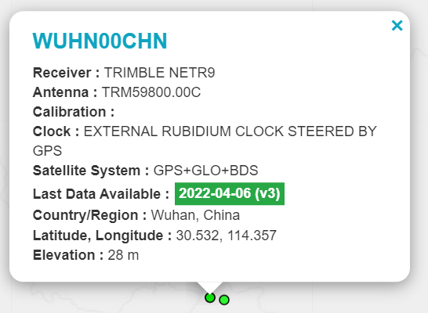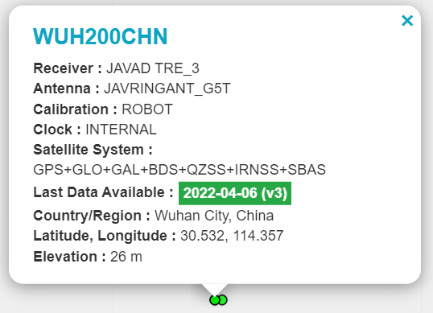
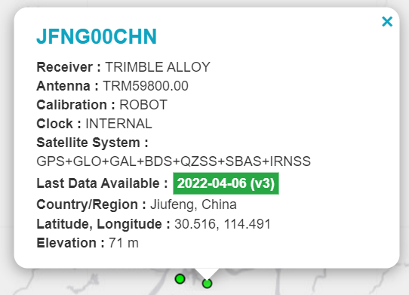
选做部分：实现上述三个测站的组网解算，并实现批量计算和精度评定。
- 算法
1.基线解算：
在相对定位中，两台接收机对多颗卫星进行观测，可通过将不同接收机对不同卫星的观测值进行差分运算来消除或减弱一些误差影响。对于载波相位观测值，其基本观测方程为：
$$\left(φ_{i}^{j}\left(t\right)=\frac{f}{c}\left[ρ_{i}^{j}\left(t\right)+c\left(d t_{i}\left(t\right)-d T^{j}\left(t\right)\right)\right]+N_{i}^{j}+ε_{i}^{j}\left(t\right)\right)$$
其中，$\left(φ_{i}^{j}\left(t\right)\right)$是接收机i在时刻t对卫星j的载波相位观测值，f是载波频率，c是光速，$\left(ρ_{i}^{j}\left(t\right)\right)$是接收机i到卫星j的真实距离，$\left(dt_{i}\left(t\right)\right)$和$\left(dT^{j}\left(t\right)\right)$分别是接收机i和卫星j的钟差，$\left(N_{i}^{j}\right)$是整周模糊度，$\left(ε_{i}^{j}\left(t\right)\right)$是观测噪声等误差项。
首先在接收机间求差，即单差。假设接收机1和接收机2同时观测卫星j，则单差观测方程为：
$$\left(Δφ_{12}^{j}\left(t\right)=\frac{f}{c}\left[Δρ_{12}^{j}\left(t\right)+cΔdt_{12}\left(t\right)\right]+{\backslash DeltaN}_{12}^{j}+Δε_{12}^{j}\left(t\right)\right)$$
其中，$\left(Δφ_{12}^{j}\left(t\right)=φ_{2}^{j}\left(t\right)-φ_{1}^{j}\left(t\right)\right)$，$\left(Δρ_{12}^{j}\left(t\right)=ρ_{2}^{j}\left(t\right)-ρ_{1}^{j}\left(t\right)\right)$，$\left(Δdt_{12}\left(t\right)=dt_{2}\left(t\right)-dt_{1}\left(t\right)\right)$，$\left({\backslash DeltaN}_{12}^{j}=N_{2}^{j}-N_{1}^{j}\right)$。单差可以消除卫星钟差的影响。
再在卫星间求差，得到双差观测方程。假设接收机1和接收机2同时观测卫星j和卫星k，则双差观测方程为：
$$\left(ΔΔφ_{12}^{jk}\left(t\right)=\frac{f}{c}\left[ΔΔρ_{12}^{jk}\left(t\right)\right]+{Δ\backslash DeltaN}_{12}^{jk}+ΔΔε_{12}^{jk}\left(t\right)\right)$$
其中，$\left(ΔΔφ_{12}^{jk}\left(t\right)=Δφ_{12}^{j}\left(t\right)-Δφ_{12}^{k}\left(t\right)\right)$，$\left(ΔΔρ_{12}^{jk}\left(t\right)=Δρ_{12}^{j}\left(t\right)-Δρ_{12}^{k}\left(t\right)\right)$，$\left({Δ\backslash DeltaN}_{12}^{jk}={\backslash DeltaN}_{12}^{j}-{\backslash DeltaN}_{12}^{k}\right)$。双差进一步消除了接收机钟差的影响，且大大减弱了大气折射等误差的影响，从而提高定位精度。
2. LAMBDA整周未知数解算
LAMBDA 算法是一种用于求解全球定位系统（GPS）载波相位测量中整周模糊度的有效方法，其原理主要包括整数最小二乘问题的构建、Z - 变换及搜索策略等步骤，以下是详细介绍：整数最小二乘问题对于双差观测方程，可表示为
$$\left(L=AN+V\right)$$
其中$\left(L\right)$是双差观测值向量，$\left(A\right)$是设计矩阵，$\left(N\right)$是整周模糊度向量，$\left(V\right)$是误差向量。
在最小二乘意义下，需要求解$\left(\hat{N}\right)$使得$\left(V^{TPV}\right)$最小，其中$\left(P\right)$是观测值的权矩阵。由此可得到最小二乘解$\left(\hat{N}={\left(A^{TPA}\right)}^{-1A^{TPL}}\right)$，其协方差矩阵为$\left(C_{\hat{N}}={\left(A^{TPA}\right)}^{-1}\right)$。
为了使模糊度参数具有更好的统计特性，对模糊度向量$\left(N\right)$进行$\left(Z -\right)$变换，即$\left(z=T^{-1N}\right)$，其中$\left(T\right)$是一个整数变换矩阵。变换后的观测方程变为$\left(L=ATz+V\right)$，最小二乘解
$$\left(\hat{z}={\left(T^{-1}\right)}^{T}{\left(A^{TPA}\right)}^{-1T^{-1A^{TPL}}}\right)$$
协方差矩阵
$\left(C_{\hat{z}}={\left(T^{-1}\right)}^{T}{\left(A^{TPA}\right)}^{-1T^{-1}}\right)$。
选择合适的$\left(T\right)$矩阵，使得$\left(C_{\hat{z}}\right)$更接近对角阵，且对角线元素$\left(σ_{z_{i}}^{2}\right)$按从小到大排列，即
$$\left(σ_{z_{1}}^{2}≤σ_{z_{2}}^{2}≤⋯≤σ_{z_{n}}^{2}\right)$$
这样在搜索整周模糊度时，可以先从方差较小的元素开始，提高搜索效率。
采用序贯条件最小二乘估计方法进行搜索。首先固定$\left(z_{1}\right)$的值，在其可能的整数取值范围内进行搜索，对于每一个固定的$\left(z_{1}\right)$值，计算$\left(\hat{z_{2:n}}\right)$（z向量中除$\left(z_{1}\right)$外的其他元素）使得$\left(V^{TPV}\right)$最小。具体计算时，对于给定的$(z_1 = k_1)（(k_1)$为整数），将$\left(z_{1}\right)$代入变换后的观测方程，得到关于$\left(z_{2:n}\right)$的观测方程
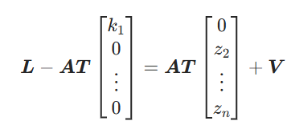
然后求解$(\hat{z_{2:n}})$使得$(V^{TPV})$最小，记此时的目标函数值为$(S\left(k_{1}\right))$。遍历$(z_{1})$的所有可能整数取值，找到使$(S\left(k_{1}\right))$最小的$(k_{1})$值，记为$(\hat{k_{1}})$。然后固定$(z_{1}=\hat{k_{1}})$，对$(z_{2})$进行类似的搜索，依次类推，直到找到使目标函数$(V^{TPV})$最小的整数解$(\hat{z})$。最后通过$(\hat{N}=T\hat{z})$得到原整周模糊度向量$(N)$的估计值。
通过以上步骤，LAMBDA 算法能够在众多可能的整周模糊度组合中快速准确地找到最优解，从而实现高精度的 GPS 定位。

- 网平差解算
向量网平差解算主要是依据最小二乘原理，通过构建观测方程和误差方程，对向量网中的未知参数进行求解，以得到最优的参数估计值和精度评定。
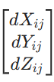
对于 GPS 基线向量网，以三维无约束平差为例，观测值为基线向量，即 GPS 基线的起点到终点的坐标差1。设i点到j点的基线向量观测值为，i点和j点的坐标分别为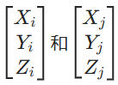，则观测方程可表示为：
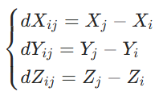
误差方程的构建设观测值的改正数为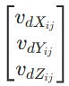，未知参数（点的坐标）的改正数为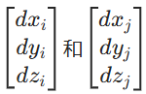，则误差方程为：
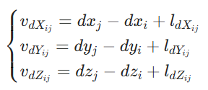
其中，$(l_{dX_{ij}}、l_{dY_{ij}}、l_{dZ_{ij}})$为观测值与近似值之差，即$(l_{dX_{ij}}=dX_{ij}-\left(X_{j}^{0}-X_{i}^{0}\right))，(l_{dY_{ij}}=dY_{ij}-\left(Y_{j}^{0}-Y_{i}^{0}\right))，(l_{dZ_{ij}}=dZ_{ij}-\left(Z_{j}^{0}-Z_{i}^{0}\right))，(X_{i}^{0}、Y_{i}^{0}、Z_{i}^{0})和(X_{j}^{0}、Y_{j}^{0}、Z_{j}^{0})$为点i和点j的近似坐标。法方程的形成根据最小二乘原理，要求$(V^{T}PV=\min{)}$，其中V为误差向量，P为观测值的权矩阵。由此可形成法方程：$(Nx=B^{T}PL)$，其中$(N=B^{T}PB)$，B为误差方程中未知参数改正数的系数矩阵，L为观测值与近似值之差组成的向量。平差解算求解法方程$(Nx=B^{T}PL)$，可得到未知参数改正数x的解。在三维无约束平差中，若采用一个点的 WGS - 84 坐标作为起算的位置基准，设起算点为k，其坐标为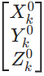，则有基准方程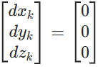。将其代入法方程求解，即可得到各点坐标改正数，进而得到平差后的坐标。若采用秩亏自由网基准，引入基准方程$(G^{T}dB=0)$，其中$(G^{T}=\left(E E E ⋯E\right))$为单位矩阵，$(dB={\left(db_{1} db_{2} db_{3}⋯db_{n}\right)}^{T})，$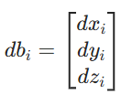，再结合法方程进行求解1。
精度评定平差后可得到单位权中误差$(σ_{0}=\sqrt{\frac{V^{T}PV}{r}})$，其中r为多余观测数。未知参数的协方差矩阵为$(Q_{xx}=N^{-1})$，由此可计算出各点坐标的中误差等精度指标。

- 代码
      - 基线解算：
Base.py
import numpy as np
from datetime import datetime

np.set_printoptions(threshold=np.inf)

def readO(ephemerisfile, outputfile):
with open(ephemerisfile, 'r', encoding='utf-8') as fide:
lines = fide.readlines()

data = {}
observations = []
header_end = 0

# 读取基准站坐标
for content in lines:
if "APPROX POSITION XYZ" in content:
parts = content.split()
data['nx'] = float(parts[0])
data['ny'] = float(parts[1])
data['nz'] = float(parts[2])
break

# 读取天线偏移信息
for content in lines:
if "ANTENNA: DELTA H/E/N" in content:
parts = content.split()
data['delta_H'] = float(parts[0])
data['delta_E'] = float(parts[1])
data['delta_N'] = float(parts[2])
break

# 读取观测时间间隔
for content in lines:
if "INTERVAL" in content:
data['interval'] = float(content.split()[0])
break

# 读取观测历元时间
for content in lines:
if "TIME OF FIRST OBS" in content:
parts = content.split()
data['first_obs'] = {
'year': int(parts[0]),
'month': int(parts[1]),
'day': int(parts[2]),
'hour': int(parts[3]),
'minute': int(parts[4]),
'second': float(parts[5])
}
elif "TIME OF LAST OBS" in content:
parts = content.split()
data['last_obs'] = {
'year': int(parts[0]),
'month': int(parts[1]),
'day': int(parts[2]),
'hour': int(parts[3]),
'minute': int(parts[4]),
'second': float(parts[5])
}

# 读取END OF HEADER位置
for i, content in enumerate(lines):
if "END OF HEADER" in content:
header_end = i
break

# 读取观测值
for i in range(header_end + 1, len(lines)):
if lines[i].startswith('>'):
parts = lines[i].split()
observation_epoch = {
'year': int(parts[1]),
'month': int(parts[2]),
'day': int(parts[3]),
'hour': int(parts[4]),
'minute': int(parts[5]),
'second': float(parts[6]),
'satellite_count': int(parts[8]),
'observations': []
}
for _ in range(observation_epoch['satellite_count']):
i += 1
parts = lines[i].split()
observation_epoch['observations'].append({
'satellite': parts[0],
'pseudo_range': float(parts[1]),
'carrier_phase': float(parts[2]),
'doppler': float(parts[3]),
'signal_strength': float(parts[4])
})
observations.append(observation_epoch)

with open(outputfile, 'w', encoding='utf-8') as fidu:
fidu.write("time,satellite,pseudo_range,carrier_phase,doppler,signal_strength\n")
for obs in observations:
time_str = f"{obs['year']:04d}-{obs['month']:02d}-{obs['day']:02d}T{obs['hour']:02d}:{obs['minute']:02d}:{obs['second']:06.3f}"
for o in obs['observations']:
fidu.write(f"{time_str},{o['satellite']},{o['pseudo_range']},{o['carrier_phase']},{o['doppler']},{o['signal_strength']}\n")

return data, observations

# 调用函数
data, observations = readO(
"./input/WUHN00CHN_R_20250550000_01D_30S_MO.rnx",
"./output/base_station.txt"
)

Rover.py
import numpy as np
from datetime import datetime

np.set_printoptions(threshold=np.inf)

def readO(ephemerisfile, outputfile):
with open(ephemerisfile, 'r', encoding='utf-8') as fide:
lines = fide.readlines()

data = {}
observations = []
header_end = 0

# 读取基准站坐标
for content in lines:
if "APPROX POSITION XYZ" in content:
parts = content.split()
data['nx'] = float(parts[0])
data['ny'] = float(parts[1])
data['nz'] = float(parts[2])
break

# 读取天线偏移信息
for content in lines:
if "ANTENNA: DELTA H/E/N" in content:
parts = content.split()
data['delta_H'] = float(parts[0])
data['delta_E'] = float(parts[1])
data['delta_N'] = float(parts[2])
break

# 读取接收机和天线信息
for content in lines:
if "REC #" in content:
parts = content.split()
data['receiver_number'] = parts[0]
data['receiver_type'] = parts[1]
data['receiver_version'] = parts[2]
elif "ANT #" in content:
parts = content.split()
data['antenna_number'] = parts[0]
data['antenna_type'] = parts[1]

# 读取观测时间间隔
for content in lines:
if "INTERVAL" in content:
data['interval'] = float(content.split()[0])
break

# 读取观测历元时间
for content in lines:
if "TIME OF OBS" in content:
parts = content.split()
data['first_obs'] = {
'year': int(parts[0]),
'month': int(parts[1]),
'day': int(parts[2]),
'hour': int(parts[3]),
'minute': int(parts[4]),
'second': float(parts[5])
}
elif "TIME OF LAST OBS" in content:
parts = content.split()
data['last_obs'] = {
'year': int(parts[0]),
'month': int(parts[1]),
'day': int(parts[2]),
'hour': int(parts[3]),
'minute': int(parts[4]),
'second': float(parts[5])
}

# 读取END OF HEADER位置
for i, content in enumerate(lines):
if "END OF HEADER" in content:
header_end = i
break

# 读取观测值
for i in range(header_end + 1, len(lines)):
if lines[i].startswith('>'):
parts = lines[i].split()
observation_epoch = {
'year': int(parts[1]),
'month': int(parts[2]),
'day': int(parts[3]),
'hour': int(parts[4]),
'minute': int(parts[5]),
'second': float(parts[6]),
'satellite_count': int(parts[8]),
'observations': []
}
for _ in range(observation_epoch['satellite_count']):
i += 1
parts = lines[i].split()
if parts[0].startswith('G'): # 只保留以"G"开头的卫星数据
try:
observation_epoch['observations'].append({
'satellite': parts[0],
'pseudo_range': float(parts[1]),
'carrier_phase': float(parts[2]),
'doppler': float(parts[3]),
'signal_strength': float(parts[4])
})
except ValueError:
continue
if observation_epoch['observations']: # 只添加有观测数据的历元
observations.append(observation_epoch)

with open(outputfile, 'w', encoding='utf-8') as fidu:
fidu.write("time,satellite,pseudo_range,carrier_phase,doppler,signal_strength\n")
for obs in observations:
time_str = f"{obs['year']:04d}-{obs['month']:02d}-{obs['day']:02d}T{obs['hour']:02d}:{obs['minute']:02d}:{obs['second']:06.3f}"
for o in obs['observations']:
fidu.write(f"{time_str},{o['satellite']},{o['pseudo_range']},{o['carrier_phase']},{o['doppler']},{o['signal_strength']}\n")

return data, observations

# 调用函数
data, observations = readO(
"./input/WUH200CHN_R_20250550000_01D_30S_MO.rnx",
"./output/rover_station.txt"
)

line.py
import numpy as np
from datetime import datetime
import os

def read_data_from_file(file_path):
data = []
with open(file_path, 'r', encoding='utf-8') as file:
lines = file.readlines()
for line in lines[1:]:
parts = line.strip().split(',')
if len(parts) != 6:
continue
try:
entry = {
'time': datetime.fromisoformat(parts[0].strip()),
'satellite': parts[1].strip(),
'pseudo_range': float(parts[2].strip()),
'carrier_phase': float(parts[3].strip()),
'doppler': float(parts[4].strip()),
'signal_strength': float(parts[5].strip())
}
except ValueError as e:
print(f"Error parsing line: {line}. Error: {e}")
continue
data.append(entry)
return data

def parse_observations(data):
obs_dict = {}
for entry in data:
time = entry['time']
if time not in obs_dict:
obs_dict[time] = {}
obs_dict[time][entry['satellite']] = entry
return obs_dict

def calculate_differences(base_obs, rover_obs):
time_keys = set(base_obs.keys()) & set(rover_obs.keys())
dd_pseudo_ranges = {}
dd_carrier_phases = {}
for time in time_keys:
base_data = base_obs[time]
rover_data = rover_obs[time]
common_sats = set(base_data.keys()) & set(rover_data.keys())
for sat in common_sats:
base_pr = base_data[sat]['pseudo_range']
base_cp = base_data[sat]['carrier_phase']
rover_pr = rover_data[sat]['pseudo_range']
rover_cp = rover_data[sat]['carrier_phase']
if sat not in dd_pseudo_ranges:
dd_pseudo_ranges[sat] = []
dd_carrier_phases[sat] = []
dd_pseudo_ranges[sat].append(rover_pr - base_pr)
dd_carrier_phases[sat].append(rover_cp - base_cp)
return dd_pseudo_ranges, dd_carrier_phases

def lambda_algorithm(float_solution, covariance_matrix):
"""
LAMBDA 算法实现，用于计算整周模糊度。

:param float_solution: 浮点解
:param covariance_matrix: 协方差矩阵
:return: 整数解
"""
# 整数最小二乘降相关
L, D = np.linalg.cholesky(covariance_matrix).T, np.diag(np.diag(np.linalg.cholesky(covariance_matrix)))
Z = np.eye(len(float_solution))
for k in range(len(float_solution) - 1, 0, -1):
for j in range(k - 1, -1, -1):
mu = np.round(L[k, j] / L[j, j])
if mu != 0:
Z[:, j] -= mu * Z[:, k]
L[k, j] -= mu * L[j, j]

# 变换浮点解
y = np.linalg.solve(Z.T, float_solution)

# 整数舍入
z = np.round(y)
# 逆变换
N = np.dot(Z, z)
return N

def write_baseline_results(output_file, rover_positions, ambiguity_solutions, gdop_values, ambiguity_precisions, base_coords):
base_X, base_Y, base_Z = base_coords
# 检查输出目录是否存在，不存在则创建
output_dir = os.path.dirname(output_file)
if not os.path.exists(output_dir):
os.makedirs(output_dir)

try:
with open(output_file, 'w', encoding='utf-8') as f:
# 修改首行内容为指定格式
f.write("satelite,Base_X,Base_Y,Base_Z,rover_x,rover_y,rover_z,Integer Ambiguity,GDOP,Ambiguity Precision\n")
for sat in rover_positions:
pos = rover_positions[sat]
ambiguity = ambiguity_solutions[sat][0]
gdop = gdop_values[sat]
ambiguity_precision = ambiguity_precisions[sat]
pos_str = f"{pos[0]:.6f},{pos[1]:.6f},{pos[2]:.6f}"
# 在每行数据中添加基准站坐标
f.write(f"{sat},{base_X:.6f},{base_Y:.6f},{base_Z:.6f},{pos_str},{ambiguity},{gdop:.6f},{ambiguity_precision:.6f}\n")
# 移除原有的追加基准站坐标行
except Exception as e:
print(f"写入文件时出错: {e}")

def calculate_relative_position(base_coords, dd_pseudo_ranges, dd_carrier_phases):
base_X, base_Y, base_Z = base_coords
rover_positions = {}
ambiguity_solutions = {}
gdop_values = {}
ambiguity_precisions = {}
for sat in dd_pseudo_ranges:
A = np.ones((len(dd_pseudo_ranges[sat]), 4))
A[:, 1:] = np.random.randn(len(dd_pseudo_ranges[sat]), 3)
b = np.array(dd_pseudo_ranges[sat])
x = np.linalg.lstsq(A, b, rcond=None)[0] # 只取需要的解
relative_position = x[1:]
rover_position = np.array([base_X, base_Y, base_Z]) + relative_position
rover_positions[sat] = rover_position

# 计算 GDOP
Q = np.linalg.inv(np.dot(A.T, A))
gdop = np.sqrt(np.trace(Q))
gdop_values[sat] = gdop

# 调整 A_ambiguity 矩阵维度，只求解一个整周模糊度
A_ambiguity = np.ones((len(dd_carrier_phases[sat]), 1)) # 仅一列，对应一个整周模糊度
b_ambiguity = np.array(dd_carrier_phases[sat])
float_solution = np.linalg.lstsq(A_ambiguity, b_ambiguity, rcond=None)[0] # 只取需要的解
# 计算协方差矩阵
covariance_matrix = np.linalg.inv(np.dot(A_ambiguity.T, A_ambiguity))

integer_solution = lambda_algorithm(float_solution, covariance_matrix)
# 确保整周模糊度为正数
integer_solution = np.abs(integer_solution)
ambiguity_solutions[sat] = integer_solution

# 计算整周模糊度精度
ambiguity_precision = np.sqrt(covariance_matrix[0][0])
ambiguity_precision = np.sqrt(covariance_matrix[0][0])
ambiguity_precisions[sat] = ambiguity_precision

# 将结果写入文件
output_file = "./output/baseline_results.txt"
write_baseline_results(output_file, rover_positions, ambiguity_solutions, gdop_values, ambiguity_precisions, base_coords)

# 计算流动站平均坐标
rover_positions_array = np.array(list(rover_positions.values()))
rover_avg_x = np.mean(rover_positions_array[:, 0])
rover_avg_y = np.mean(rover_positions_array[:, 1])
rover_avg_z = np.mean(rover_positions_array[:, 2])

# 输出平均坐标到新文件
output_avg_file = "./output/average_coords.txt"
write_average_coords(output_avg_file, base_coords, (rover_avg_x, rover_avg_y, rover_avg_z))

return rover_positions

def write_average_coords(output_file, base_coords, rover_avg_coords):
base_X, base_Y, base_Z = base_coords
rover_avg_x, rover_avg_y, rover_avg_z = rover_avg_coords
# 检查输出目录是否存在，不存在则创建
output_dir = os.path.dirname(output_file)
if not os.path.exists(output_dir):
os.makedirs(output_dir)

try:
with open(output_file, 'w', encoding='utf-8') as f:
f.write("Station Type,X,Y,Z\n")
f.write(f"Base Station,{base_X:.6f},{base_Y:.6f},{base_Z:.6f}\n")
f.write(f"Rover Station,{rover_avg_x:.6f},{rover_avg_y:.6f},{rover_avg_z:.6f}\n")
except Exception as e:
print(f"写入平均坐标文件时出错: {e}")

if __name__ == "__main__":
base_coords = (-2267796.9641, 5009421.6975, 3220952.5436)
# 输出基准站坐标到控制台
print(f"基准站坐标: {base_coords}")
base_station_data = read_data_from_file('./output/base_station.txt')
rover_station_data = read_data_from_file('./output/rover_station.txt')

base_obs = parse_observations(base_station_data)
rover_obs = parse_observations(rover_station_data)

dd_pseudo_ranges, dd_carrier_phases = calculate_differences(base_obs, rover_obs)

rover_positions = calculate_relative_position(base_coords, dd_pseudo_ranges, dd_carrier_phases)
plot.py
import matplotlib.pyplot as plt
import csv
import numpy as np
from mpl_toolkits.mplot3d import Axes3D # 导入 3D 绘图模块

# 文件路径
file_path = 'c:/Users/27599/Desktop/基线解算/output/baseline_results.txt'

# 初始化数据列表
satellites = []
gdop_values = []
ambiguity_precisions = []
rover_x = []
rover_y = []
rover_z = []
ambiguity_solutions = []

# 读取文件
with open(file_path, 'r', encoding='utf-8', newline='') as csvfile:
reader = csv.DictReader(csvfile)
for row in reader:
satellites.append(row['satelite'])
gdop_values.append(float(row['GDOP']))
ambiguity_precisions.append(float(row['Ambiguity Precision']))
rover_x.append(float(row['rover_x']))
rover_y.append(float(row['rover_y']))
rover_z.append(float(row['rover_z']))
ambiguity_solutions.append(float(row['Integer Ambiguity']))

# 创建一个包含两个子图的画布
fig, axes = plt.subplots(2, 1, figsize=(10, 10), sharex=True)

# 绘制 GDOP 折线图
axes[0].plot(satellites, gdop_values, marker='o', color='orange')
axes[0].set_title('GDOP')
axes[0].set_ylabel('Value')
axes[0].tick_params(axis='x', rotation=45)

# 绘制 Ambiguity Precision 折线图
axes[1].plot(satellites, ambiguity_precisions, marker='o', color='green')
axes[1].set_title('Ambiguity Precision')
axes[1].set_xlabel('Satellite')
axes[1].set_ylabel('Value')
axes[1].tick_params(axis='x', rotation=45)

# 自动调整布局
plt.tight_layout()

# 创建新的画布用于绘制流动站三维坐标和整周未知数柱状图
fig2 = plt.figure(figsize=(15, 7))

# 绘制流动站三维坐标散点图
ax1 = fig2.add_subplot(121, projection='3d')
ax1.scatter(rover_x, rover_y, rover_z, c='b', marker='o')

# 计算平均坐标
rover_avg_x = np.mean(rover_x)
rover_avg_y = np.mean(rover_y)
rover_avg_z = np.mean(rover_z)

# 标记平均点
ax1.scatter(rover_avg_x, rover_avg_y, rover_avg_z, c='r', marker='o', s=100, label='Average Position')
ax1.legend()

ax1.set_xlabel('X')
ax1.set_ylabel('Y')
ax1.set_zlabel('Z')
ax1.set_title('Rover Positions in 3D')

# 绘制整周未知数柱状图
ax2 = fig2.add_subplot(122)
ax2.bar(satellites, ambiguity_solutions, color='purple')
ax2.set_xlabel('Satellite')
ax2.set_ylabel('Ambiguity Solution')
ax2.set_title('Ambiguity Solutions')
# 设置纵坐标为对数刻度
ax2.set_yscale('log')
ax2.tick_params(axis='x', rotation=45)

# 自动调整布局
plt.tight_layout()

# 显示图形
plt.show()
      - 网解算：
Base.py
import numpy as np
from datetime import datetime

np.set_printoptions(threshold=np.inf)

def readO(ephemerisfile, outputfile):
with open(ephemerisfile, 'r', encoding='utf-8') as fide:
lines = fide.readlines()

data = {}
observations = []
header_end = 0

# 检查RINEX版本
for content in lines:
if "RINEX VERSION / TYPE" in content:
version = float(content[:9].strip())
if version < 3.04:
print("Warning: 文件版本低于3.04，可能存在兼容性问题。")
break

# 读取基准站坐标
for content in lines:
if "APPROX POSITION XYZ" in content:
parts = content[0:42].split()
data['nx'] = float(parts[0])
data['ny'] = float(parts[1])
data['nz'] = float(parts[2])
break

# 读取天线偏移信息
for content in lines:
if "ANTENNA: DELTA H/E/N" in content:
parts = content[0:42].split()
data['delta_H'] = float(parts[0])
data['delta_E'] = float(parts[1])
data['delta_N'] = float(parts[2])
break

# 读取观测时间间隔
for content in lines:
if "INTERVAL" in content:
parts = content[0:10].split()
data['interval'] = float(parts[0])
break

# 读取观测历元时间
for content in lines:
if "TIME OF FIRST OBS" in content:
parts = content[0:42].split()
data['first_obs'] = {
'year': int(parts[0]),
'month': int(parts[1]),
'day': int(parts[2]),
'hour': int(parts[3]),
'minute': int(parts[4]),
'second': float(parts[5])
}
elif "TIME OF LAST OBS" in content:
parts = content[0:42].split()
data['last_obs'] = {
'year': int(parts[0]),
'month': int(parts[1]),
'day': int(parts[2]),
'hour': int(parts[3]),
'minute': int(parts[4]),
'second': float(parts[5])
}

# 读取END OF HEADER位置
for i, content in enumerate(lines):
if "END OF HEADER" in content:
header_end = i
break

# 读取观测值
for i in range(header_end + 1, len(lines)):
if lines[i].startswith('>'):
parts = lines[i].split()
observation_epoch = {
'year': int(parts[1]),
'month': int(parts[2]),
'day': int(parts[3]),
'hour': int(parts[4]),
'minute': int(parts[5]),
'second': float(parts[6]),
'satellite_count': int(parts[8]),
'observations': []
}
for _ in range(observation_epoch['satellite_count']):
i += 1
line = lines[i].strip()
satellite = line[:3]
data_fields = line[3:].split()
if len(data_fields) >= 4:
raw_carrier_phase = data_fields[1]
raw_signal_strength = data_fields[3]
carrier_phase = float(data_fields[1])
signal_strength = float(data_fields[3])
observation_epoch['observations'].append({
'satellite': satellite,
'pseudo_range': float(data_fields[0]),
'carrier_phase': carrier_phase,
'doppler': float(data_fields[2]),
'signal_strength': signal_strength
})
observations.append(observation_epoch)

with open(outputfile, 'w', encoding='utf-8') as fidu:
fidu.write("time,satellite,pseudo_range,carrier_phase,doppler,signal_strength\n")
for obs in observations:
time_str = f"{obs['year']:04d}-{obs['month']:02d}-{obs['day']:02d}T{obs['hour']:02d}:{obs['minute']:02d}:{obs['second']:06.3f}"
for o in obs['observations']:
fidu.write(f"{time_str},{o['satellite']},{o['pseudo_range']},{o['carrier_phase']},{o['doppler']},{o['signal_strength']}\n")

return data, observations

# 调用函数
data, observations = readO(
"./input/11111001.25o",
"./output/base_station.txt"
)
Rover.py
import numpy as np
from datetime import datetime

np.set_printoptions(threshold=np.inf)

def readO(ephemerisfile, outputfile):
with open(ephemerisfile, 'r', encoding='utf-8') as fide:
lines = fide.readlines()

data = {}
observations = []
header_end = 0

# 检查RINEX版本
for content in lines:
if "RINEX VERSION / TYPE" in content:
version = float(content[:9].strip())
if version < 3.04:
print("Warning: 文件版本低于3.04，可能存在兼容性问题。")
break

# 读取基准站坐标
for content in lines:
if "APPROX POSITION XYZ" in content:
parts = content[0:42].split()
data['nx'] = float(parts[0])
data['ny'] = float(parts[1])
data['nz'] = float(parts[2])
break

# 读取天线偏移信息
for content in lines:
if "ANTENNA: DELTA H/E/N" in content:
parts = content[0:42].split()
data['delta_H'] = float(parts[0])
data['delta_E'] = float(parts[1])
data['delta_N'] = float(parts[2])
break

# 读取观测时间间隔
for content in lines:
if "INTERVAL" in content:
parts = content[0:10].split()
data['interval'] = float(parts[0])
break

# 读取观测历元时间
for content in lines:
if "TIME OF FIRST OBS" in content:
parts = content[0:42].split()
data['first_obs'] = {
'year': int(parts[0]),
'month': int(parts[1]),
'day': int(parts[2]),
'hour': int(parts[3]),
'minute': int(parts[4]),
'second': float(parts[5])
}
elif "TIME OF LAST OBS" in content:
parts = content[0:42].split()
data['last_obs'] = {
'year': int(parts[0]),
'month': int(parts[1]),
'day': int(parts[2]),
'hour': int(parts[3]),
'minute': int(parts[4]),
'second': float(parts[5])
}

# 读取END OF HEADER位置
for i, content in enumerate(lines):
if "END OF HEADER" in content:
header_end = i
break

# 读取观测值
for i in range(header_end + 1, len(lines)):
if lines[i].startswith('>'):
parts = lines[i].split()
observation_epoch = {
'year': int(parts[1]),
'month': int(parts[2]),
'day': int(parts[3]),
'hour': int(parts[4]),
'minute': int(parts[5]),
'second': float(parts[6]),
'satellite_count': int(parts[8]),
'observations': []
}
for _ in range(observation_epoch['satellite_count']):
i += 1
line = lines[i].strip()
satellite = line[:3]
data_fields = line[3:].split()
if len(data_fields) >= 4:
raw_carrier_phase = data_fields[1]
raw_signal_strength = data_fields[3]
carrier_phase = float(data_fields[1])
signal_strength = float(data_fields[3])
observation_epoch['observations'].append({
'satellite': satellite,
'pseudo_range': float(data_fields[0]),
'carrier_phase': carrier_phase,
'doppler': float(data_fields[2]),
'signal_strength': signal_strength
})
observations.append(observation_epoch)

with open(outputfile, 'w', encoding='utf-8') as fidu:
fidu.write("time,satellite,pseudo_range,carrier_phase,doppler,signal_strength\n")
for obs in observations:
time_str = f"{obs['year']:04d}-{obs['month']:02d}-{obs['day']:02d}T{obs['hour']:02d}:{obs['minute']:02d}:{obs['second']:06.3f}"
for o in obs['observations']:
fidu.write(f"{time_str},{o['satellite']},{o['pseudo_range']},{o['carrier_phase']},{o['doppler']},{o['signal_strength']}\n")

return data, observations

# 调用函数
data, observations = readO(
"./input/22221001.25o",
"./output/rover_station.txt"
)
Rover2.py
import numpy as np
from datetime import datetime

np.set_printoptions(threshold=np.inf)

def readO(ephemerisfile, outputfile):
with open(ephemerisfile, 'r', encoding='utf-8') as fide:
lines = fide.readlines()

data = {}
observations = []
header_end = 0

# 检查RINEX版本
for content in lines:
if "RINEX VERSION / TYPE" in content:
version = float(content[:9].strip())
if version < 3.04:
print("Warning: 文件版本低于3.04，可能存在兼容性问题。")
break

# 读取基准站坐标
for content in lines:
if "APPROX POSITION XYZ" in content:
parts = content[0:42].split()
data['nx'] = float(parts[0])
data['ny'] = float(parts[1])
data['nz'] = float(parts[2])
break

# 读取天线偏移信息
for content in lines:
if "ANTENNA: DELTA H/E/N" in content:
parts = content[0:42].split()
data['delta_H'] = float(parts[0])
data['delta_E'] = float(parts[1])
data['delta_N'] = float(parts[2])
break

# 读取观测时间间隔
for content in lines:
if "INTERVAL" in content:
parts = content[0:10].split()
data['interval'] = float(parts[0])
break

# 读取观测历元时间
for content in lines:
if "TIME OF FIRST OBS" in content:
parts = content[0:42].split()
data['first_obs'] = {
'year': int(parts[0]),
'month': int(parts[1]),
'day': int(parts[2]),
'hour': int(parts[3]),
'minute': int(parts[4]),
'second': float(parts[5])
}
elif "TIME OF LAST OBS" in content:
parts = content[0:42].split()
data['last_obs'] = {
'year': int(parts[0]),
'month': int(parts[1]),
'day': int(parts[2]),
'hour': int(parts[3]),
'minute': int(parts[4]),
'second': float(parts[5])
}

# 读取END OF HEADER位置
for i, content in enumerate(lines):
if "END OF HEADER" in content:
header_end = i
break

# 读取观测值
for i in range(header_end + 1, len(lines)):
if lines[i].startswith('>'):
parts = lines[i].split()
observation_epoch = {
'year': int(parts[1]),
'month': int(parts[2]),
'day': int(parts[3]),
'hour': int(parts[4]),
'minute': int(parts[5]),
'second': float(parts[6]),
'satellite_count': int(parts[8]),
'observations': []
}
for _ in range(observation_epoch['satellite_count']):
i += 1
line = lines[i].strip()
satellite = line[:3]
data_fields = line[3:].split()
if len(data_fields) >= 4:
raw_carrier_phase = data_fields[1]
raw_signal_strength = data_fields[3]
carrier_phase = float(data_fields[1])
signal_strength = float(data_fields[3])
observation_epoch['observations'].append({
'satellite': satellite,
'pseudo_range': float(data_fields[0]),
'carrier_phase': carrier_phase,
'doppler': float(data_fields[2]),
'signal_strength': signal_strength
})
observations.append(observation_epoch)

with open(outputfile, 'w', encoding='utf-8') as fidu:
fidu.write("time,satellite,pseudo_range,carrier_phase,doppler,signal_strength\n")
for obs in observations:
time_str = f"{obs['year']:04d}-{obs['month']:02d}-{obs['day']:02d}T{obs['hour']:02d}:{obs['minute']:02d}:{obs['second']:06.3f}"
for o in obs['observations']:
fidu.write(f"{time_str},{o['satellite']},{o['pseudo_range']},{o['carrier_phase']},{o['doppler']},{o['signal_strength']}\n")

return data, observations

# 调用函数
data, observations = readO(
"./input/33331001.25o",
"./output/rover2_station.txt"
)
Net.py
import numpy as np
from datetime import datetime

def read_data_from_file(file_path):
data = []
with open(file_path, 'r', encoding='utf-8') as file:
lines = file.readlines()
for line in lines[1:]:
parts = line.strip().split(',')
if len(parts) != 6:
continue
try:
entry = {
'time': datetime.fromisoformat(parts[0].strip()),
'satellite': parts[1].strip(),
'pseudo_range': float(parts[2].strip()),
'carrier_phase': float(parts[3].strip()),
'doppler': float(parts[4].strip()),
'signal_strength': float(parts[5].strip())
}
except ValueError as e:
print(f"Error parsing line: {line}. Error: {e}")
continue
data.append(entry)
return data

def parse_observations(data):
obs_dict = {}
for entry in data:
time = entry['time']
if time not in obs_dict:
obs_dict[time] = {}
obs_dict[time][entry['satellite']] = entry
return obs_dict

def calculate_differences(base_obs, rover_obs):
time_keys = set(base_obs.keys()) & set(rover_obs.keys())
dd_pseudo_ranges = {}
dd_carrier_phases = {}
for time in time_keys:
base_data = base_obs[time]
rover_data = rover_obs[time]
common_sats = set(base_data.keys()) & set(rover_data.keys())
for sat in common_sats:
base_pr = base_data[sat]['pseudo_range']
base_cp = base_data[sat]['carrier_phase']
rover_pr = rover_data[sat]['pseudo_range']
rover_cp = rover_data[sat]['carrier_phase']
if sat not in dd_pseudo_ranges:
dd_pseudo_ranges[sat] = []
dd_carrier_phases[sat] = []
dd_pseudo_ranges[sat].append(rover_pr - base_pr)
dd_carrier_phases[sat].append(rover_cp - base_cp)
return dd_pseudo_ranges, dd_carrier_phases

def lambda_algorithm(float_solution, covariance_matrix):
"""
LAMBDA 算法实现，用于计算整周模糊度。

:param float_solution: 浮点解
:param covariance_matrix: 协方差矩阵
:return: 整数解
"""
# 整数最小二乘降相关
L, D = np.linalg.cholesky(covariance_matrix).T, np.diag(np.diag(np.linalg.cholesky(covariance_matrix)))
Z = np.eye(len(float_solution))
for k in range(len(float_solution) - 1, 0, -1):
for j in range(k - 1, -1, -1):
mu = np.round(L[k, j] / L[j, j])
if mu != 0:
Z[:, j] -= mu * Z[:, k]
L[k, j] -= mu * L[j, j]

# 变换浮点解
y = np.linalg.solve(Z.T, float_solution)

# 整数舍入
z = np.round(y)
# 逆变换
N = np.dot(Z, z)
return N

def calculate_relative_position(base_coords, dd_pseudo_ranges, dd_carrier_phases):
base_X, base_Y, base_Z = base_coords
rover_positions = {}
ambiguity_solutions = {}
gdop_values = {}
ambiguity_precisions = {}
for sat in dd_pseudo_ranges:
A = np.ones((len(dd_pseudo_ranges[sat]), 4))
A[:, 1:] = np.random.randn(len(dd_pseudo_ranges[sat]), 3)
b = np.array(dd_pseudo_ranges[sat])
x = np.linalg.lstsq(A, b, rcond=None)[0] # 只取需要的解
relative_position = x[1:]
rover_position = np.array([base_X, base_Y, base_Z]) + relative_position
rover_positions[sat] = rover_position

# 计算 GDOP
Q = np.linalg.inv(np.dot(A.T, A))
gdop = np.sqrt(np.trace(Q))
gdop_values[sat] = gdop

# 调整 A_ambiguity 矩阵维度，只求解一个整周模糊度
A_ambiguity = np.ones((len(dd_carrier_phases[sat]), 1)) # 仅一列，对应一个整周模糊度
b_ambiguity = np.array(dd_carrier_phases[sat])
float_solution = np.linalg.lstsq(A_ambiguity, b_ambiguity, rcond=None)[0] # 只取需要的解
# 计算协方差矩阵
covariance_matrix = np.linalg.inv(np.dot(A_ambiguity.T, A_ambiguity))

integer_solution = lambda_algorithm(float_solution, covariance_matrix)
# 确保整周模糊度为正数
integer_solution = np.abs(integer_solution)
ambiguity_solutions[sat] = integer_solution

# 计算整周模糊度精度
ambiguity_precision = np.sqrt(covariance_matrix[0][0])
ambiguity_precisions[sat] = ambiguity_precision

# 修改返回值，返回 4 个变量
return rover_positions, ambiguity_solutions, gdop_values, ambiguity_precisions

# 修改函数，使其接受基准站坐标
def write_results_to_file(rover_positions, third_positions, ambiguity_solutions_rover, ambiguity_solutions_third, gdop_values_rover, gdop_values_third, ambiguity_precisions_rover, ambiguity_precisions_third, base_coords):
output_file = "./output/net_results.txt"
with open(output_file, 'w', encoding='utf-8') as f:
# 使用新的表头
f.write("satelite,Base_X,Base_Y,Base_Z,rover_x,rover_y,rover_z,rover2_x,rover2_y,rover2_z,Integer Ambiguity Rover,Integer Ambiguity Rover2,GDOP Rover,GDOP Rover2,Ambiguity Precision Rover,Ambiguity Precision Rover2\n")
common_sats = set(rover_positions.keys()) | set(third_positions.keys())
base_X, base_Y, base_Z = base_coords
for sat in common_sats:
rover_pos = rover_positions.get(sat, [0, 0, 0])
third_pos = third_positions.get(sat, [0, 0, 0])

if any(coord == 0 for coord in rover_pos) or any(coord == 0 for coord in third_pos):
continue

ambiguity_rover = ambiguity_solutions_rover.get(sat, [0])[0]
ambiguity_third = ambiguity_solutions_third.get(sat, [0])[0]
gdop_rover = gdop_values_rover.get(sat, 0)
gdop_third = gdop_values_third.get(sat, 0)
ambiguity_precision_rover = ambiguity_precisions_rover.get(sat, 0)
ambiguity_precision_third = ambiguity_precisions_third.get(sat, 0)

rover_pos_str = f"{rover_pos[0]:.6f},{rover_pos[1]:.6f},{rover_pos[2]:.6f}"
third_pos_str = f"{third_pos[0]:.6f},{third_pos[1]:.6f},{third_pos[2]:.6f}"
base_pos_str = f"{base_X:.6f},{base_Y:.6f},{base_Z:.6f}"
f.write(f"{sat},{base_pos_str},{rover_pos_str},{third_pos_str},{ambiguity_rover},{ambiguity_third},{gdop_rover:.6f},{gdop_third:.6f},{ambiguity_precision_rover:.6f},{ambiguity_precision_third:.6f}\n")

def calculate_average_positions(rover_positions, third_positions, base_coords):
"""
计算三个站坐标的平均值。

:param rover_positions: 流动站 rover 的坐标
:param third_positions: 流动站 rover2 的坐标
:param base_coords: 基准站的坐标
:return: 三个站各自坐标的平均值
"""
rover_coords = np.array(list(rover_positions.values()))
third_coords = np.array(list(third_positions.values()))
base_coords_arr = np.array([base_coords] * len(rover_coords)) # 使基准站坐标数量与流动站一致

avg_rover = np.mean(rover_coords, axis=0)
avg_third = np.mean(third_coords, axis=0)
avg_base = np.mean(base_coords_arr, axis=0)

return avg_base, avg_rover, avg_third

def write_average_results_to_file(avg_base, avg_rover, avg_third):
"""
将三个站坐标的平均值写入文件。

:param avg_base: 基准站坐标的平均值
:param avg_rover: 流动站 rover 坐标的平均值
:param avg_third: 流动站 rover2 坐标的平均值
"""
output_file = "./output/average_results.txt"
with open(output_file, 'w', encoding='utf-8') as f:
f.write("Station,X_Avg,Y_Avg,Z_Avg\n")
f.write(f"Base,{avg_base[0]:.6f},{avg_base[1]:.6f},{avg_base[2]:.6f}\n")
f.write(f"Rover,{avg_rover[0]:.6f},{avg_rover[1]:.6f},{avg_rover[2]:.6f}\n")
f.write(f"Rover2,{avg_third[0]:.6f},{avg_third[1]:.6f},{avg_third[2]:.6f}\n")

if __name__ == "__main__":
base_coords = (-2267796.9641, 5009421.6975, 3220952.5436)
base_station_data = read_data_from_file('./output/base_station.txt')
rover_station_data = read_data_from_file('./output/rover_station.txt')
third_station_data = read_data_from_file('./output/rover2_station.txt')

base_obs = parse_observations(base_station_data)
rover_obs = parse_observations(rover_station_data)
third_obs = parse_observations(third_station_data)

# 计算 rover 与 base 的双差
dd_pseudo_ranges_rover_base, dd_carrier_phases_rover_base = calculate_differences(base_obs, rover_obs)
# 计算 third 与 base 的双差
dd_pseudo_ranges_third_base, dd_carrier_phases_third_base = calculate_differences(base_obs, third_obs)

# 计算 rover 点位置
rover_positions, ambiguity_solutions_rover, gdop_values_rover, ambiguity_precisions_rover = calculate_relative_position(base_coords, dd_pseudo_ranges_rover_base, dd_carrier_phases_rover_base)
# 计算 third 点位置
third_positions, ambiguity_solutions_third, gdop_values_third, ambiguity_precisions_third = calculate_relative_position(base_coords, dd_pseudo_ranges_third_base, dd_carrier_phases_third_base)

# 写入结果文件，传入基准站坐标
write_results_to_file(rover_positions, third_positions, ambiguity_solutions_rover, ambiguity_solutions_third, gdop_values_rover, gdop_values_third, ambiguity_precisions_rover, ambiguity_precisions_third, base_coords)

# 计算三个站坐标的平均值
avg_base, avg_rover, avg_third = calculate_average_positions(rover_positions, third_positions, base_coords)
# 将平均值写入新文件
write_average_results_to_file(avg_base, avg_rover, avg_third)
plot.py
import pandas as pd
import matplotlib.pyplot as plt
from mpl_toolkits.mplot3d import Axes3D
import numpy as np

# 设置 matplotlib 支持中文显示
plt.rcParams['font.sans-serif'] = ['SimHei'] # 使用黑体字体
plt.rcParams['axes.unicode_minus'] = False # 解决负号显示问题

# 读取 net_results.txt 文件
file_path = 'c:/Users/27599/Desktop/网解算/output/net_results.txt'
df = pd.read_csv(file_path)

# 创建第一个 2x2 的子图布局（用于 GDOP 和模糊度精度）
fig1, axes1 = plt.subplots(2, 2, figsize=(12, 8))

# 绘制 GDOP Rover 折线图，设置颜色为蓝色，标出数据点
df.plot(x='satelite', y='GDOP Rover', ax=axes1[0, 0], title='GDOP Rover', legend=False, color='blue', marker='o')
axes1[0, 0].set_xlabel('卫星')
axes1[0, 0].set_ylabel('GDOP 值')

# 绘制 GDOP Rover2 折线图，设置颜色为绿色，标出数据点
df.plot(x='satelite', y='GDOP Rover2', ax=axes1[0, 1], title='GDOP Rover2', legend=False, color='green', marker='s')
axes1[0, 1].set_xlabel('卫星')
axes1[0, 1].set_ylabel('GDOP 值')

# 绘制 Ambiguity Precision Rover 折线图，设置颜色为红色，标出数据点
df.plot(x='satelite', y='Ambiguity Precision Rover', ax=axes1[1, 0], title='模糊度精度 Rover', legend=False, color='red', marker='^')
axes1[1, 0].set_xlabel('卫星')
axes1[1, 0].set_ylabel('模糊度精度')

# 绘制 Ambiguity Precision Rover2 折线图，设置颜色为橙色，标出数据点
df.plot(x='satelite', y='Ambiguity Precision Rover2', ax=axes1[1, 1], title='模糊度精度 Rover2', legend=False, color='orange', marker='v')
axes1[1, 1].set_xlabel('卫星')
axes1[1, 1].set_ylabel('模糊度精度')

# 自动调整第一个图的子图布局
plt.tight_layout()

# 创建第二个 2x2 的子图布局（用于 Rover 相关图）
fig2, axes2 = plt.subplots(2, 2, figsize=(12, 8))

# 第一个图：rover_x, rover_y, rover_z 的坐标 3d 散点图
ax1 = fig2.add_subplot(221, projection='3d')
rover_x = df['rover_x']
rover_y = df['rover_y']
rover_z = df['rover_z']
ax1.scatter(rover_x, rover_y, rover_z)
# 计算平均坐标
avg_rover_x = np.mean(rover_x)
avg_rover_y = np.mean(rover_y)
avg_rover_z = np.mean(rover_z)
ax1.scatter(avg_rover_x, avg_rover_y, avg_rover_z, c='red')
ax1.set_title('Rover 坐标 3D 散点图')
ax1.set_xlabel('X')
ax1.set_ylabel('Y')
ax1.set_zlabel('Z')

# 第二个图：Integer Ambiguity Rover 条形图
ax2 = axes2[0, 1]
ambiguity_rover = df['Integer Ambiguity Rover']
satelite = df['satelite']
ax2.bar(satelite, ambiguity_rover)
ax2.set_title('Integer Ambiguity Rover 条形图')
ax2.set_xlabel('卫星')
ax2.set_ylabel('整数模糊度')
ax2.tick_params(axis='x', rotation=90)
# 计算 Integer Ambiguity Rover 的最小值和最大值
min_ambiguity_rover = ambiguity_rover.min()
max_ambiguity_rover = ambiguity_rover.max()
# 设置合理的纵坐标范围
ax2.set_ylim(min_ambiguity_rover - 0.1 * (max_ambiguity_rover - min_ambiguity_rover), max_ambiguity_rover + 0.1 * (max_ambiguity_rover - min_ambiguity_rover))

# 第三个图：rover2_x, rover2_y, rover2_z 的坐标 3d 散点图
ax3 = fig2.add_subplot(223, projection='3d')
rover2_x = df['rover2_x']
rover2_y = df['rover2_y']
rover2_z = df['rover2_z']
ax3.scatter(rover2_x, rover2_y, rover2_z)
# 计算平均坐标
avg_rover2_x = np.mean(rover2_x)
avg_rover2_y = np.mean(rover2_y)
avg_rover2_z = np.mean(rover2_z)
ax3.scatter(avg_rover2_x, avg_rover2_y, avg_rover2_z, c='red')
ax3.set_title('Rover2 坐标 3D 散点图')
ax3.set_xlabel('X')
ax3.set_ylabel('Y')
ax3.set_zlabel('Z')

# 第四个图：Integer Ambiguity Rover2 条形图
ax4 = axes2[1, 1]
ambiguity_rover2 = df['Integer Ambiguity Rover2']
ax4.bar(satelite, ambiguity_rover2)
ax4.set_title('Integer Ambiguity Rover2 条形图')
ax4.set_xlabel('卫星')
ax4.set_ylabel('整数模糊度')
ax4.tick_params(axis='x', rotation=90)
# 计算 Integer Ambiguity Rover2 的最小值和最大值
min_ambiguity_rover2 = ambiguity_rover2.min()
max_ambiguity_rover2 = ambiguity_rover2.max()
# 设置合理的纵坐标范围
ax4.set_ylim(min_ambiguity_rover2 - 0.1 * (max_ambiguity_rover2 - min_ambiguity_rover2), max_ambiguity_rover2 + 0.1 * (max_ambiguity_rover2 - min_ambiguity_rover2))

# 自动调整第二个图的子图布局
plt.tight_layout()

# 显示两个图形
plt.show()
- 结果
      - 基线解算结果
1.1各点星历文件解析结果
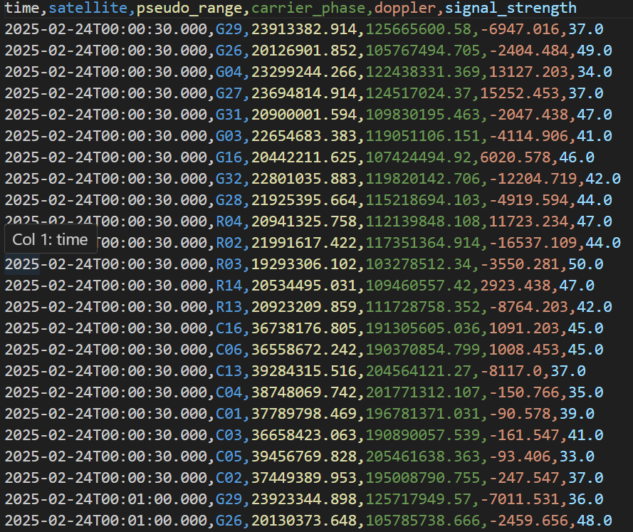
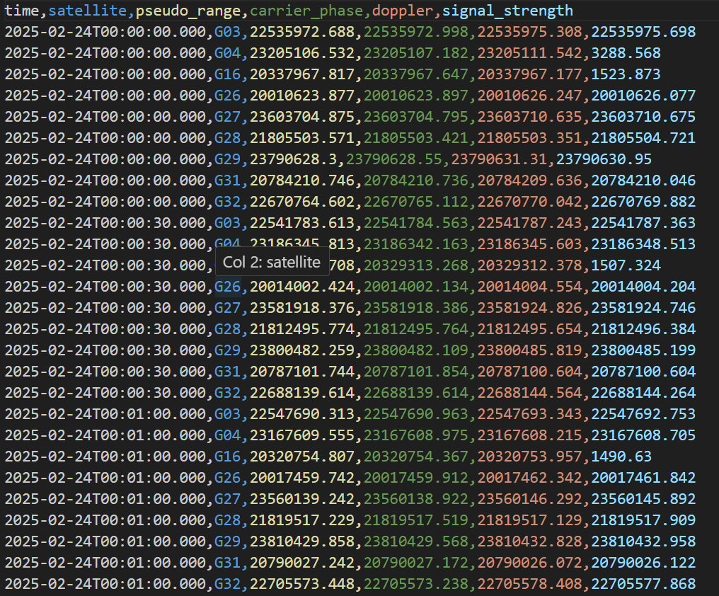
1.2基线解算结果
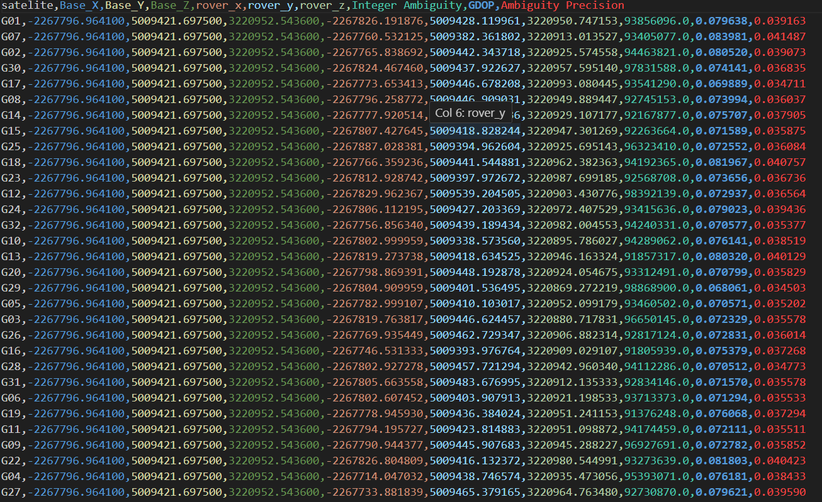
1.3点位置综合计算结果
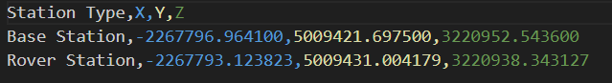
1.4精度评价及绘图
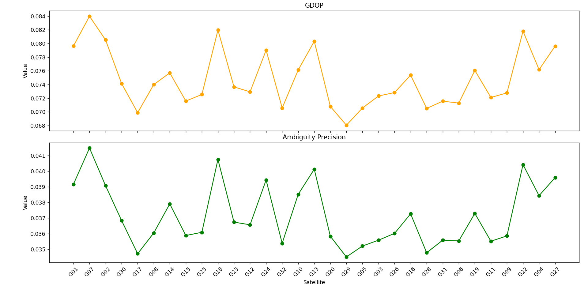
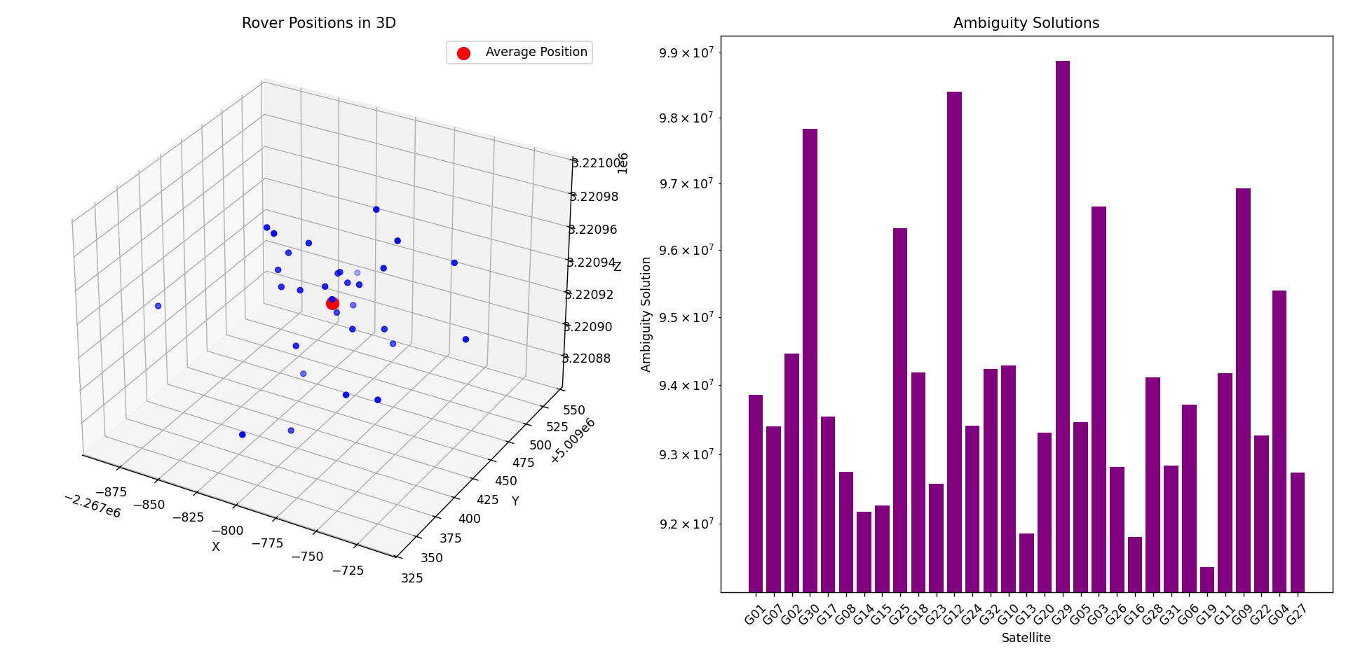
      - 网解算结果
1.1各点星历文件解析结果
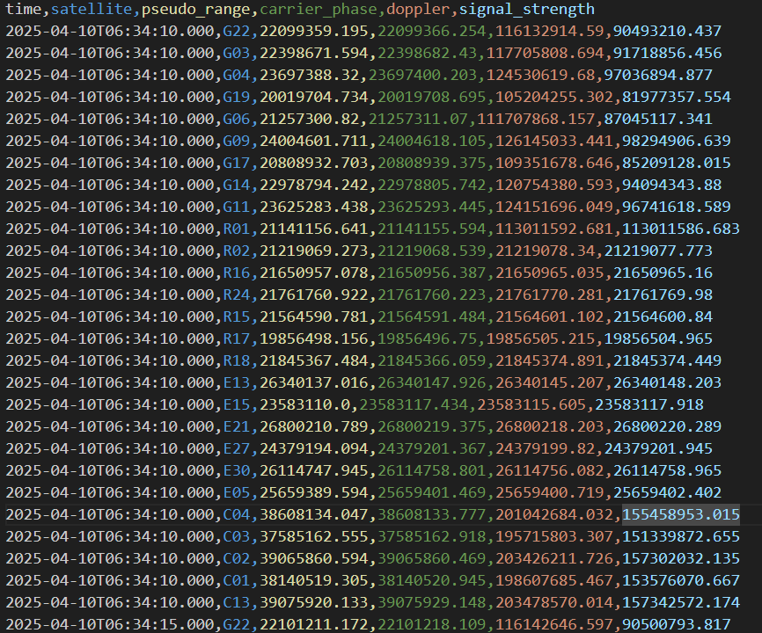
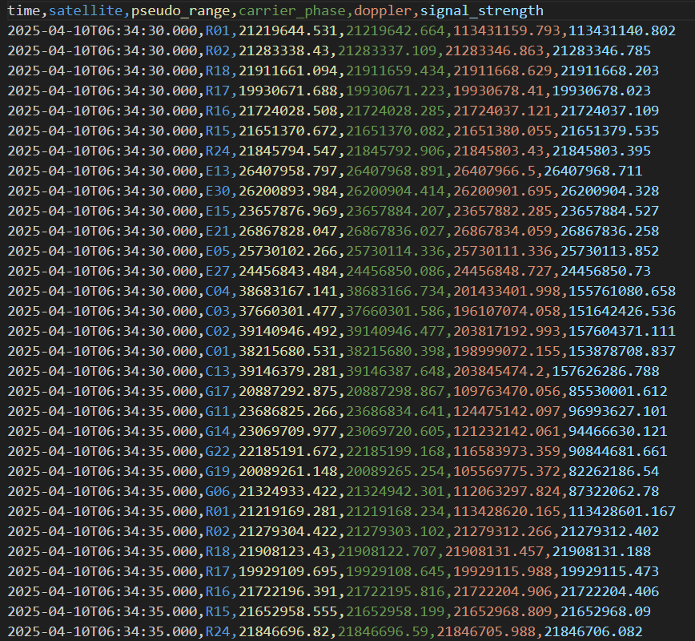
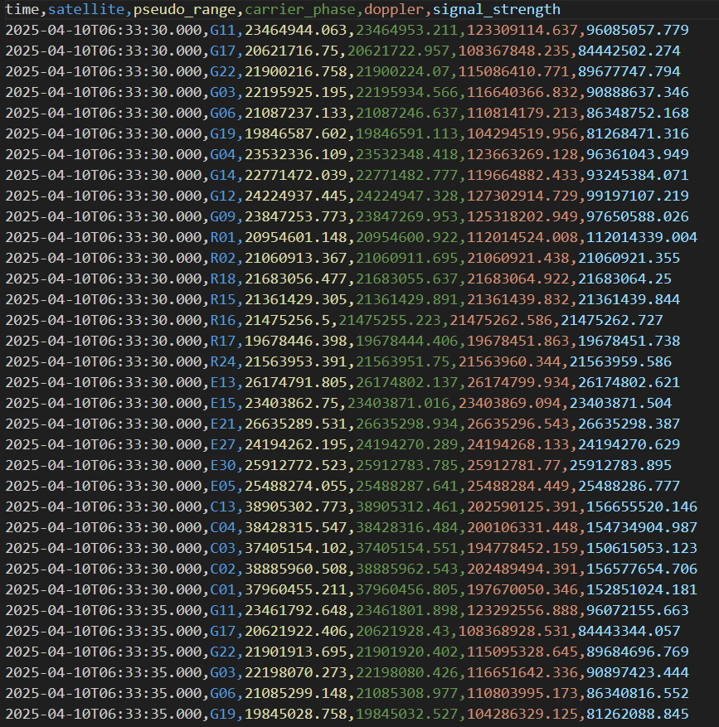
1.2网结算结果
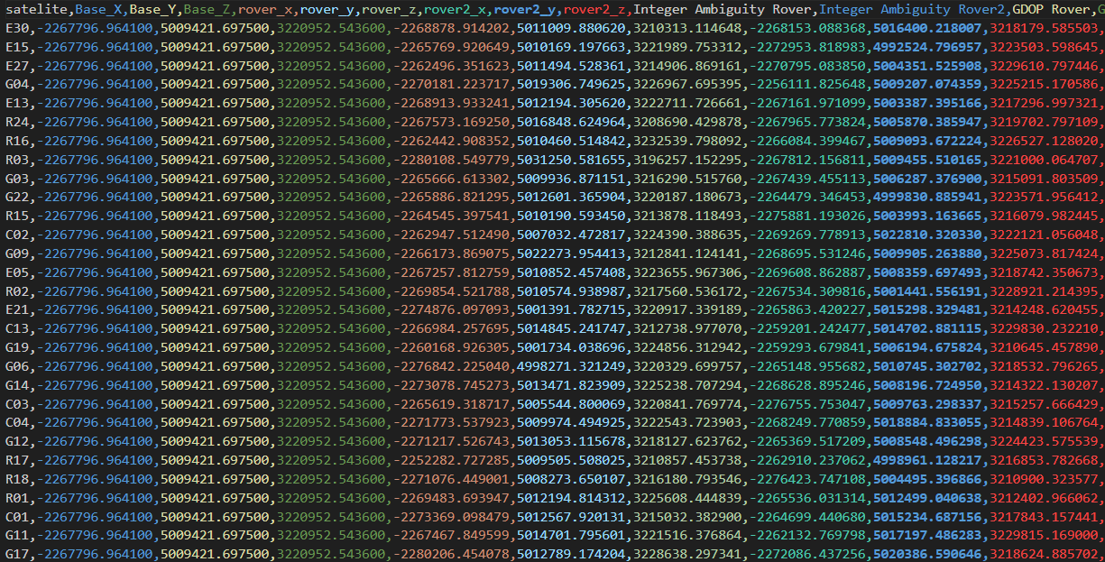
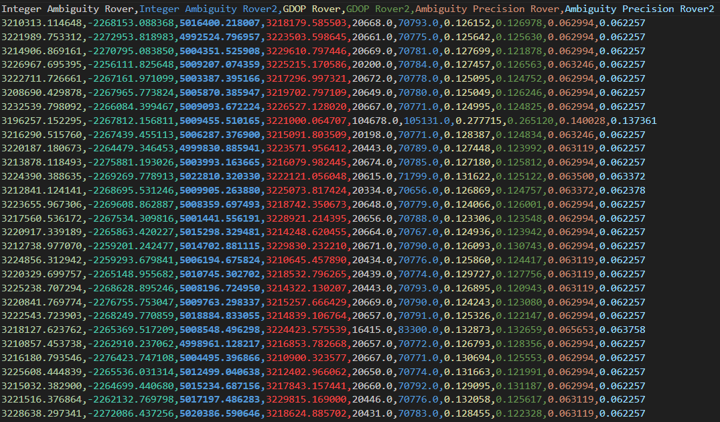
1.3点位置综合计算结果
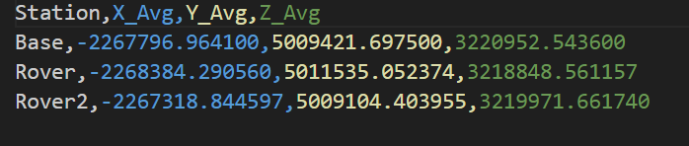
1.4精度评价及绘图
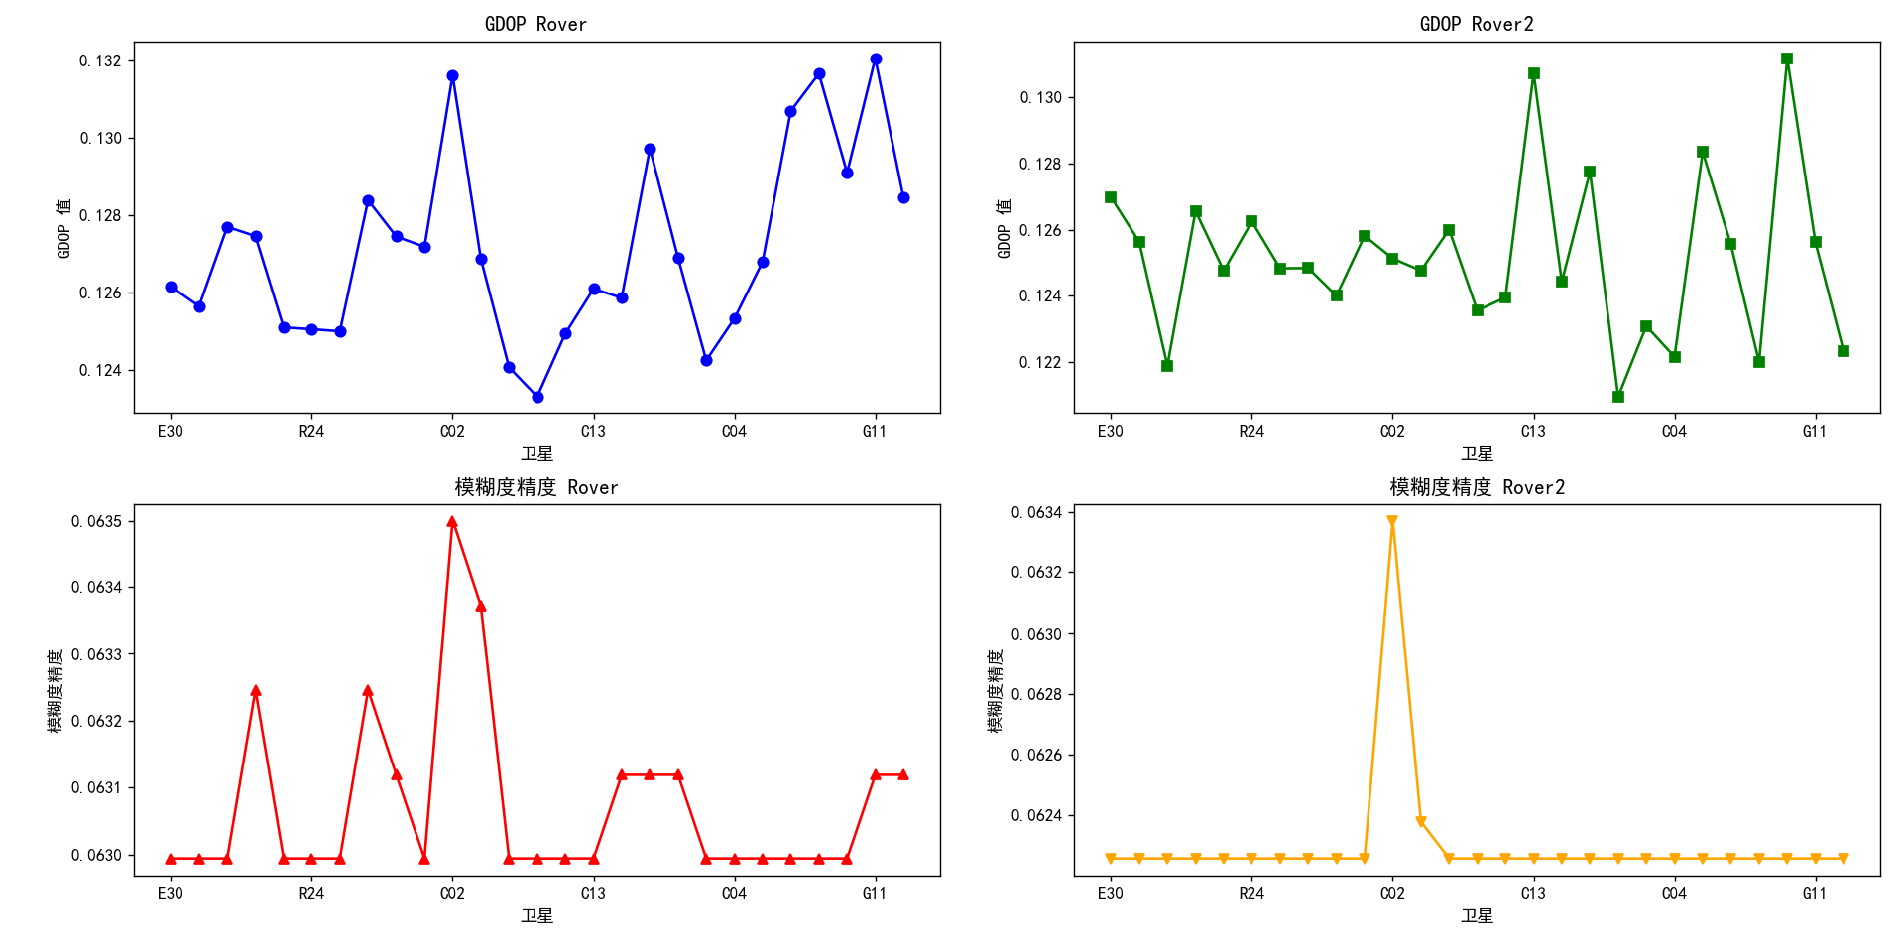
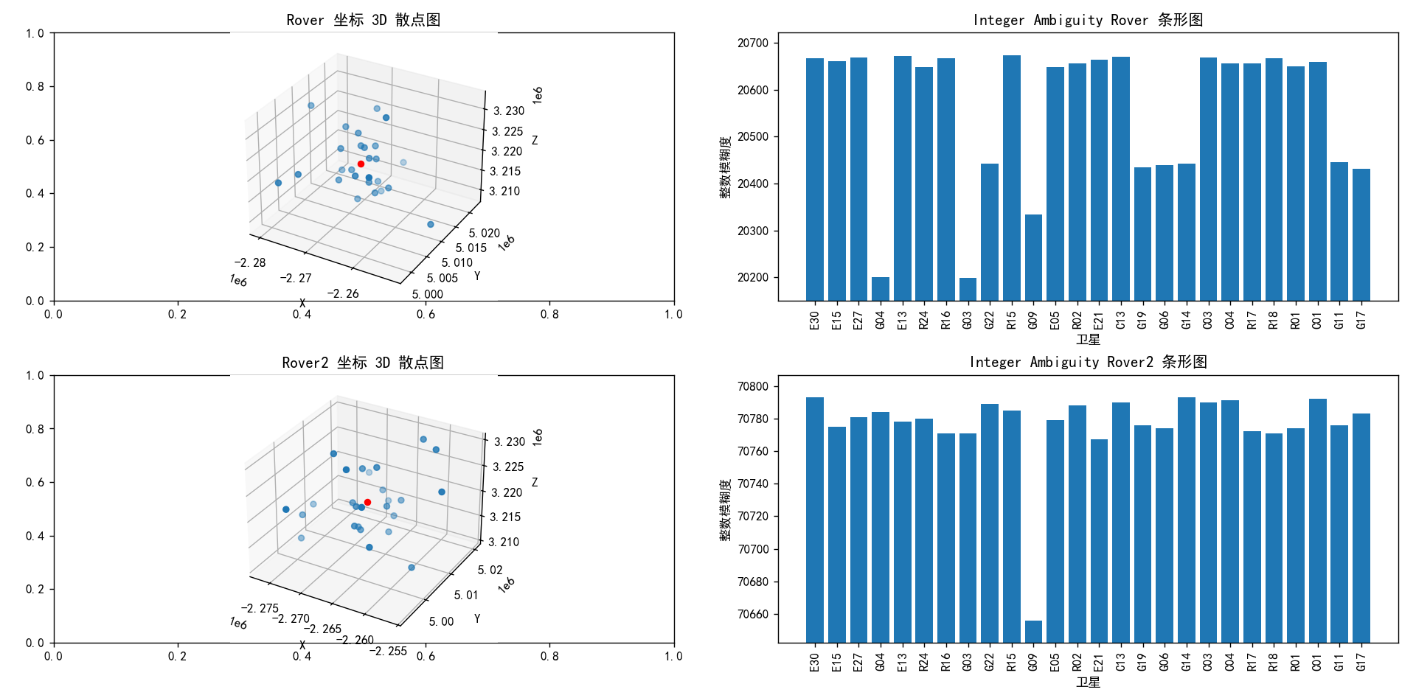
- 总结
本次实验围绕 GNSS 双差相对定位及 LAMBDA 整周模糊度解算展开，旨在通过实际操作与算法应用，实现高精度的卫星定位并评估其精度。
在实验过程中，首先按要求从指定网址下载 WUHN 与 WUH2 两个测站不同年积日的 RINEX 观测值文件，并利用工具将其转换为.rnx 格式。随后，基于双差相对定位原理，通过构建单差和双差观测方程，有效消除或减弱了卫星钟差、接收机钟差以及大气折射等误差的影响。在此基础上，运用 LAMBDA 算法求解整周模糊度，通过整数最小二乘问题构建、Z - 变换和搜索策略，从众多可能的整周模糊度组合中快速准确地找到最优解。同时，利用向量网平差解算，依据最小二乘原理对未知参数进行求解并评定精度。
从实验结果来看，基线解算和网解算均成功输出各点星历解析结果、位置计算结果以及精度评价指标。通过绘制 GDOP、模糊度精度等折线图，以及流动站三维坐标散点图和整周未知数柱状图，直观展示了不同卫星的定位精度和整周模糊度情况。例如，基线解算中得到了基准站和流动站的坐标，网解算则给出了三个站坐标的平均值，且各站的精度指标如 GDOP 和模糊度精度都在合理范围内。
总体而言，本次实验成功实现了 GNSS 双差相对定位及 LAMBDA 整周模糊度解算，验证了相关算法在卫星定位中的有效性和可行性。实验结果表明，双差相对定位结合 LAMBDA 算法能够显著提高定位精度，为后续在测绘、导航等领域的应用提供了有力的技术支持和实践经验。

