|  |  |
| --- | --- |
| **Practicum Case** |  |
| SCIE6062 | SCIE6062001 | SCIE6062016 | SCIE6062049  Computational Biology |
| **Mathematics & Statistics** | **E231-SCIE6062-VO01-03** |
| ***Valid on*** *Even Semester Year 2022/2023* | **Revision 00** |

**Learning Outcome**

* LO3 – implement basic bioinformatics analysis in scope of DNA composition and sequence analysis, protein synthesis, sequence alignment, and other works related to biological database using Biopython
* LO4 – analyze the basic bioinformatics analysis results using Biopython

## Topic

* Session 03 – Protein Synthesis

## Sub Topics

* Protein Synthesis
* Amino Acid Codon Table
* 3D Structure of Protein

## Soal

*Case*

For given **DNA sequences**:

Sequence A:

**ATGCGTTTATGACGTATCTGAAGTCTACTAGGGTGATCTGACTAA**

Sequence B:

**GTGTTAGTGCGCTAGTGCTGACTAGGTACAGTAGCTAGTTACTAG**

And following **mRNA codon arrangements table**:

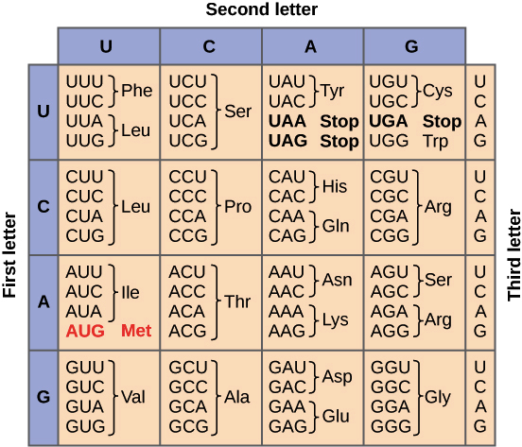

Please use **Biopython** to:

* **Transcribe** the **DNA** **sequence A** and **sequence** **B** into **mRNA**.
* **Combine** **24 starting** nucleotides of **mRNA** **sequence** **A** and **21 ending** nucleotides of **mRNA** **sequence** **B** and **set** it as **mRNA** **sequence** **C**.
* **Translate** the **mRNA** **sequence** **A**, **sequence** **B**, and **sequence** **C** into **amino** **acids sequences**.
* **Transcribe** back the **mRNA** **sequence** **C** into **DNA**.
* **Calculate** the **complementary** **sequences** of **DNA** **sequence** **A**, **sequence** **B**, and **sequence** **C**.