Name of members:
- PAQUIBOT, Nicole John L.
- CALAYAN, Jan Allen O.

1. Language Specification

Describe the rules of the mini-language.

11 Keywords
Keyword | Description
var | variable declaration
input | read value from user
output | display value

1.2 Operators
Operator | Meaning
+ | addition
- | subtraction
* | multiplication
/ | division
^ | exponentiation

1.3 Sample Program
Example program written in the mini-language:
var x = 12;
var y = 0;
y = 1;
input(y);
var z = x + y;
output(z);

2. Compiler Architecture
Explain the phases implemented.
Lexical:
Syntax:
Semantic:
3/16/2026 progress:
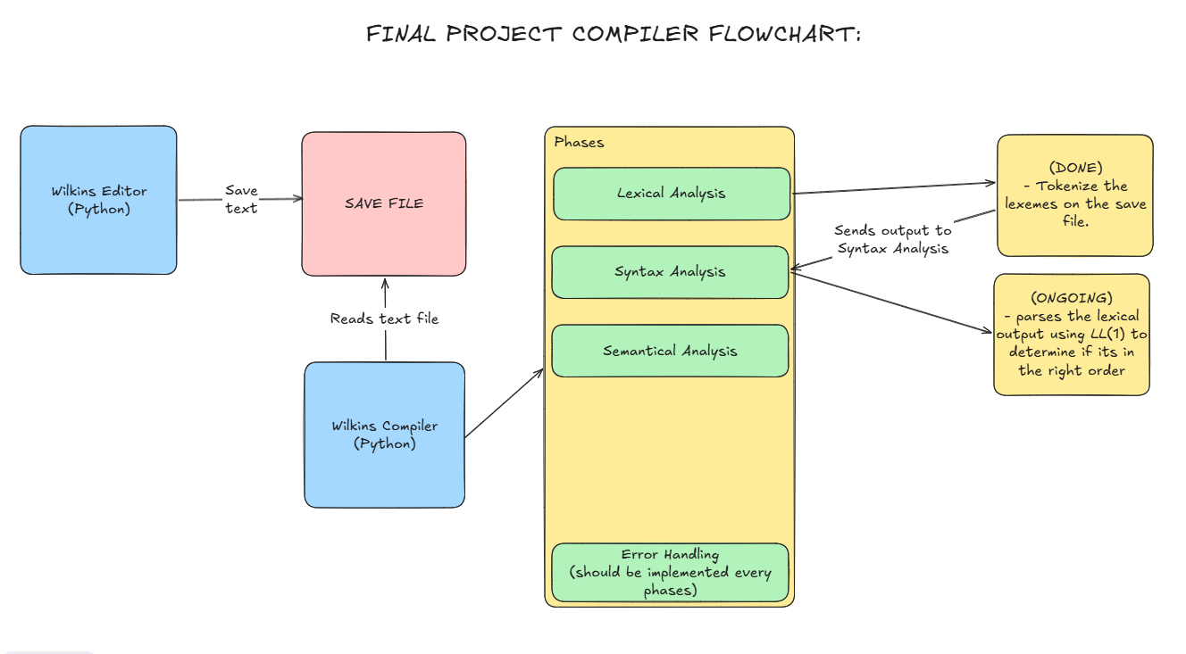
https://github.com/All3N-25/Wilkin-s-Compiler

3. Program Demonstration (Video recording)
3.1 Source Code Input - Example program entered by user.
3.2 Token Output - Example token list generated.
3.3 Parse Tree (Optional visualization)
3.4 Program Output

4. Compiler Setup
Add here instructions on how to setup or run your mini-compiler. You may see layout of README files.

5. Conclusion
Answer the given questions below:
- Which phase of the mini-compiler design you find the most challenging?
- How do you think your mini-compiler can be extended to handle looping statements?

6. References
- links or prompts you used and other tools
- you can attach appendices specially for prompt outputs
https://chatgpt.com/share/699bf435-676c-8000-878e-ab9adbf346ef
Github Link:
https://github.com/All3N-25/Wilkin-s-Compiler

