对接指南 - WPS开放平台
📌 原文链接：https://365.kdocs.cn/...
🕘 收藏时间：2026年05月24日
📂 文档目录：我的云文档/!!!01_网络收藏
📑 本文档由【金山收藏助手】一键生成

前置操作
调用 365开放平台MCP server前，需要完成一些前置操作

1、创建开放平台应用，获取应用ak/sk，后续能力调用需要使用。应用创建方式详见：创建企业自建应用
2、在应用详情的权限管理菜单，完成对相关应用能力权限的申请：
MCP 能力对权限的依赖，详见工具列表

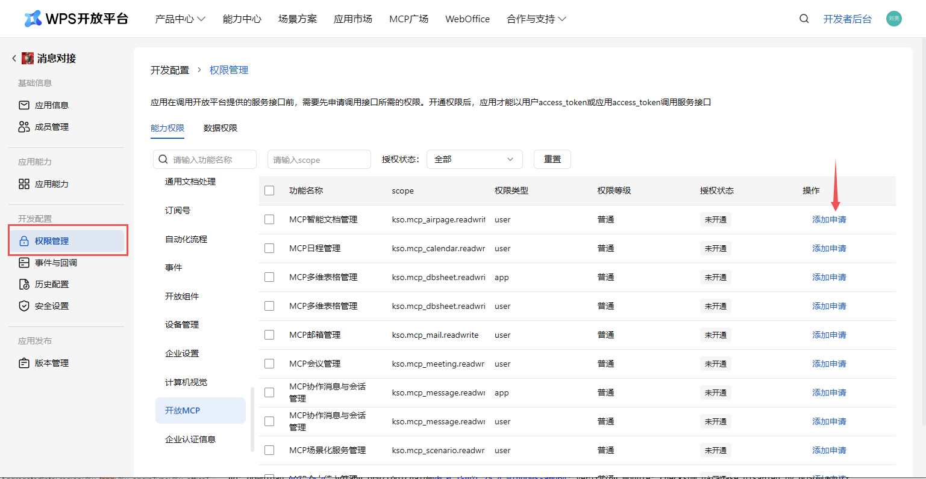

3、申请用户访问凭证，详见用户授权流程、获取用户access_token
4、访问前请确认关闭接口签名（暂不支持接口签名）
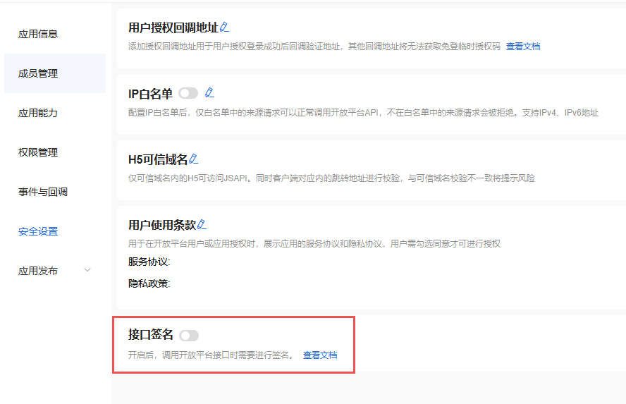

对接流程
前置操作完成，可以进行MCP server调用。MCP 2.0 已发布，主要在授权范围、服务URL 与工具名称等方面做了升级；对 MCP 1.0 的调用保持完全兼容，现有集成无需改动即可继续使用，也可按需切换到 MCP 2.0 的调用方式。

客户端配置

Cursor

新增MCP服务
在Cursor中使用Ctrl+Shift+P打开命令列表
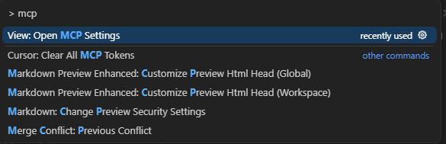

点击View: Open MCP Settings打开设置面板
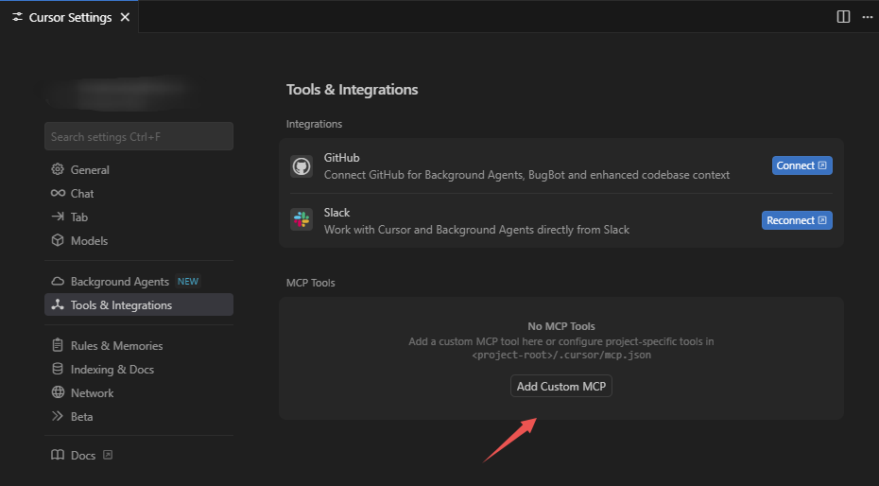

选择Add Custom MCP创建自定义MCP配置，Cursor会在用户目录下创建MCP配置文件~/.cursor/mcp.json。
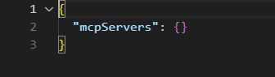

以日历工具为例，在文件中添加一个wps_calendarmcp服务配置，在url中添加端点路径和在headers添加鉴权令牌。

浏览已支持的mcp server和查看mcp server 端点 url 可以在工具列表查看
在实际配置中，需要将{access_token}替换为自己申请的令牌如何申请鉴权令牌

- {
- "mcpServers": {
- "wps_calendar": {
- "url": "https://openapi.wps.cn/mcp/v2/kso-calendar/message",
- "headers": {
- "Authorization": "Bearer {access_token}"
- }
- }
- }
- }

添加成功后回到Cursor配置界面，出现wps_calendar并能展示获取的工具列表后说明MCP已添加成功。


配置完成后即可在Cursor Chat里进行调用

日程工具调用示例
如下图所示，用户已有在2025/09/02 ~ 2025/09/04之间已有一个日程
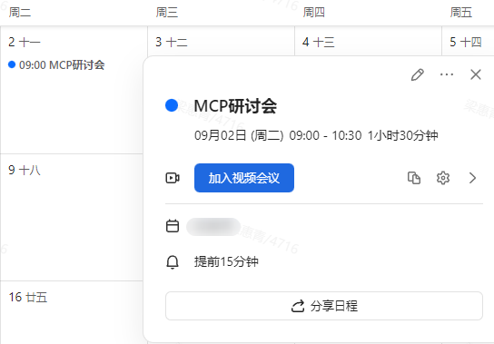

接下来将通过调用工具来获取日程信息并新建一个日程


调用成功后，在协作日历中查看日程（对应申请令牌用户的日历），如下图所示即为调用成功。
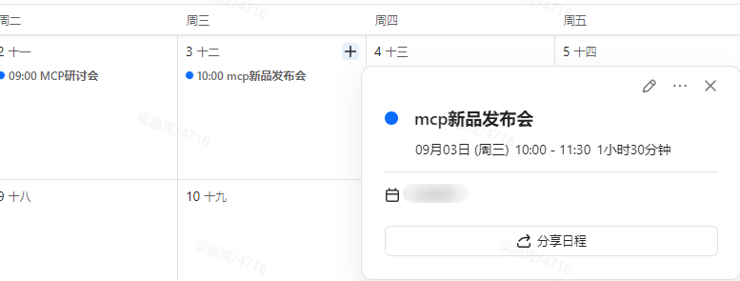

更多Cursor配置能力请参考Cursor官方配置指南

代码调用（python示例）

环境搭建

安装python环境管理工具uv
MacOS/Linux
- curl -LsSf https://astral.sh/uv/install.sh | sh

Windows
- powershell -ExecutionPolicy ByPass -c "irm https://astral.sh/uv/install.ps1 | iex"

初始化项目
MacOS/Linux
- # 创建项目
- uv init mcp-client
- cd mcp-client

- # 创建并激活虚拟环境
- uv venv
- source .venv/bin/activate

- # 安装依赖
- uv add "mcp[cli]" httpx

- # 创建客户端实现文件
- touch client.py

Windows
- # 创建项目
- uv init mcp-client
- cd mcp-client

- # 创建并激活虚拟环境
- uv venv
- .venv\Scripts\activate

- # 安装依赖
- uv add mcp[cli] httpx

- # 创建客户端实现文件
- new-item client.py

构建StreamableHTTP客户端
由于MCP Server是根据wps开放接口封装生成，访问开放接口所需的凭证在访问MCP Server时一样需要。目前开放平台采取的方案是通过http header透传Authorization信息。构建MCP HTTP Client时可参考下列代码传递凭证，HTTP方式可用日历MCP服务试用：https://openapi.wps.cn/mcp/v2/kso-calendar/message

更多MCP可在工具列表查看

- async with streamablehttp_client(url: "https://openapi.wps.cn/mcp/v2/kso-calendar/message", headers={
- "Authorization": f"Bearer " + access_token
- }) as (
- read_stream,
- write_stream,
- _,
- ):
- async with ClientSession(read_stream, write_stream) as session:
- result = await session.initialize()
- assert isinstance(result, InitializeResult)
- assert result.serverInfo.name == "StatelessServer"
- tool_result = await session.call_tool("echo", {"message": "hello"})
- assert len(tool_result.content) == 1
- assert isinstance(tool_result.content[0], TextContent)
- assert tool_result.content[0].text == "Echo: hello"

- for i in range(3):
- tool_result = await session.call_tool("echo", {"message": f"test_{i}"})
- assert len(tool_result.content) == 1
- assert isinstance(tool_result.content[0], TextContent)
- assert tool_result.content[0].text == f"Echo: test_{i}"

以下是一个使用MCP Client 访问MCP HTTP Server的代码示例。
- # client.py
- import asyncio
- import json
- import os
- from typing import Optional
- from contextlib import AsyncExitStack
- from mcp import ClientSession
- from mcp.client.streamable_http import streamablehttp_client
- from mcp.types import InitializeResult, TextContent

- from openai import AsyncOpenAI
- from dotenv import load_dotenv

- load_dotenv() # load environment variables from .env

- async def streamable_http_tools(method, **kwargs):
- async with streamablehttp_client(url=sys.argv[1], headers={
- "Authorization": f"Bearer {sys.argv[2]}"
- }) as (
- read_stream,
- write_stream,
- _,
- ):
- async with ClientSession(read_stream, write_stream) as session:
- if method == "initialize":
- return await session.initialize()
- elif method == "list":
- return await session.list_tools()
- elif method == "call":
- result = await session.call_tool(**kwargs)
- return result

- class MCPClient:
- def __init__(self):
- self.openai = AsyncOpenAI(api_key=os.getenv("OPENAI_API_KEY"), base_url=os.getenv("OPENAI_BASE_URL"))

- async def connect_to_http_server(self, server_url: str, access_token: str):
- """Connect to an MCP server running with HTTP transport"""
- await streamable_http_tools("initialize")

- async def process_query(self, query: str) -> str:
- """Process a query using OpenAI API and available tools"""
- messages = [
- {
- "role": "user",
- "content": query
- }
- ]
- response = await streamable_http_tools("list")
- available_tools = [{
- "type": "function",
- "function": {
- "name": tool.name,
- "description": tool.description,
- "parameters": tool.inputSchema
- }
- } for tool in response.tools]
- print("Available tools: ", [tool["function"]["name"] for tool in available_tools])

- # Initial OpenAI API call
- completion = await self.openai.chat.completions.create(
- model=os.getenv("OPENAI_MODEL"),
- max_tokens=1000,
- messages=messages,
- tools=available_tools
- )

- # Process response and handle tool calls - support multiple rounds
- max_iterations = 10 # Prevent infinite loops
- iteration = 0

- while iteration < max_iterations:
- assistant_message = completion.choices[0].message

- if assistant_message.tool_calls:
- print(f"\n--- Round {iteration + 1}: AI wants to call {len(assistant_message.tool_calls)} tool(s) ---")

- # Add assistant message with tool calls to conversation
- messages.append({
- "role": "assistant",
- "content": assistant_message.content,
- "tool_calls": assistant_message.tool_calls
- })

- # Execute all tool calls in this round
- for tool_call in assistant_message.tool_calls:
- tool_name = tool_call.function.name
- tool_args = json.loads(tool_call.function.arguments)

- print(f"Calling tool: {tool_name} with args: {tool_args}")
- result = await streamable_http_tools("call", name=tool_name, arguments=tool_args)

- # Add tool result to conversation
- messages.append({
- "role": "tool",
- "tool_call_id": tool_call.id,
- "content": result.content[0].text
- })

- # Get next response from OpenAI after all tools in this round
- completion = await self.openai.chat.completions.create(
- model=os.getenv("OPENAI_MODEL"),
- max_tokens=1000,
- messages=messages,
- tools=available_tools
- )

- iteration += 1
- else:
- # No more tool calls, we have the final response
- break

- # Get the final response content
- final_response = completion.choices[0].message.content

- if iteration >= max_iterations:
- return f"Reached maximum iterations ({max_iterations}). Last response: {final_response or 'No final response'}"

- if isinstance(final_response, (dict, list)):
- return str(final_response)
- else:
- return final_response or "No response generated"

- async def chat_loop(self):
- """Run an interactive chat loop"""
- print("\nMCP Client Started!")
- print("Type your queries or 'quit' to exit.")

- while True:
- try:
- query = input("\nQuery: ").strip()

- if query.lower() == 'quit':
- break

- response = await self.process_query(query)
- print("\n" + response)

- except Exception as e:
- print(f"\nError: {str(e)}")

- async def main():
- if len(sys.argv) < 3:
- print("Usage: python client.py <path_to_server_script> <your access token>")
- sys.exit(1)

- client = MCPClient()
- try:
- await client.connect_to_http_server(server_url=sys.argv[1], access_token=sys.argv[2])
- await client.chat_loop()
- except KeyboardInterrupt:
- print("\nClient is closing...")
- except Exception as e:
- print(f"Error: {e}")
- finally:
- print("Client is closed.")

- if __name__ == "__main__":
- import sys
- asyncio.run(main())

配置运行
在client.py同级目录下创建配置文件.env，填写选用的llm模型配置，文件示例
- # OpenAI 兼容API配置
- OPENAI_API_KEY=your-llm-key
- OPENAI_BASE_URL=your-llm-base-url
- OPENAI_MODEL=your-llm-model

在创建的 mcp-client 目录下执行命令 （{access_token}需替换为用户自己的令牌，获取方式见详见用户授权流程、获取用户access_token）
- uv run client.py https://openapi.wps.cn/mcp/v2/kso-calendar/message {access_token}

运行成功如图
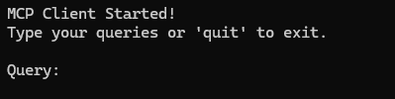

运行成功后可以开始进行对话了
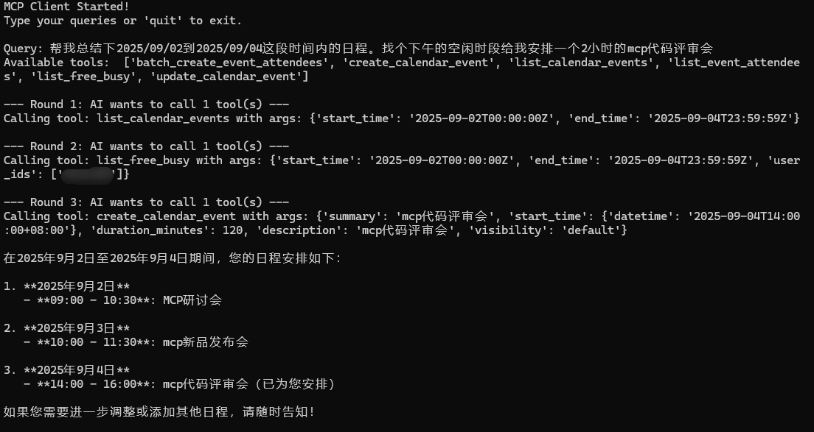

可以在协作日历中查看添加结果
