Ansible dependency graph:

ansible==2.5.5

  - cryptography [required: Any, installed: 2.2.2]

    - asn1crypto [required: >=0.21.0, installed: 0.24.0]

    - cffi [required: >=1.7, installed: 1.11.5]

      - pycparser [required: Any, installed: 2.18]

    - enum34 [required: Any, installed: 1.1.6]

    - idna [required: >=2.1, installed: 2.7]

    - ipaddress [required: Any, installed: 1.0.22]

    - six [required: >=1.4.1, installed: 1.11.0]

  - jinja2 [required: Any, installed: 2.10]

    - MarkupSafe [required: >=0.23, installed: 1.0]

  - paramiko [required: Any, installed: 2.4.1]

    - bcrypt [required: >=3.1.3, installed: 3.1.4]

      - cffi [required: >=1.1, installed: 1.11.5]

        - pycparser [required: Any, installed: 2.18]

      - six [required: >=1.4.1, installed: 1.11.0]

    - cryptography [required: >=1.5, installed: 2.2.2]

      - asn1crypto [required: >=0.21.0, installed: 0.24.0]

      - cffi [required: >=1.7, installed: 1.11.5]

        - pycparser [required: Any, installed: 2.18]

      - enum34 [required: Any, installed: 1.1.6]

      - idna [required: >=2.1, installed: 2.7]

      - ipaddress [required: Any, installed: 1.0.22]

      - six [required: >=1.4.1, installed: 1.11.0]

    - pyasn1 [required: >=0.1.7, installed: 0.4.3]

    - pynacl [required: >=1.0.1, installed: 1.2.1]

      - cffi [required: >=1.4.1, installed: 1.11.5]

        - pycparser [required: Any, installed: 2.18]

      - six [required: Any, installed: 1.11.0]

  - PyYAML [required: Any, installed: 4.1]

  - setuptools [required: Any, installed: 39.2.0]

=> Go this URL - [https://pypi.org/](https://urldefense.proofpoint.com/v2/url?u=https-3A__pypi.org_&d=DwMFaQ&c=H50I6Bh8SW87d_bXfZP_8g&r=FLwmDD-yVJtELbBvT2fKhs9QCw_AH-BlV2_TKLZX3so&m=gJsdc9Zj2Rlcsg8Xx3rW2IJ5Ii2z1gc85ZBKm-QqcNE&s=9I66thtIt_3krXJEkBqybdTD3_LcEMAbrjw8EkWx6Zg&e=) and search for each artifact (first look for .whl packages and if not got with tar.gz files)

Please run the command in following order:

1) Initial dependencies:

python pip-10.0.1-py2.py3-none-any.whl/pip install --no-index pip-10.0.1-py2.py3-none-any.whl

python pip-10.0.1-py2.py3-none-any.whl/pip install --no-index wheel-0.31.1-py2.py3-none-any.whl

python pip-10.0.1-py2.py3-none-any.whl/pip install --no-index setuptools-39.2.0-py2.py3-none-any.whl

**Please run the same command as above.**

* python pip-10.0.1-py2.py3-none-any.whl/pip install --no-index <required_Package.whl>
* Any tar.gz packages: pip install ./<DIR>/<FileName.tar.gz>

2) Install transitive dependencies:

Packages: pycparser, asn1crypto, cffi, enum34, idna, ipaddress, six, MarkupSafe, bcrypt,

3) Install primary packages:

cryptography, jinja2, paramiko, pyasn1, pynacl, PyYAML

4) Finally download ansible 2.5

ansible

# How and where to download:

Step 1) Type Pip or packages



Step 2) Press enter

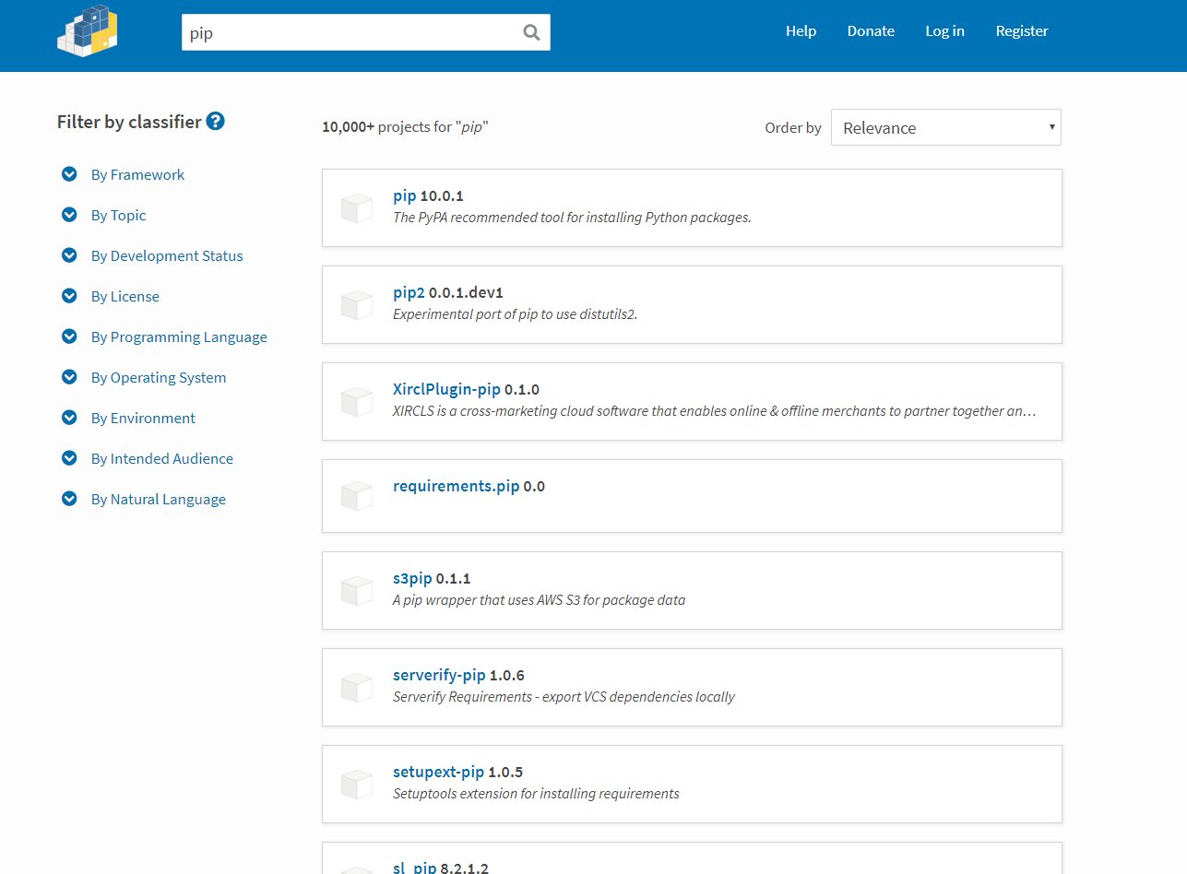

Step 3) Click download files

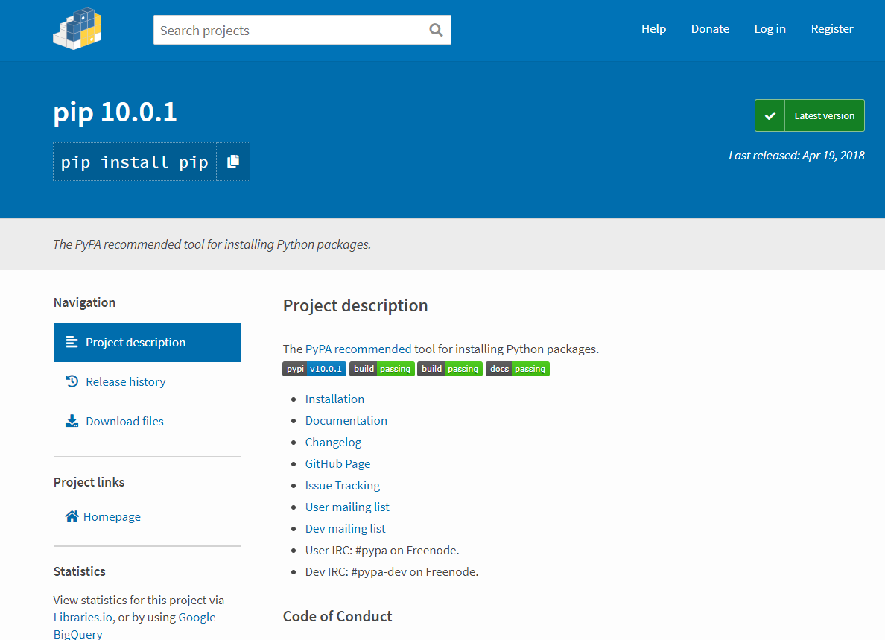

4) Click .whl packages to download and if no .whl packages download .tar.gz

