Purpose
The goal of this model is to identify forest management units in Glacier National Park, for agriculture forestry, and managed forestry (i.e., controlled burning and thinning).
Problem
The park would like to manage forests of a reasonable size. They don’t want the forest management to affect the water in the forest, and it must be vegetation forest type.
Methods
The 3 independent variables are: Forest type (Forest and Woodland, Agricultural Vegetation, Non-vegetated Land, Shrubland and Grassland, Polar and High Montane Vegetation, Nonvascular and Sparse Vascular Vegetation, Semi-Desert Scrub and Grassland), Distance from water (meters), Size of management unit (hectares). The dependent variable is the number of management units.
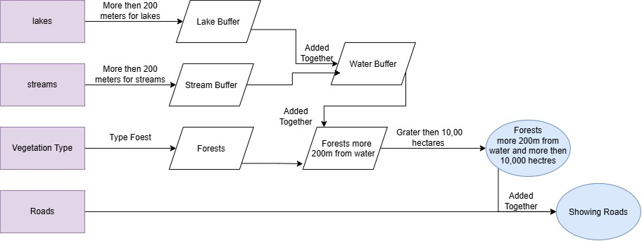
Model and methods
Forest and Woodland is the only vegetation type that is primarily forest, so it’s the only one currently in the model, along with size of management unit (greater than 10,000 hectares). For testing the model, distance from water was looked at with 3 different distances (100, 200, 500m).
Results
As the distance from water goes up, the number of management units goes down, along with the total area of management units.
Water buffer | Number of management units | Total area of management
100 | 35 | 89,202 hectares
200 | 22 | 43,856 hectares
500 | 1 | 1,196 hectares
In the future, having more than a Boolean raster of the model will be ideal for defining each variable's power in the model. It would also be pertinent to examine how the size of the management unit affects the model.

