**NTT**

hiroki takesue

1. With external field [Simulating Ising spins in external magnetic fields with a network of degenerate optical parametric oscillators](https://journals.aps.org/prapplied/abstract/10.1103/PhysRevApplied.13.054059) (2020)
2. Scaling: [100,000-spin coherent Ising machine](https://www.science.org/doi/abs/10.1126/sciadv.abh0952) (2021)
3. Application in wireless communication:

[Resource Allocation for Large Scale UAV Networks Using Coherent Ising Machine](https://www.ieice.org/publications/proceedings/summary.php?iconf=NOLTA&session_num=A2L-2&number=A2L-24&year=2023) (2023)

[High-speed resource allocation algorithm using a coherent ising machine for noma systems](https://ieeexplore.ieee.org/abstract/document/10225415/) (2023) Resource allocation algorithm for non-orthogonal multiple access (NOMA) technique.

1. Application in machine learning: [Supporting Energy-Based Learning with an Ising Machine Substrate: A Case Study on RBM](https://dl.acm.org/doi/abs/10.1145/3613424.3614315)
2. Extension [10-GHz-clock time-multiplexed non-degenerate optical parametric oscillator network with a variable planar lightwave circuit interferometer](https://opg.optica.org/abstract.cfm?uri=ol-48-21-5787) large-scale CXYM with >47,000 spins by generating 10-GHz-clock time-multiplexed NOPO pulses, extending the concept of the Ising machine to include simulations of multi-valued spin models (e.g., the Potts model, continuous-spin models (e.g., the XY model), or multi-dimensional hyperspins.

**Yoshihisa Yamamoto**

1. The concept of CIM: Network of time-multiplexed optical parametric oscillators as a coherent Ising machine (2014)
2. [Effect of Coupling Discretization on Coherent-Ising-Machine-Implemented Hopfield Model](https://journals.jps.jp/doi/full/10.7566/JPSJ.92.044002)(2023)

Goal> reduce the number of bits of coupling strength

evaluate the effect of discretization of the coupling strength in the MFB-CIM

the effect of the discretization on the macroscopic properties of CIM-implemented Hopfield model with discrete coupling (CIM-HMDC)

derived the relationship between the number of bits of the coupling strength and the critical memory capacity for various pump rates

compared the model with the zero-temperature Ising spin Hopfield model with continuous coupling (ZTIS-HMCC), the zero-temperature Ising spin Hopfield model with discrete coupling (ZTIS-HMDC),[24](javascript:void(0);)) and the CIM-implemented Hopfield model with continuous coupling (CIM-HMCC)

evaluated the difference between the discretization effects in the equilibrium Ising model and in the CIM

**Yamamoto, NTT and Standford**

1. [Skew-Gaussian model of small-photon-number coherent Ising machines](https://arxiv.org/pdf/2403.00200) (2024)

Goal > Control of amplitude homogeneity

coherent Ising machines (CIMs) consisting of χ(2) degenerate optical parametric

oscillators (DOPOs) + two third-order fluctuation products called self-skewness and cross-skewness, respectively.

1. [Dynamic Anisotropic Smoothing for Noisy Derivative-Free Optimization](https://arxiv.org/pdf/2405.01731) (2024)

Goal: Further improve CIM with chaotic amplitude control ((Leleu et al., 2019)

DAS (dynamic anisotropic smoothing) algorithm for noisy derivative-free optimization such as Ising problem tuning. This algorithm adjusts to the different sensitivities of the different parameters, benchmark with Sherrington-Kirkpatrick (SK) model

1. [Mean-field coherent Ising machines with artificial Zeeman terms](https://pubs.aip.org/aip/jap/article/134/23/234901/2930409) (2023)

The primary objective of this paper is the efficient implementation of Zeeman terms within Mean-Field CIM (MF-CIM) models that do not incorporate quantum noise terms and measurements [henceforth referred to as MFZ (Mean-Field-Zeeman)-CIM]. The mean-field CIM model is a physics-inspired heuristic solver that does not accurately represent the CIM’s behavior. However, due to their low computational costs, mean-field models are suitable for implementation with field programmable gate arrays (FPGAs) and for simulations on a large scale. So far, three approaches have been proposed to address the realization problem for CIM, namely, the **absolute mean amplitude method （2016）, the auxiliary spin method (2021), and the chaotic amplitude control (CAC) method (2022)**. In this paper, we examine the applicability of CAC to realizing the Zeeman term in MFZ-CIM.

Coherent Ising Machines with Optical Error Correction Circuits (2021)

Control of amplitude homogeneity in coherent ising machines with artificial zeeman terms (2022).

**Applied Physics Research Group, Vrije Universiteit Brussel, Pleinlaan 2, 1050, Brussels, Belgium** (**VUB**)

opto-electronic oscillator based Ising machine

[A poor man’s coherent Ising machine based on opto-electronic feedback systems for solving optimization problems](https://www.nature.com/articles/s41467-019-11484-3) (2019)

[Solving MAXCUT Optimization Problems with a Coherent Ising Machine Based on Opto-Electronic Oscillators](https://ieeexplore.ieee.org/document/8873336) (2019)

**(VUB + Hewlett Packard Labs)**

[Order-of-magnitude differences in computational performance of analog Ising machines induced by the choice of nonlinearity](https://www.nature.com/articles/s42005-021-00655-8#author-information) (2021)

<https://www.spiedigitallibrary.org/conference-proceedings-of-spie/11804/118041Q/Time-multiplexed-optical-systems-for-reservoir-computing-and-coherent-Ising/10.1117/12.2594700.full#_=_>

[Compact and inexpensive photonic Ising machines based on optoelectronic oscillators](https://ieeexplore.ieee.org/abstract/document/9489449) (2021)

“DOPOs employ a polynomial transfer function due to the Kerr nonlinearity while OEOs employ a periodic transfer function due to the Mach-Zehnder interferometer.”

“broad amplitude inhomogeneity leads to an incorrect mapping to the Ising Hamiltonian”

“While the amplitude of the polynomial is unbound and grows continuously with the feedback gain, the transfer function for the other models saturates for large gain and thus limits the maximal amplitude. We find that this saturation ensures that the analog amplitude for each spin is narrowly distributed around the fixed points, while the amplitudes are broadly distributed for the polynomial model. “

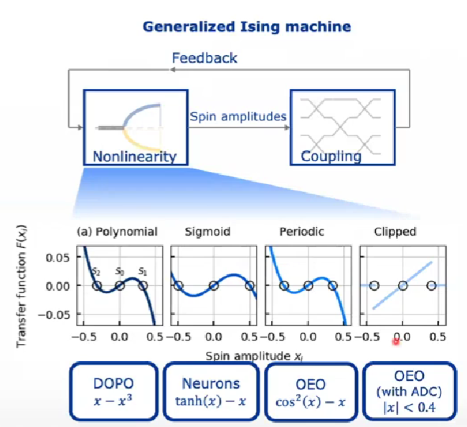

**Hewlett Packard Labs Belgium**

1. Integrated Coherent Ising Machines Based on Self-Phase Modulation in Microring Resonators (2019)
2. [Tunable coherent Ising machines with fifth-order nonlinearity](https://photonics.intec.ugent.be/download/pub_5109.pdf) (2024)

a fifth-order nonlinearity to have more hyperparameters and a large noise regime to facilitate exploration

**Columbia University+Cornell University**

1. [Demonstration of chip-based coupled degenerate optical parametric oscillators for realizing a nanophotonic spin-glass](https://www.nature.com/articles/s41467-020-17919-6) (2020)

**Korea Advanced Institute of Science and Technology, KAIST + Daegu-Gyeongbuk Institute of Science and Technology, DGIST, Korea**

1. [Low Power Coherent Ising Machine Based on Mechanical Kerr Nonlinearity](https://journals.aps.org/prl/abstract/10.1103/PhysRevLett.130.073802) (2023)

**Others**

**Toshiba Corporation, Hayato Goto, Taro Kanao**

**Behavior of coupled KPO:**

Chaos in coupled Kerr-nonlinear parametric oscillators (2021)

[High-accuracy Ising machine using Kerr-nonlinear parametric oscillators with local four-body interactions](https://www.nature.com/articles/s41534-020-00355-1) (2021)

[Fast Tunable Coupling Scheme of Kerr Parametric Oscillators Based on Shortcuts to Adiabaticity](https://journals.aps.org/prapplied/abstract/10.1103/PhysRevApplied.18.034076) (2022) together with NTT

**Simulated Bifurcation (algorithm)**: ballistic and discrete SBs (bSB and dSB):

High-performance combinatorial optimization based on classical mechanics (2021)

[Simulated bifurcation for higher-order cost functions](https://www.researchgate.net/publication/366279429_Simulated_bifurcation_for_higher-order_cost_functions?_tp=eyJjb250ZXh0Ijp7InBhZ2UiOiJzY2llbnRpZmljQ29udHJpYnV0aW9ucyIsInByZXZpb3VzUGFnZSI6bnVsbH19) (2022)

[Simulated bifurcation assisted by thermal fluctuation](https://www.researchgate.net/publication/361299803_Simulated_bifurcation_assisted_by_thermal_fluctuation?_tp=eyJjb250ZXh0Ijp7InBhZ2UiOiJzY2llbnRpZmljQ29udHJpYnV0aW9ucyIsInByZXZpb3VzUGFnZSI6bnVsbH19) (2022)

Higher order cost function and added thermal fluctuation help solve optimization problems

(from other companies or institutes:

Efficient optimization with higher-order Ising machines

 Bybee, C., Kleyko, D., Nikonov, D.E. et al. Efficient optimization with higher-order Ising machines. Nat Commun 14, 6033 (2023). https://doi.org/10.1038/s41467-023-41214-9)

**ETH Zürich + University of Konstanz**

[Biased Ising Model Using Two Coupled Kerr Parametric Oscillators with External Force](https://journals.aps.org/prl/abstract/10.1103/PhysRevLett.132.207401)(2024): for quantum computing

**California Institute of Technology**

Large-scale time-multiplexed nanophotonic parametric oscillators (2024)

Quadratic nonlinearity

thin-film lithium niobate have enabled realization of nanophotonic OPOs with substantial miniaturization and threshold enhancement due to the sub-micron modal confinement.

implement a 40-pulse, time-multiplexed optical parametric oscillator in thin-film lithium niobate nanophotonics and demonstrate the independent phase behavior of the pulses in the degenerate and non-degenerate regimes, enabling scalable optical computers and complex simulators.

**Summary of researching goals:**

More compact, faster and more accurate

more physically accurate models

1. External magnetic field

**Zeeman term is the term that represents the external magnetic field in a system**.

1. Added thermal fluctuation
2. Higher order of nonlinearity / higher order of coupled bodies in cost function
3. Tuning of hyperparameters

Faster

1. Adjusted model for optimization
2. Reduce bits for coupling strength

**Furthermore**

[Effect of loss mechanisms on Kerr-nonlinear resonator behaviour](https://opg.optica.org/abstract.cfm?uri=ipra-2005-ITuC4) (2005)

Abstract

The degradation of Kerr-nonlinear behaviour in resonating structures due to optical loss is investigated. From this, the feasibility of ultrafast, Kerr-nonlinear operation is derived for the AlGaAs and Si material system.

© 2005 Optical Society of America

-------------------------------------------------------

**Silicon Photonics**