**数据库实验**

**第一次实验——SQL语言中的单表查询与连接查询**

曹广杰

数据科学与计算机学院

2017/1/12

任课教师：刘玉葆。

关键词：数据库；SQL语言；

Contents

Task1 **Error! Bookmark not defined.**

实验结果： **Error! Bookmark not defined.**

Task2 **Error! Bookmark not defined.**

实验结果 **Error! Bookmark not defined.**

Task3 **Error! Bookmark not defined.**

实验结果： **Error! Bookmark not defined.**

Task4 **Error! Bookmark not defined.**

实验结果： **Error! Bookmark not defined.**

Task5 **Error! Bookmark not defined.**

实验结果： **Error! Bookmark not defined.**

Task6 **Error! Bookmark not defined.**

实验结果： **Error! Bookmark not defined.**

Task7 **Error! Bookmark not defined.**

实验结果： **Error! Bookmark not defined.**

Task8 **Error! Bookmark not defined.**

实验结果： **Error! Bookmark not defined.**

Task9 **Error! Bookmark not defined.**

实验结果： **Error! Bookmark not defined.**

Task10 **Error! Bookmark not defined.**

实验结果： **Error! Bookmark not defined.**

1. 代码如下：

|  |
| --- |
| **create table CARD(**  **cid char(10) unique, -- unique 表唯一约束**  **sid char(10),**  **money decimal(10, 2),**  **--设置主键**  **primary key(cid)**  **foreign key(sid) references students**  **)** |

运行结果如下：

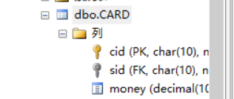

1. 代码：

|  |
| --- |
| alter table CARD add bank char(20) |

1. 代码：

|  |
| --- |
| alter table CARD  drop column bank; |

实验结果：



1. 代码：

|  |
| --- |
| 1. **select tname** 2. **from Teachers** 3. **where salary >=** 4. **all(** 5. **select salary** 6. **from Teachers** 7. **where salary is not null** 8. **)** 9. **select cname** 10. **from courses** 11. **where cid =** 12. **any(** 13. **select cid** 14. **from choices,** 15. **where tid =** 16. **any(** 17. **select tid** 18. **from Teachers** 19. **where salary >=** 20. **all(** 21. **select salary** 22. **from Teachers** 23. **where salary is not null** 24. **)** 25. **)** 26. **)** |

实验结果：

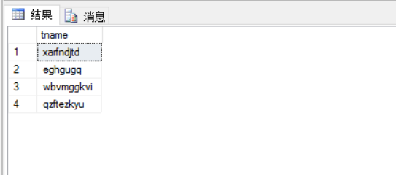

5. 代码：

|  |
| --- |
| **select cname**  **from courses**  **where hour =**  **any(**  **select hour**  **from courses**  **where cname = 'uml' or cname = 'c++'**  **)**  **and cname <> 'uml'**  **and cname <> 'c++'** |

实验结果：

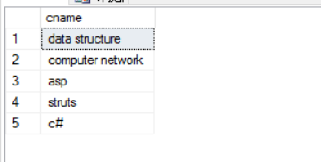

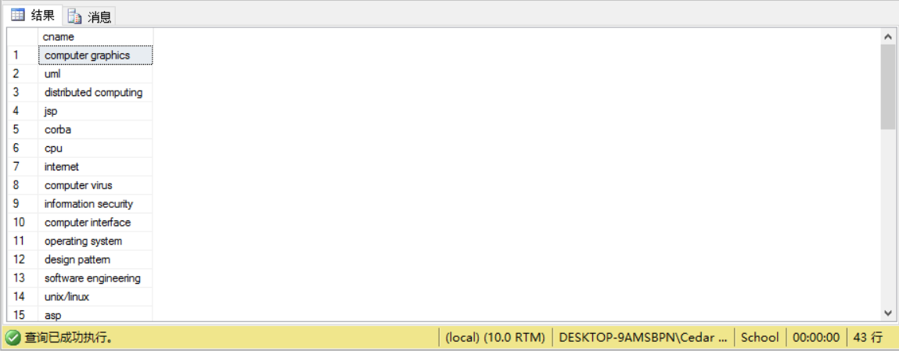

6. 代码：

|  |
| --- |
| **select sid**  **from choices**  **where cid =**  **(**  **select cid**  **from courses**  **where cname = 'c++'**  **)**  **except**  **select sid**  **from choices**  **where cid =**  **(**  **select cid**  **from courses**  **where cname = 'database'**  **)** |

实验结果：

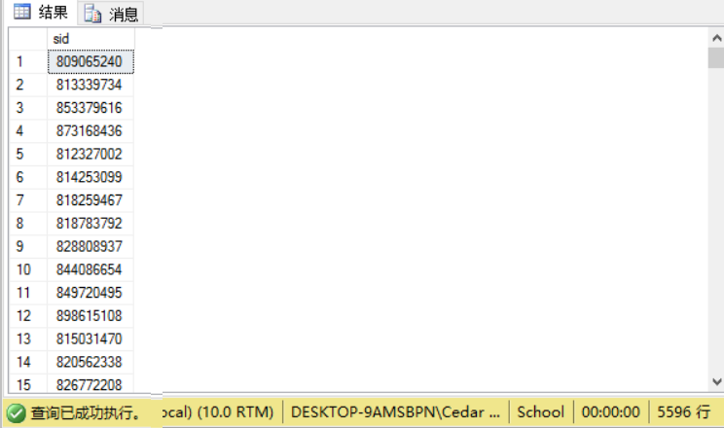

7. 代码：

|  |
| --- |
| **select sid**  **from choices**  **where cid =**  **(**  **select cid**  **from courses**  **where cname = 'database'**  **)**  **and**  **score >**  **(**  **select score**  **from choices**  **where sid =**  **(**  **select sid**  **from students**  **where sname = 'ruvldjlm'**  **)**  **and**  **cid =**  **(**  **select cid**  **from courses**  **where cname = 'database'**  **)**  **)** |

实验结果：

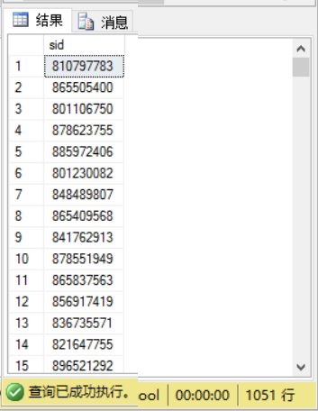

8. 代码：

|  |
| --- |
| **select avg(score) as avg, max(score) as max**  **from choices**  **where cid =**  **(**  **select cid**  **from courses**  **where cname = 'database'**  **)** |

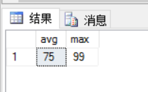

9.

|  |
| --- |
| **select sname**  **from students**  **where sid =**  **any(**  **select sid**  **from choices**  **where**  **cid =**  **(**  **select cid**  **from courses**  **where cname = 'database'**  **)**  **and**  **score >=**  **all(**  **select score**  **from choices**  **where score is not null**  **)**  **)** |

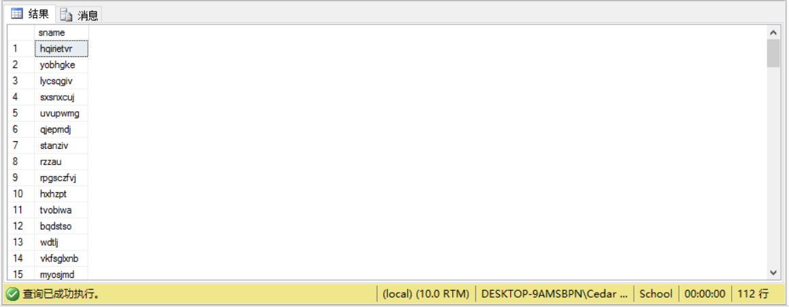

10.

|  |
| --- |
| **select sname**  **from students**  **where sid =**  **any(**  **select sid**  **from students**  **except**  **select sid**  **from choices**  **where cid =**  **(**  **select cid**  **from courses**  **where cname = 'database'**  **)**  **)** |

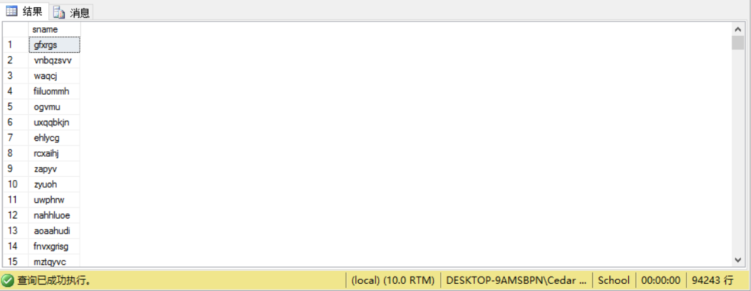

11.

|  |
| --- |
| **select sname**  **from students as s**  **where sid =**  **select cid**  **from choices as c**  **where s.sid = c.sid** |

12.

|  |
| --- |
| **create view view_sc**  **(sname, cname, score)**  **as**  **select sts.sname, crs.cname, cis.score**  **from CHOICES as cis, students as sts, courses as crs**  **where sts.sid = cis.sid, crs.cid = cis.cid** |

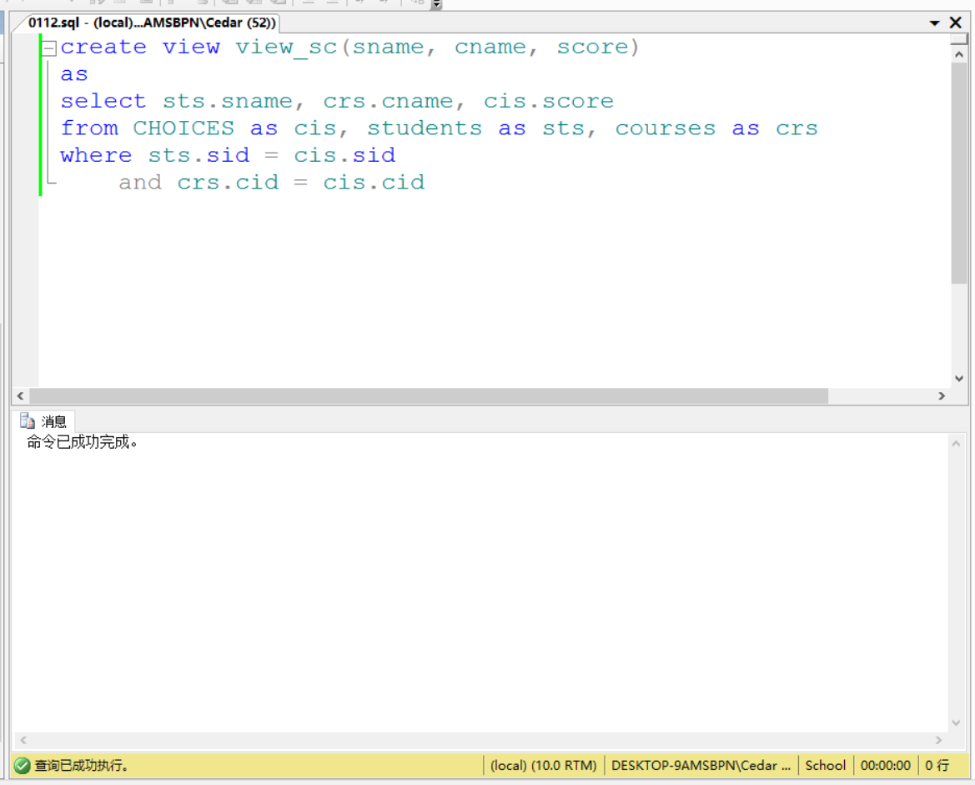

13.

|  |
| --- |
| **select sname**  **from view_sc**  **where score > 90** |

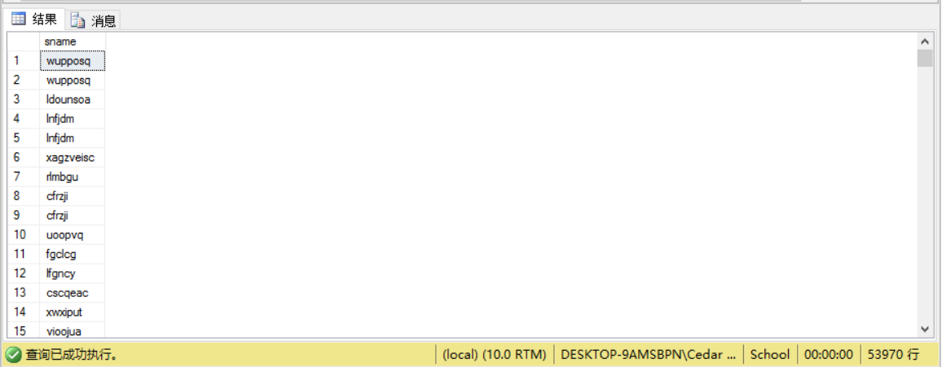

14.

|  |
| --- |
| 不能，因为有关联的table |

15.

|  |
| --- |
| **create rule R1**  **as @value > 0**  **go**  **exec sp_bindrule R1, 'CARD.[money]'** |

16.

|  |
| --- |
| alter table CARD  insert value(10037, 823069829, -2) |

17.

|  |
| --- |
| **exec sp_unbindrule 'CARD.[money]'**  **drop rule R1** |

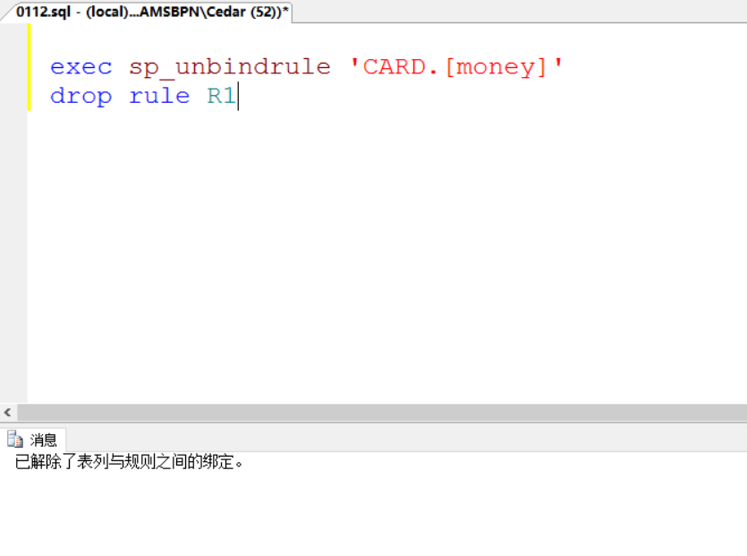

18.

|  |
| --- |
| **create trigger T1**  **on students**  **for delete**  **as**  **if(**  **(select cid**  **from deleted) = '800015960'**  **)**  **begin**  **print 'No delete'**  **Rollback transaction**  **End** |

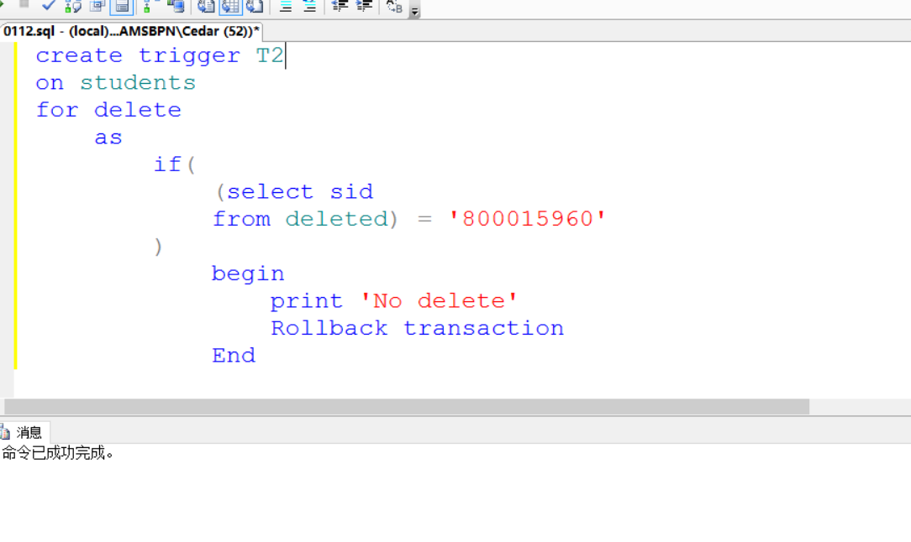

19.

|  |
| --- |
| **delete**  **from students**  **where sid = '800015960'** |

