Lecture Lec03.ppt in class worksheet
Question 1. To use an I/O pin as a UART function, to what value to we set AFSEL?
Question 2. What does it mean to say the SW1 switch on the board is negative logic?
Question 3. What does it mean to say the Blue LED on the board is positive logic?
Question 4. After an addition of two unsigned numbers, the C bit is set. What does it mean?
Question 5 After an addition of two signed numbers, the V bit is set. What does it mean?
Question 6. After a subtraction of two unsigned numbers, the C bit is set. What does it mean?
Question 7. After a subtraction of two signed numbers, the V bit is set. What does it mean?
Question 8. When does a subroutine need to save and restore LR?
Question 9. Interface a switch to Port A bit 5 using positive logic.
--------------------------------------
Question 10. Interface an LED to Port A bit 7 using positive logic. The LED parameters are 1.5V 20mA. Assume the output low voltage of a 7406 V_{OL} is 0.5V. Calculate the limiting resistor and give the connection Diagram.

Question 11. Interface an LED to Port A bit 4 using positive logic. The LED parameters are 1.4V 2mA. Assume the microcontroller output voltage V_{OH} is 3.2V. Calculate the limiting resistor and give the connection Diagram.

Question 12. What address allows us to access just pin PA7?

Answer 1. We set AFSEL to 1 to use an I/O pin as a UART function, because it is an alternate function

Answer 2. There are 8 UART modules one the LM4F120/TM4C123

Answer 3. It means a logic 1 (3.3V) output will create the true state (Blue LED on). It means a logic 0 (0V) output will create the false state (Blue LED off).
Answer 4. After an addition of two unsigned numbers, the C bit is set if the result does not fit back into the 32-bit register. C=1 means unsigned overflow

Answer 5. After an addition of two signed numbers, the V bit is set if the result does not fit back into the 32-bit register. V=1 means signed overflow

Answer 6. After a subtraction of two unsigned numbers, the C bit is set if the result DOES fit back into the 32-bit register. C=0 means unsigned overflow

Answer 7 After a subtraction of two signed numbers, the V bit is set if the result does not fit back into the 32-bit register. V=1 means signed overflow

Answer 8. A subroutine needs to save and restore LR if it itself calls another subroutine.

Answer 9. Interface a switch to Port A bit 5 using positive logic.
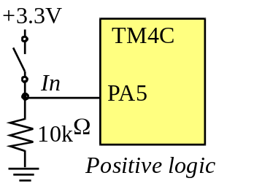
Answer 10. R = (5-1.5-0.5V)/20 mA = 150 ohms
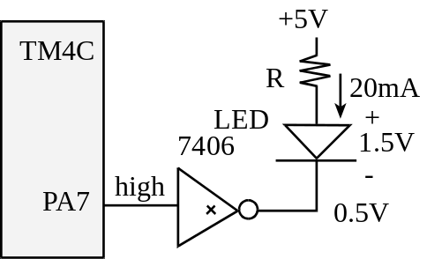

Answer 11. R = (3.2-1.4)/2 mA = 990 ohms
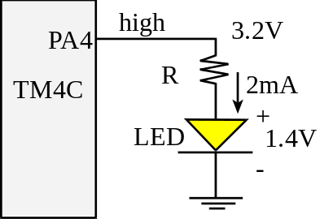

Answer 12. What address allows us to access just pin PA7?
Base address is 0x4000.4000
Offset for bit7 0x200
PA7 0x4000.4200

