Lecture Lec4.ppt in class worksheet
Question 1. How does it matter that a number is unsigned or signed? Which instructions are specific for unsigned numbers?

Which instructions are specific for signed numbers?

Question 2. How does it matter if a number is 8 16, or 32 bits. Which instructions are specific for 8-bit numbers?

Which instructions are specific for 16-bit numbers?

Question 3. Give an example of promotion on the ARM Cortex M?

Why do we use it?

Question 4. Notice the names of the functions in Program 4.3 (LED_Init, LED_On, LED_Off, LED_Toggle) do not mention the port PF2. Why not call the functions PF2_Init, PF2_On, PF2_Off, PF2_Toggle?

Question 5. In terms of a device driver, what does public mean? Private?

Question 6. Assume V1 is a 32-bit unsigned global variable. We wish to write code that decrements V1 with the exception that it will not decrement if V1 is already 0. Draw a flowchart of the process. Write the code in both C and assembly.

Question 7. Assume V1 is a 32-bit unsigned global variable. We wish to write code that increments V1 if V1 is less than 100. Draw a flowchart of the process. Write the code in both C and assembly.

Question 8. Assume PF2 is initialized as an output port already. We wish to write code that toggles PF2 100 times. Draw a flowchart of the process. Write C and assembly code.

Question 9. Assume PA7 is initialized as an input port already. A negative logic switch is interfaced to PA7. We wish to write code that waits for the switch to be pressed. If the switch is already pressed when the code starts, then it does not wait at all. Draw a flowchart of the process. Write C and assembly code that waits for PA7 to be pressed.

Lecture Lec4.ppt in class worksheet
Question 1. Which instructions are specific for unsigned numbers?
Answer: LSR, UDIV, BHI, BLO, BLS, BHS, LDRB, LDRH
Which instructions are specific for signed numbers?
Answer: ASR, SDIV, BGT, BLT, BLE, BGE, LDRSB, LDRSH

Question 2. Which instructions are specific for 8-bit numbers?
Answer: LDRB, LDRSB, STRB
Which instructions are specific for 16-bit numbers?
Answer: LDRH, LDRSH, STRH

Question 3. Give an example of promotion on the ARM Cortex M?
Answer: Loading an 8- or 16-bit number into a 32-bit register (LDRB LDRSB LDRH, LDRSH)
Why do we use it?
Answer1: all operations occur in 32-bit registers.
Answer2: perform operations at higher precision to make sure it fits before storing it back at the original precision (demotion).

Question 4. Notice the names of the functions in Program 4.3 (LED_Init, LED_On, LED_Off, LED_Toggle) do not mention the port PF2. Why not call the functions PF2_Init, PF2_On, PF2_Off, PF2_Toggle?
Answer1: Abstraction makes it easier to understand.
Answer2: Abstraction makes it easier to change.

Question 5.
Answer: Public means shared and other functions can call it. Private means not shared and other functions cannot access or call it.

Question 6. Assume V1 is a 32-bit unsigned global variable. We wish to write code that decrements V1 with the exception that it will not decrement if V1 is already 0. Draw a flowchart of the process. Write the code in both C and assembly.
if(V1 != 0){
V1--;
}
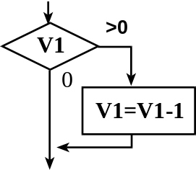
LDR R0,=V1
LDR R1,[R0] ;value of V1
CMP R1,#0
BEQ No
SUB R1,#1 ;decrement
STR R1,[R0] ;update
no

Question 7. Assume V1 is a 32-bit unsigned global variable. We wish to write code that increments V1 if V1 is less than 100. Draw a flowchart of the process. Write the code in both C and assembly.
if(V1 < 100){
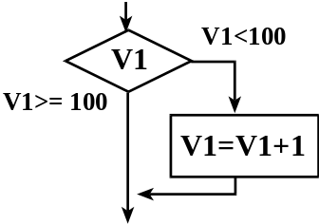
V1++;
}

LDR R0,=V1
LDR R1,[R0] ;value of V1
CMP R1,#100
BHS No
ADD R1,#1 ;increment
STR R1,[R0] ;update
no

Question 8. Assume PF2 is initialized as an output port already. We wish to write code that toggles PF2 100 times. Draw a flowchart of the process. Write C and assembly code.
uint32_t i;
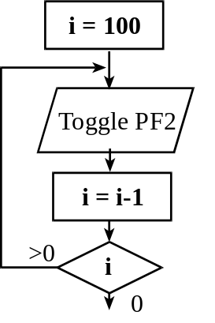
for(i=100; i>0; i--){
GPIO_PORTF_DATA_R ^= 0x04;
}

LDR R0,=GPIO_PORTF_DATA_R
MOV R2,#100
loop LDR R1,[R0]
EOR R1,#0x04
STR R1,[R0]
SUBS R2,#1
BEQ loop

Question 9. Assume PA7 is initialized as an input port already. A negative logic switch is interfaced to PA7. We wish to write code that waits for the switch to be pressed. If the switch is already pressed when the code starts, then it does not wait at all. Draw a flowchart of the process. Write C and assembly code that waits for PA7 to be pressed.
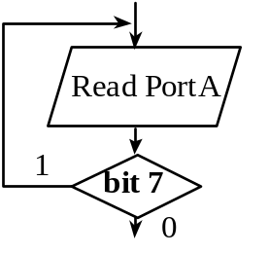
while(GPIO_PORTA_DATA_R&0x80){
}

LDR R0,=GPIO_PORTA_DATA_R
loop LDR R1,[R0]
ANDS R1,#0x80 ;PA7= when touch
BNE loop

