EE319K Lecture Lec6.ppt in class worksheet
Question 1. How many bits wide is the SysTick timer?

Question 2. Does SysTick count up or down?

Question 3. At what rate does SysTick count?

Question 4. What happens if you read from NVIC_ST_CURRENT_R?

Question 5. What happens if you write to NVIC_ST_CURRENT_R?

Question 6. Write a C function that uses SysTick to wait 100 μs. Assume the bus clock is running at 16 MHz.

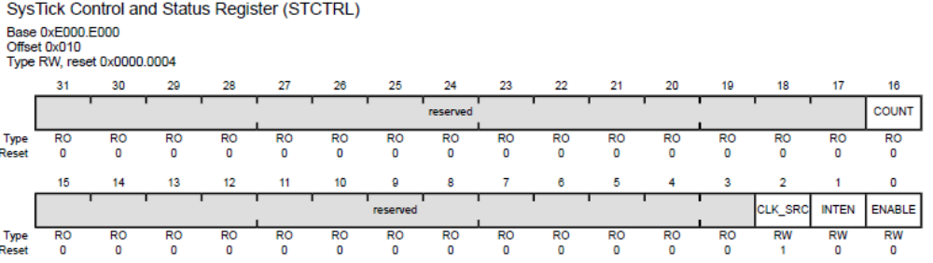

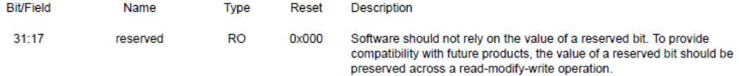
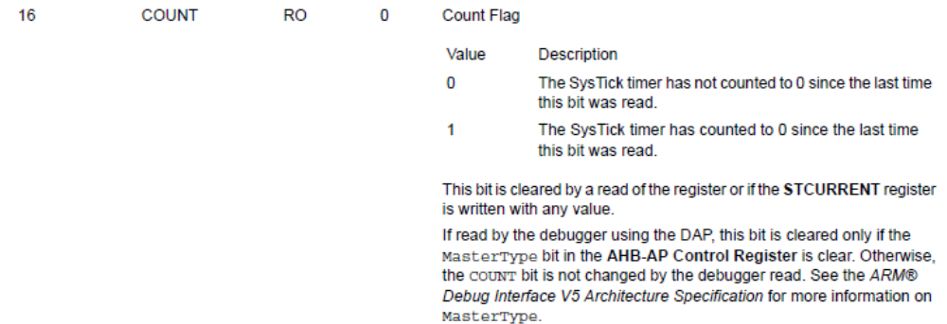
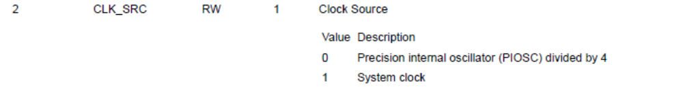
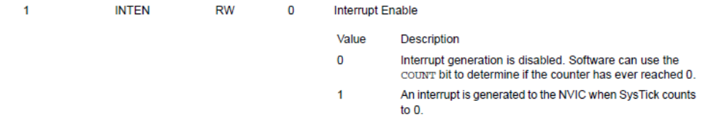
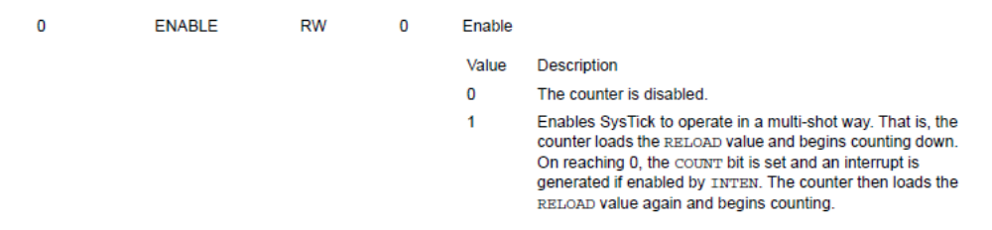
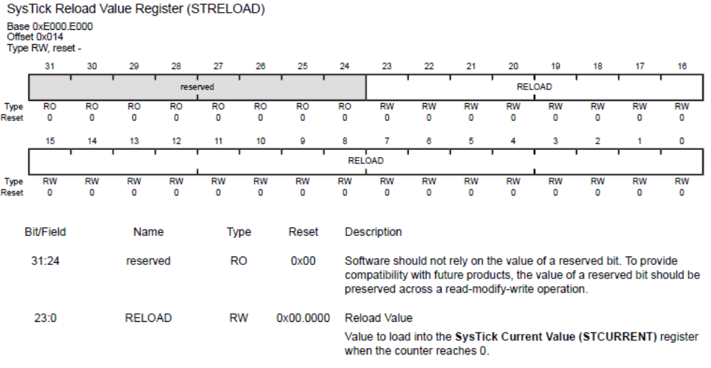
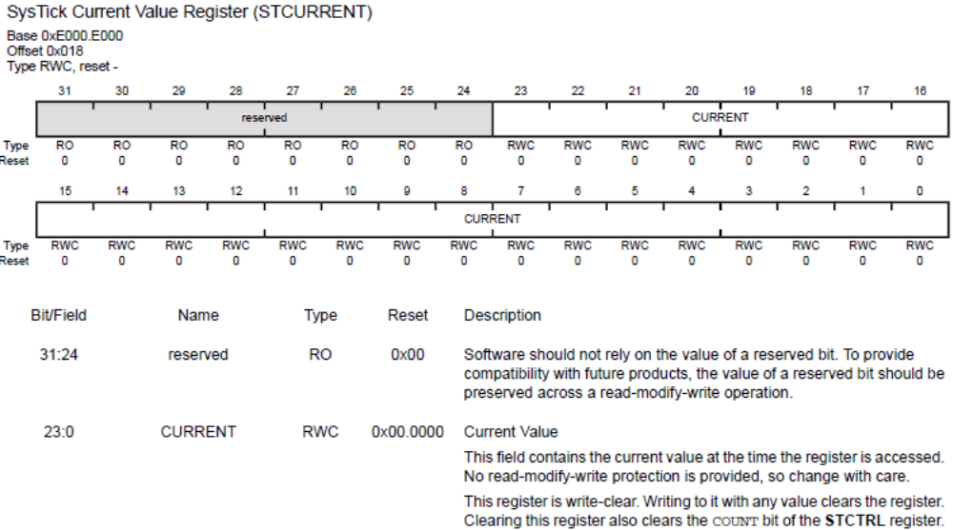 Answer 1. SysTick is 24 bits.
Answer 2. SysTick counts down
Answer 3. SysTick counts at the bus clock frequency. In this class the bus clock is initially 16 MHz and will change to 80 MHz once we activate the phase lock loop (PLL).
Answer 4. Reading NVIC_ST_CURRENT_R gets the current value of the counter.
Answer 5. When write any value to NVIC_ST_CURRENT_R it clears this register and also clears the COUNT bit in the NVIC_ST_CTRL_R register.
Answer 6. (1599+1)*62.5ns = 100 μs.
void SysTick_100usWait(void){
NVIC_ST_RELOAD_R = 1599; // number of counts to wait
NVIC_ST_CURRENT_R = 0; // any value written to CURRENT clears
while((NVIC_ST_CTRL_R&0x00010000)==0){ // wait for count flag
}
}

