Lecture Lec03.ppt in class worksheet
Question 1. How many bits wide is Port B? How many bits wide is Port F?
Answer 1. Port B is 8 bits wide. Port F is 5 bits wide.
Question 2. Why are there two shift right instructions (LSR and ASR)?
Answer 2. LSR is an unsigned shift right, bringing zeros into the most significant bit. ASR is a signed shift right, maintaining the sign bit as it shifts
Question 3. Why are there five versions of the LDR instruction?
LDR, LDRB, LDRSB, LDRH, LDRSH
Answer：
LDR loads 32-bit signed or unsigned value from memory
LDRH loads 16-bit unsigned value from memory
LDRSH loads 16-bit signed value from memory
LDRB loads 8-bit unsigned value from memory
LDRSB loads 8-bit signed value from memory
Question 4. What address allows us to access just pin PA7?
Answer Base address is 0x4000.4000
Offset for bit7 0x200
PA7 0x4000.4200
Question 5. Interface a switch to Port A bit 5 using positive logic.
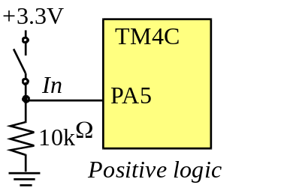
Question 6. Interface an LED to Port A bit 7 using positive logic. The LED parameters are 1.5V 20mA. Assume the output low voltage of a 7406 V_{OL} is 0.5V. Calculate the limiting resistor and give the connection Diagram.
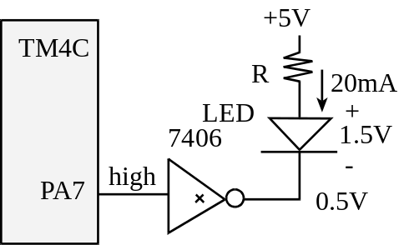
Question 7. Interface an LED to Port A bit 4 using positive logic. The LED parameters are 1.4V 2mA. Assume the microcontroller output voltage V_{OH} is 3.2V. Calculate the limiting resistor and give the connection Diagram.
