Test Case 1: Successful Login
- Description: Verify that the DBUtils.login method allows a user to log in successfully with valid credentials.
- Input:
  - username: "validUser"
  - plaintextPassword: "correctPassword"
- Expected Result:
  - The login method returns true.
  - The user data is stored in the application's current session.
- Implementation Details:
  - The test sets up mocked database components, including a Connection, PreparedStatement, and ResultSet, to simulate a successful login process.
  - The password is hashed using BCryptPasswordEncoder.
  - The DriverManager.getConnection method is mocked to return the simulated database connection.
  - The test verifies that the login method returns true when valid credentials are provided.
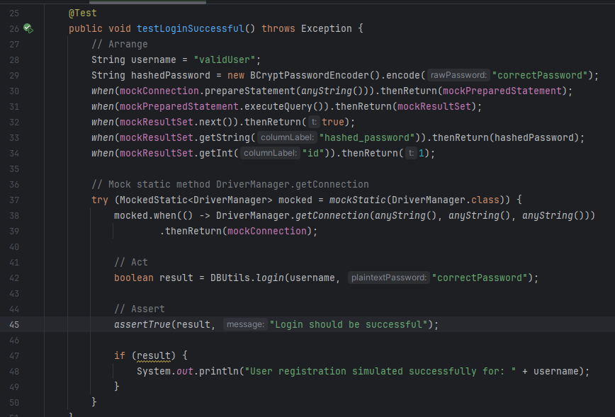
- Code Implementation:
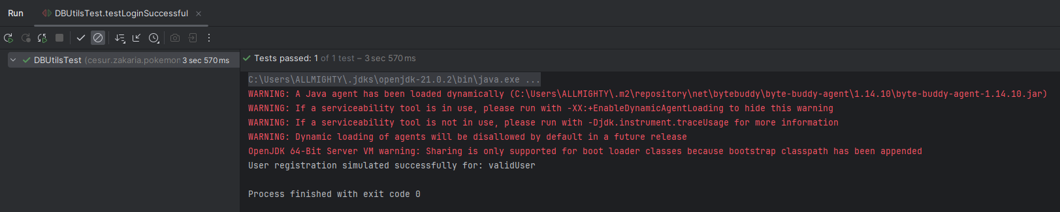
- Output :

Test Case 2: Login with Incorrect Password
- Description: Verify that the DBUtils.login method denies access when a user provides the wrong password, even with a valid username.
- Input:
  - username: "validUser"
  - plaintextPassword: "wrongPassword"
- Expected Result:
  - The login method returns false because the password does not match the hashed password stored in the database.
- Implementation Details:
  - The test mocks the Connection, PreparedStatement, and ResultSet objects to simulate a database response.
  - The hashed password for the valid user is encoded using BCryptPasswordEncoder.
  - The ResultSet returns the expected hashed password for the user.
  - The DriverManager.getConnection method is mocked to return the simulated database connection.
  - The test verifies that DBUtils.login returns false when a wrong password is provided, ensuring proper password validation.
- Code Implementation:
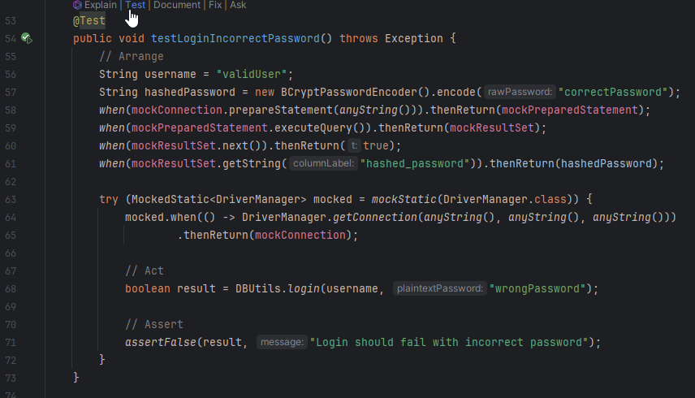
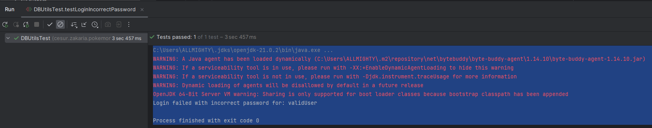
- Output:

Test Case 3: Login with Nonexistent Username
- Description: Verify that the DBUtils.login method denies access when the user provides a username that does not exist in the database.
- Input:
  - username: "nonexistentUser"
  - plaintextPassword: "somePassword"
- Expected Result:
  - The login method returns false because the username is not found in the database.
- Implementation Details:
  - The test mocks the Connection, PreparedStatement, and ResultSet objects to simulate the database behavior.
  - The ResultSet is configured to return false when calling next(), meaning no matching user was found.
  - The static DriverManager.getConnection method is mocked to return the simulated connection.
  - The test verifies that DBUtils.login returns false due to a nonexistent username.
- Code Implementation:
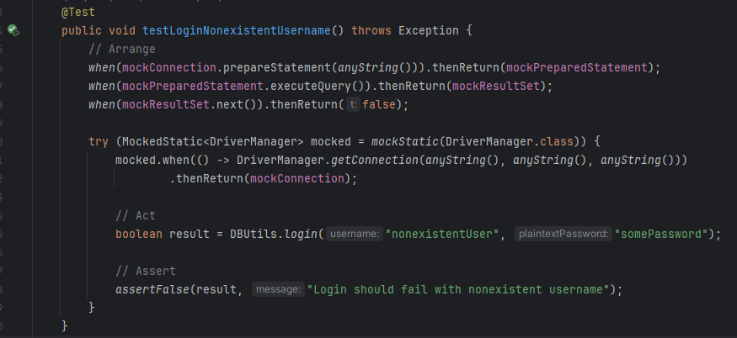
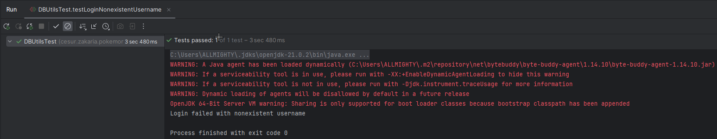
- Output :
Test Case 4: Login with Empty Username
- Description: Verify that the DBUtils.login method denies access when a user tries to log in with an empty username.
- Input:
  - username: ""
  - plaintextPassword: "somePassword"
- Expected Result:
  - The login method returns false because an empty username is considered invalid.
- Implementation Details:
  - The test mocks the Connection, PreparedStatement, and ResultSet objects to simulate the database response.
  - The ResultSet is set up to return false for next(), meaning no matching user was found (as the username is empty).
  - The static DriverManager.getConnection method is mocked to return the simulated database connection.
  - The test asserts that DBUtils.login returns false due to an empty username.
- Code Implementation:
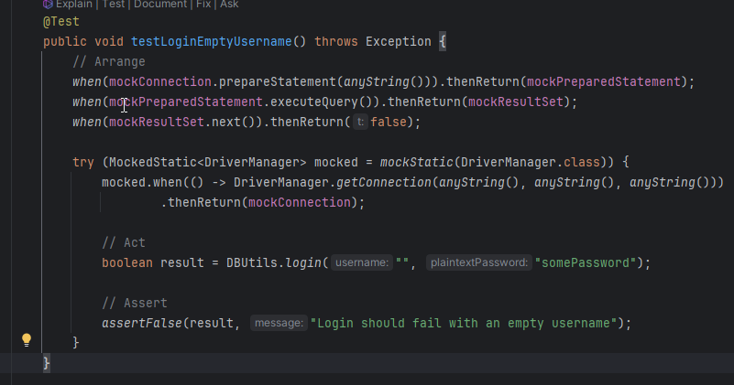
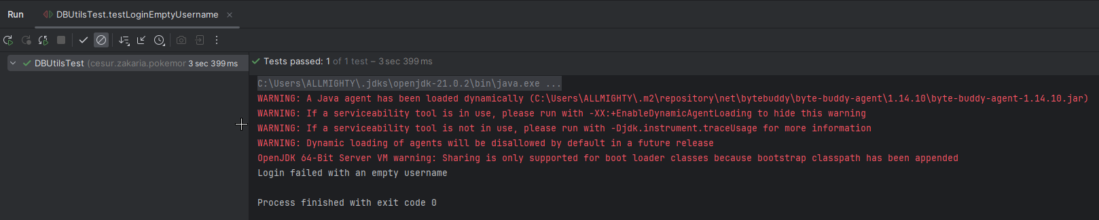
Expected Outcome Screenshot:

Test Case 5: Successful User Registration
- Description: Verify that the DBUtils.registerUser method successfully registers a new user when provided with all required and valid fields.
- Input:
  - username: "newUser"
  - password: "securePassword"
  - firstName: "John"
  - lastName: "Doe"
  - gender: "Male"
- Expected Result:
  - The registerUser method returns true, indicating a successful registration.
- Implementation Details:
  - The test mocks the Connection, PreparedStatement, and ResultSet objects.
  - The ResultSet is set to return false for next(), indicating that the username doesn't already exist.
  - The PreparedStatement is mocked to return 1 for executeUpdate(), meaning the insertion succeeded.
  - The static DriverManager.getConnection method is mocked to return the simulated connection.
  - The test confirms that DBUtils.registerUser returns true for a successful registration.
- Code Implementation:
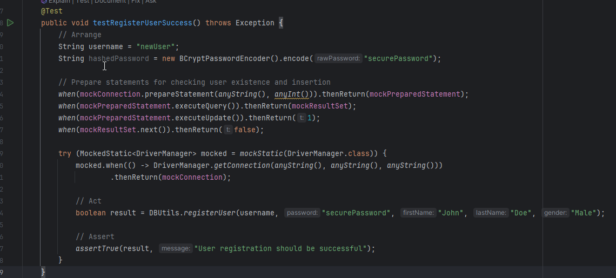

Test Case 6: Registration with Duplicate Username
- Description: Verify that the DBUtils.registerUser method denies registration if the username already exists in the database.
- Input:
  - username: "existingUser"
  - password: "anotherPassword"
  - firstName: "Jane"
  - lastName: "Smith"
  - gender: "Female"
- Expected Result:
  - The registerUser method returns false due to the duplicate username.
- Implementation Details:
  - The test mocks the Connection, PreparedStatement, and ResultSet objects.
  - The ResultSet is set up to return true for next(), indicating that the username already exists.
  - The static DriverManager.getConnection method is mocked to return the simulated database connection.
  - The test asserts that DBUtils.registerUser returns false due to the existing username.
- Code Implementation:
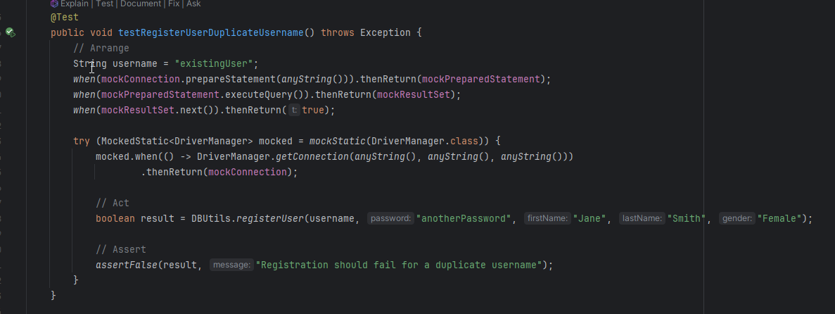

Test Case 7: Registration with Missing Required Fields
- Description: Verify that the DBUtils.registerUser method denies registration when required fields are missing.
- Input:
  - username: "missingFieldsUser"
  - password: ""
  - firstName: ""
  - lastName: "Jones"
  - gender: "Male"
- Expected Result:
  - The registerUser method returns false due to missing required fields.
- Implementation Details:
  - The test directly calls DBUtils.registerUser with incomplete parameters.
  - The result is asserted to be false, indicating registration failure due to missing data.
- Code Implementation:
