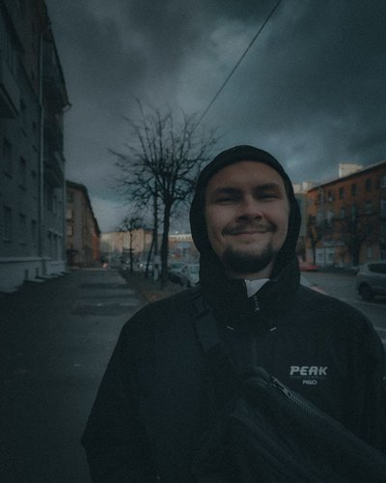 |  | Andrew Karnaushenko  Male, 24 years, born on 15 October 1997  +375 (29) 5863122  allloneneon@gmail.com — preferred means of communication  Reside in: Minsk  Citizenship: Belarus, work permit at: Belarus  Not ready to relocate, ready for business trips
Desired position and salary
Junior python developer
Specializations:
— Programmer, developer

Employment: full time
Work schedule: full day
travel time to work: any
Work experience —2 years
July 2020 — till now  2 years |  | JSC Minsk Automobile Plant  Occupational Safety Engineer  - worked with documentation (knowledge testing protocols, briefings, orders,  state reporting, etc.);  - conducted employee training;  - provided assistance to employees and officials in the field of  labor protection legislation;  - provided control over the state of labor protection, industrial safety and  industrial sanitation in the workplace;  - interacted with the inspectors of state bodies;  - investigated accidents at work.
Education
Higher
2020 |  | Belarusian National Technical University, Minsk  MTF, Mechanical and technological, Metallurgical production and material processing (by directions)
Professional development, courses
2022 |  | BELHARD Academy  European Software Development Center LLC, "Programming in Python"
Electronic certificates
2022 |  | Udemy Django 3 - Full Stack Python website Development
Key skills
Languages |  | Russian — Native  English — A2 — Elementary
Skills |  | Responsibility Python Django Framework Git SQL PostgreSQL OOP Diligence MongoDB Communication Docker English B1 HTML CSS Flask Teamwork Bootstrap
Driving experience
Driver's license category B

Additional information
About me |  | I am looking for a Junior Python developer job.  I want to work in a modern company, with modern views on the organization of work, where I can fully realize myself and develop in the direction necessary for the company and interesting to me without formalism and excessive bureaucracy.  Now I'm learning Python, Django, HTML/CSS, SQL, Flask, Docker, design patterns and OOP on my own.  I speak English at the level of:  A2 - Elementary  He took courses in Python programming at the BELHARD Academy. I also take courses at Udemy, Stepik.  In the future I want to grow up to Senior.  I am learning to program in various languages  Python, JavaScript Basics, as well as HTML and CSS.  GitHub:  https://github.com/AllOneNeon  Certificates:  https://drive.google.com/file/d/1SeBa93hLE_HqzCBX_tsjyODOkI_IONU8/view? usp=sharing  https://drive.google.com/file/d/1Fvy4EzXCGIfplGtBnT258u1mlT_acoCa/view?usp=sharing

