Module 10 Assignment 3

CYBR 410 – Data/Database Security

Jeff Haberman

Database creation screenshot



SQL User creation screenshot



Creating User Table screenshot

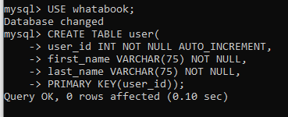

Creating Book Table screenshot

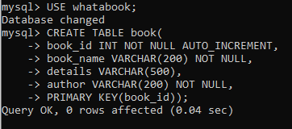

Creating Wishlist Table screenshot

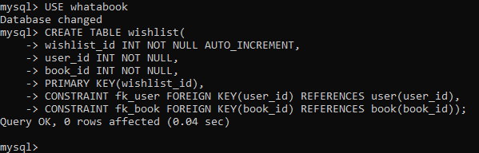

Creating Store Table screenshot

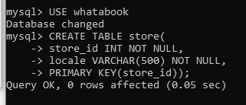

Inserting new store record screenshot



Inserting new books screenshots

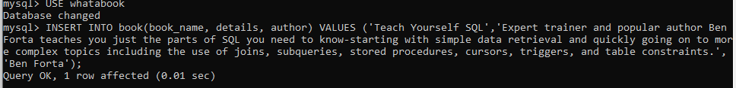

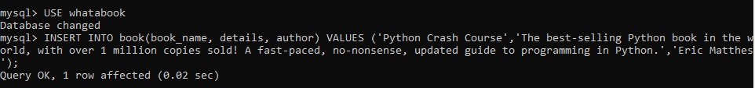

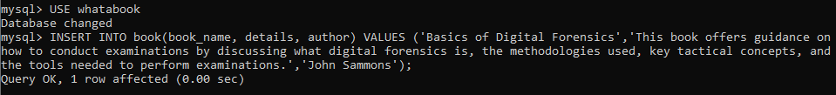





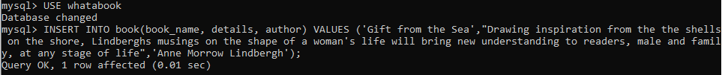



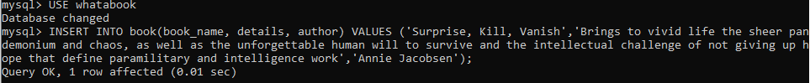

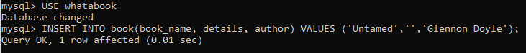

Inserting new users

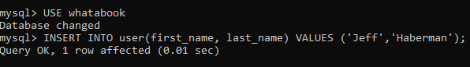

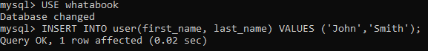

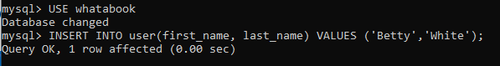

Inserting wish lists screenshots

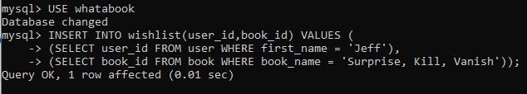

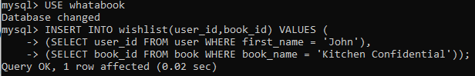

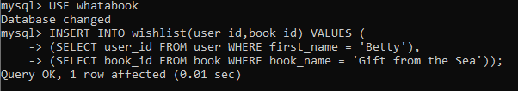

Screenshot of running sql script of all the above commands to create database and add data.

