Module 3 Assignment 2

CYBR 410 – Data/Database Security

Jeff Haberman

Business Rules

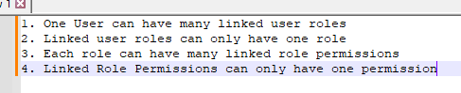

NoSQL Data Structure

