Module 3 Assignment 3

CYBR 410 – Data/Database Security

Jeff Haberman

Business Rules

1. A Publisher can have many Books
2. A Publisher can have only one address
3. A Book can have many authors

ORD

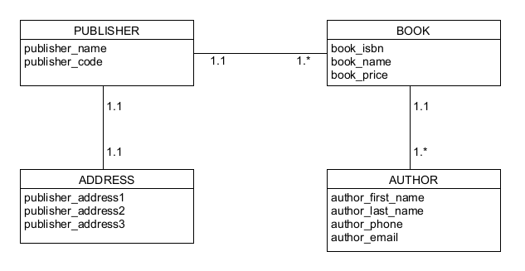

NoSQL Document Diagram

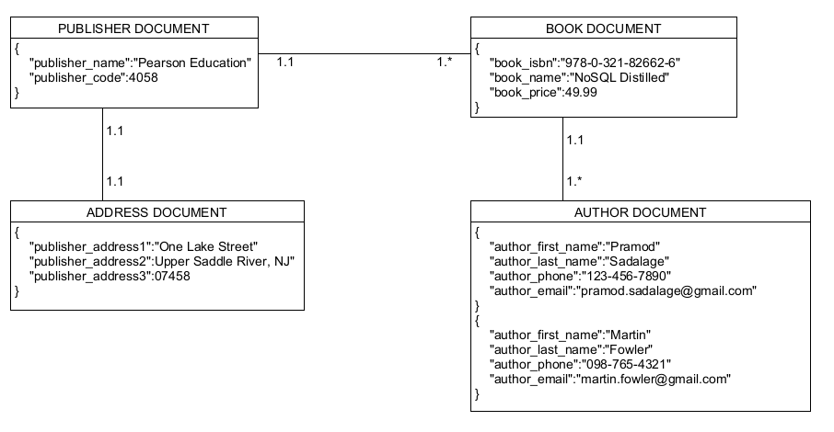

NoSQL Data Structure

