Module 8 Assignment 2

CYBR 410 – Data/Database Security

Jeff Haberman

Script running and show tables command screenshot

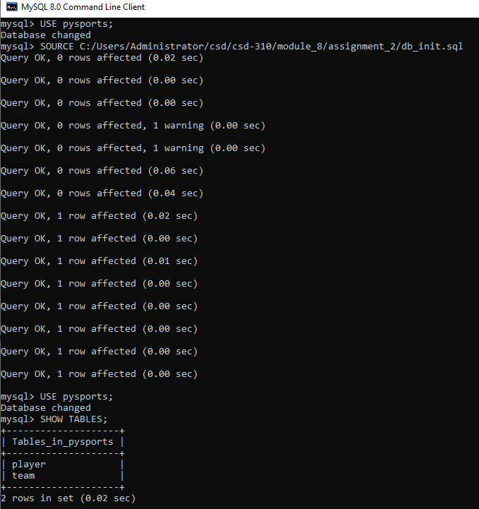

Select statement screenshot

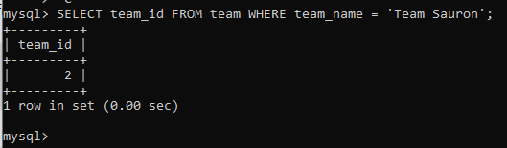

Mysql_test.py script screenshot

