Technical Story Card for:
All WRITE

Revision History
Version No. | Date | Prepared by / Modified by | Significant Changes
 | 8 Jan 2022 | Akash Tiwari
 | 21 Feb 2022 | Akash Tiwari

Glossary
Abbreviation | Description
BSC | Business Story Card
TSC | Technical Story Card
MSG | Message

Table of Contents
1 Introduction 3
2 Scope of Change 3
3 List of impacted modules 3
4 Design and Detailed technical updates 4
4.1 Process model 4
4.1.1 Use case Model 4
4.1.2 Flow Diagram………………………………………………………………………………8
4.1.3 DB Structure……………………………………………………………………………….9

4.2 Technologies/Frameworks used…………………………………………………………………10

4.3 Hardware Requirement……………………………………………………………………………10

Introduction
This document marks the beginning of a unique project. A lot of people like diary writing, so with this project we are trying to take that experience to a digital realm.

Finding a person to tell everything going on in your mind is practically a very tough task. What a lot of people do is, they maintain a diary and write all their thought in it. People have been doing this for centuries now. The diary becomes a person for them whom they tell everything without any filters.

This initiative is trying to get the essence of diary entry in a digitalized format. It will address most of the problems with the conventional method. It will provide the user a digit platform to write their diary entries.

Scope of Change
There is scope for changes. Changes will be entertained and whatever specifications mentioned in this document are not final.

List of impacted modules
Everything will begin from scratch.

Design and Detailed technical updates

Process model

Use case Model


User Registration

User Login
User

New entry

View entries

All entries

Profile

Basic Description | User Registration
Basic flow | This use case describes how a user registers into the system.  - The user has to register himself into the system.  - After successful registration he can go to the login page.  - User will need the following for registration.  - Name  - Email  - Phone number  - Password  - gender  - about
Alternate flow | Provided information will be validated and if any invalid data is found then an error message will be displayed.
Validation | - Username should be min 5 letters, max 15 letters.  - Password should contain min 8 and maximum 12 characters.  - Email should be valid.  - About should be within 40 words.
Pre-condition | User should have network access and Browser with latest updates.
Post-condition | User should be redirected to the login page.

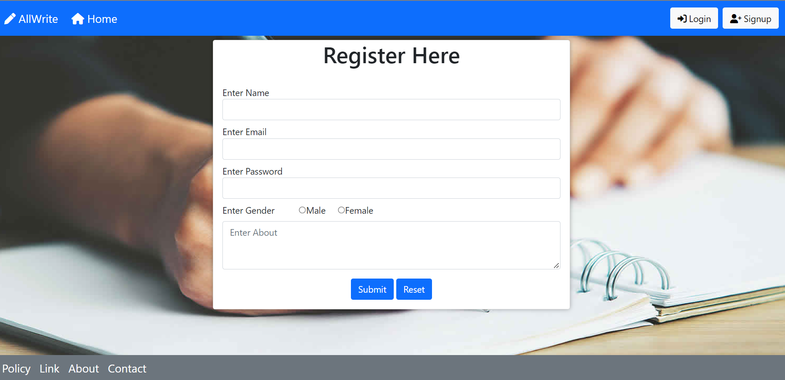

Basic description | User login
Basic flow | This use case describes how a user login in to the system.  - User have to register himself and then login in to the system.  - After login user will be taken to the appropriate landing page.  - For login user needs:  - Username  - Password
Alternate flow | The credentials will be validated and if found invalid credentials, a message showing “invalid username or password” will be displayed.
Validation | - Valid username  - Valid password
Pre-condition | User should already be registered.
Post-condition | Appropriate landing page has to be displayed.

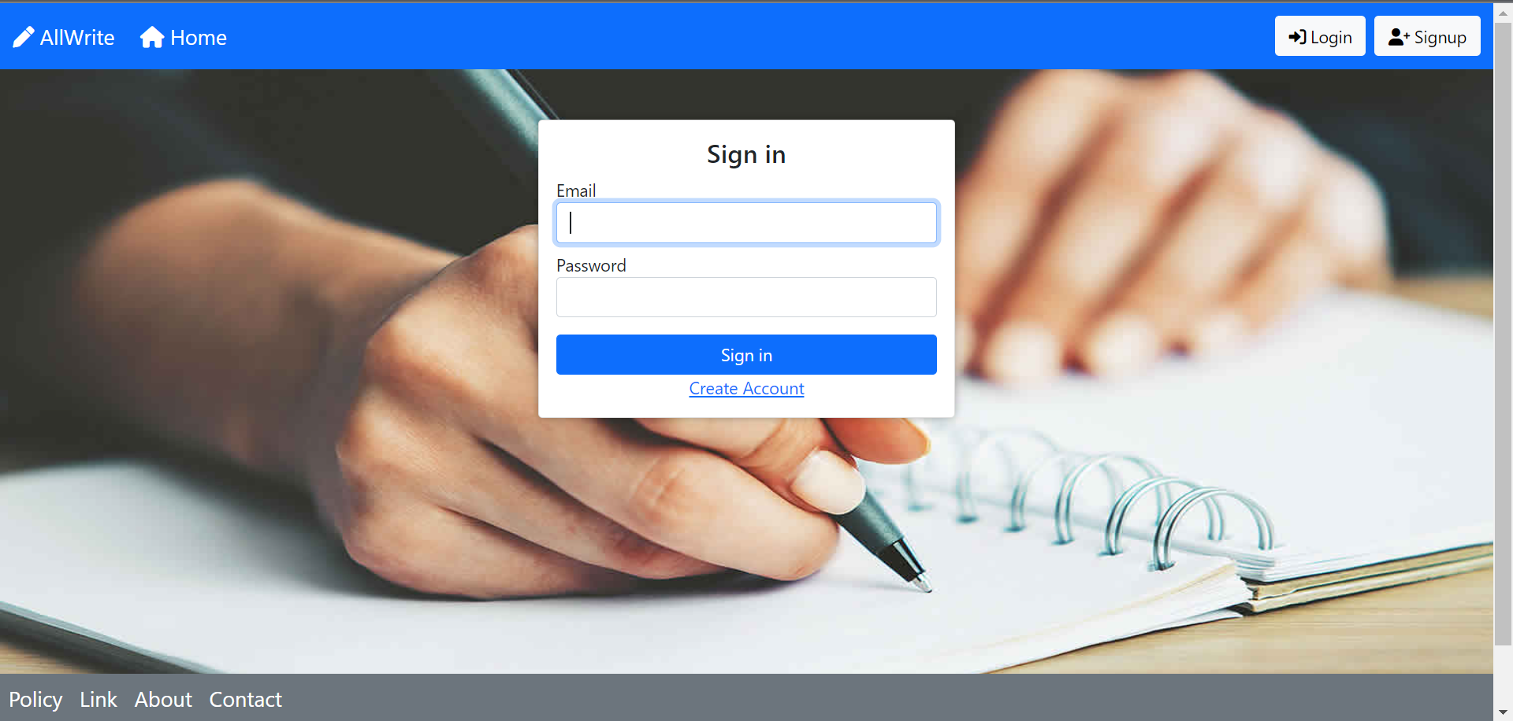

Basic description | New entry
Basic flow | This use case describes how a user writes a new entry.  - User have to log into the system.  - Write his entry, and then post it.
Validation | 4000 character are allowed.
Pre-condition | User should be logged into the system.
Post-condition | A message showing “new entry added” will be displayed.

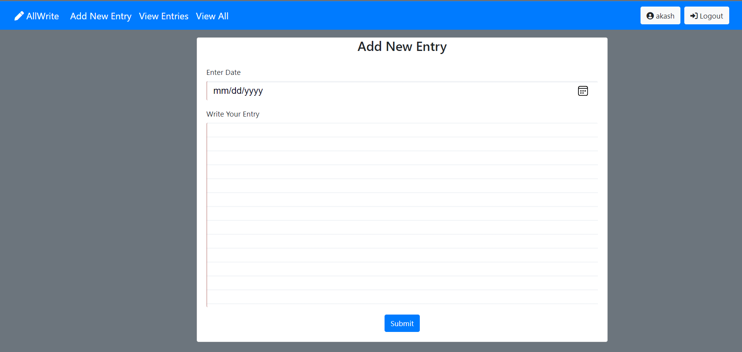

Basic description | View Entries
Basic flow | This use case describes how a user views his entries.  - User should be logged into the system.  - Users can view all the entries he has written.  - They can edit and delete their entries.
Alternate flow | Not applicable.
Validation | Not applicable.
Pre-condition | User should be logged into the system.
Post-condition | Not applicable.

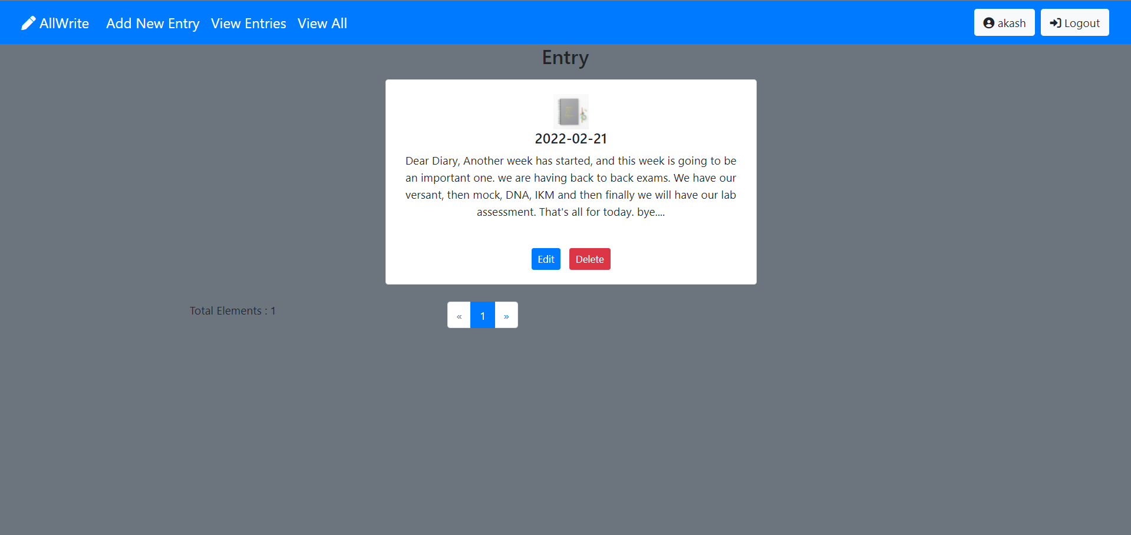

Basic description | Profile
Basic flow | This use case describes how a user views his profile.  - User should be logged into the system.  - User can view his profile.  - He can edit his/her all details except the email id.
Alternate flow | Not applicable.
Validation | Not applicable.
Pre-condition | User should be logged into the system.
Post-condition | Not applicable.
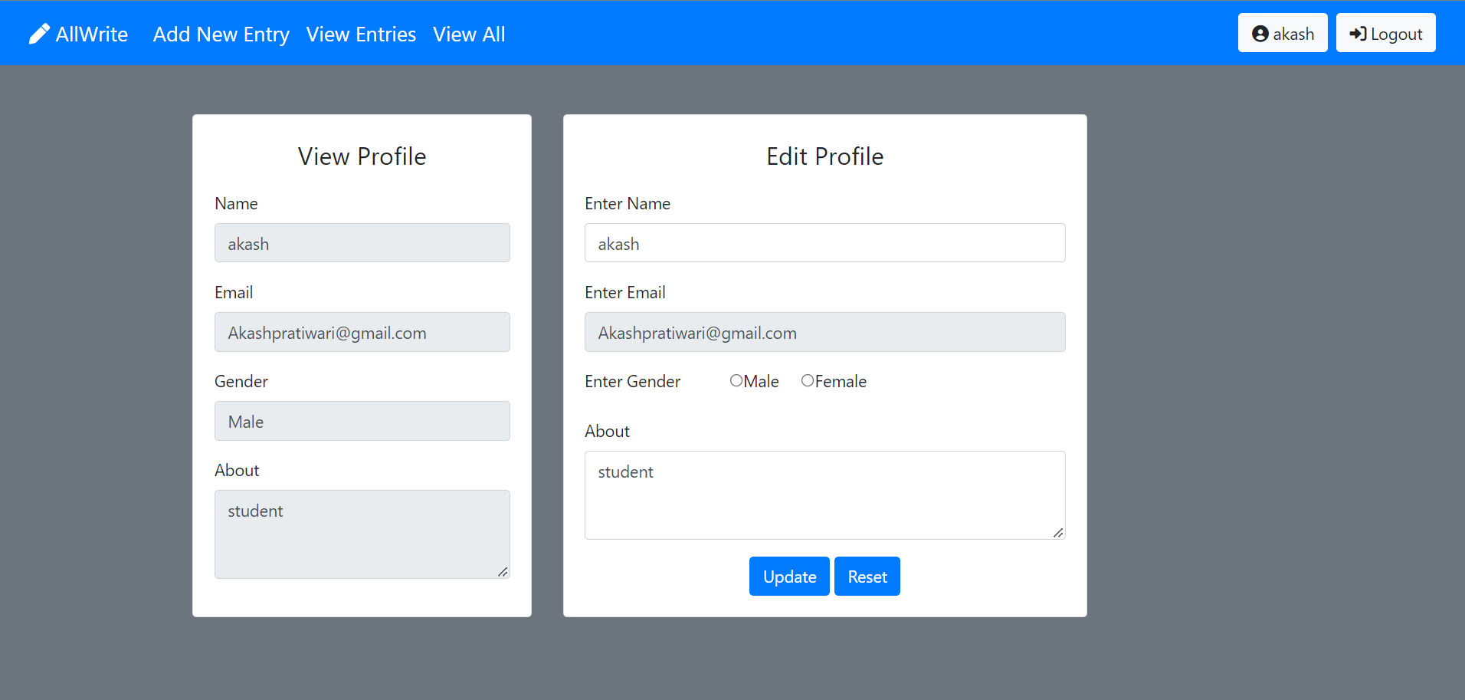

DB
User
UI
Middleware

USER REGISTRATION

INVALID DATA

ERROR
ERROR
MESSAGE

VALID DATA

SUCCESS

SUCCESS MSG

USER LOGIN

INVALID DATA

ERROR
ERROR MSG
VALID DATA

SUCCESS

SUCCESS
MESSAGE

NEW ENTRY

DATA

SUCCESS

SUCCESS
MSG

4.1.2 DB Structure
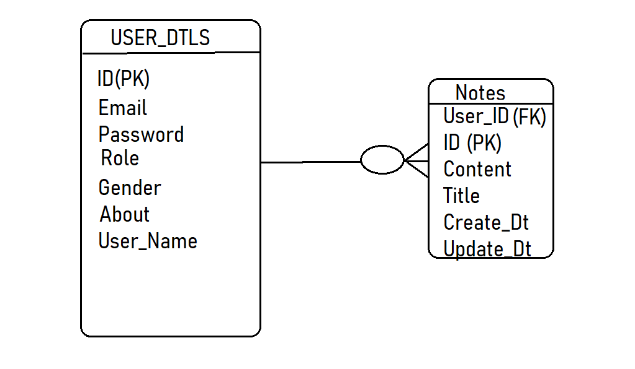
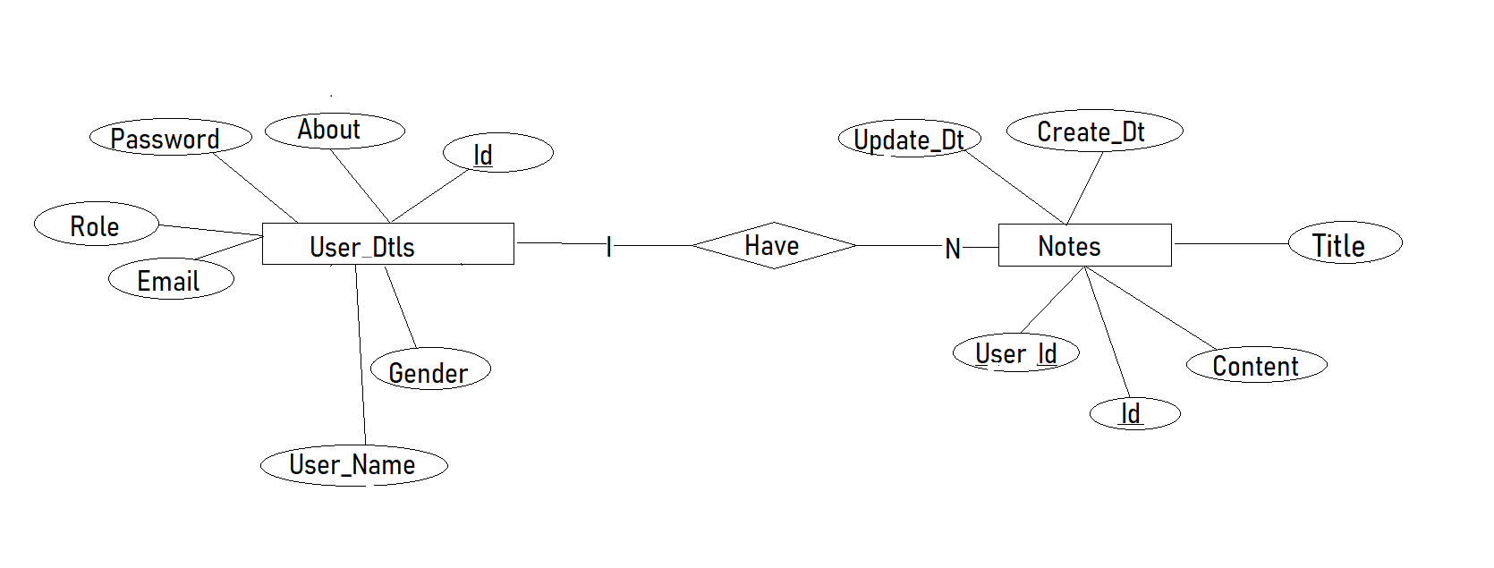

4.2 Technologies/Frameworks used:
Technologies used | HTML/ CSS/ JavaScript/ Bootstrap/Angular
Technologies used | Java 1.8/ Spring Boot and its various modules.
Technologies used | Hibernate ORM

Hardware Requirements:
Hardware Requirements | Pentium IV or higher  256 MB RAM  1 Gb hard free drive space

