School Centre Celje,
Middle School for chemistry, electrical engineering and computer science


BLOCKBENCH

Enej Vodušek, R3B

Subjects: SMV, STE
Professors: Boštjan Resinovič, Klavdija Jereb Špur
7. 1. 2023
Abstract
Blockbench is a free, open source software used for creating low-poly 3D models. We can download it from their official website. We are able to create models for different purposes, meaning that models can also be built differently, either out of cubes or meshes, regarding of the complexity of the model itself. Simple models consist of cubes only, while complex models are made out of meshes. Blockbench also has many built in tools for us to add changes and decorate our models, such as the Painter and Animation tool. With the Animation tool, we can create simple animations for our models. Meshes allow us to create more complex models, as they are more flexible and can have more functions done on them. Blockbench also allows us to export our models into different files and games, like Minecraft, or even to a website called Sketchfab, where other people can see and rate our work.

Keywords: Blockbench, simple modelling, complex modelling, pivot point, textures, cubes, meshes.

Introduction 3
Blockbench 3
How to install 3
How to use 4
Modelling 6
Cubes 7
Grouping 8
Adding Textures 9
Painter 10
Animation 11
How to animate 11
Complex Modelling 12
Meshes 13
Advanced Editing 13
Exporting of files and their use 13
Exporting and uploading 14
Minecraft Entity Wizard 15
Conclusion 16
Sources 17
Glossary 18

Introduction
Blockbench is a free, open-source 3D modelling software, used for simple and low-poly 3D modelling and can also be used for pixel art background images. We can also create simple animation as well as the complex ones with it. However, besides being primarily created for low-poly modelling, many have started using it to create absurd high-quality models with it. It is very often used with Minecraft and has many features regarding it, meaning we are able to model, retexture and import our models into it. Several of nowadays organizations use Blockbench software as their primary modelling software for their video games. It is easy to use, therefore anyone can use it with a bit of practice.

Blockbench
What exactly is Blockbench? Blockbench is an open-source 3D model editor and animation program. Starting in the year 2017 as an editor for simple low-poly models, it has become used by huge corporations implementing such models into their games. Because it started in 2017, it is among the newer softwares on the Internet. And the best part, it is absolutely free for anyone.
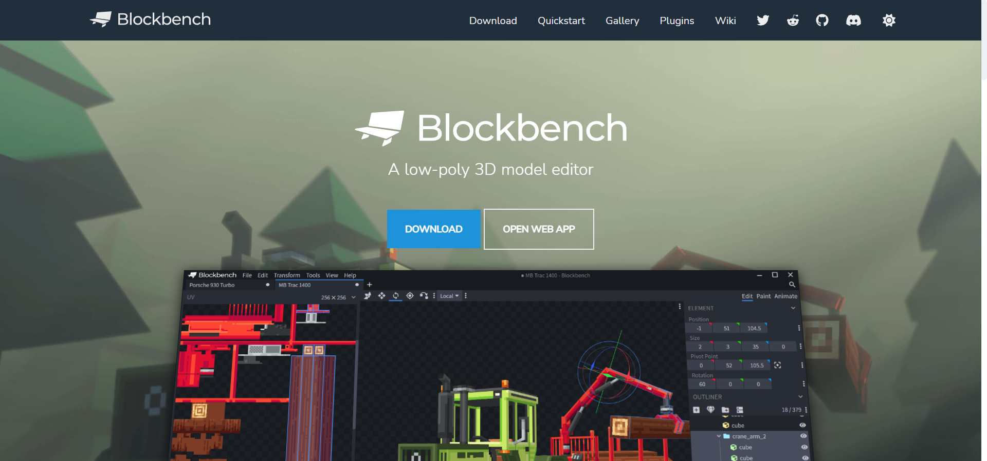
Figure 1: Blockbench's Home Page

How to install
Now, how to install it? It is rather simple, as it is an open-source program. We simply open a browser and go to the Blockbench’s website where we can choose the appropriate version of the program for our device, Windows or Linux for example. When we successfully download it, we follow the so called “installation wizard”, which is an interface, made for users to follow, like a digital manual on how to install a program.

How to use
Blockbench has a highly user-friendly interface, which makes using it easier and more fun. The main menu of Blockbench does not have many functions which is good as well, as the less experienced people can use it without much trouble, all they need to do is to watch a tutorial video or explore the program themselves, which is what most people do. Blockbench, despite having very little functions, still has many if we go and count them. The toolbar in the home page doesn’t have many options at first glance. There, you can change the look of the home page and the program and adjust it to your liking, but that is not necessary as our main point of using Blockbench after all is a 3D model we can create. We can however, upload different plugins to ease our importing or creating files for different games such as Minecraft.
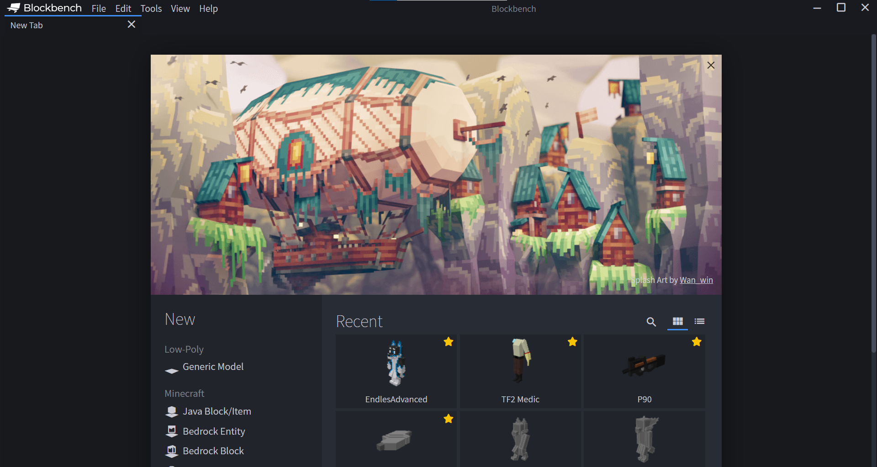
Figure 2: Blockbench
If we scroll down, we will see we have a display, containing our previous models, which we can favourite and continue modelling, and seven possible options to start with a 3D model. Six of them are classified under Minecraft, the other one is under Low-Poly. The only difference between these seven options is the preset when we open and launch the model option, for example, if we choose Generic Model, we will get a blank area with full control over the model, on the other hand, if we choose Minecraft Skin, we will get a full Minecraft skin with all 6 of its separate parts already there, but there will be some limitations. Let us open the Generic Model option and begin to study the functions we will be presented. We can also open a new model through the toolbar, but this way it is quicker and more clear. For example, when we click on the option, it will display a few targets, a simple tip and a tutorial link for the chosen option. To begin, simply click Create New Model button.
We are greeted by a pop-up window in the middle of our screen with Blockbench editor behind it. The window is asking us to fill out some important forms, such as the name the project will save as (it always saves as CustomName.bbmodel, a completely unique save file), its UV mode and texture size, which can both be changed later numerous times when modelling. You can also add a model identifier, but they are not necessary, as it is just a short description which distinguishes two models with the same name. We can also cancel this and do all of this later if we do not want to do it at the beginning.
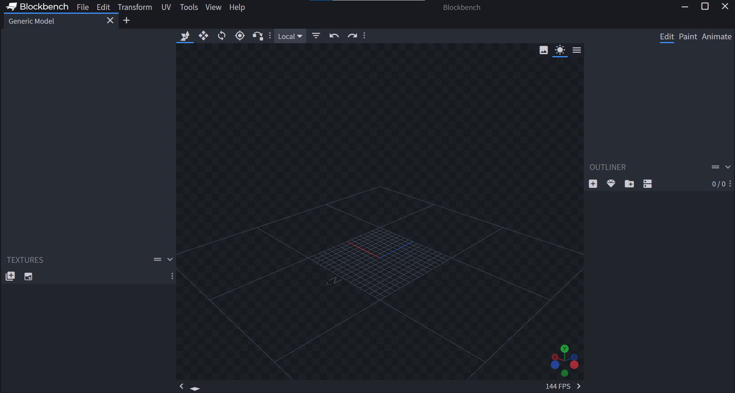
Figure 3: Blockbench Editor's overview
After we are finished with this, the modelling area appears with some of the functions on the side and on top. The camera, our point of view, can be changed by simply dragging the cursor while holding down left mouse button on the moddeling screen. We can also change our point of view by clicking on certain arrows in the bottom right corner, where we have our current orientation shown.
On the right side, we have only four options. These are Add Cube, Add Mesh, Add Group and Toggle More Options. As their names suggest, they create a cube, a mesh, which is a more complex shape than a cube, or a group to store meshes and cubes inside for easier orientation and model configuration.
On the left side, we have texture buttons, one being Import Texture and the other being Create texture. Importing the textures allows us to add our own texture files from outside Blockbench itself. It allows any texture file that is a normal image file, such as .png, .jpg and .jpeg. Creating our own texture makes a file within the program itself which we can then add on the model.
With the toolbar on the top we can select the classic tools that are needed for our modelling, such as Move tool, Resize tool, Rotation tool and Pivot tool. The set would not be complete without two crucial buttons, so that is why Redo and Undo buttons are not missing in the toolbar either. When we have a mesh selected instead of a cube, more tools show up in the toolbar, but more of those special tools later.

Modelling
And now we know the program’s basics. Which also means we should know how to use its primary functions. Before we can begin, we need to know that there are two types of models: simple and complex. Simple models, as the name suggests, are made of simple polygons such as cubes and plain textures in this case. On the other hand, complex models are made of polygons called meshes. These meshes come in many shapes, such as a triangle or cylinder in Blockbench. But let us, as beginners, stay focused on simple models made of cubes.
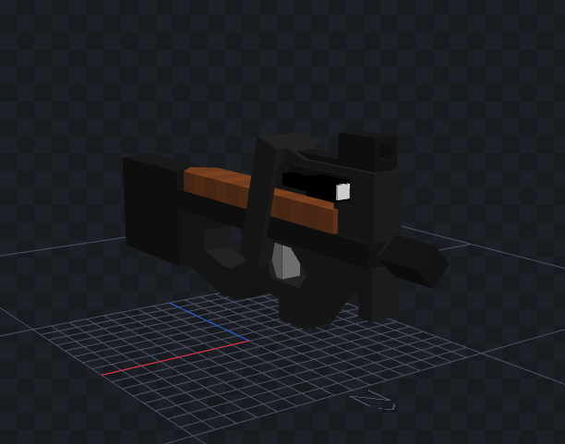
Figure 4: Simple model (FN P90)

Cubes
But what exactly are cubes? Cubes are actually a square or rectangle shaped 3D object in an open space. We can spawn a cube by clicking on the Add Cube button on the right side of the editor. That will spawn a single 2x2x2 cube in the middle of the open space. We can see that some things have changed on the right side. It added a new cube below all the “Add” buttons. We can also notice changes above the buttons, a completely new display of different settings. Four different elements, also known as Position, Size, Rotation and Pivot Point. Each of them has three numbers with them. These three numbers represent coordinates x, y and z. To understand these elements a bit better, we should take a look at each of them more closely.
The Position element displays the position of a cube or a mesh in this threedimensional space. The plate below the spawned cubes is a simple coordinate system with four quadrants which work exactly the same as a normal twodimensional coordinate system with an addition of a third coordinate displaying threedimensionality. The plate is positioned in x0, y0 and z0 which means it is in the center of the open space.
The Size elements actually consists of four numbers instead of three. The first three are the coordinate system representing the size in different ways (x, y and z) and the last one is inflation. That means by how many Blockbench sizes will we inflate the selected cube. Inflation is usually in decimal numbers, because if we set it to a full number, we are best off if we just make the cube bigger with the first three numbers instead of inflating it. Inflating cubes does not resize texture applied to it, they stay the same, which is an another plus if we just use size coordinates for full number cubes. It is recommended to keep sizes in full numbers to avoid any kind of potential problems later. This is also the only element we should keep in positive numbers instead of negative, as it might displace textures being displayed on a cube.
Pivot Point is actually, if we sum it up, the point where a cube is rotated from. These points are usually in decimal numbers as well as in full: depends on which position the point is. However, most pivot points will be a full number and a two digit decimal number (it can be a greater decimal number too, even up to seven digits). The small button next to the coordinates is called Center Pivot. This button centers the pivot point of the selected cube in the exact middle of it. It can be sometimes useful, but it is better to set the pivot point manually.

And lastly, the Rotation element does precisely what it is named. It allows us to rotate a selected cube in three directions. This element automatically adds 2,5 degrees when increased unlike all other ones which increase or decrease by one only.
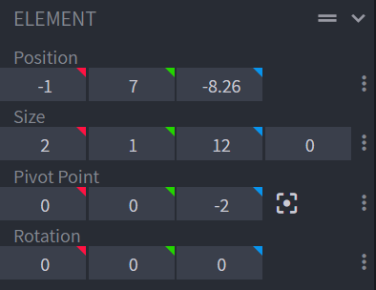
Figure 5: Example of all four elements

Grouping
Grouping is extremely useful when working with more complex models. Even if we are not, grouping is still useful as it allows us to store and put cubes and meshes in a custom order. Groups are displayed in the right toolbar as folder images. We can change their names into whatever we want and it even allows empty spaces between letters and words (it is recommended to use normal characters and not signs though). When we spawn a cube or a mesh, it automatically appears inside the right taskbar. Thankfully, Blockbench allows us to simply drag them and drop them inside groups. Clicking on a group will select every single cube or mesh that is stored inside it. If we select a group, we show the hidden pivot point, which also means we can rotate groups. Every group has a separate pivot point and it affects all of the cubes or meshes inside it, treating them as one object. The pivot points of cubes and meshes remain unaffected if we rotate the group or change the group’s pivot point.
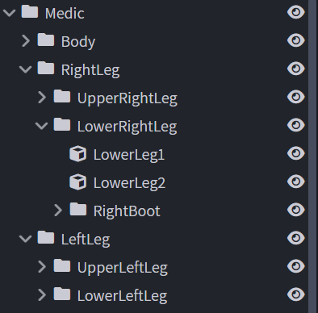
Figure 6: Example of grouping cubes and groups
As any other normal program, Blockbench also has functions hidden in the right click button. For example, if we right click on a cube, we notice it has many different functions. The always needed copy and paste, duplication, grouping, texture adding, UV mode selection and converting to meshes. The one that should come in handy is the Duplicate option, because it copies the selected cube, pastes it in the exact same spot as original and if we have previously numbered the cube, it will increase that number by one.

Adding Textures
A model without textures is absolutely nothing. It cannot exist. Blockbench detects if we have a texture applied to a cube or a mesh and if we do not it generates its own texture preset and applies it on an object. The most appropriate way of adding a texture is not via the built in painter, but through a toolbar on the left. There we can import a texture from any image file on our device, create a texture for the built in painter or change the postion of a texture on our device. The best function in texturing is real-time texture updating. If we update a texture in an outside software, let us say, Paint.net, all we need to do is save it and the texture will automatically be updated in Blockbench. Textures can be any size, but the most optimal size for a texture image is sixty-four times sixty-four pixels. It does not matter how many textures we have associated with the model. An another advantage is that textures can be semi-transparent or fully transparent.
To add textures on an object, we have to right click it and select Texture and apply one of the textures we have previously imported into the editor. But there we come to a small hiccup. The textures do not fit on all sides properly. We have to take a look in the left toolbar once again. We are able to see the texture we used on the object and six selected rectangles in it. Those six rectangles are the object’s sides and those are Up, Down, West, East, South and North. We can move each of these individually anyhwere across the texture display to set up object textures manually. This process can be quite time-consuming, more than the actual modelling itself.
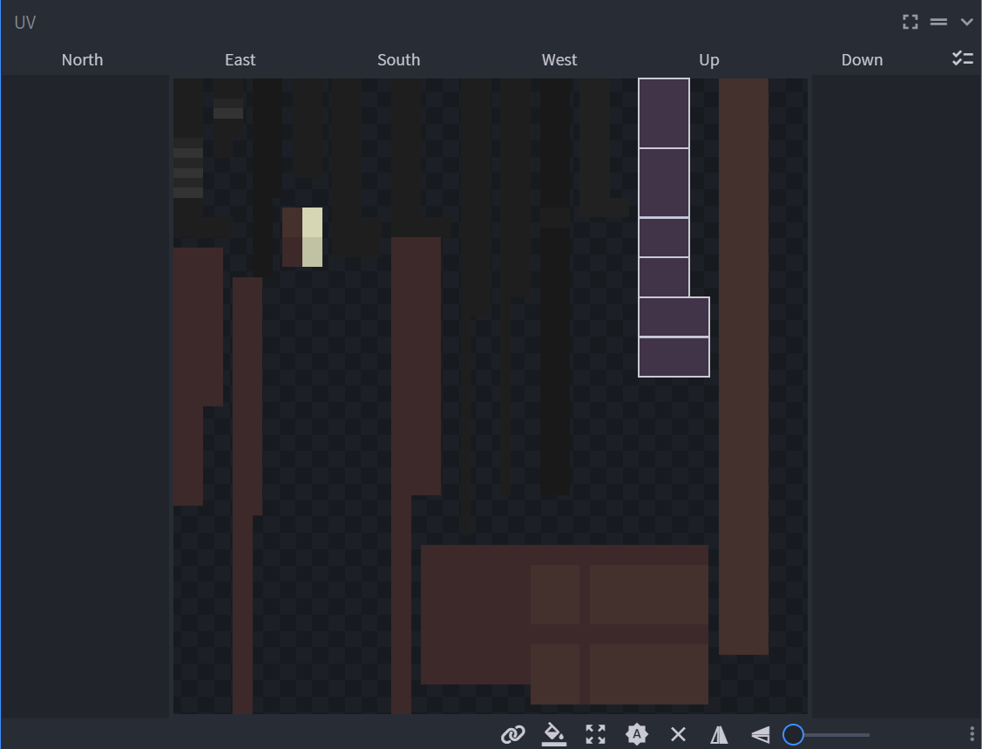
Figure 7: Example of a texture with an object's texture highlited

Painter
However, as I mentioned before, there is a built-in painter tool which we can use to paint texture right inside Blockbench without outside source. In the top right corner of the editor, there is a Paint button in the toolbar above the right sided toolbar. If we click on it, a whole new interface opens. Instead of elements for objects, we now have a simple painter in its place. A whole bunch of different tools also appears in the top toolbar, helping us with painting textures directly onto the model and not inside the texture file. The paint tool also allows us to make our own colour palletes for later use.
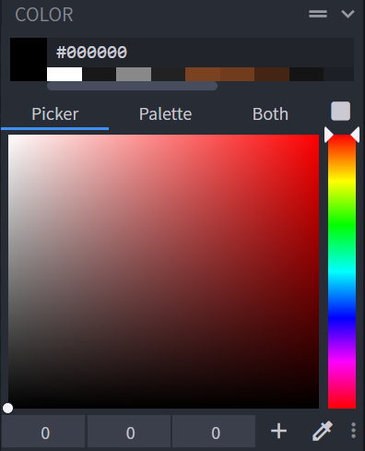
Figure 8: Built-in painter tool

Animation
Next to the painter tool, there lies an Animation tool. This tool opens a whole new display of settings and a completely different look. We still have the model, but all of the previous toolbars are gone and have been replaced by new ones. The left toolbar now shows Animations and Variables. The right toolbar might seem to have stayed the same, however, it does not display cubes, but only groups. This is why groups are much needed as well, as they make animating easier. There is also a fourth toolbar now, below the model display. It shows seconds and animation parameters inside it as dots we can move to our liking to create an animation.

How to animate
Blockbench does not have a complex animation tool. It does not allow us to have extremely complex animations however, we can still create fun and smooth animations regardless. To begin animating, we must add an animation with the button in the top left corner. We must set a name, loop mode (play once or infinite loop), animation time update, start delay and some more. We do not actually have to set any of these other than the name and loop mode as they are the only one required for an animation to work. We can have several animations at once to ease our detailing on certain animations.
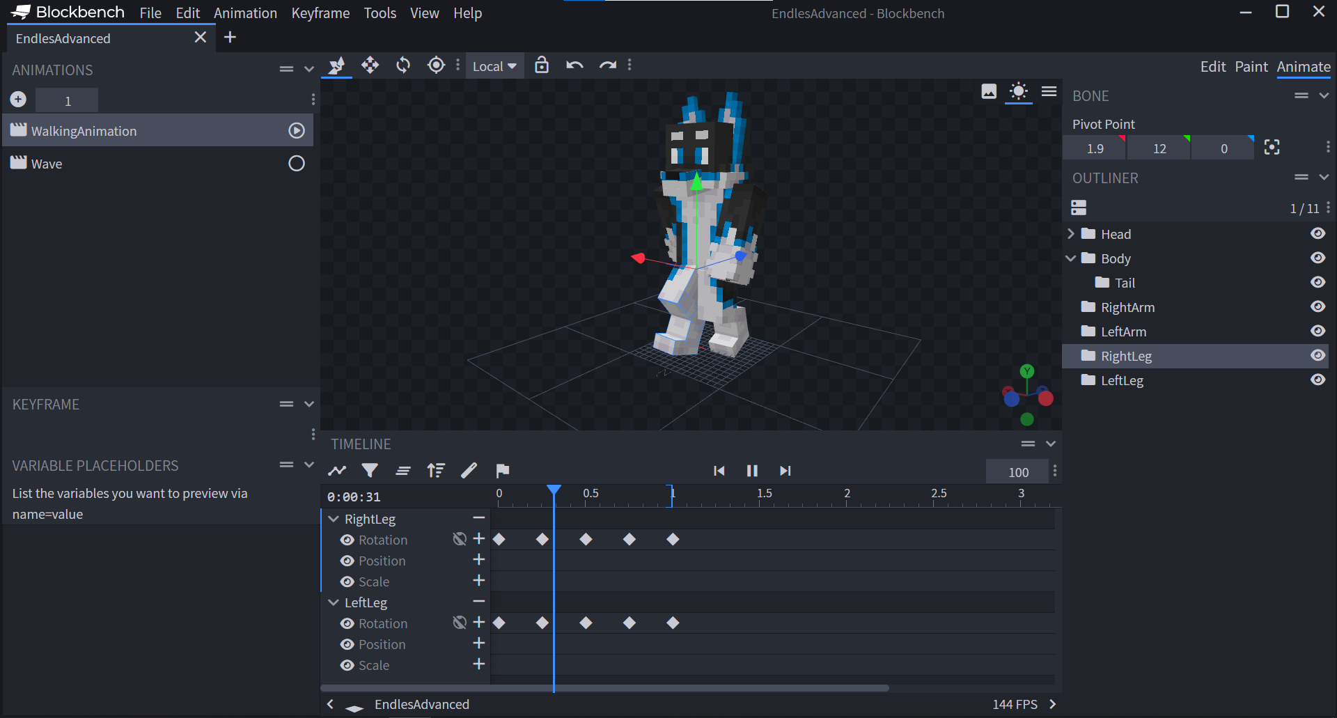
Figure 9: Animation tool with a created animation
To add an animation parameter, we simply click on a group, or the model part and it will add it in the animation toolbar and display it as a blue square. In the toolbar, we can then animate the selected group by changing its rotation, position, and its scale. The animations will automatically detect each other and will fill in spaces between animations with its own ones in order to make the animation smoother. This means we do not have to make it frame by frame like stop motion, but we can simply set at what time should the selected group move to a certain destination.

Complex Modelling
Complex modelling is a model that use more complex objects, also known as Meshes. These kind of objects are of different shapes, such as Pyramids, Cylinders, Cones, Cubes, Planes, Tubes (empty cylinders), Toruses (empty tube circles), Circles and Spheres. The animation and texture does not affect how complex the model itself is.
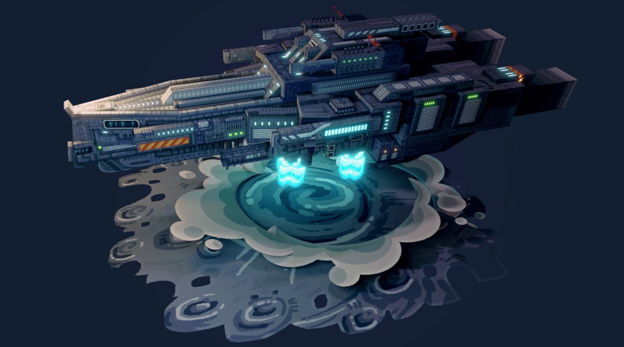
Picture provided from: https://sketchfab.com/3d-models/the-wayfarer-8dca282cc3f3439eadb8ea2712d5871e
Figure 10: Complex model (Wayfarer by Ycar, 2021 Sketchfab contest winner)

Meshes
Regardless their shape, meshes still work the same as cubes. We can rotate them, set their pivot points, move them and resize them however, resizing might affect them in unusual ways if we do it improperly. Meshes are mostly made out of triangular and rectangular shapes, which makes them better for making models look real, but not their texturing, as their textures still remain pixels and not triangles so we must be careful when texturing. We can also notice in the texture applier that the object’s sides are what they are. In order to get a triangle, we select a cylinder and make it have only one side and that will spawn a triangle. Since that breaks something within Blockbench, we cannot resize it normally, so we just have to make a new one if we want a bigger or a smaller triangle.

Advanced Editing
Advanced editing only works with meshes. When we select a mesh, more options appear in the top toolbar. Now we can choose how to select the chosen mesh: whole mesh or just one side. If we have only certain sides selected, we can right click and more options will be displayed. To make a separate mesh, we use Split Mesh, which creates a brand new mesh with a name chosenmesh_selection. Merge Vertices just merges all of the selected verticles in one point, Invert Face flips the selected textures on the inside, Loop Cut cuts the selection at one point, Dissolve Edges just deletes the bordering edges and connects the remaining to most nearby ones, Extrude Selection bumps out the selection, but it is still connected to the original mesh and lastly, the Inset Selection is the second most useful option right after Split Mesh.
Inset Selection option decreases the size of the selection, but it still says on a surface of the original mesh. This allows us to lower the selection inside the actual mesh so we can create more depth in a model easily. Although it is best if we use only one sided selections, preferably on a plane. Advanced editing usually takes a lot more time than normal editing with cubes.

Exporting of files and their use
Exporting files is very easy, but we must be careful in what file we export our model. There are four different files we can export our model to. Those can be .gltf or .obj for rendering our model, .fbx to use it in 3D applications and game engines and .dae to use it in applications. There is also an option to share the model with a short link or to upload it to a model viewing and selling website known as Sketchfab.

Exporting and uploading
To export our model, we click on the File button in the taskbar at the top of our screen. We go all the way down and select one of the previously mentioned file types. We then simply save it somehwere on our device. However, if we choose to upload a model to Sketchfab, we again get a bunch of forms we have to fill out before we can proceed. But before we can actually upload it to Sketchfab, we must have a Sketchfab account in the first place. Those accounts are free and we are allowed to upload ten models per month.
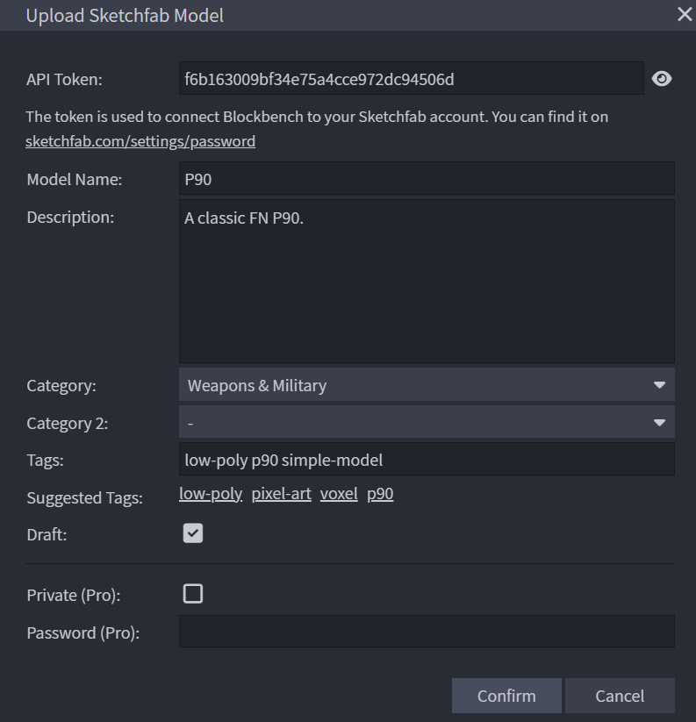
Figure 11: Uploading a model to Sketchfab via Blockbench
The first setting in line is the API Token. This is a randomly generated, thirty-two characters long identifier used by both Sketchfab and Blockbench to connect a model between these two. We should not change the token and leave it as it is. Next we have the classic, a name this model we are trying to upload will be shown as and its description. Below we have categories. If our model belongs in a category, such as music or architecure, we can select those two options there. We can also leave it blank, but our model will not be as discoverable by users. We can also add tags to make our model more discoverable. Tags should be lowercase and must not have empty spaces between them as those represent a line between a new tag. Ticking the animation box will upload our animations with the model as well. If we tick the Draft box, our model will not get uploaded immediately and we will have to set a few more settings on Sketchfab before we are able to finalize it.

Minecraft Entity Wizard
Blockbench has many pugins connected with Minecraft, but Minecraft Entity Wizard was the first one. This plugin, made by Mojang itself, allows us to directly import entities, blocks and items into Minecraft Bedrock Edition straight out of Blockbench. They even have a webpage made specifically for this plugin. Mojang, now under Microsoft, began using Blockbench in year 2019 and has been using it as their primary entity, block and item editor and modeller since their 1.17 update. Due to large popularity, Mojang distributed some more plugins later on. However, some of the Minecraft plugins were made by completely different individuals.

Conclusion
I began using Blockbench because I wanted to make my own entity for Minecraft. I found out it is very easy to learn it as I learned its basics in under ten minutes and did not even need a tutorial for it. It takes very little time to figure out how all of the fucntions work. I myself have not yet used meshes in my models, but I know how to use them, but none of my models needed meshes yet. I prefer not to use the built in painter, because I got used to creating textures in Paint.net, which is primarily used for pixel art. I really suggest you use Blockbench and not any other editor if you are making a low-poly model because it is way easier than anywhere else.

Sources
ArtsByKev. (2021, Maj 15). Here is how to Animate a Human Walk Cycle in Blockbench in under 10 minutes. Retrieved 11 20, 2022, from Youtube: https://www.youtube.com/watch?v=y0ees2j17AY
Blockbench. (2017 - Present, November - Present 30 - Present). Quickstart - Blockbench. Retrieved 11 20, 2022, from Blockbench: https://www.blockbench.net/quickstart
mammerla, v-josjones, & quinnelton. (2022, October 25). Getting Started with the Minecraft Entity Wizard. Retrieved 11 20, 2022, from Minecraft: Bedrock Documentation Homepage: https://learn.microsoft.com/en-us/minecraft/creator/documents/minecraftentitywizard
Muck, T., & Križanovskij, I. (2015). 3D-TISK. Ljubljana, Ljubljana, Slovenija: Pasadena. Retrieved 11 20, 2022
Stagnitta, M. (2019, November 9). Introduction to Minecraft Entity Wizard in Blockbench. Retrieved 11 20, 2022, from Minecraft.net: https://www.minecraft.net/en-us/creator/article/introduction-minecraft-entity-wizard-blockbench

Glossary
- Animation - the manipulation of electronic images by means of a computer in order to create moving images.
- Exporting - transfer (data) in a format that can be used by other programs.
- Importing - transfer (data) into a file or document.
- Mesh - a representation of a given shape or form, consisting of an arrangement of a finite set of geometric components.
- Pivot - the central point, pin, or shaft on which a mechanism turns or oscillates.

