

**COMPANY PROFILE**



**APROTEKSecureZone**A. S. was constituted in 2003 in order to provide highest technological solutions and services in the field of Fire Fighting, Security Systems and Electric sector for privately owned or

governmental leading institutions in India.

! control of all of its installed systems located allover India, trusting its technical staff that consists of

highly expertised engineers and technicians in advanced security technologies and telecommunication systems.

 field of Fire Fighting, Security Systems, Networking and Electrical in relevance with project design and implementation services; and it provides solutions through applying the latest technological events.



**ABOUT US**



•**Consultancy and project preparation services,**

•**Engineering services,**

•**Distribution and Representation services,**

•**System & product procurement, and installation services,**

•**After sales services: Technical support and maintenance,**

# Complete Electrical Works - LT

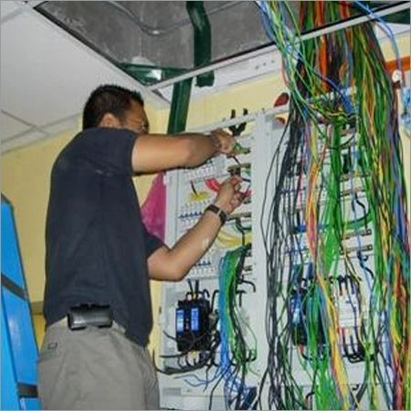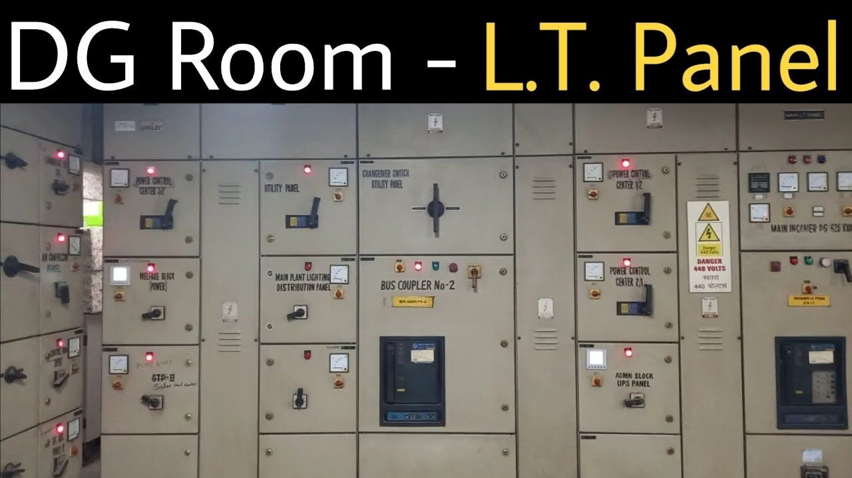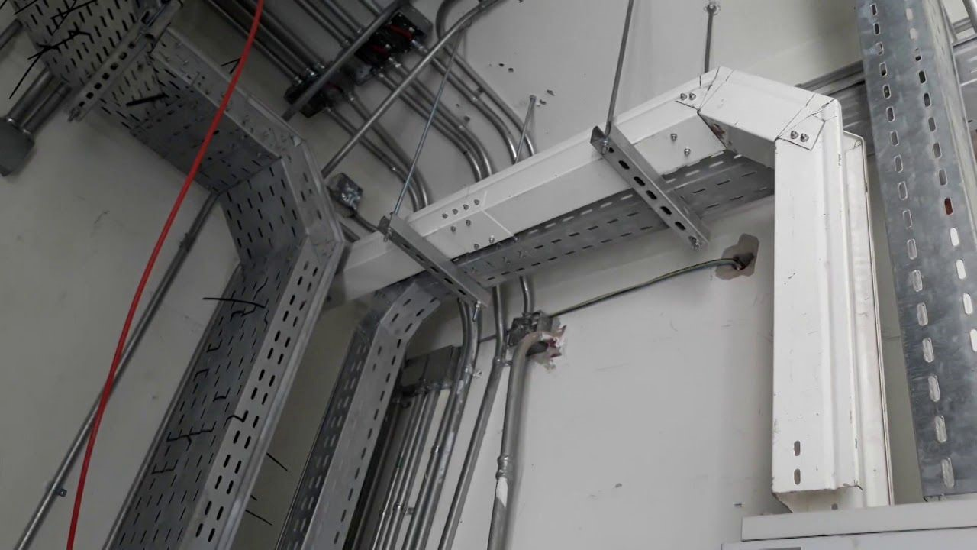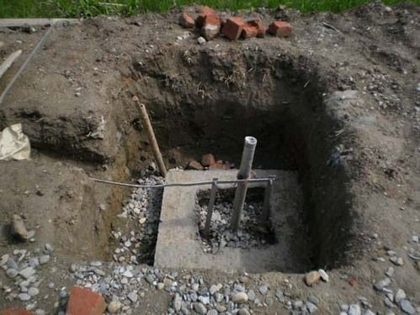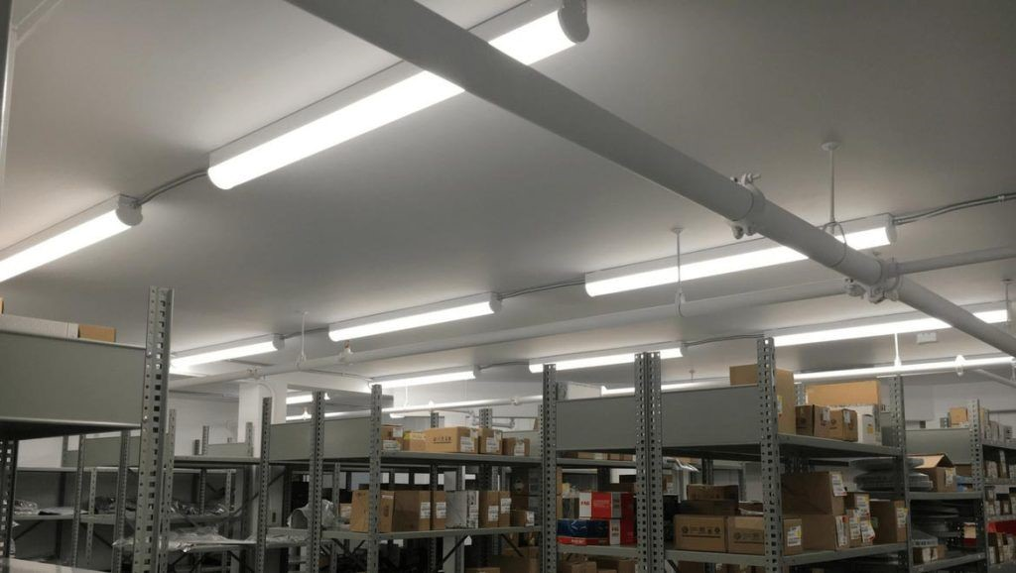

we have built our business around understanding our customers'

needs & expectations, in order to deliver quality electrical solutions which perform

and protect each and every time. Our no compromise approach to our work shows

in the finished product. From commercial and retail fit-outs to residential buildings

and industries, each project is treated the same. Experienced project managers,

qualified electricians and office based support staff ensures that your contract is

completed successfully. We owe our success to our customers who have patronized

our services with confidence and trust. We believe strongly in providing quality

service on time and within budget while maintaining safety and cooperating with

those involved. An emphasis on Quality Control and Customer Service ensures that a

large portion of our work comes from a number of clients who come back to use our

services time and time again. And most of our new contacts approach us as a result

of personal recommendations.

Cable Tray / Raceways Earthing Works Lighting Works



# Fire hydrant & Sprinklers

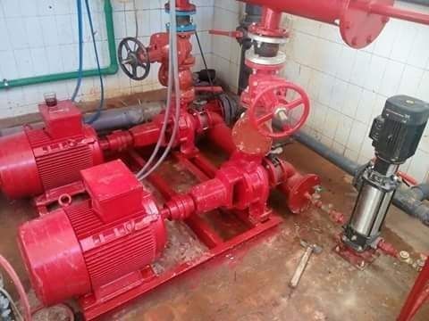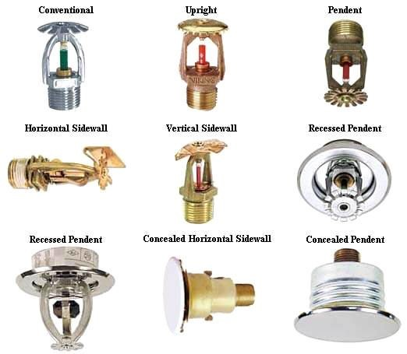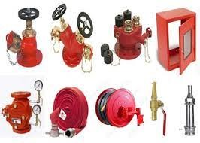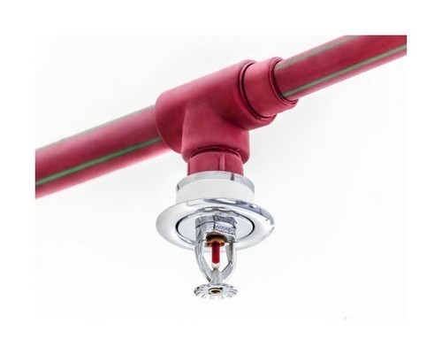SecureZone fully proficient in designing, supplying and installing various Fire Hydrant and Sprinkler Systems.

These advanced systems are available in a number of specifications, sizes and models and are accompanied by various accessories.

These are made by highly qualified and experienced engineers who have in-depth knowledge of this field.

# CLOSED CIRCUIT TV SYSTEMS





 years. Our company designs integrated systems for projects taking into account all the requirements envisaged by the customer. Large and small projects are designed by considering the operating scenarios provided by the customer and the risk analysis carried out by the engineers of our company to provide optimum equipment configuration.

Closed Circuit TV Systems installed for security purposes are normally used to manage the movement of people around the areas to be protected. The videos captured by these cameras are stored either digitally or conventionally. The digitally stored videos can be accessed from a remote location.

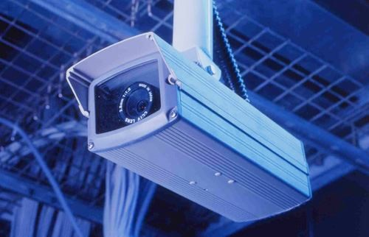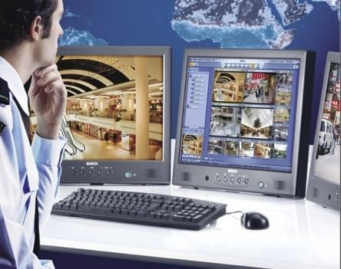

# FIRE DETECTION SYSTEMS

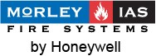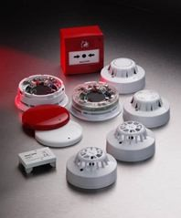 advanced and reliable technologies in the market. These systems are designed in such a way that they can be interfaced with other existing security detectors and automation systems of customers depending on their compatibility with the solution. Our company designs fire alarm solutions with facets for integration with other system to satisfy various needs. Several designs options suitable for projects with varying sizes, and compatible with both the operating scenarios provided by the customer and the risk analysis carried out by our engineers are first presented to the customer before the start of the project. Completed projects are delivered as turnkey solutions with an optimum equipment configuration.

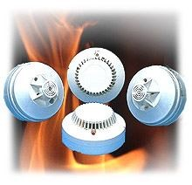

Fire alarm systems have detectors that detect the onset of the fire and this makes early intervention possible. Based on the evacuation plans of the protected building, exit points like emergency exits, turnstiles, barriers at parking lots and other road barriers and hydraulic passage control posts are set loose automatically. The power supply to many locations may be offset to prevent the fire from expanding.

# FIRE EXTINGUISHING SYSTEMS

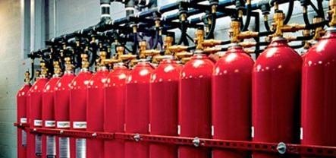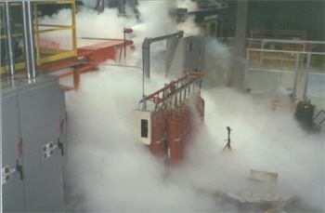 international standards. This system is ideal for protecting precious and delicate rooms Data processing centers where precious equipment and data archives are kept. It is also ideal for integrate fire extinguishing systems with other electronic detection and automation systems. Our company designs systems of various designs and sizes depending on the requirements of the customer. Operating scenarios provided by the customer and the risk analysis carried out by our engineers is also taken into account during the designing process. The completed project is delivered as a turnkey an optimum equipment configuration.



Fixed detection fire extinguishing systems are available in two categories: electronic (detection) and mechanical (extinguishing). By virtue of the Protocol of Montreal signed in 1987, it is forbidden to use HALON 1301 gas for fire extinguishing purposes. Though the gas is very effective for extinguishing fire, it has very negative effects on the ozone layer. This gas was withdrawn from markets gradually before being banned completely in 1994.

Since then, the gases FM200, FE 13, Argon and CO2 have been used as means of fire extinguishing. However, in the automatic fire extinguishing systems, each gas used in the total flooding applications has its own merits and demerits. Therefore, it is a good idea to have a good understanding of the requirements in order to make the best choice of gases.

# ACCESS CONTROL SYSTEMS

**APROTEK** provides Access Control Systems, which constitute an integral part of electronic security systems, with a wide range of products according to the operating scenarios provided by the customer and the risk analysis carried out by our engineers for the fulfillment of multiple purposes. These are put into operation and delivered as a turnkey optimum equipment configuration.

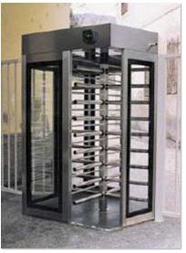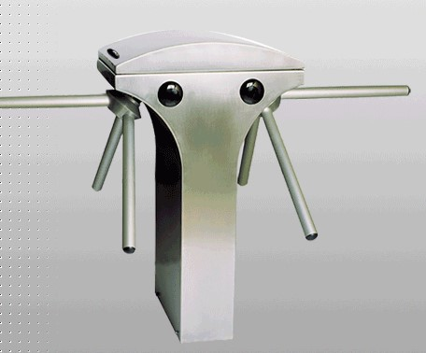

# BIOMETRIC HAND & FINGERPRINT IDENTITY



four years ago. This provides solutions and makes it possible for the system to be integrated according to the scenarios provided by the customer. The systems are therefore installed based on the risk analysis carried out by our company to provide turnkey solutions with an optimum equipment configuration.

Biometric devices, used as stand-alone or integrated systems are designed by making use of the measurable unique physical human characteristics for identity verifications.

Biometric solutions that utilize measurable unique human body parts are as follows: **Finger Print Identification System, Face Recognition System, Iris Identification System, Retina Identification System, Hand Geometry Identification System and Vein (Fist) Identification System.**

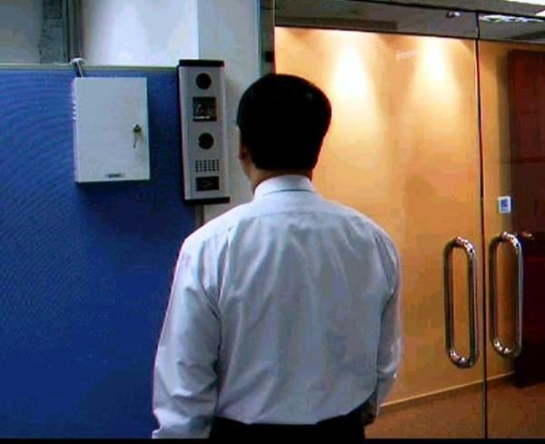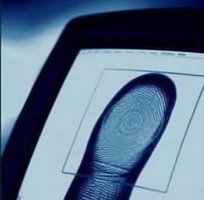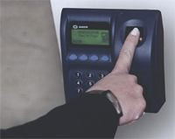

## INTERCOM & VIDEO INTERCOM SYSTEMS

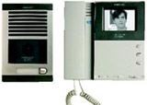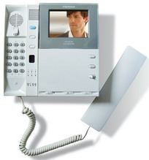 homes and offices and offers a wide range of products in this field from small home systems to large systems for residential estates such as condominiums according to the operating scenario provided by the customer and the risk analysis carried out by our engineers with an optimum equipment configuration.



Intercom systems with or without image transmission are installed in the most suitable places to ensure entrance security. They can be used as stand-alone or networked depending on the number of users and of entrances to be managed. Depending on the existing wirings of the building or by the request from the customer analog or digital intercom systems can be installed. Depending on installed configurations, the system permits host-visitor communication or communication between occupants of the same building or communication between a caretaker and visitors. In residential estates and condominiums, the system permits communication between the occupants of apartments and the security staff and visitors. Designs are normally carried out according to the chosen option and the budget of the customer.

## PUBLIC ADDRESS SYSTEMS

A public address or PA system is a combination of a set of audio equipment that allows broadcasts over a designated area. Often found in schools, office buildings, Malls. PA systems can be used for announcements or emergency information and provide a simple way to get information out quickly. PA systems can be basic or advanced, and can be adapted to fit a variety of needs.

Basic PA systems are comprised of loudspeakers placed in convenient locations around the broadcasting area, an amplifier to increase the sound, and a mixer, which allows variation in sound levels. The user speaks into a microphone, and the sound is transmitted through connected cables to the area surrounding the speakers. Some systems also include microphones or intercoms near the speaker locations, allowing the listener to reply to the central location, although not to the entire system.

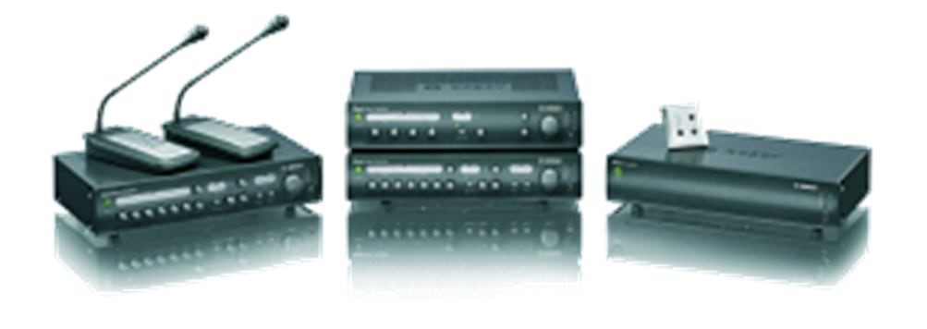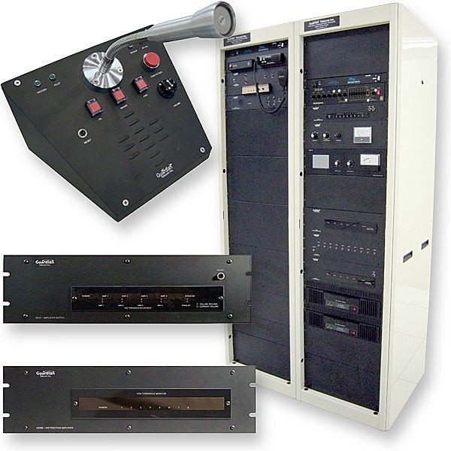

## DATA & VOICE SYSTEMS



the important projects it completed with its expert staff on LAN (Local Area Network), WAN (Wide Area Network), and complex networks.

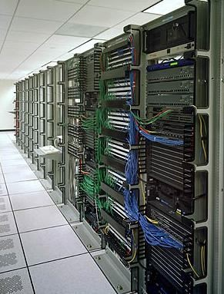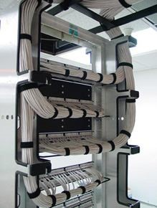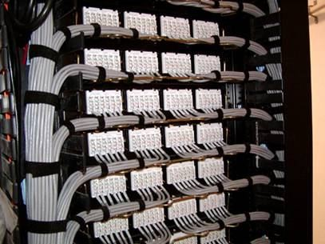 designing complete solutions on the basis of customer requirements, developing efficient solution mechanisms against possible problems, and by showing zero tolerance against any problems that may occur in data flow. Accordingly, at the beginning of every project, APROTEK’s engineers having network setup expertise carry out detailed investigation operations, determine exactly the requests and requirements of the customer, meticulously monitor the implementation of the project, and deliver keyin-hand the network setup by taking into consideration the most current world standards. APROTEK’s main objectives in its project implementations beside maximum customer satisfaction is to provide continuous and efficient data management.

network setup, remote access connections (WAN), RF-ID, and security technologies such as Ethernet, Fast Ethernet, Gigabit, Fiber Optic, and Wireless implements the application-training and consultancy services in the projects it undertakes in wholeness, and due to its expert personnel in this area, it aims to provide service as the only firm for all your network solution needs. Many of the projects completed

## WALK THROUGH WEAPON & METAL DETECTORS

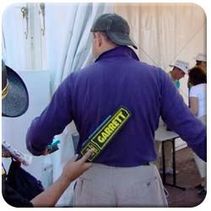These detectors ensure the security level required for the building without hindering the circulation of people at entrances. They have 20 different highspeed operation programs, a precision of 200 degrees, a scanning of 33 different dotting areas and a detection technology with horizontal and vertical zones, and are able to carry out precise scanning jobs while permitting a passage intensity of 50-60 people per minute.

These devices have specially-designed circuits that prevent asking effect interference caused by interaction between two metals with inverse properties that annihilate the signals of each other and those are able to correctly detect all kinds of metal. They also record those passages that have created a high alarm level in a digital recording device by means of a camera and transfer them into a database. 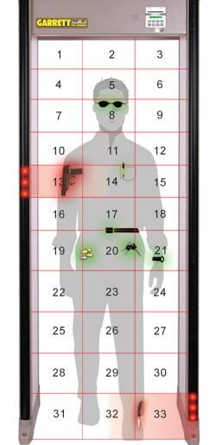

## X-RAY SECURITY SCREENING SYSTEMS

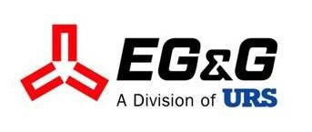These are used at entrances of buildings for the passage control of parcels, luggage, bags and other similar objects to detect any weapons or explosives and to ensure the required security level for the building. The dimensions of the tunnel may vary between 82 cm x 65 cm and 80 cm x 100 cm depending on the intensity of the passage of luggage of the building. Thanks to the two-dimension detection system, all of the objects passing through the tunnel can be checked without any loss of image on the edges. They are able to see through 29-mm-thick steel.

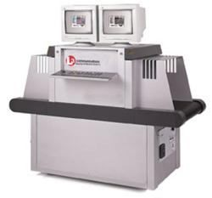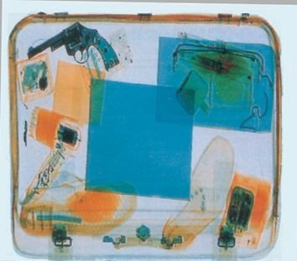

The main property of the X-ray security screening systems is their capability of distinguishing colors and of isolating images by using organic/inorganic doublemonitors to make the distinction between organic and inorganic matters with four colors to detect organic-based explosives. These detectors give a sound alarm upon detection of a suspicious piece of luggage and record the passages exhibiting a high alarm level in a digital recording device by means of a camera and transmit the data into a database. 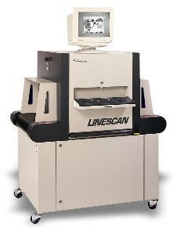



**GARAGE ENTRANCE CONTROL SYSTEMS**



Entrance Control Systems”, including parking lot barriers, electromechanical or electronic road blockers, hydraulic bollards and road traps with all sorts of entrance control and automation systems for buildings/open areas, and designs them according to the operating scenario provided by the customer and the risk analysis carried out by our engineers and delivers turnkey solutions with an optimum equipment configuration.

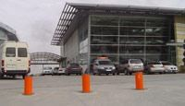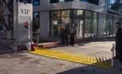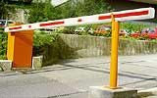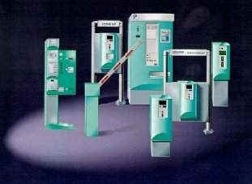



**9-1-127, Ground Floor, Deepti Appartment’s, Madhava NursingHome Lane, SD Road, Secunderabad. 500003 Hyderabad, Telangana 500003. IN e-mail: srinivas@securezone.in, Mob:+91 9059727699**