Neural Networking and Deep Learning

Student name: Vani Alla

Student ID:700757522

Git hub Link: <https://github.com/AllaVani/Allavani_ICP2/tree/main>

* 1. Write a program that takes two strings from the user: first_name, last_name. Pass these variables to fullname function that should return the (full name).   
     o For example: ▪ First_name = “your first name”, last_name = “your last name” ▪ Full_name = “your full name”

#Program

First_name = ( input("Your First Name : "))

last_name = (input("Your Last Name : "))

Full_Name = print(First_name + last_name)

* 1. Write function named “string_alternative” that returns every other char in the full_name string. Str = “Good evening” Output: Go vnn

#Program

def string_alternative(Str):

output = ""

for a in range(len(Str)):

if a % 2 == 0:

output += Str[a]

return output

print(string_alternative("Good evening"))

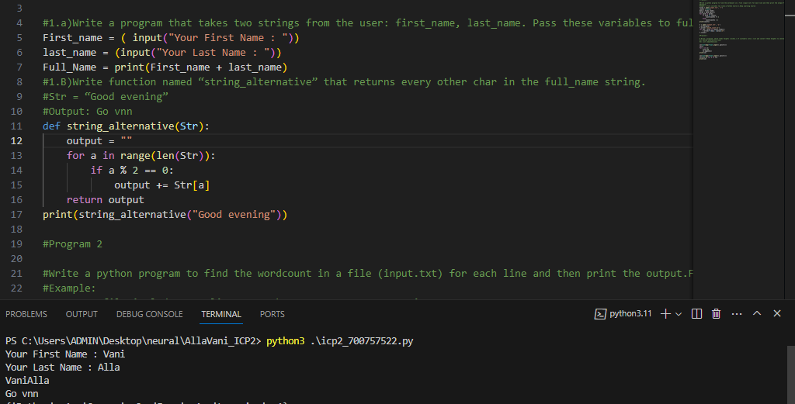

2) Write a python program to find the wordcount in a file (input.txt) for each line and then print the output. o Finally store the output in output.txt file. Example: Input: a file includes two lines: Python Course Deep Learning Course Output: Python Course Deep Learning Course

Word_Count:

Python: 1

Course: 2

Deep: 1

Learning: 1

#Program

file1 = open('input.txt', 'r')

counts = dict()

data = file1.read()

words = data.split()

for word in words:

if word in counts:

counts[word] += 1

else:

counts[word] = 1

print(counts)

f = open('output.txt', 'w')

f.write(data)

f.write('\nword_count:\n')

for key, value in counts.items():

f.write(f"{key}: {value}\n")

f.close()

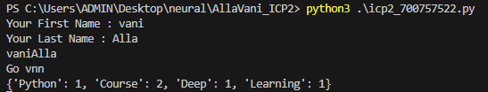

3.1) Write a program, which reads heights (inches.) of customers into a list and convert these heights to centimeters in a separate list using: 1) Nested Interactive loop.

#Program

L2=[]

for x in L1:

x=x*2.54

L2.append(x)

print(L2)

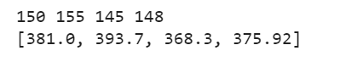

3.2) List comprehensions Example: L1: [150,155, 145, 148] Output: [68.03, 70.3, 65.77, 67.13]

#Program

L1=list(map(float,input().split()))

L2=[x*2.54 for x in L1]

print(L2)

