**Oracle Cloud Infrastructure vs. AWS**

Oracle Cloud Infrastructure is built for enterprises looking for higher performance, consistently lower costs, and easier cloud migration for their existing on-premises applications. Oracle Cloud Infrastructure is consistently less expensive than AWS for a wide range of popular cloud workloads for several reasons:

* **First, in the area of networking, charges for outbound bandwidth are 74% less expensive than AWS.**

**1/4- the cost for outbound bandwidth**

* **Second, for compute, Oracle delivers >2x better price/performance over AWS for general purpose and memory-optimized instances.**

**> 2x - better compute price/performance**

* **Third, for HPC workloads, AWS provides similar performance to Oracle, but is 44% more expensive and provides no local SSDs, half the RAM, no RDMA networking, and no performance SLA.**

**44% - lower compute costs for HPC**

* **Lastly, for block storage, Oracle offers as much as 20x the IOPS performance of AWS for less than half the cost. Read below for more information on how customers are saving money with Oracle Cloud Infrastructure.**

**20x the IOPS for half the price**

**Oracle Cloud Workload Estimator**

**Oracle designed our Gen 2 Infrastructure to be fast, efficient and priced competitively. While we are competitive across all our services, there are several scenarios where pricing differences are significant. Start with one of our scenarios or build your own to see how we compare to AWS for your key workloads.**

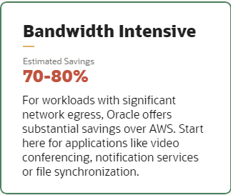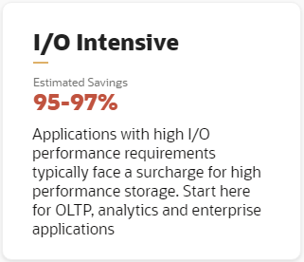

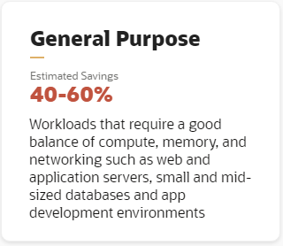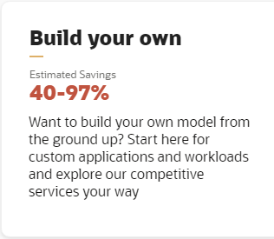

**8x8 saves 80% in network egress costs**

# 8x8 Selects Oracle as the Cloud Platform for its Secure Video Meeting Solutions

## Powers meetings for millions of users at public and private organizations of every size Moved video meeting services from AWS for performance enhancements while saving more than 80 percent 8x8 solutions available in the Oracle Cloud

**Private connectivity: simple fixed monthly price includes unlimited data transfer**

| **% Utilization of 10Gbps connection** | **TB/Month transferred** | **Oracle Cloud Infrastructure FastConnect price/month** | **AWS DirectConnect price/month (US East)** | **Oracle Cloud Infrastruct Savings** |
| --- | --- | --- | --- | --- |
| 3% utilization | 97.2 | $918 | $3,564 | **74.24%** |
| 10% utilization | 324 | $918 | $8,100 | **88.67%** |
| 30% utilization | 972 | $918 | $21,060 | **95.64%** |
| 40% utilization | 1,296 | $918 | $27,540 | **96.67%** |
| 50% utilization | 1,620 | $918 | $34,020 | **97.30%** |

**Better network pricing across all regions**

| **Regional mapping** | **Oracle Cloud Infrastructure price per GB month** | **AWS (Lowest cost tier)** | **Savings with Oracle** |
| --- | --- | --- | --- |
| **North America and Europe** | **$0.0085** | **$0.0500** | **83%** |
| **Asia, Japan, and South America** | **$0.0250** | **$0.0800** | **69%** |
| **Middle East** | **$0.0500** | **$0.0650** | **23%** |

**AWS fixed shapes result in significant waste**

|  | **Oracle Cloud Infrastructure E3.3** | **AWS r5.2xlarge** |
| --- | --- | --- |
| **Cores** | **3** | **4** |
| **List Price** | **$0.147** | **$0.504 (US East)** |
| **RAM** | **48GB** | **64GB** |
|  | **Flexible compute shapes offer the perfect size** | **242% more expensive and wastes 16GB of RAM** |

**Consistently low cost HPC , with linear performance**

Oracle Cloud Infrastructure’s HPC instances offers linear performance and consistent low cost compared to AWS. For a typical Computational Fluid Dynamics (CFD) job, with a CFD Solver for a 140-M cell mesh, AWS’s C5n instances are about 60% more expensive than Oracle’s HPC instances across all scales. You can find more information on the AWS configuration and test results on their blog: <https://aws.amazon.com/blogs/compute/running-ansys-fluent-on-amazon-ec2-c5n-with-elastic-fabric-adapter-efa/>.

## High performance computing savings

**Consistently global pricing**

