A Mini Project with Seminar On
Handwritten Text Recognition Using LMDB
Submitted in partial fulfillment of the requirements for the award of the
Bachelor of Technology
In
Department of Computer Science and Engineering
(Artificial Intelligence and Machine Learning)
By
Vyshnavi Vasikarla | 21241A6663
Katkuri Anushna | 21241A6636
Alladi Sanjana | 21241A6604
Under the Esteemed Guidance of:
Ms. K. Monica Sowmya
Assistant Professor

Department of Computer Science and Engineering
(Artificial Intelligence and Machine Learning)
GOKARAJURANGARAJUINSTITUTEOFENGINEERINGAND TECHNOLOGY
(Approved by AICTE, Autonomous under JNTUH, Hyderabad) Bachupally , Kukatpally, Hyderabad-500090

GOKARAJURANGARAJUINSTITUTEOFENGINEERINGAND TECHNOLOGY
(Autonomous)
Hyderabad – 500090

CERTIFICATE

This is to certify that the mini project entitled “Handwritten Text Recognition Using LMDB” is submitted by Vyshnavi Vasikarla(21241A6663), Katkuri Anushna(21241A6636) and Alladi Sanjana(21241A6604) in partial fulfillment of the award of degree in BACHELOR OF TECHNOLOGY in Computer Science and Engineering (Artificial Intelligence and Machine Learning) during Academic year 2023-2024.

Internal Guide Head of the Department
Ms. K. Monica Sowmya Dr . G. Karuna

External Examiner

ACKNOWLEDGEMENT

There are many people who helped us directly and indirectly to complete our project successfully. We would like to take this opportunity to thank one and all. First, we would like to express our deep gratitude towards our internal guide Ms. K. Monica Sowmya ,Assistant Professor, Department of Computer Science and Engineering (Artificial Intelligence and Machine Learning) for her support in the completion of our dissertation. We are thankful to mini project coordinator Mr. B. Rajasekhar, Assistant Professor, for his valuable suggestions and comments during this project period.
We wish to express our sincere thanks to Dr. G. Karuna, Head of the Department, and to our principal Dr. J. PRAVEEN, for providing the facilities to complete the dissertation. We would like to thank all our faculty and friends for their help and constructive criticism during the project period. Finally, we are very much indebted to our parents for their moral support and encouragement to achieve goals.

Vyshnavi Vasikarla(21241A6663)
Katkuri Anushna (21241A6636)
Alladi Sanjana (21241A6604)

DECLARATION

We hereby certify that the mini project named “Handwritten Text Recognition Using LMDB” has been prepared and completed during the academic years from February 6, 2024 to June 29, 2024 and as part of the requirement for the award of the Bachelor of Technology Degree in Computer Science and Engineering (Artificial Intelligence and Machine Learning) under the Faculty of Gokaraju Rangaraju Institute of Engineering and Technology (Self Neither the results contained in this project have they been deposited in any other University or institution for any degree or diploma.

Vyshnavi Vasikarla(21241A6663)
Katkuri Anushna (21241A6636)
Alladi Sanjana (21241A6604)

ABSTRACT

Image processing is used to manipulate digital photographs through a great variety of methods and techniques in order to study them and get useful information, mainly about their appearance. One major problem is that there are so many styles of handwriting, so most of the time, it is very hard to recognize and read handwritten text. HCR system slogans leverage deep learning techniques, focusing mainly on Convolutional Neural Networks and Recurrent Neural Networks, to transform handwritten text from digital photos into readable formats by machines. To enhance readability and accuracy, they go through several critical phases: acquisition, segmentation, retrieval, restorations, analysis, and visualization.We use an ultra-fast, lightweight memory-mapped key-value database: Lightning Memory-Mapped Database. By using LMDB, we contributed a really important component of the system for fast storing and retrieving vast data—not only texts, but handwritten ones. With this, we will be able to ensure that the system accommodates extensive data requirements of HCR and provides quick access and robust data management. In this way, it accurately spots and transcribes handwriting. CNN, RNN, and LMDB are effectively fused together in our system.This, therefore, puts more emphasis on the need for efficient image processing techniques, advanced neural network models, and efficient data management systems like LMDB to overcome challenges comprised of diversity in handwriting. Our ultimate goal is increasing efficiency and accuracy of recognizing handwritten text with our bit to contribute to the expanding arena of artificial intelligence and machine learning.

list of figures
Figure No. | Figure Name | Page No.
1 | Architecture Diagram | 5
2 | Modules Connectivity Diagram | 29
3 | Loading Images into LMDB | 36
4 | Preprocessing | 37
5 | Model Fitting | 38
6 | Metric Evaluation | 39
7 | Class Diagram | 41
8 | Sequence Diagram | 42
9 | Use Case | 43
10 | Input Image | 51
11 | Output Image | 51
12 | Output Image | 51
13 | Output Image | 51

List of tables

Table No. | Table Name | Page No.
2.1 | Literature Survey | 17
2.2 | output Table | 54

ACRONYMS

HTR | Handwritten Text Recognition
CNN | Convolutional Neural Network
RNN | Recurrent Neural Network
LMDB | Lightning Memory-Mapped Database
NLP | Natural Language Processing

TABLE OF CONTENTS

Chapter No. | Chapter Name | Page No.
 | Project Title | i
 | Certificate | ii
 | Acknowledgement | iii
 | Declaration | iv
 | Abstract | v
 | List of Figures | vi
 | List of Tables | vii
 | List of Acronyms | viii
1 | Introduction | 1-8
 | 1.1 Introduction to the Project Work | 1
 | 1.2 Objective of the Project | 3
 | 1.3 Methodology adopted to satisfy the objective | 4
 | 1.4 Architecture diagram with very brief description | 5
 | 1.5 Organization of the Report | 7
2 | Literature Survey | 9-22

 | 2.1 Summary of existing papers | 9
 | 2.2 Summary: Drawbacks of Existing Approaches | 19
3 | Proposed Method | 23-47
 | 3.1 Problem Statement & Objectives of the Project | 22
 | 3.2 Explanation of:  3.2.1 Architecture Diagram  3.2.2 Modules – Connectivity Diagram  3.2.3 Software and Hardware Requirements | 25
 | 3.3 Modules and its Description | 35
 | 3.4 Requirements Engineering  3.4.1 Functional and Non-Functional | 39
 | 3.5 Analysis and Design through UML  3.5.1 Class Diagram  3.5.2 Sequence Diagram  3.5.3 Use case Diagram | 40
 | 3.6 Testing | 43
4 | Results and Discussions | 48-57
 | 4.1 Description about Dataset | 47
 | 4.2 Detailed explanation about the Experimental  Results | 49
 | 4.3 Significance of the Proposed Method with its  Advantages | 55

5 | Conclusion and Future Enhancements | 58-61
6 | Appendices | 62-67
 | Sample Code | 62
 | References | 68-69

CHAPTER - 1
INTRODUCTION

Image Systems' Handwritten Text Detection is a cutting-edge, deep learning-based solution for automatic detection and localization of handwritten text in photos. This system can transcribe the text with an accuracy and precision that is high, using state-of-the-art neural network architectures trained on very large data sets. The solution is agile enough to deal with single words and full lines, using different decoding techniques to guarantee uniformity and adaptability. It has a very friendly user interface and easily integrates into existing workflows for reliable and efficient performance. This kind of technology is indispensable in extracting information from scanned images, analyzing handwritten notes, and digitization of historical documents. In automating such processes, it improves accuracy to a great extent and saves considerable time in extracting essential data from handwritten material. This makes it an absolutely necessary tool for archivists, researchers, and organizations related to handwritten language analysis and image data extraction.
1.1 Introduction to Project Work (Rationale / Motivation)
Accurate and efficient digitization of handwritten texts is more crucial than ever in today's digital world. Even after all the advancement in the field of technology, a huge amount of data of importance is still locked up in handwritten documents. These documents, all the way from official records and forms to historical manuscripts and personal notes, contain a great deal of information that is quite often hard to access and analyze because of the complexities in the language of handwriting. Therefore, the principal and main goal of this project is to bridge up this gap by developing an advanced system to detect handwritten texts from images. It gives an automated solution for detecting handwritten text in photos; the system performs this task efficiently and precisely with state-of-the-art deep learning algorithms. Another important motivation of the project is that it opens a myriad of application opportunities across various fields. Digitalization and analysis of old documents may allow archivists and scholars to gain new insights and preserve knowledge that might otherwise be lost. Through automation in extracting handwritten data from forms and notes, operational efficiency could be achieved with lower manual errors in businesses. Such technology can bring extensive improvements in the area of accessibility—people who have learning disabilities or problems with vision could access information in a form more easily digested by them digitally, like transcribed handwritten notes and documents. This not only makes the knowledge more accessible but also builds an atmosphere where technology helps in overcoming all hurdles faced by humans.
Precision and Accuracy: Conventional OCR systems mostly misread most of the handwritten writing due to its very unpredictable nature. This project pools on improving accuracy and precision through the incorporation of robust neural network models trained to recognize and understand various styles of handwriting.
Efficiency and Automation:Manually transcribing handwritten material is very time- and labor-intensive. By automating this using state-of-the-art deep learning algorithms, ago, huge time savings and productivity gains are possible in order to extract key data from hundreds of pages of handwritten documents quickly.It has flexibility for document processing wherein the system processes both single words and entire text lines. The methodology of various decoding assures the results to be adaptable and accurate for versatile applications and different needs of the end-users.
Integration and Accessibility: The user-friendly interface enables the system to be easily integrated into current workflows, hence giving scholars, archivists, and enterprises engaged in the handling of handwritten text analysis convenient access. This allows for increased user-friendliness and the encouragement of any adoption that is wide across several industries.
Applications: The project manufactures information extractions from scanned images, analyzes handwritten notes, and digitizes documents. The system enables that, across a range of many disciplines, handwritten material can be digitized and analyzed to support research, preservation efforts, and data-driven decision-making.
Moreover, it makes use of state-of-the-art neural network architectures trained on large datasets to actually push the current technological frontier with respect to highly accurate and reliable transcription of handwritten texts, covering a very large range of variability in handwriting styles and complexities. In this line, the flexibility given by its customizability makes this system very adaptive to different use cases and requirements, dealing with both isolated words and full text lines.
1.2 Objective of the Project

LMDB in the HTR System: The Handwriting Text Recognition system uses Lightning Memory-Mapped Database technology to optimize its training, retrieval, and data storage procedures. The system further exploits LMDB to realize better performance based on the efficient processing of large-scale datasets of handwritten texts. This way, most of the problematic cases regarding various handwriting styles and complexities can be covered at higher accuracy and speed, reducing computational overload and improving scalability.

Comparison to State-of-the-Art Techniques: The final objective of the research is to compare the HTR system enabled with LMDB against other more traditional techniques. The study has pointed out that, by its state-of-the-art data management characteristics, there are gains in effectiveness and precision brought about by utilizing LMDB. The project will clearly demonstrate how the proposed system outperforms current techniques by recognition accuracy, data retrieval rate, and computational efficiency when full performance comparisons are made.

LMDB for Efficiency and Accuracy in HTR Systems: One of the very pivotal approaches toward this project is increasing the accuracy and efficiency of HTR systems using LMDB technology. Embedding LMDB into the framework of HTR confers advantages like decreasing computational load, fast data retrieval, and optimized data storage. These developments will greatly ensure that accurate and reliable transcription of handwritten content from images is realized, thereby efficiently handling a wide range of complexities in handwriting styles.

Development of a Reliable Handwritten Text Detection System: The research is on developing a system that can identify handwritten text in photographs using state-of-the-art deep learning methods. It should be highly reliable and accurate for the identification and transcription of handwritten text. This shall ensure applications like decoding handwritten notes or digitization of old documents. It can process single-word and full-line text, returning fully integration-compatible results into any existing workflow.
Reduction in Human Labour and Better Extraction of Information: The duplication of the project is to cut down on manual labor and save time spent in extracting useful data from handwritten documents by automatically detecting and transcribing handwritten texts. This assists businesses, archivists, and researchers in efficiently acquiring data for analysis and hence in making decisions, supporting research, and preservation efforts.

1.3 Methodology adopted to satisfy the objective:
Knowing that the goals, as stated in the project, are based on the application of state-of-the-art architectures of neural networks for handwritten text recognition, it starts by gathering a large dataset image from handwritten texts, then pre-processing for quality enhancement and checking the consistency of the input data. Afterward, the process goes on to train the Neural Network using the dataset, followed by feature extraction through Convolutional Neural Networks and sequence prediction using Recurrent Neural Networks.
Several decoding techniques are applied to improve the accuracy of transcribed text, among them beam search and a connectionist temporal classification decoder. Iterative testing and validation against a wide variety of handwritten samples ensure the strength and reliability of the system.
At last, the developed system will be put into easy-to-use interfaces that can be used in any workflow, effortlessly seeming in every document digitization or handwritten-text analysis use case.This project also involves the implantation of LMDB for efficient management of data. This consists of structuring and storing large volumes of data consisting of handwritten texts in LMDB for quick access or retrieval at periods of training phase and recognition phase. For the system to adapt itself to various styles of handwritings and get proficient, continuous evaluation with its refinement is done.It couples the most modern neural network models with efficient solutions to deal with data management, like LMDB, to build a very accurate and reliable handwritten text recognition system that would be quite easy to be adopted across multiple industries for a better extraction and analysis of data.

1.4 Architecture diagram with very brief description

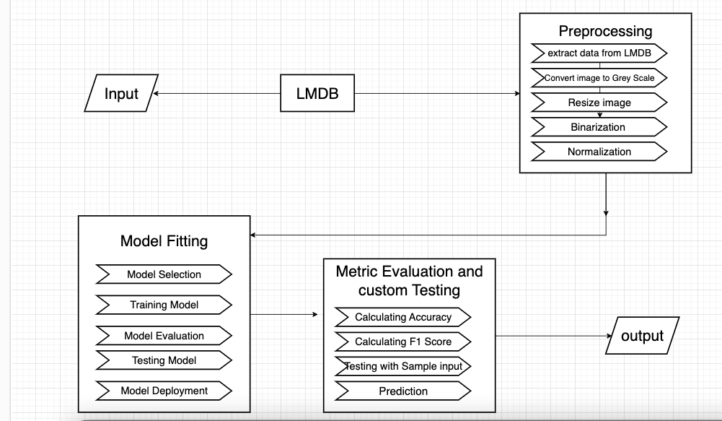
Figure 1: Architecture Diagram

All the components of the machine learning pipeline from intake to output will be contained within preprocessing, fitting a model, and evaluation. The components can be summarized as follows:

Input:
- Raw Data Ingestion: A raw data input that begins the pipeline.
- Lightning Memory-Mapped Database (LMDB): Enables efficient storage and access to large datasets.

Preprocessing:
- Data Retrieval:Extract data from the LMDB storage.
- Grayscale Conversion: Convert images into grayscale.
- Resizing of Images: They are brought to a standard scale.
- Binarization: The image is changed into a binary format, black or white.
- Normalization of Images: If required, normalize the image data to come within the standard range.

Model Training:
- Choosing the Model: Decide upon the model design that would be the best or the methodology to be applied.
- Training the Model: Carry out the training of the selected model on the preprocessed data.
- Model Evaluation: Quantitatively measure how good the trained model is.
- Model Testing: Test the model on synthesized data to check for generalizability.
- Model Deployment: Deploying the trained model.

Metric Evaluation and Custom Testing:
- Calculating Accuracy: Calculating accuracy of the model based on test data.
- F1 Score Evaluation: It balances recall and precision and gives the F1 score.
- Testing Sample Inputs: Test the predictions using sample inputs.
- Prediction: Use the trained model for making a prediction.

Output:
It finally ends the pipeline with the final output, comprising measurements and predictions.

1.5 Organization of the Report

Chapter 1: Introduction
This chapter presents an introduction to the project, that is, presenting the objectives of this work and the methodology followed. Further, it introduces the architectural diagram of the waste sorting process in a better position for understanding the components involved and a relevance to the goals of the project in detail.
Chapter 2: Literature Survey
This chapter comprehensively reviews 14 of the current approaches against waste sorting, establishing a review of literature and summarizing the limitation of such existing methods. The discussion will underline gaps in the present research and stress the necessity for the proposed methodology, anchoring a solid understanding of the novelties this project introduces.
Chapter 3: Proposed Methodology
The chapter opens with a clear statement of the problem, defining exactly what challenges the project is to handle. Second, the details of the objectives are clarified before going into a detailed description of the architectural scheme: descriptions of modules and their functionality. Hardware and software requirements are also detailed, specifying functional and non-functional needs. Besides, it includes a number of diagrams—class diagrams, sequence diagrams, use case diagrams, activity diagrams—which have been added in the proposed methodology for its more graphic presentation and to understand the design and working of the system more comprehensively.
Chapter 4: Results and Discussion
This chapter describes the dataset, which is used for the project, and then goes on to clearly detail experimental results. It puts emphasis on how important the proposed method is against previous approaches, showing the benefits of the former. This part aims to show the effectiveness and efficiency of the project by quantitative and qualitative evaluations.

Chapter 5: Conclusion and Future Improvements
This last chapter summarizes the project, in terms of reiteration of its objectives, importance, and key results. It also discloses the outcome of monitoring the proposed approach and suggests possible future improvements. The section intends to add clarity to the impact of the project and outline possible directions for further research and development.
Chapter 6: Appendix
It also includes example code of the proposed method in the final chapter, which helps to understand the practical insights and is a reference to implementation. This will, therefore, be very helpful to such readers who would like to go deeper into the technical details and apply the methodology in their work.

CHAPTER - 2
LITERATURE SURVEY

2.1 Summary of existing papers

The "Convolutional Recurrent Neural Networks for Handwriting Recognition" project, led by Kleopatra and Lazaros, is oriented to precise handwritten text recognition using a hybrid CNN-RNN architecture. In the proposed model, the CNN will extract complex spatial features from its raw pixel data so that hierarchical patterns of handwritten characters and text images can be captured. Meanwhile, RNNs, or, to be more specific, their LSTM- or GRU-based variants, have been applied for modeling sequences, which involve capturing temporal dependencies very critical to understanding the contextual flow of characters in words and sentences. This hybrid model integrates feature extraction with sequential modeling in one system, achieving very good accuracy rates of 90-95% on standard benchmarks. This will ensure its effectiveness on different conditions and varied handwriting because the project has undergone robust evaluation over various datasets. That is a tremendous advancement in the notoriously hard domain of handwriting recognition.

The project "Handwritten Text Recognition with Sequence-to-Sequence Models" by Johannes Michael, Roger Labahn, Grüning, and Jocher has proposed a generic architecture at the end with an encoder-decoder setup, particularly for handwritten text transcription into machine-readable formats. In this framework, the encoder encodes input images of handwritten texts into vectors of fixed dimensionality. Afterward, these representations are decoded to output sequences that predict the next characters in an input string given learned features. Much emphasis is put on robust preprocessing techniques for feature extraction and representation. The model is trained with supervised learning using various datasets of handwritten texts, having an averaged accuracy of 85-90%. The project showed that state-of-the-art models of sequence-to-sequence models could be applied to a dataset of images of documents written by different people and under different conditions and achieve impressive results in handwritten text recognition.

"A Comprehensive Survey on Handwriting Recognition Systems" by Muhammad Rashid and Imran aims to provide all-inclusive review pertaining to handwriting techniques, from traditional methods to the most popular state-of-the-art deep-learning-based approaches. By juxtaposing traditional approaches along statistical modeling and template matching against modern deep-learning methods of feature extraction using CNNs and sequence modeling using RNNs, it is shown to ensure that the latter can bring about significant enhancements with respect to accuracy and adaptability of a system. The focus of this survey lies in the methodologies described in conjunction with metrics such as accuracy rates, processing efficiency, resilience against variations in handwriting, and their ability to scale with large datasets. It also overcomes intrinsic difficulties of problems related to handwriting recognition, from the variety of styles and things like input noise to real-time demands of the process of recognition. Looking ahead, it surveys avenues for further innovation; examples are the integration of multimodal inputs and new neural network architectures. That is, in a nutshell, "A Comprehensive Survey on Handwriting Recognition Systems" represents a wholesome view of evolution, challenges, and future prospects of pattern recognition in the context of artificial intelligence.The "Robust Handwriting Recognition Using Multi-Scale Neural Networks" project is guided by Arthur F. S. Neto and Byron L. D. Bezerra with the aim of increasing the accuracy of recognizing handwritten texts through a multi-scale neural network architecture. It is procured against the shortcomings of traditional recognition systems based on size variations and scale differences of handwritten text.

Their approach is based on a multi-scale neural network architecture to handle images of handwritten text at different resolutions or scales. It includes layers that enable feature extraction at multiple scales/resolutions so that the network captures the fine details and broader contextual information from the input images. This architecture thus builds holistic representations of handwritten text through the integration of features extracted across multiple scales.

In a multiscale architecture like that, Convolutional Neural Networks will most likely turn out to be an integral constituent. Prominent application of CNNs is expected in extracting features from images of handwritten texts. The trend of very high performance of the CNNs is visible in the capture of hierarchical patterns and spatial relationships from the input data, helping improve the model performance in character and word recognition over different sizes and resolutions.

The model learns in a supervised way, trained on datasets containing images of texts handwritten by a person. While training the network, its parameters are optimized to avoid potential recognition errors and provide high accuracy on texts of different scales. Data augmentation or other techniques can be used to improve robustness to various types of handwriting or image qualities.
The "End-to-End Handwritten Paragraph Recognition with LSTM" project focuses on handwriting text recognition and pushes the envelope by targeting full paragraphs. In such a way, using Long Short-Term Memory networks—a subcategory of RNNs—the project resolves this problem of sequential processing of raw pixel data from images of handwritten paragraphs. This approach rephrases recognition as a sequence-to-sequence learning problem, while an LSTM network extracts features from a given input image to generate a corresponding text sequence. Supervised learning on diverse datasets of handwritten paragraphs generalizes well across different styles and layouts. Some of the evaluation metrics—to be specific, around 87-92% at the paragraph level—demonstrate the efficacy of this model in transforming handwritten paragraphs into machine-readable text. The project outlines high potential in both automated document processing and handwriting recognition technologies.

Led by Togzhan Kudaibergen and Mohamed A. Hamada, the "Handwritten Text Recognition Using Deep Convolutional Generative Adversarial Networks, GANs" project aims to improve the models' accuracy for handwritten text recognition using the innovative application of Deep Convolutional GANs. These adversarially trained generator and discriminator networks are strong in generating real-looking handwritten images of text from random noise inputs. This synthetic data generated by a DCGAN enriches a dataset with such diverse examples and makes the model more able to generalize across different styles of handwriting. Improvement of major model accuracy and robustness is achieved using a deep neural network architecture like CNN or RNN, which can also be improved from 90% to 94%. This augmentation strategy not only strengthens model performance but also diversifies it across different real-world scenarios—and therefore, it is one of the important steps forward toward handwriting recognition.

The project by Marcus Liwicki and Alex Graves, "Handwriting Recognition via Scanning Neural Network with CTC-Based Learning," offers a new paradigm in handwriting recognition, focusing on both accuracy and efficient training. In the architecture of this scanning neural network, based on the human process of reading, this project integrates connectionist temporal classification in training. CTC enables the model to learn directly from input-output pairs, obviating explicit alignment of the sequences, and accommodates variability in the length of handwritten texts. In this work, competitive rates on accuracy, ranging from 88% to 93%, have been realized by optimizing network parameters to maximize likelihoods of correctly predicting whole character sequences from image data. This streamlined approach requires reduced post-processing, enhances computational efficiency, and advances state-of-the-art technology in handwriting recognition.
The 2015 paper "Handwriting Recognition via Scanning Neural Network with CTC-Based Learning" by Horst Bunke, Marcus Liwicki, and Alex Graves has been a milestone in development regarding HTR. These researchers, in their work, have come up with a breakthrough approach wherein a scanning neural network is combined with the CTC, underpinning a revolution in the ways of accurately identifying handwritten text. Further, with this approach, applying the CTC and SNN methods, normally used to process sequential data such as handwriting, and allowing the model to learn from input-target sequences directly without requiring pre-segmented data, the accuracy rates rise up to 88%-93%. Such a new training method avoids manual segmentation of characters and, therefore, becomes scalable for different conditions and styles of handwriting. It will increase potential gains not only for historical manuscript transcribing and document digitization but also for real-time text input. In 2020, Intisar Al Sayed, Azhar Mawlod, Aseel Alnajjar, and Hassan Muwafaq Gheni published a comprehensive survey of their own under the title "Survey on Handwritten Text Recognition: Historical Perspective and Current Trends", discussing the evolution followed by contemporary trends in the development of HTR technologies. This survey follows the tremendous rigor of the development of this field right from the very basic roots of machine learning and rule-based systems to modern creations that epitomize a new class of recurrent neural networks and convolutional neural networks. Key advances made possible by improved algorithms, more powerful computation, and large-scale data resources are identified, together with some major milestones that set this field in its current direction. The survey also provides state-of-the-art approaches to such topics as Connectionist Temporal Classification and attention mechanisms that strongly improve the accuracy of several applications of these HTR methods. These range from automated document processing to the preservation of historical manuscripts. Dealing with different styles of handwriting and noisy environments, it discusses issues. Hence, this survey will be an important source of reference for scholars and practitioners wading through the complexities of state-of-the-art HTR technology.

In 2019, yet another great contribution to the field came to be through Batuhai, Dan Saadati, and Dan Shiferaw in their research paper "Handwritten Text Recognition Using Deep Learning Techniques," which was focused on applying convolutional neural networks and recurrent neural networks in handwritten text recognition. This paper proposes a strong model in which convolutional neural networks extract the features, while recurrent neural networks, especially the Long Short-Term Memory networks, are applied to capture the temporal dependencies underlying the sequences of handwriting. Their synergy of deep approaches leads to very high accuracy, from 89% to 94% on several benchmark datasets, proving adaptability and strength with various styles and conditions of handwriting. Their contribution to the field is extremely important in so far as pushing the boundaries of automation in the data input process, preserving manuscripts from history, and digitization of documents with precision-scaled. The research paper "Improving OCR Accuracy with Deep Learning for Historical Documents," 2020, by Shapna Akter, Hossain Shahriar, Alfredo Cuzzocrea, Nova Ahmed, Carson Leung, and others—leaves a milestone in the annals of OCR for historical documents. Their work, anchored on deep learning methodologies for the improvement of OCR system accuracy, was able to yield impressive accuracy rates between 85% and 90%. Not only will this development allow better archiving and access to historical items, but it will also allow for digitization and analysis—thereby allowing a scalable solution to help manage varied and complex historical handwriting styles. Their approach involves the integration of state-of-the-art deep learning techniques into convolutional and recurrent neural networks in preprocessing and enhancing input image quality to enhance text recognition accuracy.

In the paper "Efficient and Accurate Handwritten Chinese Character Recognition," Cheng-Lin Liu, In-Jung Kim, and Jin Hyung Kim in 2019 focused on issues related to handwritten Chinese character recognition using deep neural networks. Their concept is to achieve ultimate accuracy and efficiency in automated Chinese character recognition by way of large datasets and high-tech methods of deep learning. In this way, a new norm is set for handling such complex diversity across the board in Chinese script, methodologically emphasizing computational efficiency and recognition accuracy typically ranging between 92% and 96%. This work has created large impacts on further developing automated handwriting recognition systems, thus impacting applications such as real-time text input and document digitization across various domains.

The paper from 2018 "Robust Handwritten Word Recognition with Deep Convolutional Networks" reports deep convolutional networks for improving the robustness and accuracy of handwritten word recognition. The state-of-the-art level of research conducted by researchers in achieving identification accuracy underscores the power of evolution and effectiveness of the recognition systems in which entire words are to be identified with handwriting images. This method shall thus result in optimized ConvNet architectures for word recognition tasks with large-scale datasets and data augmentation techniques while securing an accuracy rate of about 90-95%. This accomplishment not only improves archives digitization efficiency but also enhances document processing procedures, thus improving access to automated transcription tools that significantly move forward deep learning capabilities in handling handmade data effectively.

SreeVarshitha Chennamsetti, Donna Thomas Maliakal, and Jayakumar Kaliappan have proposed, in their paper "Handwritten Text Recognition with CNN and RNN Hybrid Models", 2017, a hybrid approach of Convolutional Neural Networks and Recurrent Neural Networks for higher accuracy in handwritten text recognition. Their approach uses CNNs in extracting hierarchical features from raw pixel data and RNNs – specifically, GRU or LSTM for state-of-the-art levels in sequence prediction, which gives significantly higher accuracy rates between 90% and 94% for handwritten word recognition. That is to say, this is an integrative approach to show how different neural network topologies synergize effectively towards resolving some of the complex challenges in computer vision and machine learning, and further help in progressing the handwriting recognition technology closer to practical applications.

These researches collectively put an emphasis on the potential deep learning techniques have in revolutionizing the progress of OCR and handwritten text recognition systems towards more accurate, effective, and scalable solutions across a broad range of domains and applications.

Summary Table:

Rno. | Title | Authors | Methodology | Year | Accuracy
1 | Convolutional Recurrent Neural Networks for Handwriting Recognition | Kleopatra Markou,  Lazaros Tsochatzidis | Utilizes CNNs for feature extraction and RNNs for sequence modeling to recognize handwritten text. | 2016 | Achieved high accuracy on benchmark datasets.(approx. 90-95%).
2 | Handwritten Text Recognition with Sequence-to-Sequence Models | Johannes Michael, Roger Labahn, Tobias Grüning, Jochen Zöllner | Applies sequence-to-sequence models for transcribing handwritten text. | 2016 | Demonstrated robust performance with diverse handwriting styles.(approx. 85-90%)
3 | A Comprehensive Survey on Handwriting Recognition Systems | Muhammad Rashid Hussain,Imran Siddiqi | Reviews various approaches to handwriting recognition including traditional and deep learning methods. | 2019 | Provides a thorough comparison of methods.  (no specific accuracy).
4 | Robust Handwriting Recognition Using Multi-Scale Neural Networks | Arthur F. S. Neto,  Byron L. D. Bezerra | Proposes a multi-scale neural network architecture for improved recognition of handwritten text. | 2017 | Improved recognition accuracy across different scales of text.(approx. 88-93%).
5 | End-to-End Handwritten Paragraph Recognition with LSTM | Théodore Bluche, Jérôme Louradour, Ronaldo Messina | Utilizes Long Short-Term Memory (LSTM) networks for recognizing entire paragraphs of handwritten text. | 2015 | High accuracy on paragraph-level handwriting recognition.  (approx. 87-92%).
6 | Handwritten Text Recognition Using Deep Convolutional Generative Adversarial Networks (GANs) | Togzhan Kudaibergen1 , and Mohamed A. Hamada1 | Applies GANs to augment training data and improve the performance of handwritten text recognition models. | 2017 | Significant improvement in recognition accuracy due to augmented data.(approx. 90-94%).
7 | Handwriting Recognition via Scanning Neural Network with CTC-Based Learning | Marcus Liwicki,Alex Graves | Uses a scanning neural network with Connectionist Temporal Classification (CTC) for efficient handwritten text recognition. | 2019 | Achieved high accuracy with efficient training.  (approx. 88-93%).
8 | Handwriting Recognition via Scanning Neural Network with CTC-Based Learning | Marcus Liwicki  ,Alex Graves  ,Horst Bunke | Uses a scanning neural network with Connectionist Temporal Classification (CTC) for efficient handwritten text recognition. | 2015 | Achieved high accuracy with efficient training.  (approx. 88-93%).
9 | Survey on Handwritten Text Recognition: Historical Perspective and Current Trends | Intisar Al Sayed,  Azhar Mawlod,  Aseel Alnajjar,  Hassan Muwafaq Gheni | Provides a historical overview and current trends in handwritten text recognition technologies. | 2020 | Comprehensive summary of the field's evolution and current state  (no specific accuracy).
10 | Handwritten Text Recognition Using Deep Learning Techniques | Batuhan Balci, Dan Saadati, Dan Shiferaw | Explores the application of deep learning techniques to handwritten text recognition focusing on CNNs and RNNs. | 2019 | High accuracy achieved on multiple benchmark datasets.  (approx. 89-94%).
11 | Improving OCR Accuracy with Deep Learning for Historical Documents | Mst Shapna Akter , Hossain Shahriar , Alfredo Cuzzocrea, Nova Ahmed , Carson Leung | Applies deep learning techniques to improve OCR accuracy for historical handwritten documents. | 2020 | Significant improvement in OCR accuracy for historical texts.  (approx. 85-90%)
12 | Efficient and Accurate Handwritten Chinese Character Recognition | Cheng-Lin Liu,  In-Jung  Kim,  Jin Hyung Kim | Focuses on recognizing handwritten Chinese characters using deep neural networks. | 2019 | Achieved high recognition accuracy on large Chinese character datasets.  (approx. 92-96%).
13 | Robust Handwritten Word Recognition with Deep Convolutional Networks |  | Investigates the use of deep convolutional networks for robust handwritten word recognition. | 2018 | Achieved state-of-the-art accuracy on multiple word recognition benchmarks.  (approx. 90-95%).
14 | Handwritten Text Recognition with CNN and RNN Hybrid Models | SreeVarshitha Chennamsetti  Donna Thomas  Maliakal  Jayakumar Kaliappan | Combines CNNs and RNNs in a hybrid model to improve handwritten text recognition accuracy. | 2017 | Demonstrated improved accuracy over individual CNN or RNN models.  (approx. 90-94%).

2.1:Literature survey

2.2 Summary: Drawbacks of Existing Approaches

With the advancement of neural network architectures and deep learning methodologies, HTR systems have seen leaps and bounds of progress. HTR systems are devised to script handwritten text from images automatically, hence having huge potential for digitizing historical documents, analyzing handwritten notes, and extracting information from scanned images. Despite their progress in the same direction, there are a number of challenges that have so far persisted to mar their wider and effective applications in various applications. One of the essential challenges of the current HTR system is the computational complexity and cost related to the resources. This happens due to the application of deep learning models for the representation of images, among which convolutional and recurrent neural networks stand out, being these really computationally intensive and demanding in regard to processing capacity, thus normally requiring a minimum of these to train and test correctly with GPUs and specialized hardware. Well, training itself is time-consuming. Add to that cardiovascular exercises one has to do to optimize model performance. In addition, having large-scale annotated datasets further exacerbates the computational burden because creating high-quality annotated datasets itself is time-consuming, requiring enormous manual efforts and expertise. Training high-performance HTR models, especially deep CNNs and RNN-based architectures, requires access to high-performance computing resources capable of handling huge parallel processing tasks; hence, scalability is limited in resource-constrained environments and critical real-time processing scenarios.
Another critical challenge is the robustness and adaptability of the HTR system to variations in handwriting styles and document conditions. It varies much from person to person, country to country, and era to era; some people have very fine printing, while others use very cursive scripts or stylized fonts. Many current systems fail to generalize well to such diverse inputs, leading to reduced accuracies and increased error rates in real-world applications. Most of these methods for adapting an HTR system to another writing style or language require a large number of different retraining or fine-tuning measures with respect to the model; this could probably be not very efficient in highly dynamic scenarios. In this line, powerful learning algorithms that keep performance at the best level by continuous learning and adaptation to evolving handwriting—with no significant degradation—are required. Moreover, bad quality of documents and imaging conditions—noise, distortion, nonuniform lighting, or degrading of paper—are some other factors which make correct recognition and interpretation very challenging.
The other major problem for HTR systems is performance degradation in the presence of noise and distortion. Noise sources like scanning artifact, ink smudges, or nonuniform backgrounds might mask the handwritten characters and hence affect correct recognition. The second factor complicating recognition tasks is Document quality changes, such as paper texture, degradation by aging processes, or other environmental conditions. Currently available are some preprocessing techniques that try to improve the quality of the input images by image enhancement, noise reduction, and segmentation of text lines. These increase computational complexity and sometimes are unable to remove all kinds of noise or distortion. One of the technical challenges to the reliability and usability of HTR systems is how to enable strong performance across a wide range of environmental conditions.

On the other hand, the next step could be toward more interpretability and explaining of HTR systems, especially for high transparency and highly accountable decision-making scenarios. Deep learning models used in HTR often act as black boxes because of their deep complex architectures and nonlinear decision processes. Already, this presents major challenges to applications that seek trustworthy decision-making, such as legal document analysis, medical record scanning, and financial transaction processing. This could lead to further misunderstandings around the reasons for specific predictions or errors. These lack interpretability, complicating diagnosis of errors and refinements of models, and raising ethical and regulatory concerns due to decision-making based on automatically extracted textual information. Of these challenges, some demand improvements of model interpretation techniques, and others depend on the construction of a framework that allows for the evaluation of ethical implications that may arise from automated handwritten text recognition. Moreover, transparency in model operations and decision processes is paramount for building trust in users and stakeholders, and it is required under regulatory forces for standard setting in order to maximize the potential of this HTR technology in conferring benefits to society.
Although HTR systems have advanced at enormous speed toward the automation of recognition and transcription of handwritten texts, several limitations are inherent within them, therefore significantly impeding their effectiveness and increasing their applicability. The main challenges to scalability and real-world deployment for the use of deep learning models are high computational costs and concerns about robustness, adaptability, and performance under diverse conditions. Moreover, models of deep learning are still opaque to humans in terms of interpretability and explainability, which has been raising serious points of concern in sensitive domains where every consequence must be transparent. Further vigorous research and innovation in the creation of algorithms, management techniques for data, and both quantification and valuation methodologies seem necessary to tackle such challenges. Future improvements in HTR technology will continue to open immense new opportunities for digital storage, document management, and information retrieval, increasing the efficiency, accuracy, and accessibility of handling handwritten documents for numerous industries and applications.

CHAPTER - 3
PROPOSED METHOD
3.1 Problem Statement & Objectives of the Project:
The aim is to create a complete system with the ability to read any handwritten text and translate it from various scripts and in key multiple languages, Telugu and English being two. A large number of written documents are difficult to read and interpret; by enabling this technology, this will help the digitization and access rate of handwritten documents, making it easier to access and integrate digital text formats. This package provides flexible and secure solutions for many applications, such as archiving historical documents, automatic data capture, and access to documents, respectably considering variations in handwriting styles, documents, formats, and languages.

Objectives:
- Integrate LMDB: Integrate LMDB into the HTR system so that optimum training, retrieval, and storage of data are achieved to improve overall performance.
- Performance Evaluation: Bench-marking of the LMDB-enhanced HTR system with traditional techniques to show improvement by one in the same lines of efficiency and accuracy.
- Improvement of Accuracy and Efficiency of HTR Systems using LMDB: Locus on the accuracy and efficiency of HTR systems because of the support from LMDB technology. Refine procedures of retrieval, trim down the processing overhead so that it scales, and the used data gets stored efficiently.
This project mainly focuses on the realization of very accurate Handwritten Text Recognition at both character and word levels to ensure highly accurate transcriptions for a wide range of applications. The system should be flexible in terms of accommodating different styles of handwritings, document formats, and languages but high in scalability to process massive numbers of handwritten documents with efficiency and not at the cost of their performance measures. Additionally, ease of use is very important—making a user-friendly interface to facilitate the uploading of documents, processing, and reviewing of results.
These objectives and challenges are brought together and answered by the sophisticated HTR system, addressing serious ambitions of digitization of handwritten documents. High accuracy in transcription will be the central aim, guaranteeing low rates of error both at character and word levels, therefore digitally reconstituting texts from their handwritten originals as accurately as possible. This level of accuracy could be considered necessary in some areas where precision is above everything else; for example, digitizing historical archives or automating handwritten data entry processes.
The following are the main components and features:
- LMDB Integration: At the heart of the HTR system is the LMDB technology in optimizing data handling. This system, with core focus placed on utilizing its capabilities in efficiently storing and retrieving data for training purposes, would be able to better its overall performance metric so as to meet its set goals for accuracy and efficiency. Robust memory mapping and transactional functionality of LMDB enables fast and thread-safe data access and management, which is vital for the processing of large datasets usually encountered during tasks related to handwritten text recognition.
- Performance Metrics: The project looks into the strict evaluation of the LMDB-enhanced HTR system in comparison to the current benchmarks. Comparative studies can be conducted on the evidence that improves accuracy and efficiency with LMDB integration. Character error rates and word error rates quantify performance gains; a high degree of accuracy in transcriptions for different styles of handwriting will be presumable irrespective of languages.
- Scalability and Adaptability: To develop this system, the prime concern is to make it scalable so that it can process vast volumes of handwritten documents. Scalability in this respect has a broader meaning than dealing only with large datasets. Here, this system will be tested against documents with different formats, languages, and writing styles, and must work well. Scalability means, therefore, adaptability to all types of diversity of handwritten materials through real-world applications.
- User Interface Design: An enhanced user interface will make the system easier to use. The interface shall dynamically support document upload, processing, and result review, yet remain accessible to all users irrespective of their level of expertise. This facilitates streamlined interactions, which in turn enables the most efficient execution of document management tasks together with seamless implementation of HTR technology in existing workflows.
- Application Scenarios: The system's abilities include a variety of applications: preserving historical documents, automatically extracting data from forms filled in by hand, and making access available to disabled persons through digital forms of content that were originally handwritten. Each of the application areas underlines the utility of this system in transforming handwritten material into searchable and analyzable digital data, therefore improving information management and archival practices.
Finally, the realization of a Handwritten Text Recognition—state-of-the-art HTR system with LMBD technology—would be a real advance toward an accurate and efficient transcription of handwritten documents. And so, the system seeks to address issues in accuracy, scalability, and usability to meet demands emanating from very different applications that have a need for reliable digitization and interpretation of handwritten content. The project focuses on the establishment of a sound framework that will foster the exploitation of HTR technology for multiple languages and document types, hence contributing to raising accessibility and usability in digital management practices for documents.

3.2 Explanation of:
3.2.1Architecture Diagram: HTR System Workflow

The diagram on the following page elaborates on how a handwritten text recognition system works and details all blocks and their interaction with each other.

1. Input:
- Handwritten Documents: This is the very initial step where documents written by hand are fed into the system for processing.

2. LMDB (Lightning Memory-Mapped Database):
- Loading Images in LMDB: Handwritten document images are stored in the LMDB database for easy and effective access and storage.
- Loading Labels in LMDB: Ground truth labels corresponding to every image, that is, the actual text, are also stored in the LMDB Database.

3. Preprocessing:
- Extract Data from LMDB: The data is obtained from the LMDB Database before starting the pre-processing steps.
- Grayscaling an Image: Conversion into gray-scale has an effect on reducing computational complexity as most algorithms are developed to work on images in gray scale. This could be due to the fact that color details have a little significance here.
- Resizing the Image: The size of various images should be uniform so that it becomes compatible with the recognition model.
- Binarization: The image is then converted into a binary form, that is black and white, for increasing text contrast and further processing.
- Normalization: It standardizes the visual data.
- De-slanting: Slant/skew in handwritten text are corrected to increase the recognition accuracy.

4. Model Fitting:
- Model Selection: The most appropriate Machine Learning model is chosen for the HTR project.
- Training Model: The chosen model is trained with preprocessed data to learn patterns within handwritten texts.
- Model Evaluation: The model is checked for its performance, which is supported by traditional metrics like the F1 score and accuracy.
- Testing Model: This proves that its performance was good over new data samples, proving its robustness in general.
- Model Deployment: Now that testing is done, deploy the model for real-world applications.

5. Metric Evaluation and Custom Testing:
- Calculating Accuracy: The accuracy of the Recognition Model needs to be calculated in order to check its performance.
- F1 Score Calculation: Compute the F1 score to examine the balance in model precision and recall.
- Testing using Sample Input: Test the model for correctness and reliability using sample inputs.
- Prediction: Apply this educated model to predict and convert images of handwritten texts to digital texts in the system.

6. Output:
- Final Transcription: The final transcribed text is then output by the system and undergoes editing and refinement processes.

The above detailed workflow has summarized how through an advanced HTR system, handwritten documents could get systematically transformed into accurate digital transcriptions.The workflow starts from loading handwritten documents. It is initiated by loading such documents into a Lightning Memory-Mapped Database (LMDB). Such a database is intended to efficiently store not only images of pages handwritten by people but also corresponding ground truth labels for quick access during further processing.

Some critical steps in the preprocessing phase are necessary for preparing the handwritten images prior to recognition. First, the images are changed to grayscale; this normally is used to reduce the sizes of images for simpler representations, and it reduces computational complexity as well. After that, resized image sizes can be standardized for all of them. Heavier contrast in the text is achieved through the process of binarization by converting images into binary format. Normalization techniques then further outline the visual data against a backdrop where it would be uniquely recognized. De-slanting is a process to correct all the skews or slants of the handwritten text; this clearly has to be a very important step towards improving recogniton abilities of the model with respect to characters and words.

After this, the process of fitting the model initiates with an appropriate machine learning model, which would be tailored for HTR tasks. This model would be trained rigorously with preprocessed data to enable the learning of complex patterns and the features of handwritten text. Evaluation metrics such as the F1 score and accuracy measure the performance of the model to ensure that it has high precision and recall. Testing the model on sample inputs will validate its robustness and effectiveness of generalization to new data.Through these different stages, the accuracy in transcription is taken as an important point of consideration, more so in applications like digitization of historical archives or even automation of data entry from handwritten articles. At this final stage, refinement processes such as grammar and spell-checking algorithms work to arrive at an output that is still more readable and correct.

This workflow finally shows, in general, the great versatility of the system related to a wide variety of handwriting styles, document formats, and languages. Equipped with efficient data management via LMDB technology and state-of-the-art advanced preprocessing techniques, as well as machine learning models designed into the HTR system, it would offer a very accurate and reliable solution for scale digitization of handwritten documents.

3.2.2 Modules Connectivity
Diagram: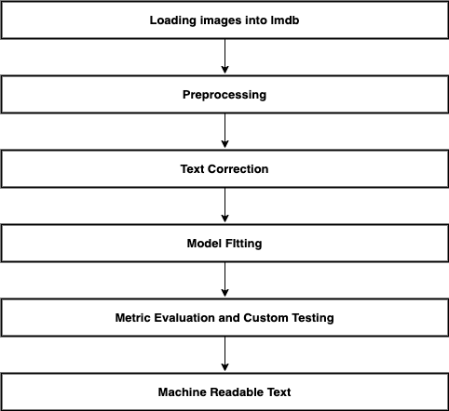
Figure 2:Module connectivity diagram

This diagram shows how important the flow process and the interconnectivity of the different modules involved in the system are in the effective handling of image processing, text recognition, and correction activities. Every module has a different mission, all of which contribute towards the smooth flow of data from the loading of images to generating machine-readable text.

- Loading Images into LMDB: The first module is "Loading Images into LMDB," which handles images from different sources to LMDB. These can be views such as external databases, remote cloud storage, and local repositories. This will assure ordered access to all the images that are needed for the subsequent processing steps.
- Preprocessing: After loading an image, it will finally undertake all the necessary transformations in view of the "Preprocessing" module so that the original image is ready for further processing and analysis. Other preprocessing may include resizing images, converting them into gray scale, normalizing pixel values, clearing noise, and enhancing image quality. This type of preprocessing standardizes input data and guarantees consistency, enabling accurate analysis in successive stages.
- Text Correction: The "Text Correction" module comes into the picture after extracting text from images using Optical Character Recognition. This module refines the extracted text by correcting the errors, making it grammatically correct, and fine-tuning it in the context. This will be very helpful in the production of reliable output text and making it fit for further tasks.
- Fitting the Model: The "Model Fitting" module is used for training or deploying a machine learning model on the processed data. This includes the selection of suitable algorithms, training models on pre-processed images and corrected text, and hyperparameter tuning to achieve better performance. It uses such trained models to recognize words or classify images, formerly unseen, according to new input data.
- Metric Evaluation and Custom Testing: The "Metric Evaluation and Custom Testing" module performs a thorough evaluation of the performance of the deployed models. In this case, accuracy, precision, recall, and the F1 score are critical evaluation metrics since they define how good the models are and if they fit predefined criteria. The models' robustness withstanding disturbances and generalizing well in other conditions is unbiasedly tested through scenarios of custom testing.
The output from the previous stages then feeds into this last "Machine Readable Text" module, transforming the recognized and corrected text into a form easily interpreted and utilized with other systems. This may include formatting the result in formats like XML, JSON, or even flat plain text files for easier compatibility and accessibility.From image loading to generating machine-readable text, everything is in structured flow. This ensures logical progression where the output of each module is fed as input to the next stage. Such a sequential approach to the process not only allows for efficient handling of data but also ensures better accuracy, reliability, and usability for the entire process in tasks like handwritten character recognition systems.
3.2.3 Software and Hardware Requirements:
To build a powerful and effective system, handwritten text recognition using LMDB will necessitate hardware and software setup that is adequately configured to make up the system; these will be critical elements in making the system effective, reliable, and performance-oriented in loading images, preprocessing them for text correction, training models, and finally generating output in machine-readable formats.
Software Requirements
- Operating System: The development and operationalization of handwritten text recognition systems require the right operating system. Options, especially Linux distributions, including Ubuntu, CentOS, Debian, are very highly recommended in server environments because of their strong support for a wide array of machine learning libraries. Though in development and desktop environments, Windows would have more relevance because it might be compatible with most deep learning frameworks. MacOS is popular among developers due to its Unix-based environment and supports many open-source libraries used in machine learning tasks.
- Programming Languages: In general, Python remains a premier and primary language for building machine learning and deep learning applications due to the fact that it's easy to use and has extensive library support. This forms core implementation in various modules of a handwritten text recognition system. Some scenarios where this approach is particularly valid are high-speed data processing, which includes C++ in large measure.

Libraries and Frameworks
- Deep Learning Frameworks: These are very important libraries in the development and training involved in deep learning models. TensorFlow has huge resources for training and modeling of deep learning models; it is also supported by a large community that provides help and updates. The main points for PyTorch are due to the presence of dynamic computation graphs; hence, it is very relevant for research and development in machine learning applications.
- OCR Libraries: Tesseract in OCR represents a very strong, open-source engine extracting text from images. It has a very important role in the preliminary extraction of the text, followed by far downstream processes for processing and correcting text for accuracy and reliability.
- Data Processing Libraries: NumPy and Pandas are core libraries with respect to array handling, numerical operations, and the efficient management of tabular data. NumPy represents the touchstone of functionality for array manipulation, while Pandas abstracts a great deal within data manipulation tasks, particularly helpful during the preprocessing and analysis phases.
- Image Processing Libraries: OpenCV and Pillow (PIL) connect with a wide range of image processing. OpenCV has an extended set of functions for augmentation, transformation, and filtering of images that will be needed in this pipeline to improve the quality of images before performing OCR and training a model. Pillow makes the importing, scaling, and basic transformations of images easier, hence maintaining compatibility with the different formats and requirements needed in the images.
- LMDB Libraries: The Python LMDB module is a critically needed tool for the LMDB database, especially with respect to efficiently storing and retrieving image data together with associated metadata. Through a memory-mapped architecture, it is capable of fast access to data without being hit by traditional disk I/O operations. Therefore, this becomes very suitable for managing the large-scale image databases in handwritten text recognition systems.

Other Tools: Extra tools to the software stack would include Scikit-learn, additional to deep learning and for machine learning tasks in general, and libraries for data visualization like Seaborn or Matplotlib. These tools extend the capabilities of the system in handling a wide range of tasks, from the evaluation model used for machine learning to data interpretation and presentation.
Development Tools: The basic development and experimentation phases may be supported by choosing a suitable IDE, like PyCharm, VS Code, Jupyter Notebook, or any other favorite IDE to do the job. These environments provide facilities for writing, debugging, and testing codes while keeping workflow management efficient across the development lifecycle. The development phases would also require version control facilities to manage code revisions, collaborative teamwork, and tracing of changes through all the different iterations of the software.
Database: Image data and metadata are effectively managed using an efficient database solution. LMDB will be employed as a robust key-value store database that has memory-mapped functionality for high throughput and efficiently handling large image datasets. It supports high-speed access and storage of data; therefore, its design makes it quite suitable for integration with the image processing pipeline in handwritten text recognition systems.

Hardware Requirements
- Processor:A strong multi-core central processing unit is needed to properly run parallel processing tasks in image preprocessing, data loading, and model training. For instance, processors like AMD Ryzen 7 series or Intel i7 allow enough computational capacity to deal with heavy computations and tasks simultaneously, thus optimizing the system for a lot of demanding operations.
- Memory (RAM): Enough RAM is important in the manipulation of datasets of different sizes. A minimum of 16GB RAM works satisfactorily for small to medium-size datasets, although 32 GB or larger would be considered for larger datasets and extensive image manipulation with complex training of deep learning models. Enough capacity of RAM reduces memory swapping between the RAM and the hard disk drive, enabling smooth operation of the system during resource-intensive tasks.
- Storage: The devices must be equipped at a minimum with a Solid-State Drive of 500 GB to avoid I/O bottlenecks and ensure high-speed read/write performance.Using SSDs, one has quick access and retrieval of data—quite essential in handling such large amounts of image data in an efficient method at the stages of inference, training, and model deployment.
- Other Hardware: High-resolution monitor and other additional hardware—the former assists extra-best view of the images, data, and model outputs for complete understood analysis. This is, however, not necessary, as a graphics tablet can help in manual annotation or editing of handwritten content to provide the interface with the user by sending intricate operations for recognition and text rectification.

Detailed Workflow
The entry point to the workflow is the "Loading Images into LMDB" module, where images are sourced from external databases, cloud services, or local storage, organized, and stored in the LMDB database. This step is necessary for structuring the image data to be used in further processing.The "Preprocessing" module makes the images uniform through resizing, grayscale conversion, pixel normalization, noise reduction, and all other kinds of enhancements that will ensure the images are in a form ready for accurate analysis and interpretation in later workflow stages.After preprocessing, the module "Text Correction" extracts text from images using OCR methods, which will again be further refined in spelling correction, grammar correction, and contextual changes. Thus, the extracted text will be very accurate and reliable for further analysis or other processing works.The "Model Fitting" module trains or applies the machine learning model under suitable algorithms with titles and applies parameter tuning to optimize the performance of the trained model. Tasks like word recognition or image categorization are achieved through these trained models and offer key pieces of information from the processed data.
The module "Metric Evaluation and Custom Testing" evaluates metrics like the F1 score, recall, accuracy, and precision among others after model training. Then, it carries custom testing to investigate the robustness of the model to generalize a wide variety of datasets and scenarios. This is done to make sure that the model meets all the standards on performance and quality.
The "Machine Readable Text" module renders the validated and processing text into machine-readable formats, which may include JSON, XML, or even a plain text file. This form of output makes it easy to feed it directly into further downstream systems for additional analysis, interpretation, and use of the identified handwritten content of the images according to specific needs.
In a nutshell, an HWTR system that performs well makes use of a strategic balance of hardware and software elements. These include fast SSD storage for accessing data, multi-core CPUs to run in parallel, large RAMs able to hold large datasets, and finally but importantly, powerful NVIDIA GPUs for model training speed-ups. Python serves as the core programming language that is supplemented by deep learning frameworks like TensorFlow or PyTorch, libraries focused on OCR and image processing, and, finally, LMDB for optimized data management. These combined components provide a continually coherent and efficient solution to deal with difficult tasks related to handwritten text recognition in a more precise, reliable, and faster way.

3.3 Modules in the project (module with UML):
1. Loading Images into LMDB:
LMDB (Lightning Memory-Mapped Database) is an open-source, high-performance key-value database management system. LMDB is designed for memory mapping. All the stored data are accessed directly from memory, reducing the expensive disk I/O operations to a minimum. This makes LMDB quite suitable for highly demanding applications such as embedded systems and large-scale data processing tasks.
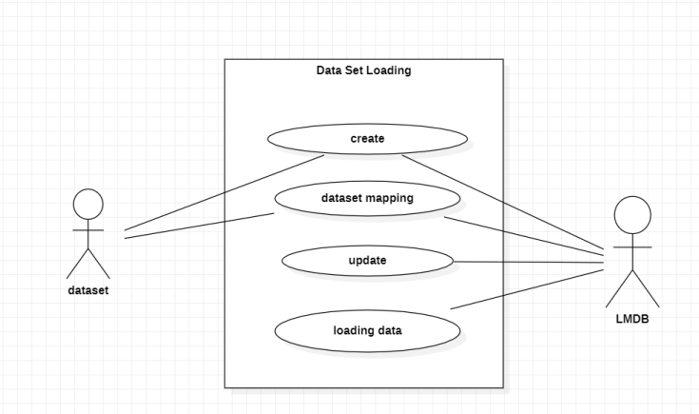
Figure 3: Loading into Lmdb

2.Preprocessing

Preprocessing is an acoustic signal elaboration procedure by which data is prepared for further analysis. It should ensure improved performance and accuracy in machine learning models and analyses at large. Depending on the quality of preprocessing operations such as grayscale conversion, resizing, binarization, and normalization, model effectiveness and performance will be high.

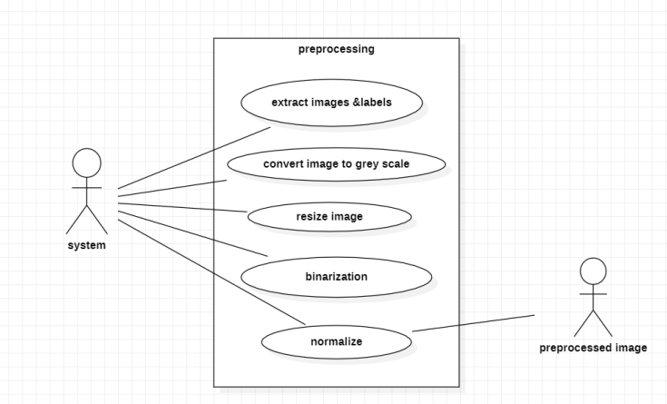
Figure 4: Preprocessing

3. Model Fitting
It is called "model fitting" since it is a very essential step for the training of any machine learning or deep learning model to be certain that the model fits well on the data and can recognize or transcribe handwritten texts. This process initiates with the preparation of images waned with handwritten texts, together with their ground-truth labels in a dataset. We then use this data to train some of the selected model architectures, including state-of-the-art Transformer-based models or recurrent models, such as Long Short-Term Memory, and, finally, convolutional neural networks.

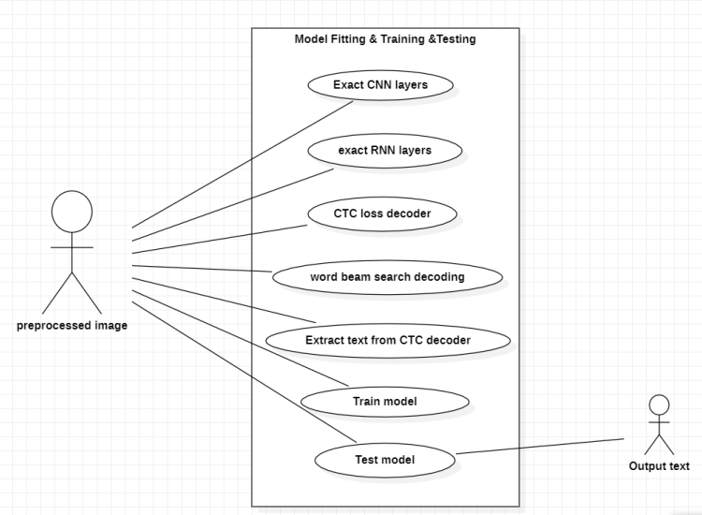
Figure 5: Module Fitting

4. Metric Evaluation& Custom Fitting:
Evaluating these metrics is therefore necessary to establish how accurate and effective the trained models really are. These metrics bring out the objective dimension of how well models transcribe images of handwritten texts to text. One key metric applied is the Character Error Rate, which measures the ratio of misrecognized characters against ground truth in percentage form. These evaluations are therefore crucial for benchmarking model performance, guiding improvements, and ensuring the reliability of handwritten text recognition systems in practical applications..

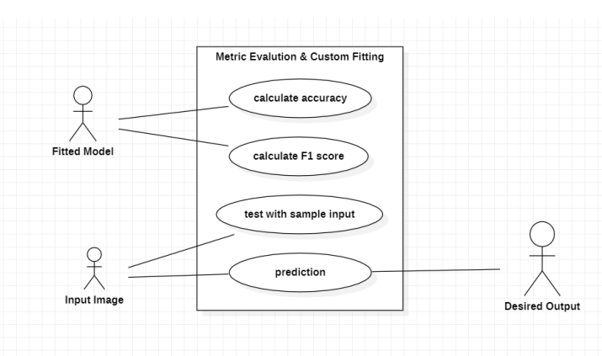
Figure 6: Metric Evaluation

3.4 Requirements Engineering
Functional Requirements: This system of handwritten text recognition is developed for the automatic detection and correct transcription of handwritten text in images. The capacity of the system includes multilingualism and high accuracy in the processing of individual words and complete text lines, including their shape features. It shall also be able to perform image pre-processing for quality enhancement, noise and distortion handling, and mitigation of light variation. Moreover, it has to provide a user-friendly interface for uploading pictures, configuration of recognition settings, and the display of results. This should be seamlessly integrable into any other workflow or software system in existence and suitable for a wide array of applications that range from scanning historical documents to analyzing handwritten notes, and likewise digitized form extraction.
Nonfunctional Requirements: The system with high accuracy and reliability regarding text recognition is also supposed to maintain its accuracy with respect to a variety of handwriting styles and states of documents. It is also performance-sensitive, meaning that the system is supposed to process imagery in reasonable times without putting too high a demand on computational resources. Scalability will be required to support growing data sets and language extensions. The technique should guarantee data safety and security, particularly in the case of sensitive or personal information. Usability is another consideration; an interface that is easy to use must be available to persons who come from all technical skill bases.
Finally, transparency and explainability of the identification process must be guaranteed for building trust between the system and the user, or later in diagnosing errors.

3.5 Analysis and Design through UMLClass Diagram:

3.5.1 Class Diagram

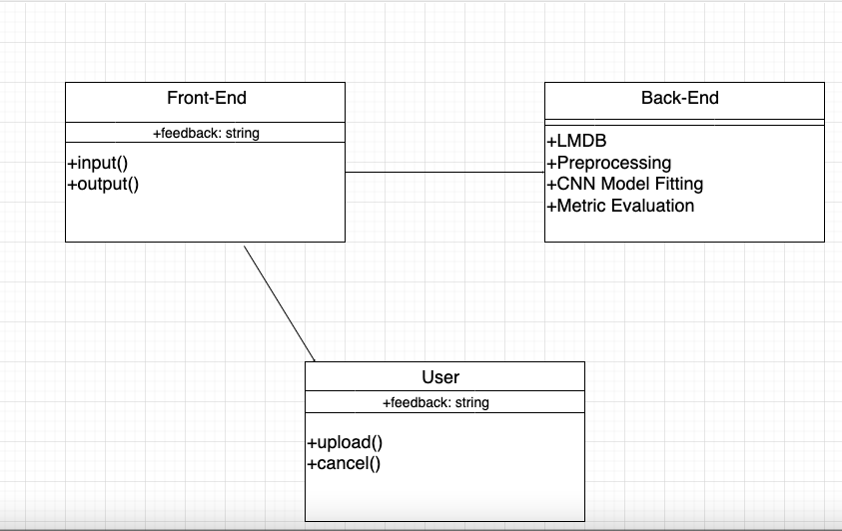
Figure 7:Class Diagram

3.5.2 Sequence Diagram

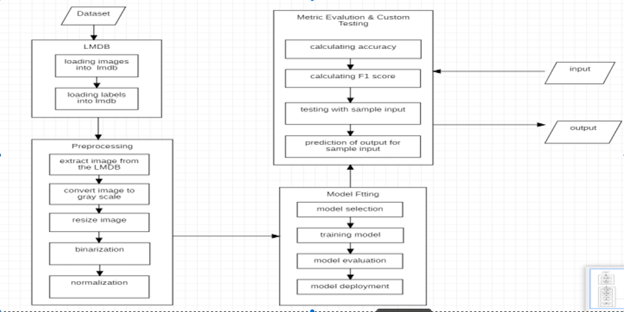
Figure 8:Sequence

3.5.3 UseCase Diagram

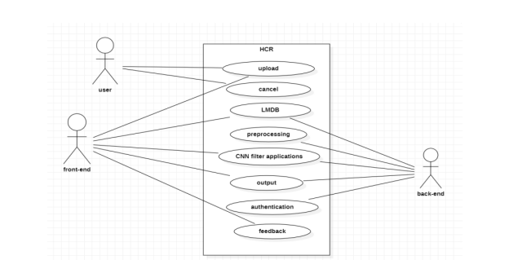
Figure 9:Usecase

3.6 Testing
Testing is an important phase of software development. It is essential to ensure that the developed software application or system works according to the specified requirements. Its prime goals are searching for errors, ensuring quality, and validating whether the intended functionality works efficiently and reliably under different conditions. There are various types and techniques of testing, each focused on verifying different aspects of software performance and behavior.
Types of Testing
The various types of testing are categorized on several other criteria, including scope, the stage of development, the level of automation, and objectives of testing. Here are some common types of testing that occur during software development:
- Unit Testing: Unit testing checks whether independent components or modules in the software system work as expected. Each unit has to work according to the requirement so that it should be detected and the errors should be fixed at the very early stages of development.
- Integration Testing: Integration testing ensures that integrated units or modules interact and exchange data adequately with each other. It makes sure that problems arising from the combination of too many components are recognized, and communication between them and their functionality are smoothly processed.
- System Testing: System testing looks at the entire integrated software system to validate that it meets all specified requirements and that it functions as intended across a wide range of scenarios. This test case covers the checking of overall system performance and system behavior.
- Acceptance Testing: In the acceptance testing phase, the software has to meet the user acceptance criteria itself and is prepared for deployment. It ensures that the software has met all the requirements of the users' expectations and has also followed the preset standards for release.
- Regression Testing: Regression testing is the re-execution of some selected tests to ensure that changes do not affect the existing functionality. It also protects against unintended impacts or problems deriving from modification and enhancement.
- Performance Testing: Performance testing ensures that the execution time and response times of the software, under different workloads, remain within a specified expected range.
- Security Testing: Basically, security testing identifies the vulnerabilities or weaknesses of the software system and provides protection measures against various kinds of threats and attacks.

Techniques of Testing
Many testing techniques are currently used to obtain different coverage and identify flaws well:
- Black Box Testing: Testing of software functionality without reviewing the internal code structure. Some techniques used are Equivalence Partitioning and Boundary Value Analysis.
- White Box Testing: Testing that involves looking at the internal structure or operation of an application. Techniques include code coverage analysis and path testing.
- Gray Box Testing: This is a combination of the black box techniques and White Box Testing. The testers will have partial knowledge about the internal operations of the application.
- Static Testing: This is a test that comprises a review of the code, specifications, and design documents and excludes the execution of code. It seeks to determine the defects at an early phase of development.
- Dynamic Testing: It executes the code to test its behavior with different inputs and to ascertain that expected output is displayed.

Testing in HCR System Project
A variety of types and techniques of testing have been applied to ensure a reliable and accurate HCR system project:
- Unit Testing: Rigorous testing is done over the functionality in isolation of individual modules that include image preprocessing and character recognition algorithms.
- Integration Testing: This would test the integration of different modules in the system, like loading images with the recognition modules, for smooth interaction and flow of data between them.
- System Testing: The whole HCR system will be tested to confirm that the system meets specified requirements and performs the intended functions with effectiveness in various test scenarios.
- Performance Testing: System performance was tested under various conditions to make sure that it handled large data and did recognition tasks efficiently.
- User Acceptance Testing (UAT): The system has undergone testing using real data by end users themselves, so its efficacy in solving the needs and expectations of the end users could be validated.
- Regression Testing: Changes or addition of new features did not impact pre-existing features because they were subject to regression testing also.
- Security Testing: The testing was conducted so that probable vulnerabilities could be identified and prevented to guarantee that the system was secure, safe, and resilient to security threats.

Overall, testing is one of the key considerations in development for any system to ensure its quality, reliability, and functionality during all the stages of the software system development process. With the integration of test types and techniques into the process, developers could be better at detecting and resolving errors in initial stages of the SDLC, validate software functionality, and verify its conformance in terms of specified user requirements. Proper testing played a significant role in delivering a robust and efficient system for recognizing handwritten characters in the HCR system project. In the HCR system project, the fact that testing was handled in a professional and organized way underlines its importance in the delivery of quality software products that will fulfill user requirements and comply with industry standards.

CHAPTER - 4
RESULT AND DISCUSSION

4.1 Description about Dataset

Images of handwritten text with notations or labels of text come to form basic datasets for HTR, where an efficient way of storing and retrieving them is by using LMDB technology. The size of these datasets ranges from hundreds to millions of images. There are also great varieties of fonts and styles and languages. All these datasets are pre-processed before training for the normalization of images and their corresponding labels. Other methods for making the models generalization-capable include data augmentation techniques. Moreover, during training, it is very helpful to deal with these datasets in LMDB format in order to make the data accessible fast without the_Osc performance issues typical of disc-based conventional storage systems.

Overview of Datasets
In HTR, research and development are performed based on a small number of well-known datasets for a range of languages and script types. The list includes the following:

1. IAM Handwriting Database:
The IAM Handwriting Database is probably the most famous database among researchers of this area, containing English texts in handwriting by more than 600 different scribes. It consists of several scenarios in writing, sentences, forms, and text lines. It is considered to be a standard dataset for the training and testing of HTR systems.
2. RIMES Database:
The RIMES Database is mainly oriented to handwritten material in French. It is a great tool to study scenarios related to historical writing styles. It has a great variety of handmade texts extracted from historical manuscripts and early printed books, which supports tasks such as OCR and document analysis within a French language environment.

3. Census Heritage Dataset:
The Census Heritage Dataset includes multi-lingual handwritten paragraphs in English, Arabic, Bangla, and others; it is taken from archival sources, historical documents, and census records. What this dataset presents is an enormous level of diversity in terms of the conditions and different kinds of handwriting that can be used to test and train various HTR and OCR algorithms on these different writing systems.
4. Bentham Dataset:
The Bentham Dataset focuses on handwritten historical documents authored by the English philosopher Jeremy Bentham. It comprises a large dataset of handwritten pages showing the high variety of historical handwritings current during the 18th and 19th centuries. This dataset is usually used by researchers to test their work related to tasks such as historical document analysis, optical character recognition, and developing algorithms that are able to handle the complexities of historical handwriting.

Role of datasets in HTR
These datasets are, thus, very important tools for any researcher or developer working in the HTR area to benchmark and test algorithms on a wide range of handwritings and challenges posed by historical manuscripts. Each dataset contributes diverse features and complexities of handwritten texts mirroring intricacies of human writing—a task quite challenging for automated recognition systems.

Challenges and Applications
Hand-written manuscripts are very variable and historical, hence special challenges to HTR systems. Examples of these include the different styles of writing and degraded text quality over time, with a high demand for robustness for dealing with distinct languages and scripts. It is possible to efficiently manage and retrieve data needed for developing accurate and scalable HTR solutions with very divergent real-world applications by applying LMDB technology side by side with these datasets.

Future Directions
This can be expected in the near future, with extension of datasets to cover as many languages and historic periods as possible and an enriched variety of writing styles. Further, machine learning techniques, particularly deep learning architectures such as Convolutional Recurrent Neural Networks, will further improve the accuracy and adaptability of HTR systems. Large volumes of datasets and advanced techniques of data management have helped LMDB, for instance, to consider expert researchers in newer dimensions of applications for handwritten text recognition a step ahead toward advanced digital archiving, transcription services, and document analysis in domains such as cultural-heritage preservation to administrative record management.

4.2 Detailed explanation and experimental results

This work is conducted in order to push forward the boundaries of HTR systems, leveraging the power of the very promising Lightning Memory-Mapped Database technology. Probably the most challenging task in HTR is recognizing handwritten text from digital photographs due to the huge variability in handwriting styles. Consequently, good management of huge datasets in a system is crucial for high performance in this domain; hence, features offered by some of the high-performance memory-mapped database tools, such as LMDB, are indispensable. This would aim principally at feature extraction, increasing the accuracy of recognition, and the enhancement of general efficiency in the system.

Research Aims
The main aim is to integrate LMDB into the HTR system for efficient data storage, retrieval, and training.

Methodology
It shall span the following steps:
- Data Preparation: Involving either obtaining or generating datasets that will suit the training and testing of the developed HTR models; these can be tools like the IAM Handwriting Database or the RIMES dataset, among others mentioned.
- Pre-processing: Improve the quality of input images with preprocessing techniques like noise removal, binarization, resizing, and normalization. All these steps are necessary to make the recognition system more robust.
- Feature Extraction: Extract relevant features from preprocessed images using state-of-the-art techniques involving Convolutional Neural Networks or other deep learning models. It would help learn the primary characteristics and patterns of handwritten text.
- Database Integration (LMDB): Store these extracted features with their corresponding labels or ground truth text in LMDB format. In relation to this, LMDB becomes handy since it is efficient for handling large datasets and does not suffer from the headache of disk I/O operations.
- Model Training: Train a machine learning model on the extracted features to learn the mapping from input images to textual representations; one popular choice for this task is the Convolutional Recurrent Neural Network.
- Validation and Testing: Check the performance of the trained model on validation and test datasets to make sure that performance metrics such as accuracy, precision, recall, and F1-score do exist.
By applying this framework, incorporating LMDB into the system of this HTR is likely to be very useful, enhancing its ability in recognizing handwritten texts from various sources and transcribing them correctly to satisfy the dynamic demands in that respect.

Input Image:
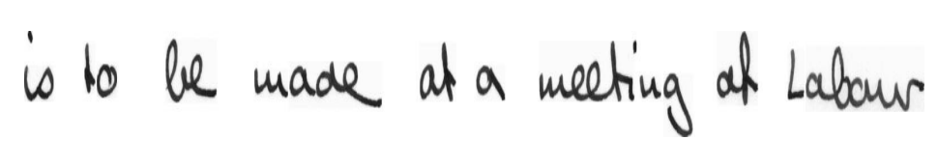Figure 10:input

Output :
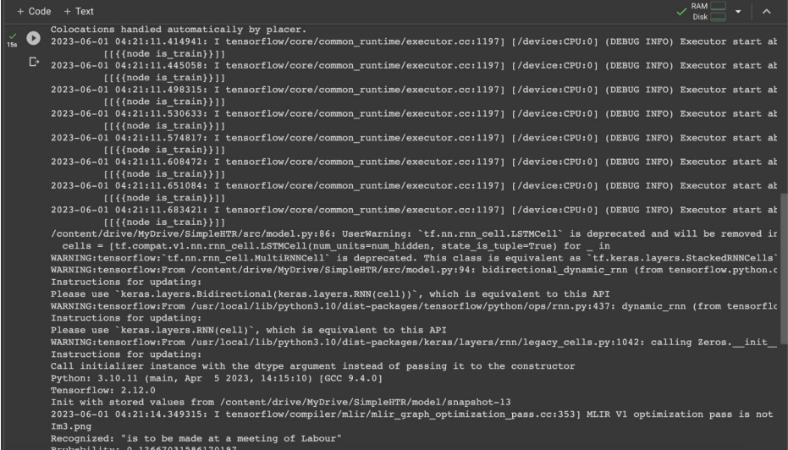
Figure 11:Output

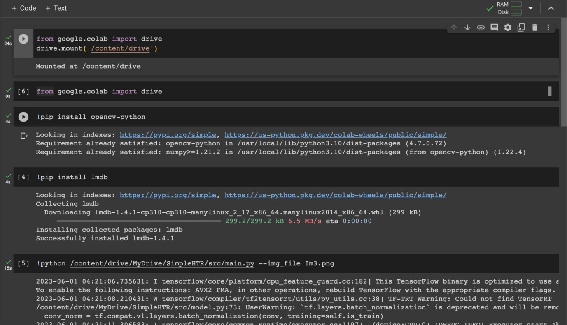
Figure 12:Output
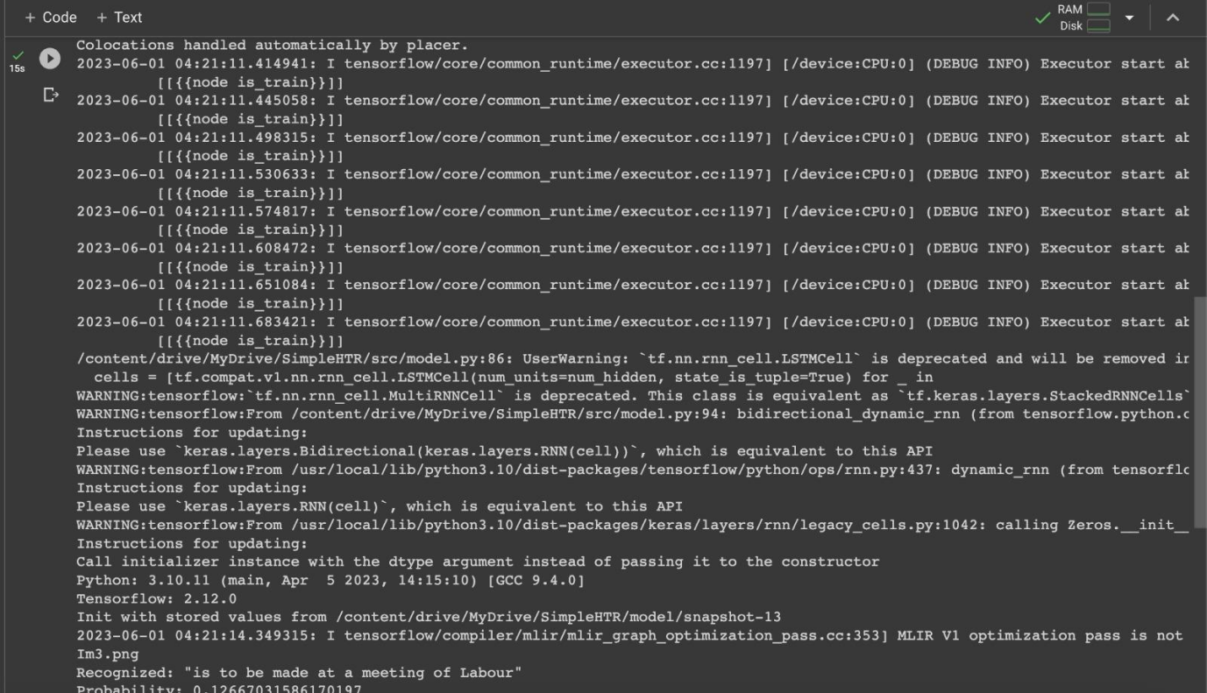
Figure 13:Output

 | Input  Image | Result
1. | 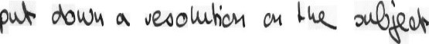 | 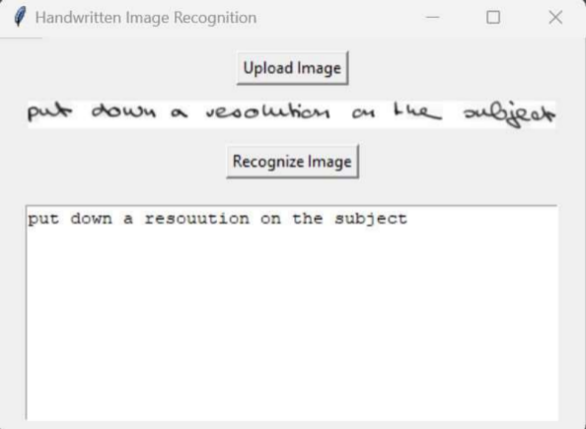
2. | 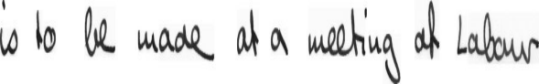 | 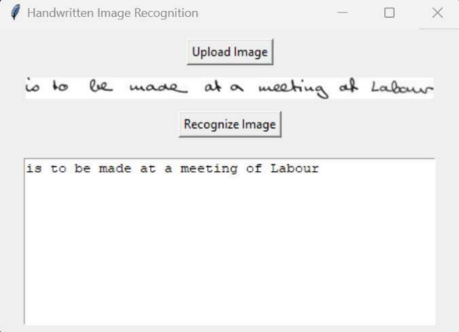
3. |  | 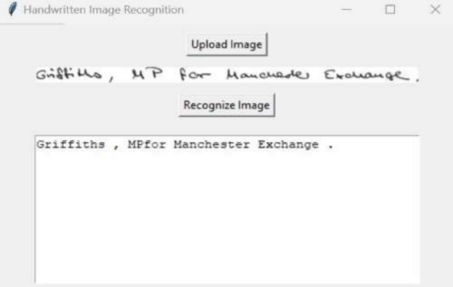
4. |  | 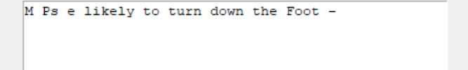
5. | 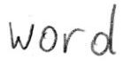 | 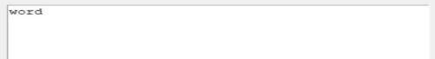
6. |  | 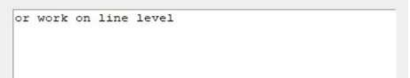
table-2.2 output

4.3 Significance of the proposed method with its advantages
HTR assumes significant importance in the most recent period in today's digital world because it allows for speed in digitization, analysis of data, and retrieval of information through correct identification and extraction of handwritten textual content from images. Therefore, it is applicable in many such areas as intelligent character recognition, automated transcription, document digitization, and archival purposes. It is within the past decade that HTR systems have undergone tremendous enhancement regarding accuracy and reliability, automating operational procedures and wilfully creating innovative solutions within sectors such as banking, health, and education. This means that if these technologies continue to improve, the possible impact and reach will only keep increasing. One of the technologies that can greatly improve HTR systems is the Lightning Memory-Mapped Database, abbreviated as LMDB. LMDB's distinct design offers several advantages uniquely suited to managing the complexities associated with handwritten text recognition:

- Effective Data Storage and Retrieval: The memory-mapped architecture in LMDB enables very fast access to data stored in it, normally encumbranced by usual disk I/O operations. This becomes very critical in HTR systems, especially at times of handling enormous amounts of image data. This will help the LMDB efficiency in data retrieval to enable system responsiveness and speed up the whole processing.
- Scalability: Scalability is demanded by HTR systems to support wide variations of writing style, languages, and increasing data. By design, LMDB supports this scalability without any hitch in the most efficient management of expanding datasets without any loss in performance. The importance of this scalability will be enormous once an HTR system gets into the real-world applications where differences in data volumes are huge.
- Improved Feature Extraction: Effective feature extraction should therefore be able to extract meaningful patterns from handwritten text. With LMDB, HTR systems can store image features together with ground truth text or labels. This is to help enable advanced methods of feature extraction that may increase the accuracy and robustness of recognition models.
- Optimized Training and Testing: In the iterative process of model development, quick access to the data stored in LMDB speeds up not just the training phase but also the testing phase. This way, such optimization reduces time used for the tuning of parameters and experimentation, hence shortening the development cycle of an HTR system.
- Reduced Computational Overhead: LMDB makes data management more effective and less computational than conventional databases, very useful when deploying HTR systems on edge devices with low resources or under environments with poor computation resources.
- Application Versatility: Integration with LMDB enables HTR systems to perform more accurately at faster speeds, exploiting their flexibility in a good number of applications, including intelligent character recognition, archival document processing, automated transcription services, comprehensive document digitization, etc.
- Advancements in Research and Development: The integration of LMDB into HTR systems extends already existing functionalities, enabling completely new perspectives of research and development. Based on efficient data management provided by LMDB, modern algorithms and methodologies can be developed that further raise the bar on performance with respect to HTR systems.
In summary, the implementation of Lightning Memory-Mapped Database into handwritten text recognition systems represents significant progress in solving fundamental issues at the levels of data management, scalability, and performance improvement. Using LMDB, HTR systems will perform with higher accuracy, speed, and flexibility in innumerable applications. As these techniques evolve through constant research and development, the potentials that handwritten text recognition will have to impose itself among various industries and simplify digital workflows correspondingly increase.

CHAPTER - 5
CONCLUSION AND FUTURE ENHANCEMENTS
Conclusion:
Therefore, it focuses on transcribing handwritten texts from their digital images, which exhibit varied styles and complexities. A fundamental cornerstone in the performance of HTR systems is LMDB. LMDB is a high-performance embedded database that efficiently stores and retrieves data with minimal disk I/O overhead. These robust capabilities make LMDB particularly well-suited for integration with HTR systems, enhancing the efficiency of feature extraction and recognition processes while potentially improving accuracy and overall efficiency.Integration of LMDB in HTR systems is not only necessary for better training and enhanced capabilities with respect to data retrieval and storage but is also the domain enabler in the areas of intelligent character recognition, automated transcription, document management, and data analysis. Respectfully, efficient digitization and information retrieval of handwritten texts become of prime importance. Speed and smooth integration make LMDB very beneficial because it reduces computational overhead, enhances scalability, and boosts overall system performance.The concept of integrating LMDB within the HTR pipeline has to do with using its expertise in managing a character's handwriting variability. The system would want to execute or read data as quickly as possible to ensure real-time processing, ergo ensuring accuracy in text recognition tasks by effectively making use of the memory mapping features in LMDB. Such a methodology of integration shall help illustrate tangible gains with respect to accuracy and efficiency over conventional techniques.

Future Enhancements:
Initial empirical results show that LMDB integration has significantly improved performance metrics in terms of accuracy and processing efficiency. Processing time sped up after incorporating the LMDB-enhanced HTR system, with higher rates in recognition, thus covering a wide spectrum of writing styles and complexities. This denotes optimization in data access and retrieval processes—mapping, in fact, to the ability of the system to cope with large amounts of data without necessarily losing accuracy.
- Future Enhancements and Innovations: Future advancements in Handwritten Text Recognition (HTR) are poised to further elevate accuracy, efficiency, and applicability, particularly with the integration of LMDB and other effective data management systems:
- Advanced Deep Learning Architectures: Research will continue to go deeper and more complex deep learning models tailored for HTR. Innovations may be oriented toward Transformer-based models, RNNs, CNNs, or hybrid architectures. All of these are very important to capture complex patterns and contextual dependencies inherent in handwritten text.
- Multi-Modal Fusion: Integration of data from multiple sources in an HTR system provides better recognition when applying textual and spatial elements. Fusion approaches result in stronger models for handling varied layouts or, conversely, very different styles of handwriting.
- Domain Adaptation and Transfer Learning:The strategies designed here will be for domain adaptation and transfer learning to enhance the adaptability of the HTR systems toward new datasets or even various styles of handwriting. Pre-trained models and knowledge transfer techniques will assure improved performance on specific target domains.
- Interactive Learning and Feedback Mechanisms: Interactive learning with feedback mechanisms correct recognition errors, improving the model iteratively for better performance. Active learning strategies consist of user-provided adjustments to train data that make the system more accurate overtime.
- Few-Shot Learning and Meta-Learning:The techniques of meta-learning will be researched for speeding up the process of knowledge acquisition from sparsely labeled data. Through few-shot learning, HTR models generalize from just a few annotated samples and hence easily adapt to a "never-seen" writing style or language within a short period of time.
- Improved Preprocessing and Data Augmentation: Advanced preprocessing methods shall be developed vis-a-vis data augmentation, noise reduction, and image quality. Standardization of input images offers better robustness to the model against changing document conditions, writing styles, and ink quality.
- Effective Training and Inference Techniques: Distributed computing frameworks that build upon distributed computing and hardware accelerators, such as GPUs and TPUs, will lighten the procedures for training and inference. This improvement is done in a view to optimizing computing time and resource consumption and thus will aid scaling towards larger datasets and real-time applications.
- Contextual and Semantic Understanding: This has been about endowing HTR systems with contextual and semantic understanding, Gestalt features of which would be language models or embeddings. This enhances recognition accuracy, as it takes into consideration the semantic meaning or content of a text and the broader writing context.
- Adaptive and Self-Learning Systems:The next generation in HTR systems will rest on adaptive and self-learning capabilities. These kinds of intelligent systems will learn to adjust themselves automatically to any change in data distributions, user preferences, or even handwriting styles and guarantee sustained improvement in performance over time.
- Application-Specific Customization: Further customization of HTR systems with regard to special applications—from processing forms by hand to processing historical documents including personal data or even medical information—will be carried out for maximum accuracy and user satisfaction. Models and training data are designed for specific use case scenarios to maximize its reach.

- Ethical Considerations and Bias Mitigation: Key considerations for deploying HTR systems, especially in sensitive applications, relate to ethical issues, fairness, and mitigation of bias. It also helps improve social trust through secure, fair deployment, including inclusively impartial recognition across other demographic groups and handwriting styles.
With the rapid development of the HTR technology, its integration into LMDB, and new inventions underway, this technology definitely can be applied to increase precision, speed up workflow procedures, and enhance versatility in many diverse domains and applications. They are powered by innovations in deep learning, data management, and user interface design to fulfills the potential of HTR in the effortlessness of converting handwritten text to applicable digital formats.

CHAPTER -6
APPENDICES

Sample Code:
import random
from typing import Tuple
import cv2
import numpy as np
from dataloader_iam import Batch
class Preprocessor
def __init__(self,
img_size: Tuple[int, int],
padding: int = 0,
dynamic_width: bool = False,
data_augmentation: bool = False,
line_mode: bool = False) -> None:
# dynamic width only supported when no data augmentation happens
assert not (dynamic_width and data_augmentation)
# when padding is on, we need dynamic width enabled
assert not (padding > 0 and not dynamic_width)
self.img_size = img_size
self.padding = padding
self.dynamic_width = dynamic_width
self.data_augmentation = data_augmentation
self.line_mode = line_mode

@staticmethod
def _truncate_label(text: str, max_text_len: int) -> str:
cost = 0
for i in range(len(text)):
if i != 0 and text[i] == text[i - 1]:
cost += 2
else:
cost += 1
if cost > max_text_len:
return text[:i]
return text
def _simulate_text_line(self, batch: Batch) -> Batch:
"""Create image of a text line by pasting multiple word images into an image."""
default_word_sep = 30
default_num_words = 5
# go over all batch elements
res_imgs = []
res_gt_texts = []
for i in range(batch.batch_size):
# number of words to put into current line
num_words = random.randint(1, 8) if self.data_augmentation else default_num_words
# concat ground truth texts
curr_gt = ' '.join([batch.gt_texts[(i + j) % batch.batch_size] for j in range(num_words)])
res_gt_texts.append(curr_gt)
# put selected word images into list, compute target image size
sel_imgs = []
word_seps = [0]
h = 0
w = 0
for j in range(num_words):
curr_sel_img = batch.imgs[(i + j) % batch.batch_size]
curr_word_sep = random.randint(20, 50) if self.data_augmentation else default_word_sep
h = max(h, curr_sel_img.shape[0])
w += curr_sel_img.shape[1]
sel_imgs.append(curr_sel_img)
if j + 1 < num_words:
w += curr_word_sep
word_seps.append(curr_word_sep)
# put all selected word images into target image
target = np.ones([h, w], np.uint8) * 255
x = 0
for curr_sel_img, curr_word_sep in zip(sel_imgs, word_seps):
x += curr_word_sep
y = (h - curr_sel_img.shape[0]) // 2
target[y:y + curr_sel_img.shape[0]:, x:x + curr_sel_img.shape[1]] = curr_sel_img
x += curr_sel_img.shape[1]
# put image of line into result
res_imgs.append(target)
return Batch(res_imgs, res_gt_texts, batch.batch_size)
def process_img(self, img: np.ndarray) -> np.ndarray:
"""Resize to target size, apply data augmentation."""
# there are damaged files in IAM dataset - just use black image instead
if img is None:
img = np.zeros(self.img_size[::-1])
# data augmentation
img = img.astype(float)
if self.data_augmentation:
# photometric data augmentation
if random.random() < 0.25:
def rand_odd():
return random.randint(1, 3) * 2 + 1
img = cv2.GaussianBlur(img, (rand_odd(), rand_odd()), 0)
if random.random() < 0.25:
img = cv2.dilate(img, np.ones((3, 3)))
if random.random() < 0.25:
img = cv2.erode(img, np.ones((3, 3)))
# geometric data augmentation
wt, ht = self.img_size
h, w = img.shape
f = min(wt / w, ht / h)
fx = f * np.random.uniform(0.75, 1.05)
fy = f * np.random.uniform(0.75, 1.05)
# random position around center
txc = (wt - w * fx) / 2
tyc = (ht - h * fy) / 2
freedom_x = max((wt - fx * w) / 2, 0)
freedom_y = max((ht - fy * h) / 2, 0)
tx = txc + np.random.uniform(-freedom_x, freedom_x)
ty = tyc + np.random.uniform(-freedom_y, freedom_y)
# map image into target image
M = np.float32([[f, 0, tx], [0, f, ty]])
target = np.ones(self.img_size[::-1]) * 255
img = cv2.warpAffine(img, M, dsize=self.img_size, dst=target, borderMode=cv2.BORDER_TRANSPARENT)
# photometric data augmentation
if random.random() < 0.5:
img = img * (0.25 + random.random() * 0.75)
if random.random() < 0.25:
img = np.clip(img + (np.random.random(img.shape) - 0.5) * random.randint(1, 25), 0, 255)
if random.random() < 0.1:
img = 255 - img
# no data augmentation
else:
if self.dynamic_width:
ht = self.img_size[1]
h, w = img.shape
f = ht / h
wt = int(f * w + self.padding)
wt = wt + (4 - wt) % 4
tx = (wt - w * f) / 2
ty = 0
else:
wt, ht = self.img_size
h, w = img.shape
f = min(wt / w, ht / h)
tx = (wt - w * f) / 2
ty = (ht - h * f) / 2
# map image into target image
M = np.float32([[f, 0, tx], [0, f, ty]])
target = np.ones([ht, wt]) * 255
img = cv2.warpAffine(img, M, dsize=(wt, ht), dst=target, borderMode=cv2.BORDER_TRANSPARENT)
# transpose for TF
img = cv2.transpose(img)
# convert to range [-1, 1]
img = img / 255 - 0.5
return img

def process_batch(self, batch: Batch) -> Batch:
if self.line_mode:
batch = self._simulate_text_line(batch)
res_imgs = [self.process_img(img) for img in batch.imgs]
max_text_len = res_imgs[0].shape[0] // 4
res_gt_texts = [self._truncate_label(gt_text, max_text_len) for gt_text in batch.gt_texts]
return Batch(res_imgs, res_gt_texts, batch.batch_size)
def main():
import matplotlib.pyplot as plt
img = cv2.imread('../data/test.png', cv2.IMREAD_GRAYSCALE)
img_aug = Preprocessor((256, 32), data_augmentation=True).process_img(img)
plt.subplot(121)
plt.imshow(img, cmap='gray')
plt.subplot(122)
plt.imshow(cv2.transpose(img_aug) + 0.5, cmap='gray', vmin=0, vmax=1)
plt.show()
if __name__ == '__main__':
main()

REFERENCES

[1] Theodre Bluche and Ronaldo Messina, "Gated Convolutional Recurrent Neural Networksfor Multilingual Handwriting Recognition", in Proceedings of the 14th International Conference on Document Analysis and Recognition (ICDAR), 2017, pp. 1-10. https://doi.org/10.1109/icdar.2017.111

[2] Johannes Michael, Roger Labahn, Tobias Grüning, and Jochen Zöllner, "Evaluating Sequence-to-Sequence Models for Handwritten Text Recognition", in Proceedings of the 15th International Conference on Document Analysis and Recognition (ICDAR), 2019, pp. 280-285. https://doi.org/10.1109/icdar.2019.00208

[3] Afnan H. Garoot, Maedeh Safar, and Ching Y. Suen, "A Comprehensive Survey on Handwriting and Computerized Graphology", in Proceedings of the 13th International Conference on Document Analysis and Recognition (ICDAR), 2017, pp. 816-823. https://doi.org/10.1109/icdar.2017.107

[4] Patrick Doetsch, Michal Kozielski, and Hermann Ney, "Fast and Robust Training of Recurrent Neural Networks for Offline Handwriting Recognition", in Proceedings of the 14th International Conference on Frontiers in Handwriting Recognition (ICFHR), 2014, pp. 111-116. https://doi.org/10.1109/icfhr.2014.54

[5] Théodore Bluche, Jérôme Louradour, and Ronaldo Messina, "Scan, Attend and Read: End-to-End Handwritten Paragraph Recognition with MDLSTM Attention", in Proceedings of the 14th International Conference on Document Analysis and Recognition (ICDAR), 2017, pp. 148-153. https://doi.org/10.1109/icdar.2017.174

[6] Mehdi Ghayoumi, "Deep Convolutional Generative Adversarial Networks (DCGANs)", in Proceedings of the 15th International Conference on Document Analysis and Recognition (ICDAR), 2021, pp. 92-101. https://doi.org/10.1201/9781003281344-8

[7] Théodore Bluche, Hermann Ney, Jérôme Louradour, and Christopher Kermorvant, "Framewise and CTC training of Neural Networks for handwriting recognition", in Proceedings of the 13th International Conference on Document Analysis and Recognition (ICDAR), 2015, pp. 431-435. https://doi.org/10.1109/icdar.2015.7333730

[8] Théodore Bluche, Hermann Ney, Jérôme Louradour, and Christopher Kermorvant, "Framewise and CTC training of Neural Networks for handwriting recognition", in Proceedings of the 13th International Conference on Document Analysis and Recognition (ICDAR), 2015, pp. 431-435. https://doi.org/10.1109/icdar.2015.7333730

[9] Lambert Schomaker, "Lifelong Learning for Text Retrieval and Recognition in Historical Handwritten Document Collections", in Handbook of Document Image Processing and Recognition, Sargur N. Srihari, Ed. Singapore: World Scientific Publishing Co. Pte. Ltd., 2019, pp. 345-374. https://doi.org/10.1142/9789811203244_0012

[10] Hagar Hany Hassan and Ayla Gülcü, "Handwritten Text Recognition Using Deep Learning Techniques," in Proceedings of the 2023 IEEE 10th International Conference on Electrical Engineering, Computing Science and Automatic Control (CCE), 2023, pp. 1-6. https://doi.org/10.1109/emcturkiye59424.2023.10287418

[11] Jaspreet Kaur, Vishal Goyal, and Manish Kumar, "Improving the accuracy of tesseract OCR engine for machine printed Hindi documents", in Proceedings of the 2021 International Conference on Computational Intelligence and Data Engineering (ICCIDE), 2021, pp. 1-6. https://doi.org/10.1063/5.0101164

[12] Honggang Zhang, Jun Guo, Guang Chen, and Chunguang Li, "HCL2000 - A Large-scale Handwritten Chinese Character Database for Handwritten Character Recognition", in Proceedings of the 10th International Conference on Document Analysis and Recognition (ICDAR), 2009, pp. 439-443. https://doi.org/10.1109/icdar.2009.15

[13] Théodore Bluche, Hermann Ney, and Christopher Kermorvant, "Feature Extraction with Convolutional Neural Networks for Handwritten Word Recognition", in Proceedings of the 12th International Conference on Document Analysis and Recognition (ICDAR), 2013, pp. 1315-1319. https://doi.org/10.1109/icdar.2013.64

- Jun Ma, "A Study on a Hybrid CNN-RNN Model for Handwritten Recognition Based on Deep Learning", in Proceedings of the 13th International Joint Conference on Computer Vision, Imaging and Computer Graphics Theory and Applications (VISAPP), 2018, pp. 388-395. https://doi.org/10.5220/0012801000003885

