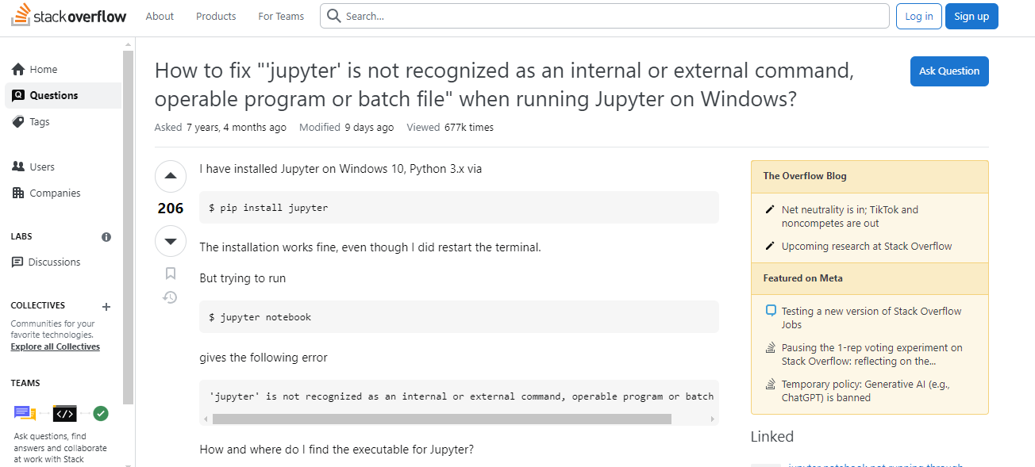

<https://www.youtube.com/watch?v=HLD-Ll_-IT4&t=33s&ab_channel=UnitedTopTech>