**TYPESCRIPT COURSE**

<https://www.youtube.com/watch?v=d56mG7DezGs&ab_channel=ProgrammingwithMosh>

**Introduction Part:**



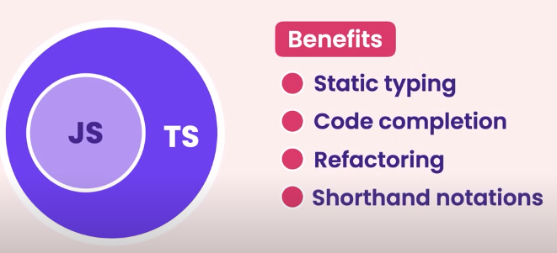

**🡺 Most of the errors are found by compilation. Typescript has its own Compiler to compile the code and transform it into JavaScript code.**

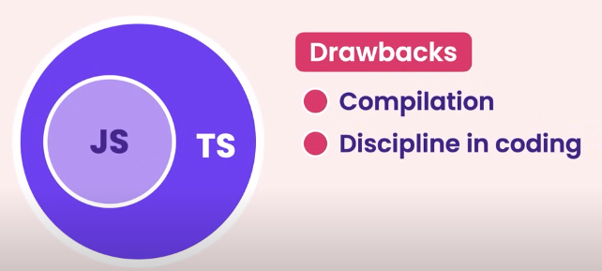

**Browser still don’t understand TypeScript, so convert it into JavaScript.**

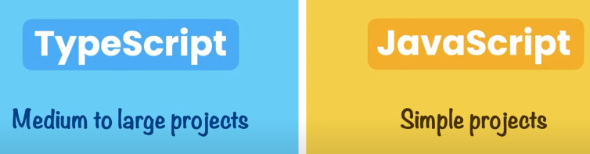

* **When we use tsc index.ts the typescript compiler creates the index.js file.**

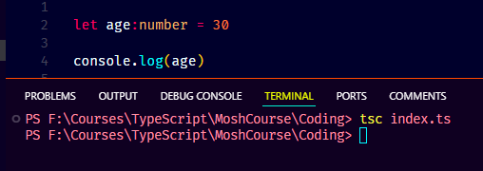

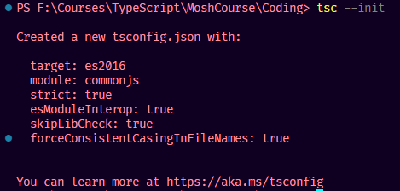

* **tsc compiles the project and generates the js files for available ts files.**

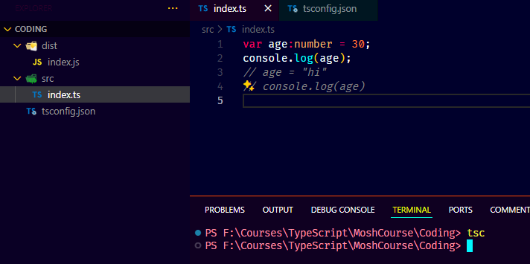

* **map file shows how each line of TypeScript code maps with each line of JavaScript code.**

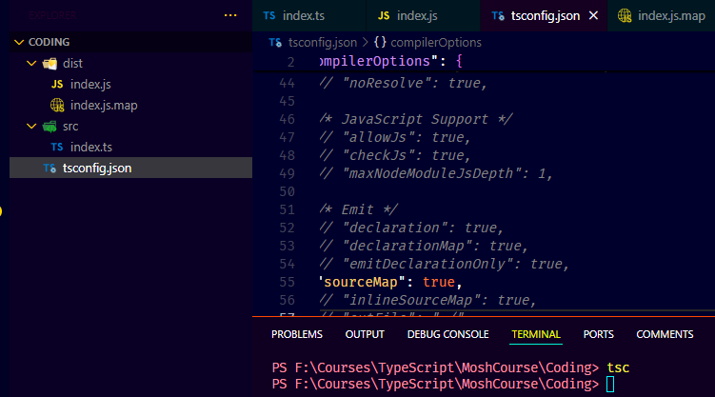

* **Debugging**

**TypeScript Basics/Fundamental Part:**

* **TS data types**

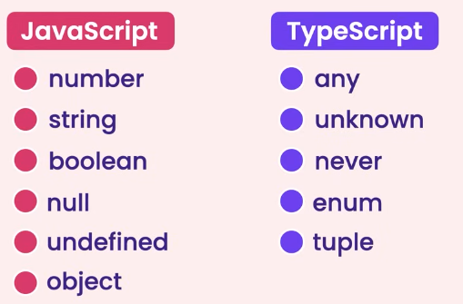

* **To avoid from implicit type error but not recommended because then there is no point to use typescript.**

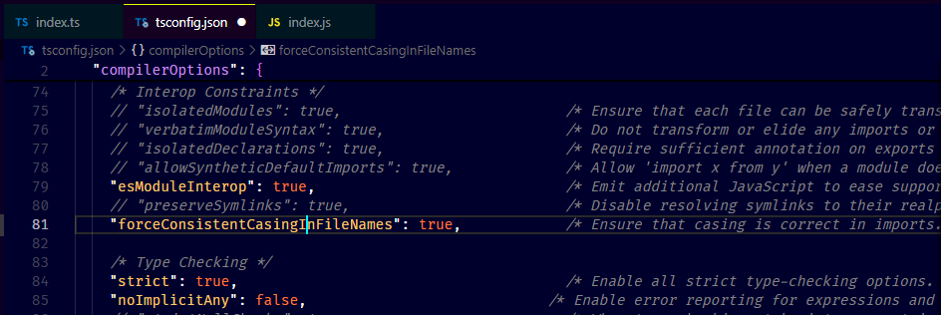

**SECTION-3 :: TypeScript Advanced Part:**



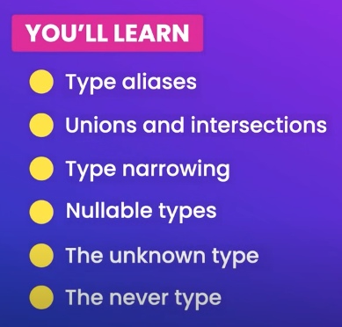

* **NULLABLE TYPES: When strict is apply the below properties apply automatically beside of, they are commented. To avoid it we can set the option to “false” or use the code logic.**

