**Type Script with Thapa**

**Type Annotations:**

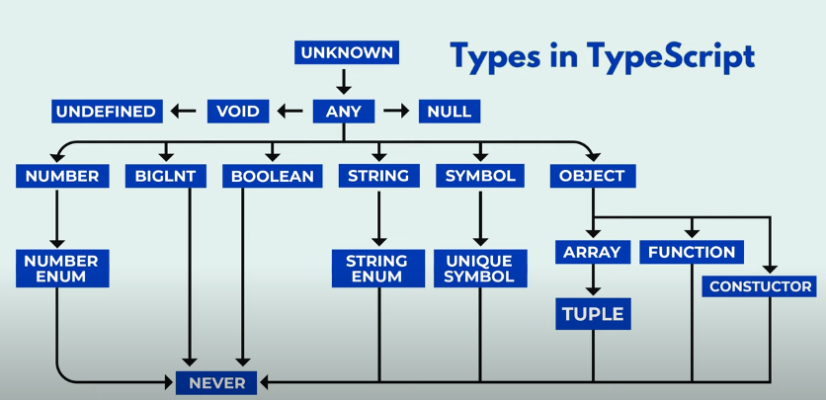

**Ignoring:**

**Sometime TSC also compiles the comment code. To ignore it use the below comment.**

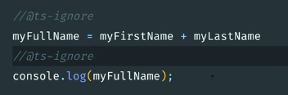

**Watch Mode:**

**In TSC on each file update we have to re-compile and re-run the files. Instead using this we can either compile the files in such a way that each time we change any file in the whole project it will automatically change the .js file.**

* **Now each time we modify the .ts file, .js file will automatically be according to .ts file.**
* **We can also compile the specific file in such a way that it changes according to .ts file:**



