**REPORT**

**WEB PROGRAMMING**

**Allam Taju Sarof (05111940000053)**

**Departemen Teknik Informatika**

**Fakultas Teknologi Elektro dan Informatika Cerdas**

**Institut Teknologi Sepuluh Nopember 2021**

**GENERAL**

Bootstrap 5 is used for layouting purpose. FontAwesome icons is used for decoration. Importing Bootstrap 5 files via CDN:

Basic Layouting in Bootstrap 5:

Importing FontAwesome icons via CDN:

Adding FontAwesome icons to the navigation bar for screen with width below 992px :



**HOMEPAGE**

The homepage layouts divided by three. The first row of homepage contains navigation bar. The second row of homepage contains a greetings. The third row contains short detail of this page and this row is divided into two-column with 2: 1 size.

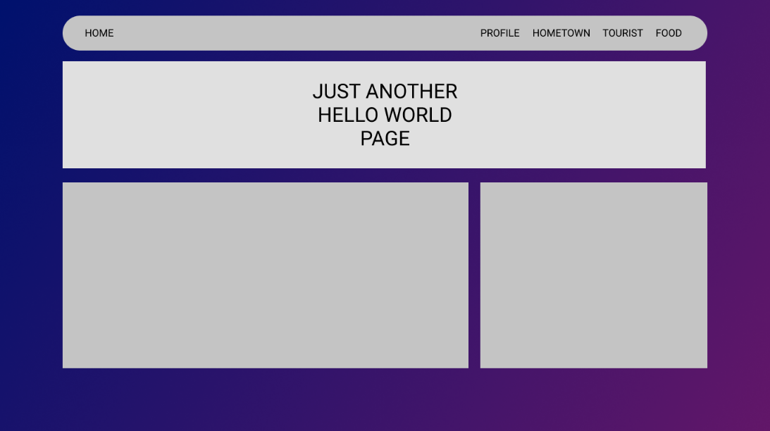

**FOOD PAGE**

The food page contains two rows which is the navigation bar on the first row and some foods description on the second row.

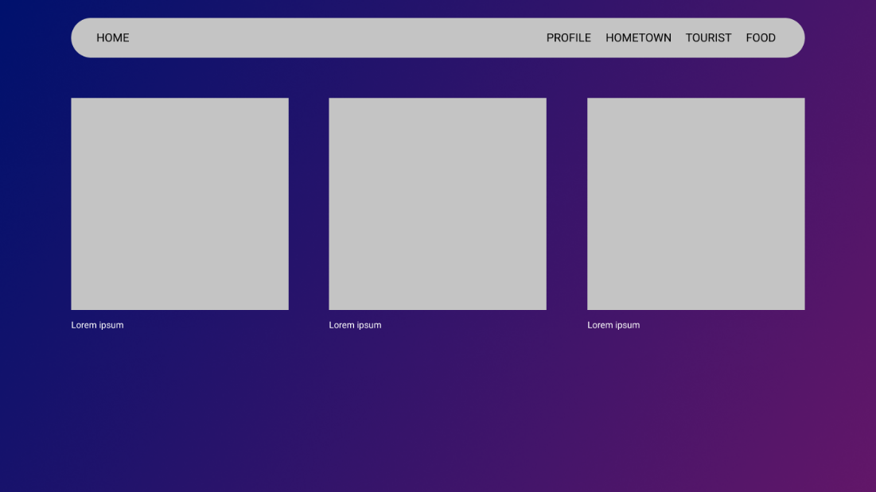

**PARALLAX PAGE**

The parallax page screen resolution is 16 : 10.8 . Added brief description about the particular topic at the center and below of it.

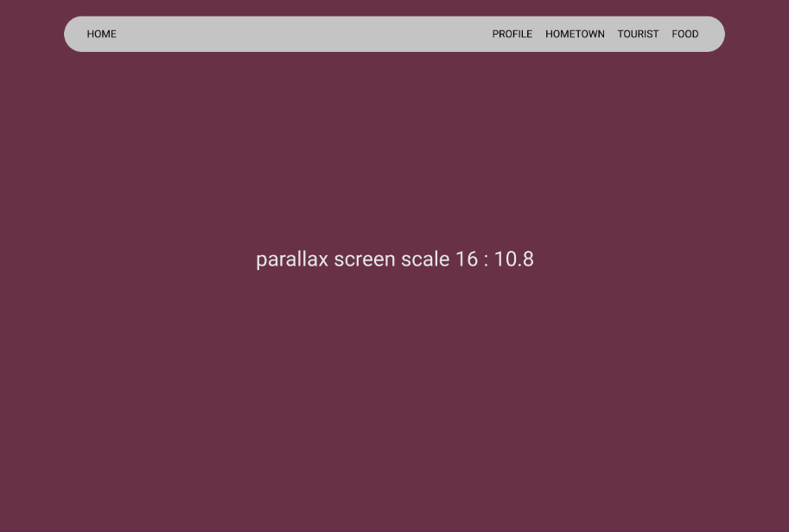

Javascript program used to create a parallax effect. The idea is to change the position of the picture fragments. The position changed relative to the scroll pixel. If the fragment is close to the viewer’s perspective, it would move quickly. If the fragment is far from the viewer’s perspective, it would move slowly.

The Javascript program fetch the element of the HTML using its ID. The HTML elements need to declare its ID for parallax purpose.

To make the picture fragments overlapping, the CSS code must declare the position property with ‘absolute’. The z-index property is needed to set the parallax images to be behind the other elements.

**DEPLOYING WEB**

I used Heroku and github for the server. To deploy on Heroku, first step is to register to its web. Second step is to download the Heroku CLI. Third step is to create new app through the Heroku dashboard.

Then, loging in via CLI.

Pushing the files to Heroku git.

Finally, the web is ready.

**LINK**

Repository : <https://github.com/Allam0053/quiz1>

Web : <https://pweb-allam.herokuapp.com/quiz1/>