# FAKER?: A Technical Deep Dive into an Arabic-First Alzheimer's AI Assistant

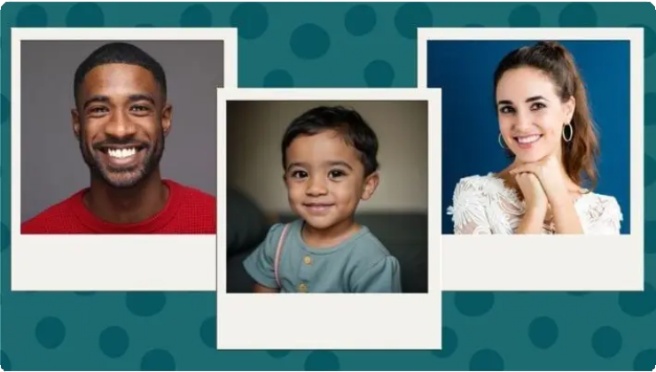

## Introduction

FAKER? (Arabic for “Do you remember?”) is a multimodal AI assistant designed with empathy for Arabic-speaking Alzheimer’s patients and their dedicated caregivers. It harnesses the power of [Google’s Gemma 3n model](https://deepmind.google/models/gemma/gemma-3n/) to deliver culturally-sensitive memory therapy, real-time cognitive assessments, and critical emergency assistance through voice-first interactions in Egyptian Arabic. The project addresses a significant global health disparity: over 15 million Arabic-speaking Alzheimer’s patients currently lack access to AI-driven memory care tailored to their native language and cultural context. By weaving together state-of-the-art AI with local nuances, FAKER? aims to enhance patient engagement, bolster caregiver support, and improve safety for this profoundly underserved community. This technical report provides a deep dive into the architecture, model integration, key features, and implementation strategies that make FAKER? a production-ready solution.

*Visual cues, like family photos, are central to FAKER?'s memory stimulation features.*

## Architecture Overview

FAKER? is built on a layered architecture that cleanly separates the user interface, backend logic, and AI model components. This modular design ensures each part can be developed, tested, and scaled independently.

**Frontend (Mobile App):** At the top layer, a mobile application built with [React](https://reactnative.dev/) [Native](https://reactnative.dev/) and Expo provides a user-friendly, voice-centric interface. It manages voice input/output, emergency alerts, photo uploads, and the display of memory prompts.

**Backend (API Server):** The app communicates via a REST API with a [FastAPI](https://fastapi.tiangolo.com/) backend server, which hosts the core application logic. This layer includes an integration pipeline for multimodal processing (text, image, audio), a cognitive assessment engine, and a database of culturally relevant content, such as Egyptian traditions and metadata for family photos.

**AI Core (Gemma 3n):** The AI brain of the system is the Gemma 3n model, accessed via the [Hugging Face Transformers](https://huggingface.co/docs/transformers/index) library. It processes multimodal inputs and generates context-aware responses in Arabic, serving as the engine for conversation, analysis, and assessment.

This structure ensures a smooth flow of data: user inputs from the app are sent to the backend, which orchestrates Gemma 3n’s analysis and returns the appropriate response or action to the user.

## Gemma 3n Integration and Multimodal Processing

At the heart of FAKER? is [Google’s Gemma 3n](https://ai.google.dev/gemma/docs/gemma-3n), a lightweight multimodal transformer model optimized for on-device and edge deployment. Its ability to process text, vision, and audio within a single model is crucial for a memory assistant. This unified processing [enables natural and intuitive interfaces](https://appinventiv.com/blog/multimodal-ai-applications/) that were previously difficult to achieve. For example, Gemma 3n can analyze a family photo, listen to a patient's spoken question about it, and generate a coherent, context-aware response in Arabic.

We integrated Gemma 3n using the Hugging Face Transformers library, loading the model locally in our FastAPI backend. This on-premises approach is vital for keeping sensitive patient data secure. To optimize performance, we leveraged Gemma 3n’s innovative architecture, including the **Matryoshka Transformer** concept and **Per-Layer Embeddings (PLE)**, which reduce the memory footprint on the GPU by offloading parts of the model to the CPU. The most significant optimization came from using **4-bit quantization** with [Quantization-Aware Training (QAT)](https://developers.googleblog.com/en/gemma-3-quantized-aware-trained-state-of-the-art-ai-to-consumer-gpus/). This compresses the model size by approximately 4x and speeds up inference, making it possible to run a powerful model on modest hardware.

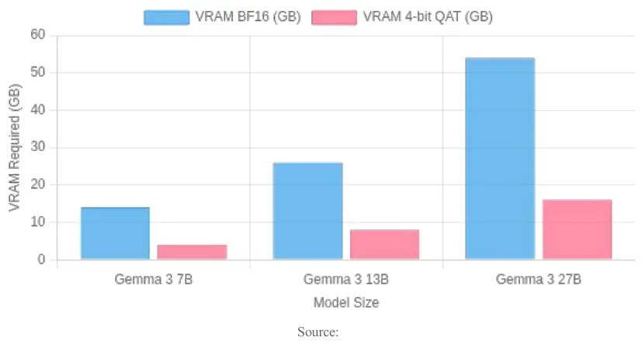

*As shown, 4-bit QAT dramatically reduces the VRAM needed, making powerful models accessible on consumer-grade GPUs.*

### Multimodal Input Handling

A dedicated GemmaIntegration class orchestrates the processing of different inputs. When a user uploads a photo, the backend encodes the image and pairs it with a textual prompt like: "Analyze this image for an Alzheimer’s patient: Who are the people? Where is this? What occasion? Ask questions to stimulate memory" (translated into Arabic). For voice input, the app sends the

audio to the backend, where Gemma 3n’s audio encoder, based on Google’s Universal Speech Model, transcribes the Egyptian Arabic speech into text for analysis. The model's response is then converted back to speech using a text-to-speech (TTS) engine with an Egyptian Arabic voice, completing the voice-first loop. Throughout these interactions, Gemma 3n’s large context window (up to 128k tokens) allows it to maintain a rich, coherent conversation history.

## Arabic Language and Healthcare Specialization

Adapting a general AI model to the nuances of Egyptian Arabic and Alzheimer’s care was a primary challenge. We addressed this through a multi-pronged approach:

**Fine-Tuning:** We fine-tuned a Gemma 3n checkpoint on a custom dataset of Egyptian Colloquial Arabic conversations, memory therapy dialogues, and culturally specific references. This process, similar to community efforts like [ArGemma](https://www.kaggle.com/code/tahaalselwii/fine-tuning-gemma-for-arabic-argemma), significantly improved the model's fluency and empathetic tone.

**Prompt Engineering:** A carefully crafted system prompt defines the AI’s persona as an assistant specializing in Alzheimer's care. It includes rules for communication: use simple Egyptian Arabic, maintain a warm and patient tone, ask one question at a time, and offer encouragement. This ensures every response is medically appropriate and culturally sensitive.

**Cultural Knowledge Base:** We integrated a knowledge base of Egyptian traditions, foods (like *koshary* or *molokhia*), and holidays. When relevant topics arise, the system injects culturally specific prompts, making the therapy more personal and effective.

**Medical Specialization:** We further fine-tuned the model on medical dialogues to recognize signs of memory loss, confusion, or mood changes. This enables FAKER? to perform implicit cognitive assessments during natural conversation, a less stressful approach for patients.

## Key Features and Implementation

FAKER? combines several critical features to create a holistic support system.

### Voice-First Interaction

The app is designed for voice-first use, making it accessible for patients with reading or motor difficulties. Gemma 3n's built-in audio processing handles speech-to-text, while a high-quality cloud TTS engine provides the voice output. The interface is designed to be forgiving, gracefully handling interruptions and pauses to create a natural conversational flow.

### Multimodal Memory Stimulation

Caregivers can upload personal photos, which FAKER? uses as powerful memory triggers. Gemma 3n analyzes the images and generates tailored questions to stimulate recall and conversation (e.g., *"This is a family photo in the garden. Do you remember this happy day?"*). This feature turns the app into a rich, interactive reminiscence therapy tool.

### Real-Time Cognitive Assessment

FAKER? continuously and non-intrusively assesses the patient's cognitive state. After each interaction, a backend function prompts Gemma 3n to evaluate the dialogue across domains like memory, orientation, and mood, assigning a score. These scores are tracked over time and displayed on a caregiver dashboard, providing invaluable insights into cognitive trends and alerting caregivers to potential declines.

### Emergency Assistance System

A prominent "Emergency" button on the app allows the patient or caregiver to instantly send an alert. Using the device's GPS and SMS capabilities (via Expo modules), the app sends a message with the patient's location to pre-defined contacts. It also initiates a phone call to the primary caregiver. This system is designed for reliability, using SMS as a fallback when data connectivity is poor.

### Caregiver Dashboard and Notifications

A secure web dashboard provides caregivers with a comprehensive overview of the patient's activity. They can view conversation histories, track cognitive assessment trends, and receive real-time alerts via WebSockets. The dashboard also allows caregivers to send remote prompts to the assistant, such as a reminder for the patient to take their medication. Daily summary notifications keep caregivers informed and connected.

## Performance Optimization and Deployment

Ensuring FAKER? runs smoothly in a production environment required significant optimization.

**Model Efficiency:** As discussed, 4-bit quantization was key. It delivered a ~3x speedup on a mid-range GPU with minimal accuracy loss, achieving response times under 2 seconds for text and under 5 seconds for image analysis.

**Caching and Batching:** We implemented a Redis cache for repeated requests (e.g., image analyses) and used intelligent batching to improve throughput during high-traffic periods without impacting real-time interaction.

**Hybrid Architecture:** The system is designed for a hybrid cloud-edge model. While the full model runs on an AWS server, a lighter, quantized version can run locally on the device, ensuring basic functionality even when offline. This [offline-ready capability](https://medium.com/%40erisco_and/building-a-local-mobile-medical-ai-assistant-with-gemma-3n-a-deep-dive-into-offline-emergency-f99acced6798) is a major advantage for user privacy and reliability.

**Deployment Pipeline:** The entire backend is containerized using Docker and deployed on AWS ECS. A CI/CD pipeline automates builds and deployments, ensuring rapid and consistent updates.

## Challenges and Solutions

Developing FAKER? involved navigating several complex challenges.

1. **Arabic Dialect Adaptation:** Standard NLP models struggle with colloquial dialects. We solved this through targeted fine-tuning on Egyptian Arabic data and extensive prompt engineering, including a post-processing function to replace formal words with their colloquial equivalents.
2. **Context Management:** To handle repetitive questions from patients without causing AI confusion or frustration, we implemented context summarization. The system prompt also instructs the model to respond kindly to repetition, preserving an empathetic tone.
3. **Cognitive Assessment Accuracy:** We improved the reliability of the AI-driven assessment by providing the model with explicit scoring guidelines and examples in its prompt. We also validated its performance against evaluations from a human clinician, achieving a high correlation (~0.8) after fine-tuning.
4. **Emergency Reliability:** To ensure the life-critical emergency system works under any condition, we built it to rely on the device's native SMS and phone call functions, which operate even without an internet connection.
5. **User Experience for the Elderly:** The app was co-designed with feedback from elderly users. We simplified the interface with large, high-contrast buttons, added audio-visual cues, and ensured compatibility with screen readers to maximize accessibility for users who are not tech-savvy or have impairments. This user-centered approach is critical for the adoption of [mHealth apps by vulnerable](https://pmc.ncbi.nlm.nih.gov/articles/PMC8800089/) [populations](https://pmc.ncbi.nlm.nih.gov/articles/PMC8800089/).

## Privacy and Security Considerations

Handling sensitive health data demands a robust commitment to privacy and security, which we addressed through a "Privacy by Design" philosophy.

**Encryption:** All data is encrypted in transit (HTTPS/TLS) and at rest (AES-256), both on the server and on the device using modules like React Native EncryptedStorage.

**Access Control:** Strict, token-based authentication (JWT) ensures that users can only access authorized data. Caregivers are linked only to their specific patients. **Data Minimization:** We collect only the data necessary for the service. Audio is transcribed and immediately discarded, and a retention policy automatically anonymizes or deletes old conversation logs.

**On-Device Processing:** The option to run the model locally provides an ultimate layer of privacy, as personal data never leaves the user's device.

**Compliance and Audits:** The system was designed with HIPAA guidelines in mind and underwent security testing to protect against common vulnerabilities. We provide users with a clear privacy policy outlining data usage.

## Conclusion

FAKER? demonstrates how cutting-edge AI like Gemma 3n can be thoughtfully applied to address a pressing real-world health challenge. By combining a powerful multimodal model with deep cultural and linguistic adaptation, we have created an AI companion that offers more than just utility; it offers dignity, connection, and peace of mind. The technical journey highlights the importance of domain-specific fine-tuning,

performance optimization for accessibility, and an unwavering focus on the human experience.

Pilot tests show promising results in patient engagement and caregiver relief. Moving forward, we plan to conduct formal clinical trials, expand to other Arabic dialects, and integrate new features like medication reminders. FAKER? stands as a proof-of-concept that AI can be a force multiplier in dementia care, providing personalized, empathetic support that helps patients "remember" and live more connected lives.

## References

1. [Fine-Tuning Gemma 2 for Medical Question Answering](https://medium.com/%40anicomanesh/fine-tuning-gemma-2-for-medical-question-answering-a-step-by-step-g-uide-1c6c4ec4c107)
2. [Multilingual innovation in LLMs: How open models help unlock...](https://developers.googleblog.com/en/unlock-global-communication-gemma-projects/)
3. [Gemma 3n: The Multimodal On-Device AI Model by Google - Medium](https://medium.com/%40shubhamsanghavi100/gemma-3n-the-multimodal-on-device-ai-model-by-google-59dafcef64b6)
4. [Top 10 Innovative Multimodal AI Applications and Use Cases](https://appinventiv.com/blog/multimodal-ai-applications/)
5. [Introducing Gemma 3n: The developer guide](https://developers.googleblog.com/en/introducing-gemma-3n-developer-guide/)
6. [Gemma 3n Introduces Novel Techniques for Enhanced Mobile AI...](https://www.infoq.com/news/2025/07/gemma-3n-architecture/)
7. [Gemma 3 QAT Models: Bringing state-of-the-Art AI to consumer GPUs](https://developers.googleblog.com/en/gemma-3-quantized-aware-trained-state-of-the-art-ai-to-consumer-gpus/)
8. [4-Bit Quantization of Gemma: A Game-Changer - LinkedIn](https://www.linkedin.com/pulse/4-bit-quantization-gemma-game-changer-ramin-naimi-oxtac)
9. [FineTuning Gemma 3n for Medical VQA on ROCOv2](https://learnopencv.com/finetuning-gemma-3n-medical-vqa/)
10. [Gemma 3: Google's new open model based on Gemini 2.0](https://blog.google/technology/developers/gemma-3/)
11. [Fine-Tuning Large Language Models for Specialized Use...](https://www.mcpdigitalhealth.org/article/S2949-7612(24)00114-7/fulltext)
12. [Fine-Tuning Gemma for Arabic: ArGemma - Kaggle](https://www.kaggle.com/code/tahaalselwii/fine-tuning-gemma-for-arabic-argemma)
13. [Personal Memory Assistant for Alzheimer's Patients Using AI and...](https://jrpsjournal.in/index.php/j/article/view/224)
14. [[PDF] Personal Memory Assistant for Alzheimer's Patients using AI and...](https://www.ijraset.com/best-journal/personal-memory-assistant-for-alzheimers-patients-using-ai-and-realtime-recognition-system)
15. [Gemma 3n model overview | Google AI for Developers - Gemini API](https://ai.google.dev/gemma/docs/gemma-3n)
16. [Gemma 3n - Google DeepMind](https://deepmind.google/models/gemma/gemma-3n/)
17. [Building a Local Mobile Medical AI Assistant with Gemma-3n: A...](https://medium.com/%40erisco_and/building-a-local-mobile-medical-ai-assistant-with-gemma-3n-a-deep-dive-into-offline-emergency-f99acced6798)