Agile Engineering Practices
Design, Collaboration, Development

1. Draw a Use Case Diagram for an online Library Management System.

Ans:
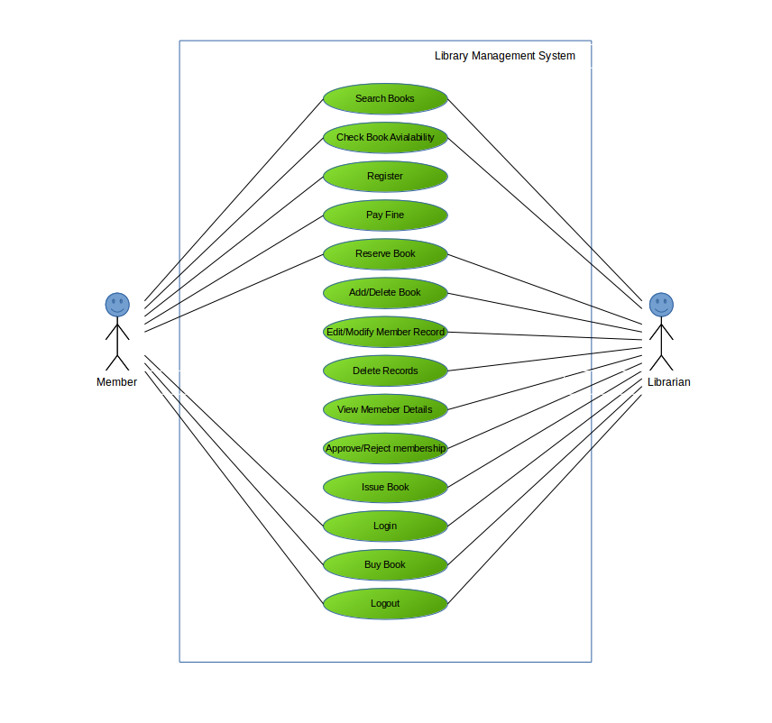

2. List down the best practices from Agile/Scrum methodology.

Ans:
Best practices in Agile methodology:
- Daily 15 min stand-up meetings help to set achievable goals daily.
- Dynamic in nature and very welcoming to changes.
- Collaborative environment forces teams with different backgrounds to work together.
- Priorities are maintained by product owner.https://github.com/Allan-Abraham/Agile-Engineering-Practices-Design-Collaboration-Development.git
- All the processes and practices are facilitated by Scrum master and influences the entire organization (possibly) to adopt agile methodology.
- Planning poker is used to estimate tasks during sprint planning.
- Self-organizing team.
- Burndown charts to monitor performance.
- Sprint review meeting to present completed work.
- Sprint retrospective is also done to learn from previous sprint and improve on the current one.
- Specified By User Stories ( As a ____ i would like to ____ so that ____) which allows for a clearer end picture.
- Open work space is provided for the team
- The customer is always available. This makes sure that the product needed by the customer is exactly what is delivered.
- Continuous integration of code allows to keep the code up to date and error-free.
- Refactor whenever and wherever needed
- All sessions begin by writing programming adaptive tests that are preceded by unit tests.
- Acceptance tests are run often

3. Collaboration
a. How does collaboration help agile development?

Ans:
Collaboration is very much emphazized in Agile methodologies. It forces people from different backgrounds to work together on the Agile team.
- The collaboration allows the teams to interact successfully and share the ideas among themselves resulting in creative ways to solve problems.
- The team delivers the products early and successfully and this would satisfy the customers.
- The team welcomes changing requirements, making them versatile assets to the organization.
- There would be regular meetings between the dev team and the clients, thereby providing a clear end picture of the product to be delivered.
- The team regularly tunes and adjusts its behaviour.

b. What if the team is distributed and can you achieve the same productivity?

Ans:
No , it is not possible to achieve the same productivity if the team is distributed.
If the team is distributed, trouble lies ahead. The best way to discover issues and blockers is through face-to-face communication.
- If the team members are not familiar with each other they will not be aware about each other’s skills.
- There are chances for miscommunication.
- It will not be easy to handle the arguments and suggestions that would arise from the different team mates which will affect the productivity.

c. What would you do to achieve the productivity for a distributed team?

Ans:
When possible, try to get people in the same room for crucial parts of a project. Otherwise, maintain communication with remote teammates and keep them in the loop so as to make better collaboration that will provide higher productivity. It is also advisable to Plan Frequent Demos and Retrospectives.

4. What is Sprint Zero in Agile? Describe the activities that are done in Sprint Zero.

Ans:
Sprint Zero is is the initialization step in an agile project which is also called as Iteration Zero. It consists of certain activities that will make the team ready for the sprint 1. It is also known as a project before a project phase because at the beginnig of a project there should be a detailed analysis about how the project has to be done. Following activities are included in the sprint zero :-

- Active stakeholder participation
It is necessary to work with stakeholders to identify what they think they want, produce something which reflects that understanding, get feedback from our stakeholders, and then update our solution.
- Obtain funding and support
- Start building the team
Agile will not succeed without teams that collaborate effectively and efficiently.
- Initial requirements envisioning
Initial requirements envisioning is particularly important for scaling agile software development techniques to larger, more complex, or globally distributed development efforts. The goal is to understand the requirements at a high-level.

- Initial architecture envisioning
It will provide improved productivity, reduced technical risk,improved communication,improved team organization etc.
- Set up environment

