Monitoring Scrum Projects & Challenges

1. How do you evaluate the performance of a project in agile?

Ans:
Performance of a project, in agile, can be evaluated as follows:
- Velocity: it determin how many user stories contain in one sprint. Velocity of new release plan depends on the historical data. After that we can obtain the actual velocity.
- Hit rate: it is the percentage of work allocated to a timebox that was actually completed.
- Working on task: Each day the team estimates the work remaining on each active Task. The estimate of work remaining Task will hopefully go down over time.
- Project cost: project cost can be done in person days or currency. First fix a baseline project cost after that estimate the actual cost.
These can also be called as metrics to evaluate project performance.

The project measures in agile are used to find the correct track of the project.They are as follows:
- Cost Performance Index: Determines whether we are ahead or behind the cost factor.
- Schedule Performance Index: Determines whether we are ahead or behind the project schedule.
- Earned Business Value: It gives a clear picture of the project’s progress and is a new metric in agile.

2. Compare traditional monitoring & control with agile monitoring & control with respect to metrics generation.

Ans:
 | Traditional Method | Agile Method
1 | Velocity is less . It takes more time to produce a working software. | Velocity is more. It takes less time to produce a working software as it is used in sprints.
2 | Delivery takes time. | Frequent delivery
3 | It doesnot focus on earned business value | It focuses on Earned Business value. Business value is based on customer satisfaction
4 | Hit rate depends on the overall completion of the delivery | Hit rate depends on the completion of each sprint.
5 | Colocation is not necessary in this method. | Colocation is necessary for the effective delivery.

3. With a total project budget of $175,000, and having completed one out of
four Iterations, we have this product backlog and these actuals:
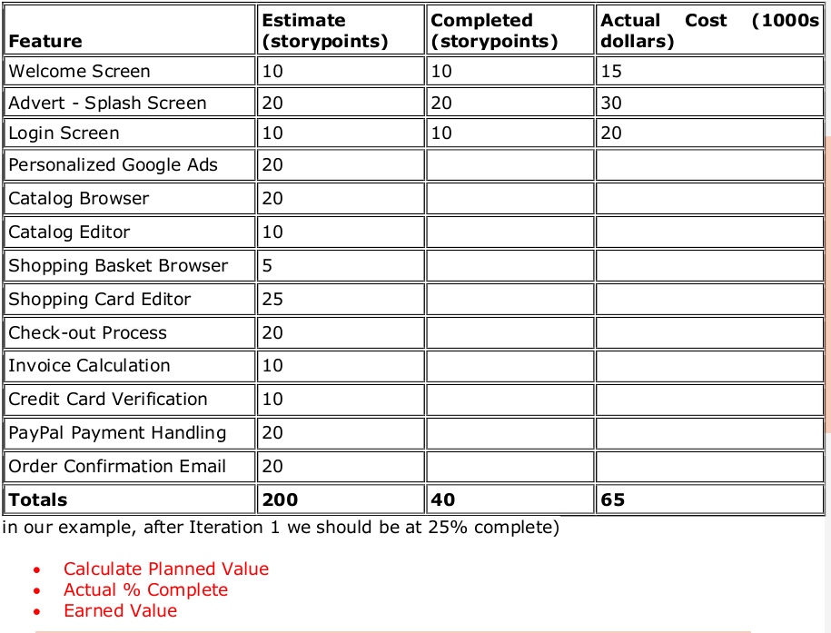

Ans:
- Planned value (PV) = Budget at Complete (BAC) * Expected Percent Complete (EPC)
Budget at Complete(BAC) = $175000
Expected Percent Complete(EPC) = Current sprint (n) / Total planned sprints
= 1/4
Planned value = 175000 * (1/4) = $43750

- Actual % complete = Story points completed / Total planned story points
Story points completed = 40
Total planned story points = 200
Actual % complete = 40/200 = 1/5 = 0.2 = 20%

- Earned value (EV) = Budget at Complete (BAC) * Actual Percent Complete (APC)
Budget at Complete (BAC) = $175000
Actual Percent Complete (APC) = 1/5
Earned value (EV) = 175000 * (1/5)= $35000

