SDLC RAD Model & How to Design ER Diagrams

1. When to use (Rapid Application Development) RAD model. When not to use (Rapid Application Development) RAD model.

Ans:
RAD Model can be used when:
- The system to be developed needs to be modularised within a time frame of 2-3 months.
- If the number of developers avaliable, for modelling, are high.
- If the budget is high enough to afford the cost of the designers and the tools used for automated code generation.
- If resources with high business knowledge are available.
RAD Model should not be used when:
- If the project requires long development times.
- If the user involvement is not practical.
- If the project undertaken doesnt have sifficient budget.

2. Define an ER diagram of a Software Organization with all the relationship
model that was discussed in the classroom.

Ans:

Employee
Emp_Id
Name
Contact
In-Charge of
Projects
Project Id
Status
Project Name
Works on
Clients
Client Name
Client Id
Requests
Departments
Dept. Id
Dept. Name
Works under

3. Describe the Entity Relationships for the following diagram.
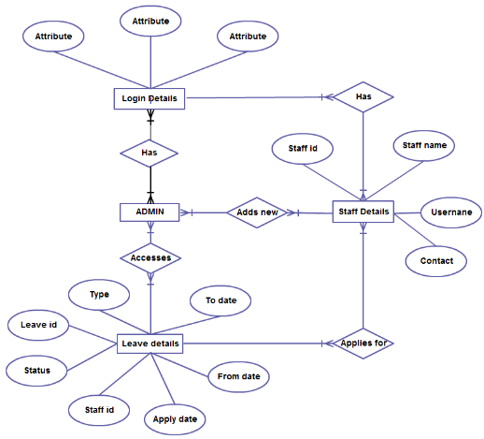

Ans:
Description of the above displayed ER Diagram:

Entities:
There are mainly 4 entities here namely: Login Details, ADMIN, Leave Details and Staff Details.

Attributes of the entities:
- Login Details has 3 Attributes.
- Staff Details has Staff Id, Staff Name, Username and Contact.
- Leave Details has Leave Id, Type, To date, From date, Apply date, Staff Id and Status.

Relationships between the entities (The relationships are the ones highlighted):
- There are more than one ADMINs, as is obvious from the diagram. So each ADMIN Has a unique Login Details. (One to One)
- The ADMIN has access to the Staff’s details; i.e. one ADMIN Accesses one or many Leave Details. (One to Many)
- The ADMIN Adds new Staff Details; i.e. one ADMIN can add one or more Staff Details. (One to Many)
- The Staff can apply to one or more leaves; i.e. One or more Staff Details can Applies of one or more Leave Details. (Many to Many).
- Each Staff has a unique login detail; i.e, One Staff Has One Login Details. (One to One)

