# 面向对象系统分析与设计课后作业03

**hw01.**

Following given example is an class diagram of decorator design pattern. Icecream is a classic example for decorator design pattern. You create a basic icecream and then add toppings to it as you prefer. The added toppings change the taste of the basic icecream.(下面是类图，请根据类图编写代码)。 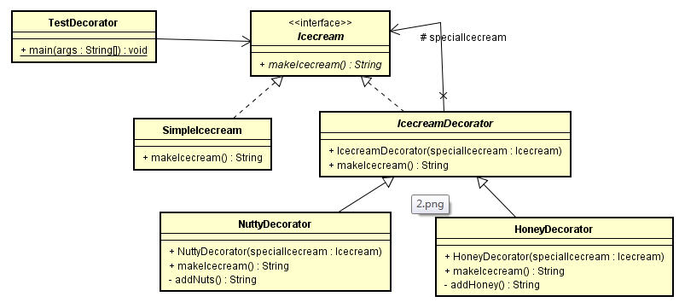

**hw02**.

We're going to create a Shape interface and concrete classes implementing the Shape interface. We will then create an abstract decorator class ShapeDecorator implementing the Shape interface and having Shape object as its instance variable.

RedShapeDecorator is concrete class implementing ShapeDecorator.

TestShape, our demo class will use RedShapeDecorator to decorate Shape objects..  
Codes:

public class testShape {

public static void main(String[] args) {

Shape circle = new Circle();

Shape redCircle = new RedShapeDecorator(new Circle());

Shape redRectangle = new RedShapeDecorator(new Rectangle());

System.out.println("Circle with normal border");

circle.draw();

System.out.println("\nCircle of red border");

redCircle.draw();

System.out.println("\nRectangle of red border");

redRectangle.draw();

}

}

interface Shape {

void draw();

}

class Rectangle implements Shape {

@Override

public void draw() {

System.out.println("Shape: Rectangle");

}

}

class Circle implements Shape {

@Override

public void draw() {

System.out.println("Shape: Circle");

}

}

abstract class ShapeDecorator implements Shape {

protected Shape decoratedShape;

public ShapeDecorator(Shape decoratedShape){

this.decoratedShape = decoratedShape;

}

public void draw(){

decoratedShape.draw();

}

}

class RedShapeDecorator extends ShapeDecorator {

public RedShapeDecorator(Shape decoratedShape) {

super(decoratedShape);

}

@Override

public void draw() {

decoratedShape.draw();

setRedBorder(decoratedShape);

}

private void setRedBorder(Shape decoratedShape){

System.out.println("Border Color: Red");

}

}

**hw03.**

To decorate a simple room with color and curtains, try to provide a solution which contains class diagrams and codes based on your class diagram.(完成类图，请根据类图编写代码）。