# 面向对象系统分析与设计课后作业04

hw01.Simple TV factory.  
A TV factory specializes in the production of all kinds of TV sets for each famous TV brand, when a Haier TV set is wanted, it is required to pass the parameter " Haier" when calling the factory method of the factory,when a Hisense TV set is wanted, we only need to pass the input parameters " Hisense ", the factory can return different brand of the TV set according to the different parameters.The Factory method pattern is used to simulate the production process of the TV factory.

hw01：简单电视机工厂 某电视机厂专为各知名电视机品牌代工生产各类电视机，当需要海尔牌电视机时只需要在调用该工厂的工厂方法时传入参数“Haier”，需要海信电视机时只需要传入参数“Hisense”，工厂可以根据传入的不同参数返回不同品牌的电视机。现使用简单工厂模式来模拟该电视机工厂的生产过程（下面是类图，请根据类图编写代码。）

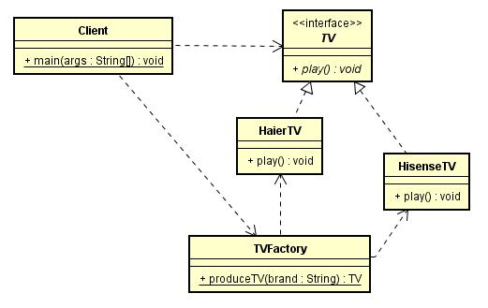

hw02. The following code is about how to decode an image based on the different formats.（实现这个系统的代码如下，请根据代码画出类图。）

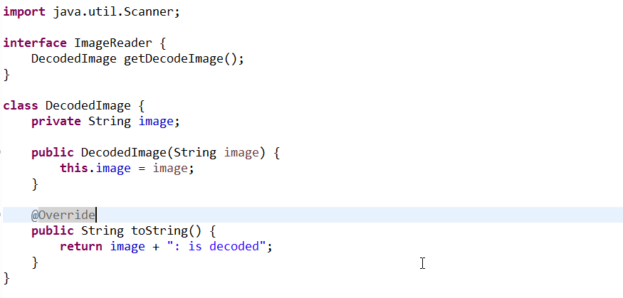

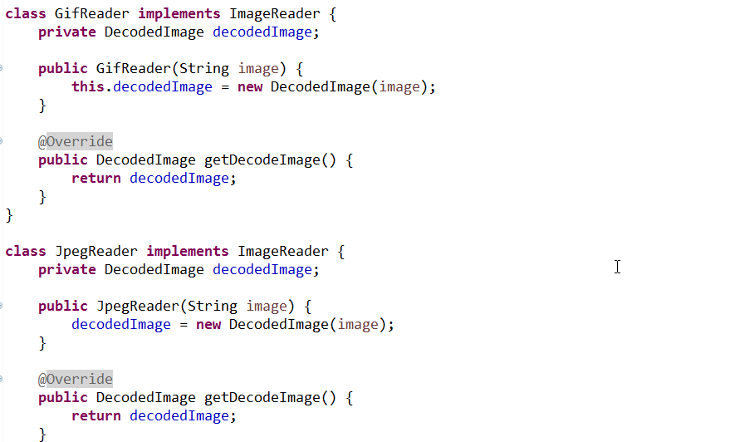

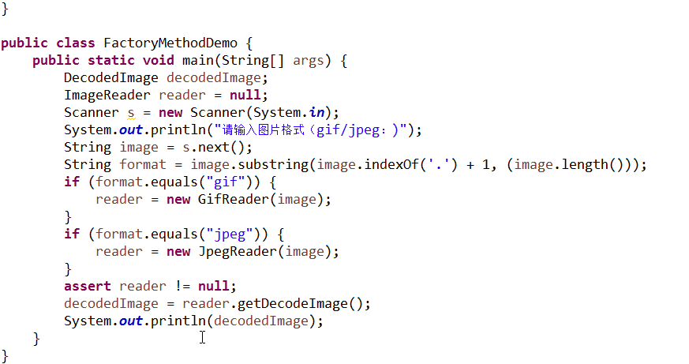

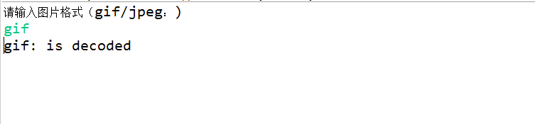

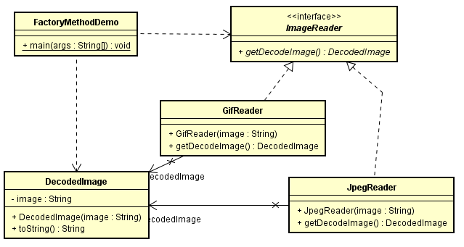

## hw03. In a simulation game, you are supposed to create different pets based on the sound they make, e.g, if the sound an animal make is "quack",then you should create a duck.（模拟游戏中，请根据宠物的声音创建相应的宠物，如宠物发出“嘎嘎“声，应当创建宠物鸭子。请使用工厂模式来实现系统，绘制类图并编程实现。）

