# 面向对象系统分析与设计课后作业02

## In a multiplayer game, many players can join the same team. As one member of the team was attacked by the enemy, all the other members will received the notice and take the action. Your job is to program according to the following class diagram.（一款多人联机对战游戏,在该游戏中,多个玩家可以加入同一战队组成联盟,当战队中某一个成员受到敌人的攻击时将给所有其他盟友发送通知,盟友收到通知后将做出响应。下面是类图，请根据类图编写代码。）

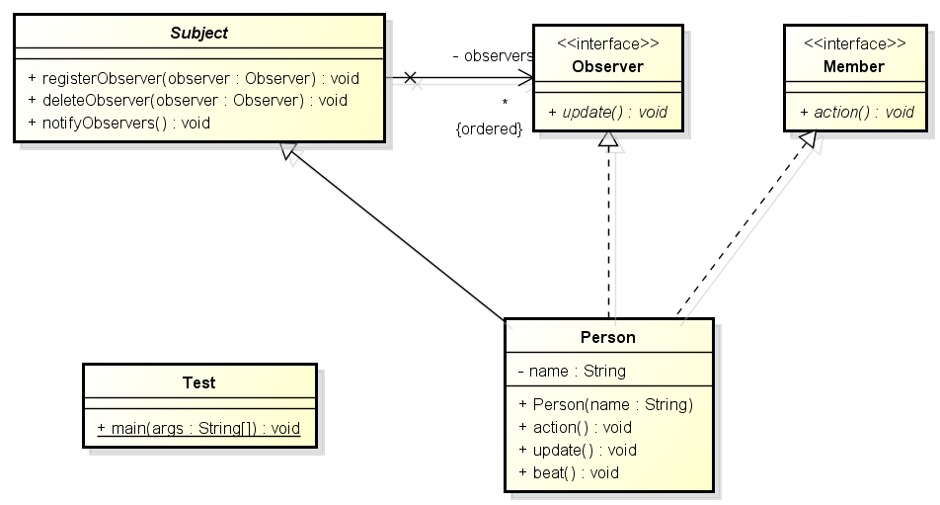

## Designing an online stock software which has the following functions: 1. Supports two securities trading markets in Shanghai and Shenzhen;2. Support common and VIP stock customers;3. When the price of shares traded on the Shanghai stock exchange fluctuate 3%, the ordinary customer will be notified, and the VIP customers will be notified when the price changes 1%.When the price of the shares traded on the Shenzhen stock exchange is 5%, the ordinary customer will be notified, and the VIP customers will be notified when the price changes 1%. Your job is to draw the class diagram according to the following code in Java.（设计一款在线股票软件,该软件具有如下功能:1.支持上海及深圳两个证券交易市场;2.支持普通和VIP两类股票客户;3.上证交易所上交易的股票价格变动3%时,通知普通客户,价格变动1%时,通知VIP客户; 深证交易所上交易的股票价格变动5%时,通知普通客户,价格变动2%时,通知VIP客户。实现这个系统的代码如下，请根据代码画出类图。）

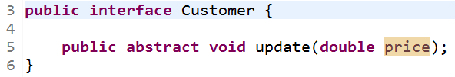

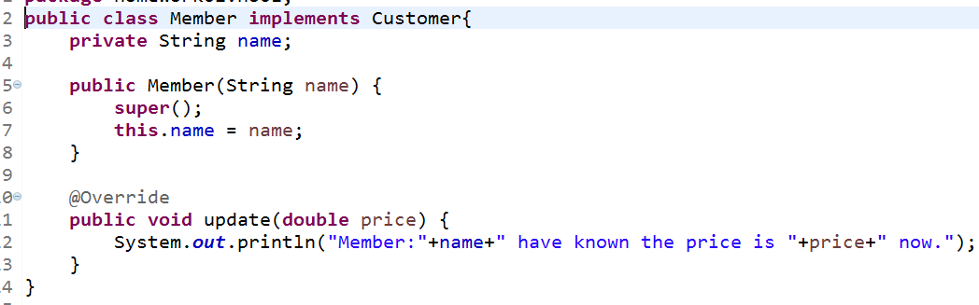

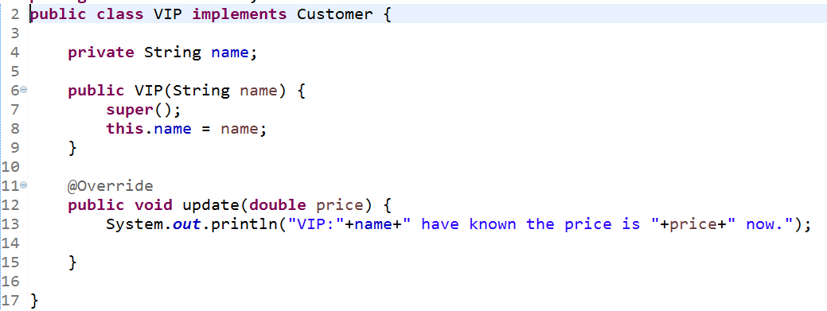

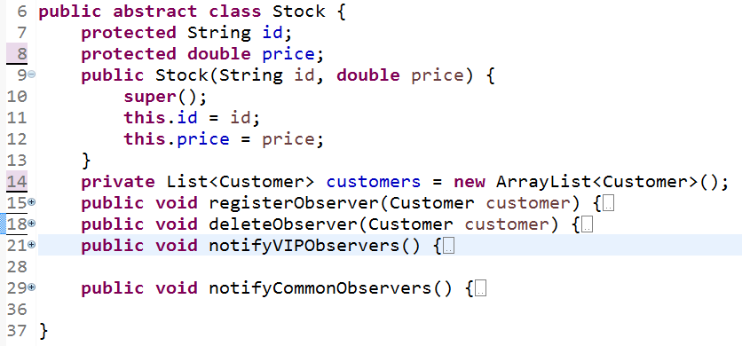

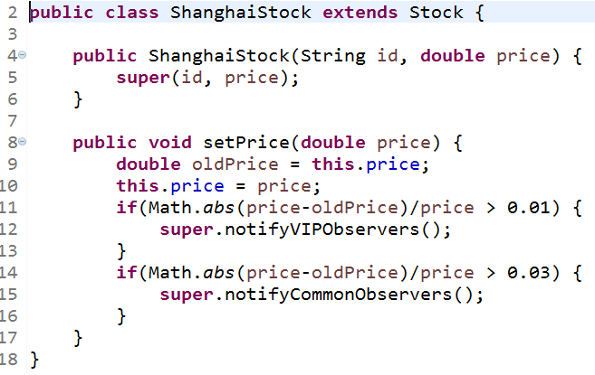

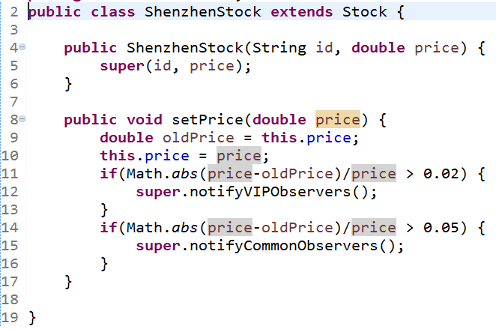

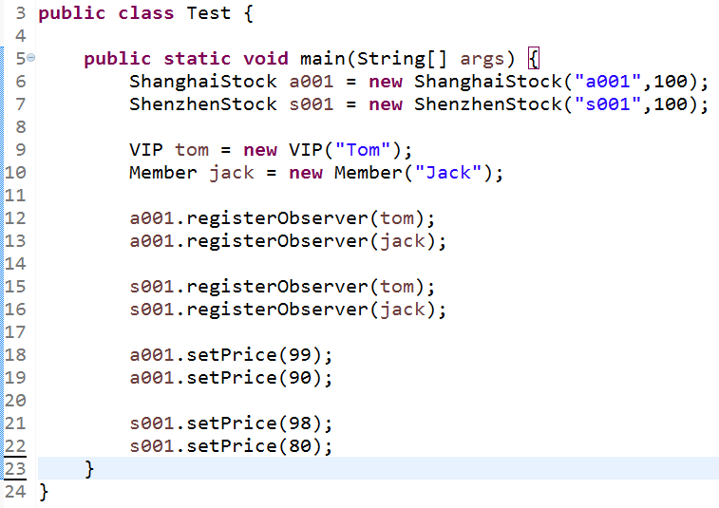

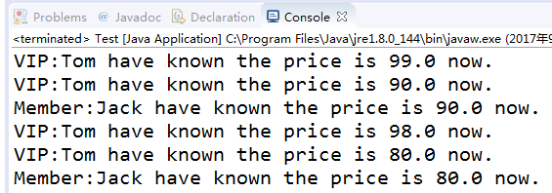

## 3. National treasure game system.

**系统名称：国家宝藏游戏系统（National treasure game system）**

人物角色：凯奇（Cage）

两个守护神(Eudemon)：老虎（Tiger）、狮子（Lion）

两种宝藏（Treasure）：黄金（Gold）、钻石（Diamond）

游戏场景（Scene）：场景中包括1个角色，5只老虎，7只狮子，500箱黄金，100箱钻石

功能需求：

1、凯奇可以拿走一定数量的宝藏take（Treature treature,double quantity）

2、宝藏可以安排数位守护神看守宝藏guard（Eudemon eudemon）

3、每当凯奇拿走宝藏时，都会惊动所有看守该宝藏的守护神notifyAll（）

4、守护神在得到通知update（）后，都会清点count（）数量，并发出攻击attacks（）

5、场景中的情节是凯奇拿走了132#整箱、357#半箱黄金，以及3#整箱钻石