# 面向对象系统分析与设计课后作业10

## Program according to the diagram to simulate the accounts’ state of a forum system.（编写代码模拟论坛中账号的状态。下面是类图，请根据类图编写代码。）

|  |  |  |
| --- | --- | --- |
| **States**  **账号状态** | **to do**  **可以做** | **Constraint**  **约束条件** |
| Beginner | writeNote发表  replyNote回复 | points<100 |
| Superior | writeNote:gains double points获得双倍积分  replyNote  downloadFile: (has enough points) 下载文档 | 100<=points<1000 |
| Expert | writeNote  replyNote:gains double points  downloadFile:costs half ponits (has enough points) | points>=1000 |

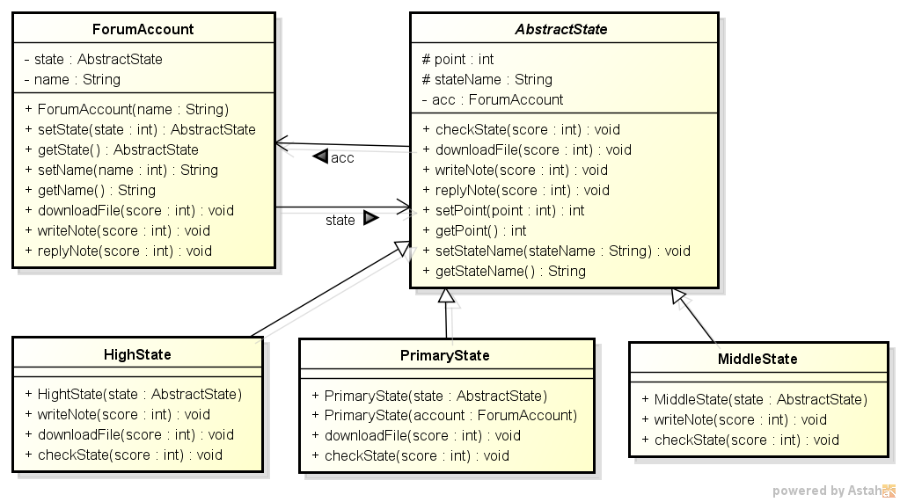

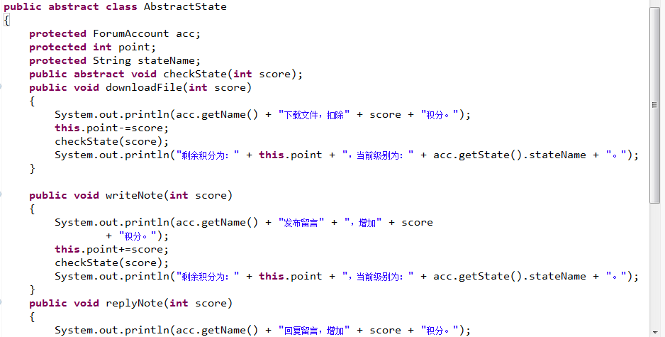

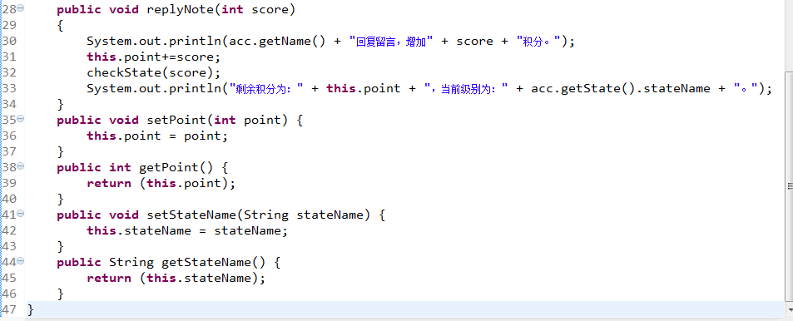

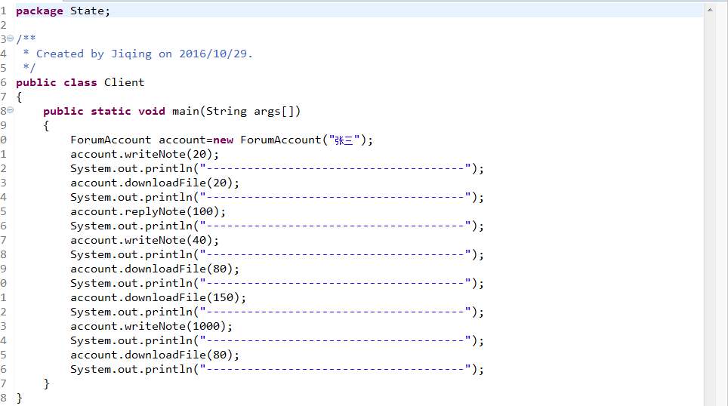

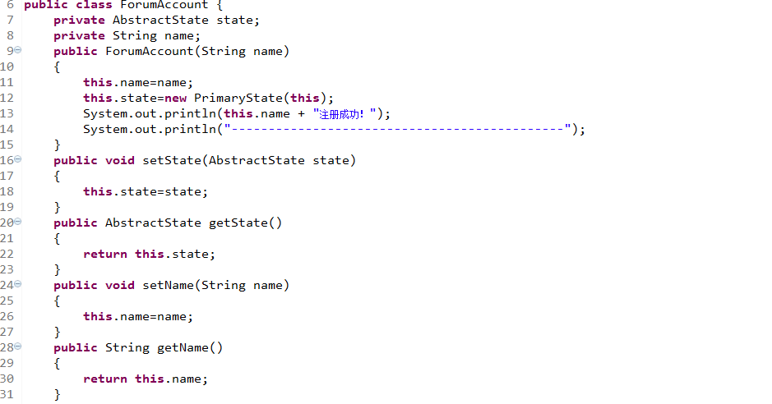 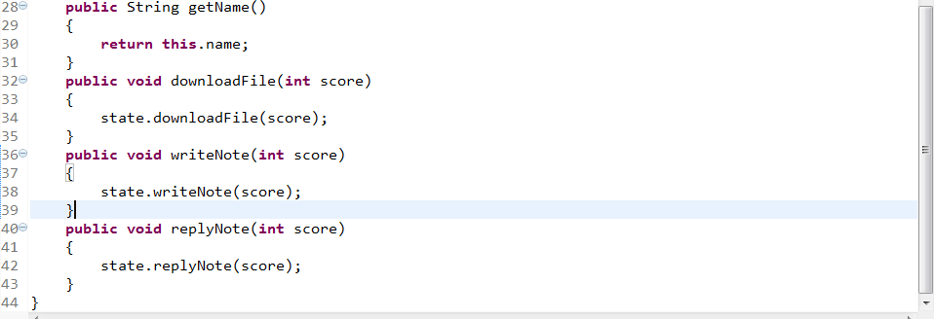

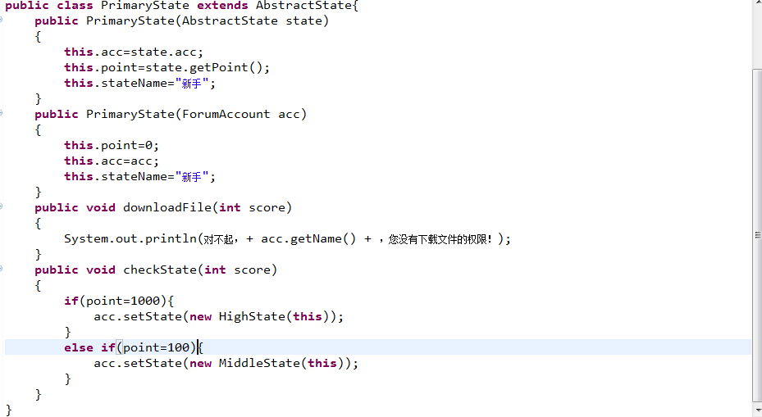 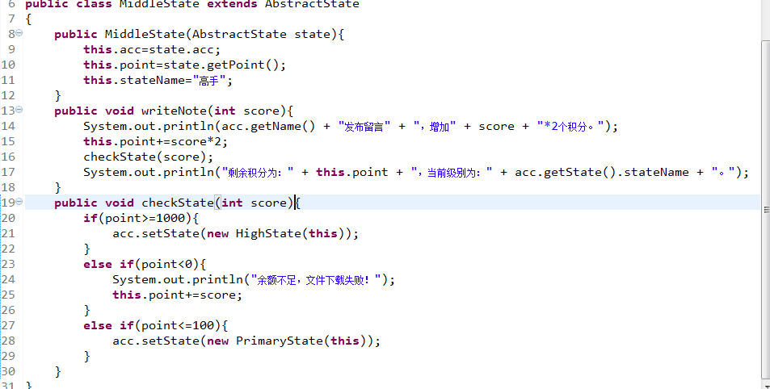 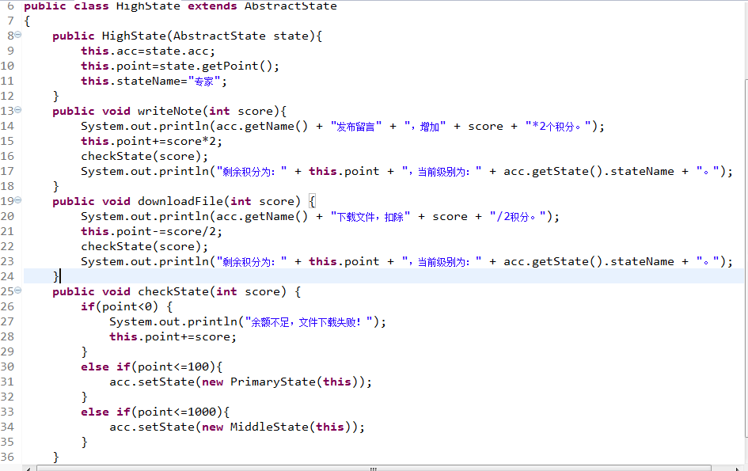

## A switcher has two statuses: on and off. Your job is to draw the class diagram according to the following code in Java.（根据给定的java代码模拟开关的状态变化：开和关）

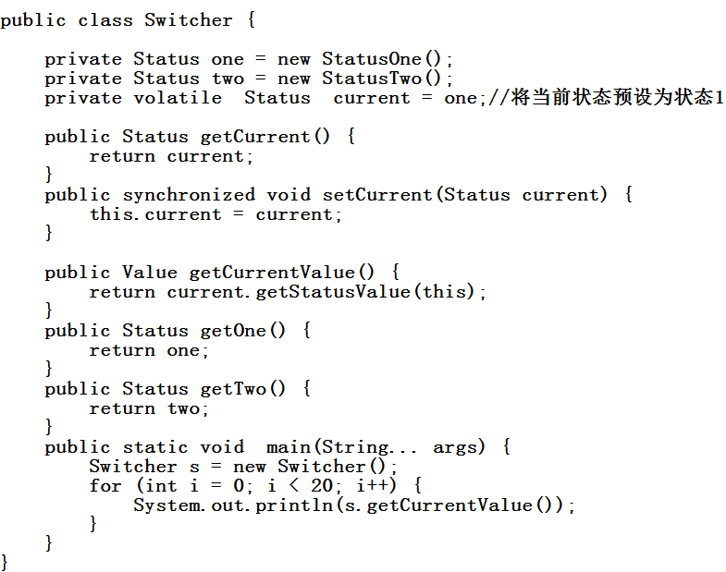 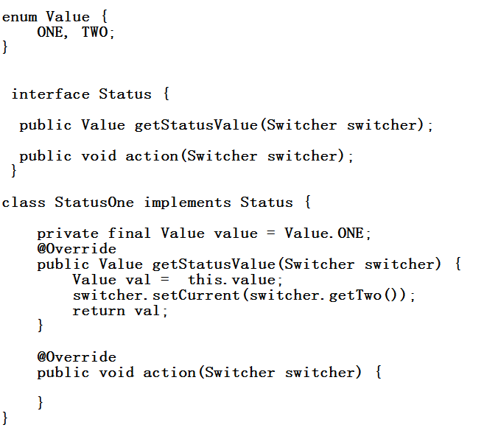 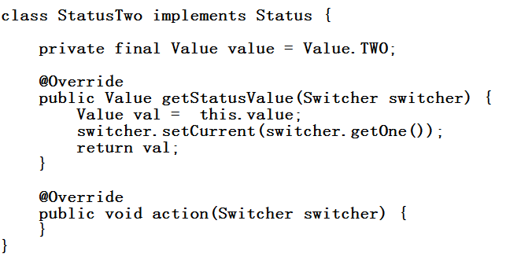



## 3. Design and program to simulate the bank account system according to the following state machine diagram.（设计并编码实现模拟银行系统的账号，状态机图如下。）

