# 面向对象系统分析与设计课后作业01

## In an action adventure game, each character can make use of one weapon at a time, but can change weapons at any time during the game. Your job is to program according to the following class diagram.（一个动作冒险游戏，每个角色一次只能使用一种武器，但是可以在游戏的过程中换武器。下面是类图，请根据类图编写代码。）

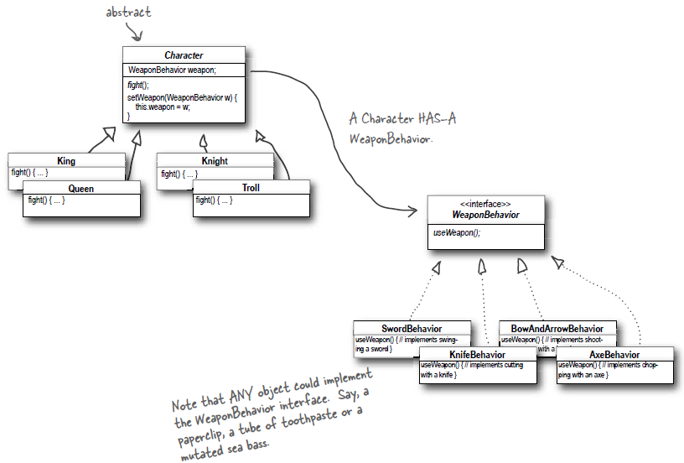

## In a university simulation system, a graduate can have three roles, and can change roles during the runtime, but can have only one role at a time. Your job is to draw the class diagram according to the following code in Java.（一个研究生在校期间，可以具有三种角色：学生、助教、收银员，但同一时刻只能具有一种角色。实现这个系统的代码如下，请根据代码画出类图。）

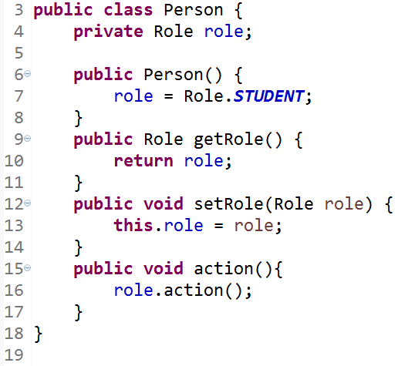

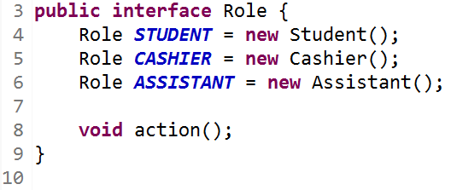

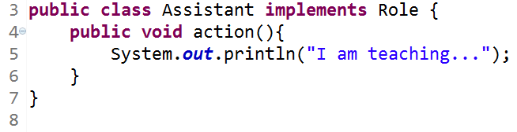

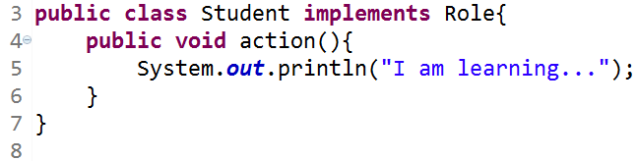

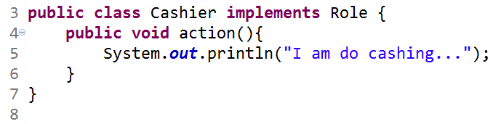

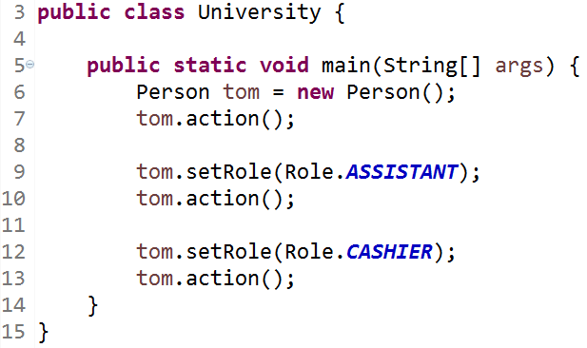

## 3. In a an online bookstore system, there are a 10% discount on every computer book, a ￥2 discount on every language book, and a ￥10 discount for every ￥100 on all the novel books .（设计一个网上书店，该系统中所有计算机类图书(ComputerBook)每本都有10%的折扣，所有语言类图书(LanguageBook)每本都有2元的折扣，小说类图书(NovelBook)每100元有10元的折扣。请使用策略模式来实现系统，绘制类图并编程实现。）