# 面向对象系统分析与设计课后作业05

hw01. Write a program using singleton pattern and make sure it is threadsafe.（写一个运用单例模式的程序，考虑多线程的情况，确保其是线程安全的。）

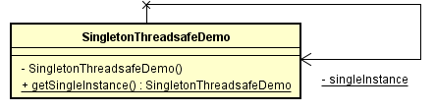

hw02. Read the codes below and work out the related class diagram.（请根据代码画出类图。）

public class Singleton { private Singleton() {}

**private** **static** **class** **SingletonHolder** {

**private** **static** **final** Singleton INSTANCE = **new** Singleton();

}

**public** **static** Singleton **getInstance**() {

**return** SingletonHolder.INSTANCE;

}

}

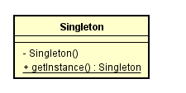

## hw03. write a program with early Early and lazy instantiation in singleton pattern respectively.（写一个小程序分别运用非懒汉和懒汉单例模式，绘制类图并编程实现。）

