Hybrid Rocket Engine

Analysis Toolkit Manual

Akshay, Daniel, Mahdi, Shane

ME Senior Design Spring 2019

**1. Fuel Grain Regression Simulator** **1**

**2. Example usage for nozzle sizing calculator:** **2**

**3. Example chamber sizing calculator:** **2**

**4. Example using bolt calculator:** **3**

# 1. Fuel Grain Regression Simulator

This calculator approximates how a given cross-section of a fuel grain, which is typically a hollow cylinder whose inner channel has some complex shape (see Fig. 1), will change over time as it is burnt away during combustion. It's pretty simple: each side of the inner channel is burnt away at a regression rate (assumed constant for this calculator), which changes the perimeter of the cross-section. This changes the amount of fuel available for oxidizer to burn (the fuel/oxidizer ratio), which changes engine pressure and other things, so, ideally, this perimeter should be constant. Achieving this is kinda tricky---that's what this calculator is for.

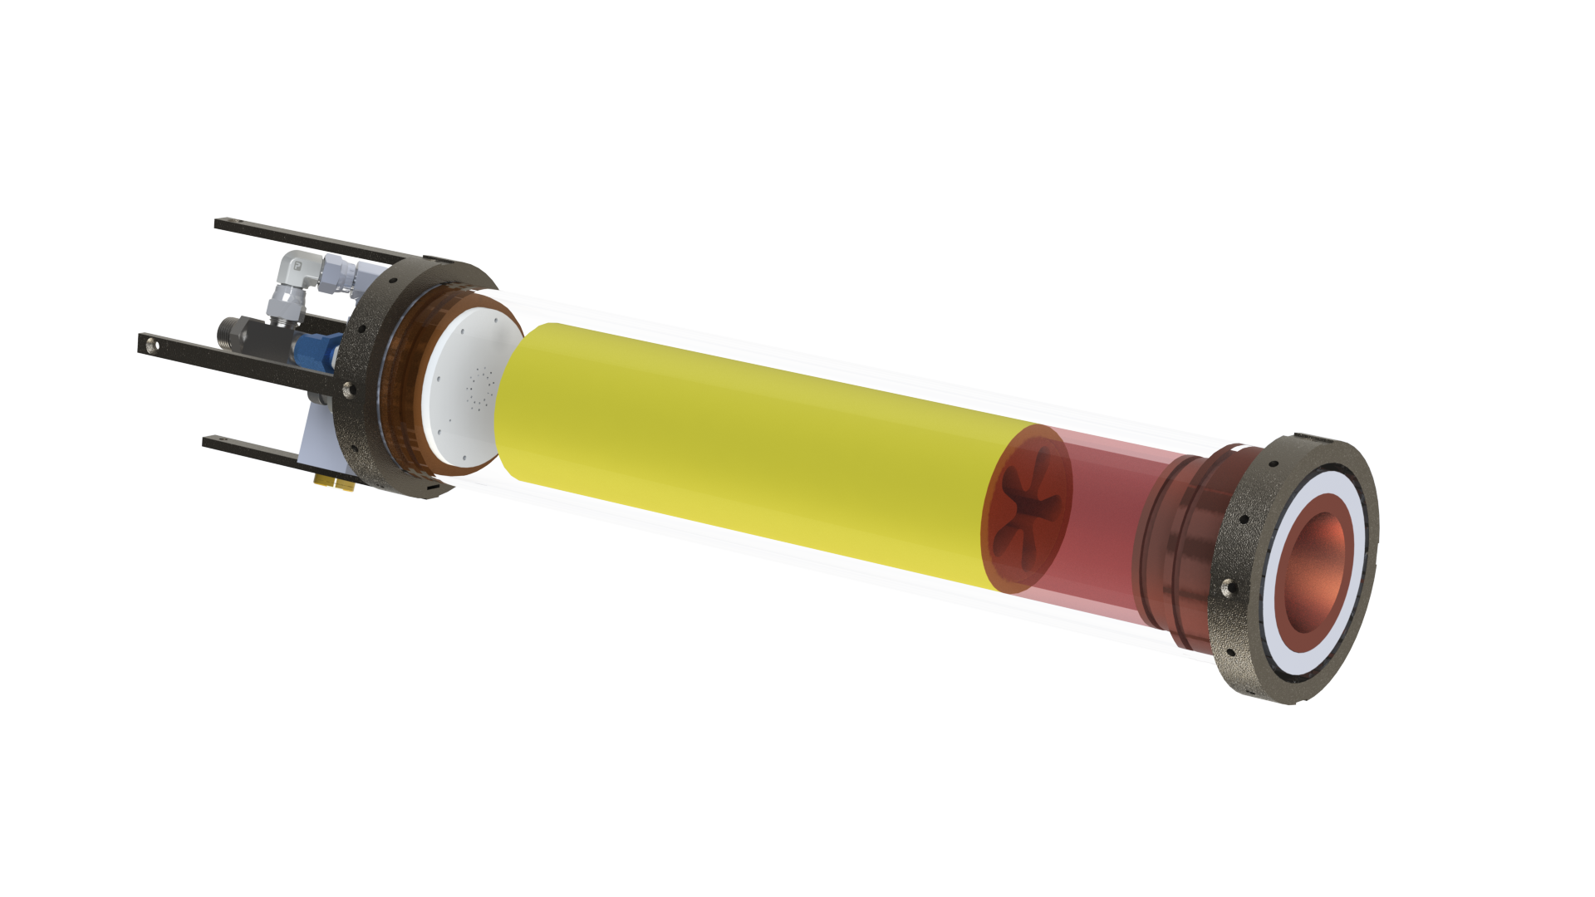

Figure 1: The combustion chamber of LRA's proposed Taurus II hybrid rocket engine. N2O fuel enters at high pressure on the left, is forced through the injector plate (white) to become a gas, reacts and combusts with the fuel grain (yellow) by flowing through its inside (see the 5-pointed rounded star hole through the middle), burning it away. The gases continue to react in the post-combustion chamber (red) before exiting the nozzle (gold) to atmosphere. The exterior aluminum casing is hidden for clarity.

The initial plans for LRA's Taurus II hybrid engine, which this set of tools was designed to optimize (although they are applicable to multiple engines), called for a fuel grain with the 5-pointed rounded star shown in Fig. 2. The entire fuel grain has a 4" cylindrical outer diameter.



Figure 2: The original fuel grain interior channel design for LRA's Taurus II hybrid rocket engine. The black outer square of this image represents a 4"x4" square, because the fuel grain has a 4" cylindrical outer diameter. Imagine the fuel grain is circumscribed in the square and the four corners are just filled in afterward (which is necessary for this software to work right).

For the Taurus II rocket engine, some rough calculations estimated the HTPB regression rate to be ~1.8 mm/s (0.071 in/s) based on the 365 kg/s-m^2 oxidizer mass flux. Typical rates for HTBP are 1-3 mm/s.

Enter these parameters into the given Python script, near the end. Run the script by putting an image in the same folder as the script, then executing “python3 regression.py nameofimage.png”.

In order to interate through designs very quickly, you can install a drawing program like Krita (<https://krita.org/en/>). Open the image file in Krita, and, using Krita’s multibrush tool (turn on “snowflake” symmetry in tool options), draw to change the cross-section image in a rotationally symmetric way. Save the image in Krita, then run the Python script to see a result. To iterate, *do not close the Python graph window yet.* Instead, edit your design in Krita again, then close the Python graph window; it detects that the file has changed and, instead of closing, will reopen with the new results (if you close the window without changing the file, it will stay closed).

Finally, to bring the design into SolidWorks, insert the image as a Sketch Picture (with a sketch open, Tools > Sketch Tools > Sketch Picture) and trace it with spline(s). If you want symmetry (on, say, a star shape with 5 lobes), you might trace half of one lobe, extrude it, then mirror it to make one full lobe. Circular pattern this for the entire cross-section (or, if SolidWorks complains of bad geometry, make a circular pattern of bodies, one body per lobe, then combine the bodies together).

Good luck!

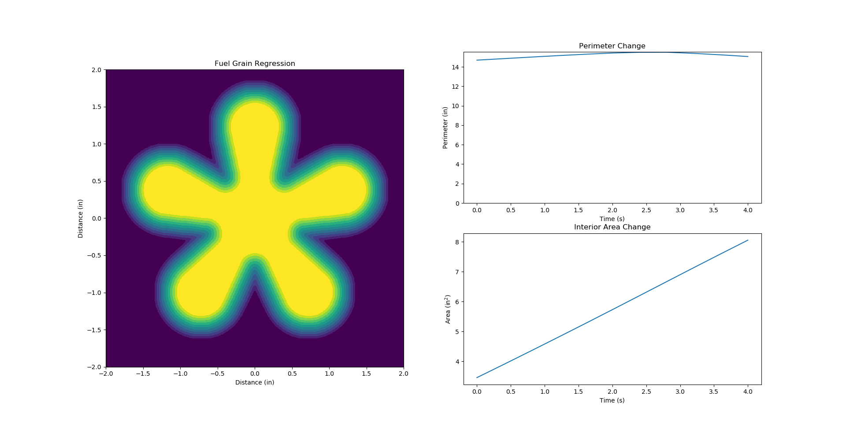

Figure 3: The results of the calculation on the original fuel grain shape.

# 2. Example usage for nozzle sizing calculator:

Prerequisites

1. Install rocketcea - <https://rocketcea.readthedocs.io/en/latest/quickstart.html>
2. Use a Python IDE – Pycharm recommended
3. Ensure familiarity with Python

This is an example of how to use the Nozzle Calcs.py calculator. All equations and code are thoroughly commented.

1. The only variables that need to be changed are as follows:

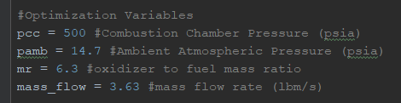

1. Run the program when the parameters have been input.

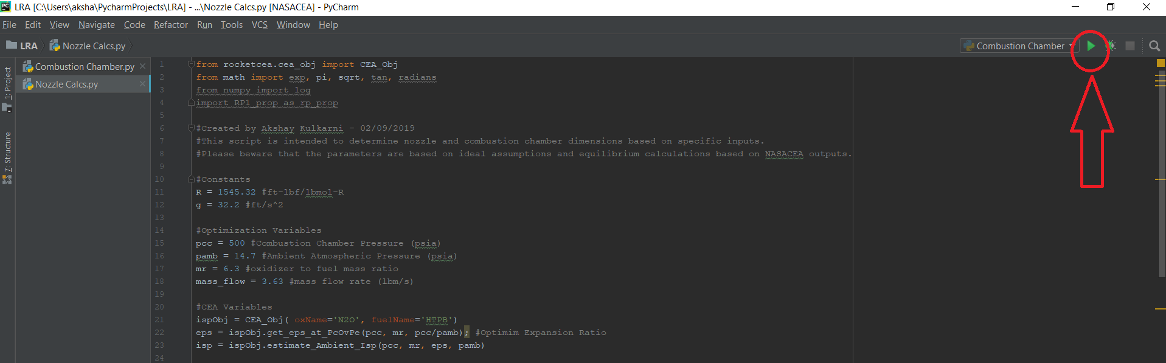

1. View the outputs:

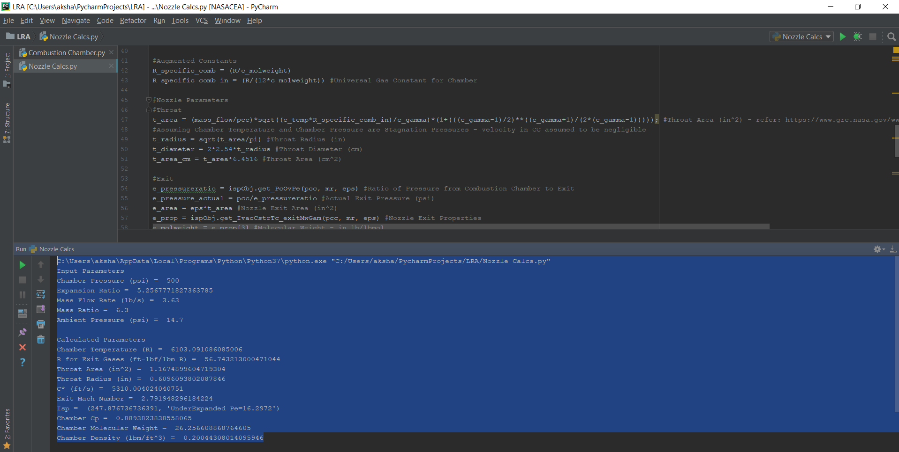

# 3. Example chamber sizing calculator:

**Combustion Chamber.py Example**

This is an example of how to use the Combustion Chamber.py calculator. All equations and code are thoroughly commented.

1. The only variables that need to be changed are as follows:



1. Adjust the ablative liner and aluminum heat sink thermal properties as required:

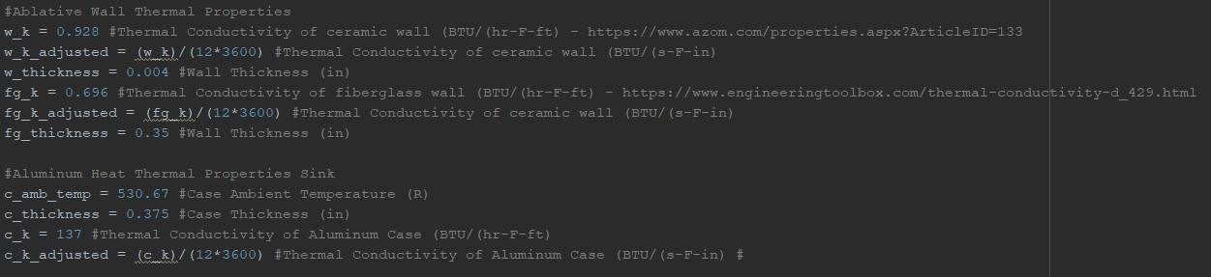

1. The heat transfer is assumed to only happen into the section of the post-combustion chamber. *Only select the volume and surface area of the post-combustion chamber of the engine casing.

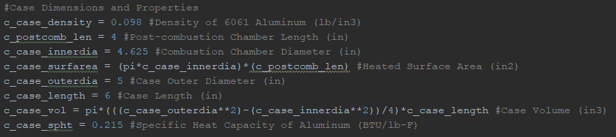

1. Run the program when the parameters have been input.



1. View the outputs:



https://krita.org/en/

# 4. Example using bolt calculator:

Assumptions:

-Units: Customary

1. Select a standard bolt: #10-24 Grade 8 Hex Steel Screw from McMaster

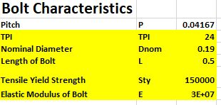

1. Enter geometric parameters into first section (highlighted yellow)
2. **Bolt Geometry**, **Preload**, and **Torque** sections will be calculated automatically
3. Enter stiffness dimensions

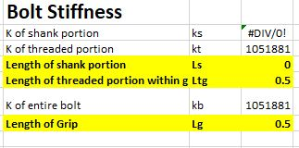

1. **Grip Stiffness** section will be solved
2. **Joint Constant** section will be solved
3. Enter in Applied Loads from ANSYS Simulations. Stresses will be summed in following section automatically.

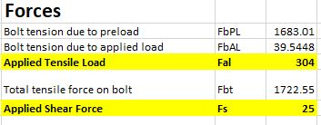

1. Enter in desired Factor of Safety for bolted joint

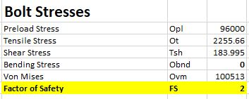

1. Iterate **Factor of Safety** value until **Von Mises** stress value is below the **Force Required to Separate** from **Joint Constant** section
2. Enter length of thread engagement to validate that FoS for threads are safe

