BCS 3101: BASICS OF MACHINE LEARNNING
Assignment 2 Report: Notebook 6
Exploratory Data Analysis of Monthly Maize and Beans Prices
Student: GUMISIRIZA AMBROSE
Registration number: 2024/A/KCS/3143/F
Group project: Predicting monthly maize and beans prices in selected Ugandan makets

1. Executive Suummary
This report explains Notebook 6. Notebook 6 is the exploratory data analysis stage of the group project. It checks the shape of the data before model training.
The notebook uses 1,652 monthly records. The records cover seven market labels and the period from 2007 to 2026. Each market has 236 records. The two main prices are maize and beans, measured in Ugandan shillings (UGX).
The main result is clear. Both price series are right-skewed. Maize has a mean of 1,078.34 UGX and a median of 980.66 UGX. Beans has a mean of 2,667.87 UGX and a median of 2,480.05 UGX. The means are higher because some months have large price spikes.
The yearly chart also shows a broad upward movement. Maize and beans prices do not stay at one level over time. This matters for forecasting. A model shold use time and other market information. It should also be checked carefully during high-price periods.
The analysis is useful, but it is not a forecast. It describes the data and points to patterns that later models should test.

2. Project Context and Materials Reviewed
The group project predicts monthly maize and beans prices in selected Ugandan markets. The project folder contains the processing notebooks, training notebooks, data files, figures, and reports. The earlier notebooks prepare, clean, encode, scale, split, and train the data. Notebook 6 then checks the prepared data through charts and summary statistics.
I reviewed the available notebooks, the group report, the existing student report, the CSV and NPZ files, and the figures folder. Notebook 6 uses the selected-markets CSV. The final plots in the figures folder match the analysis in Notebook 6.
Material | Use in the project
Earlier notebooks | Data loading, cleaning, selection, encoding, scaling, splitting, and model work.
Notebook 6 | Exploratory analysis before or alongside model training.
CSV files | Monthly market observations and prepared price variables.
NPZ files | Saved train and test arrays used by the modelling stages.
Figures folder | Saved charts for the report and presentation.
Existing reports | Group-level project explanation and previous written analysis.

3. Data Used in Notebook 6
Notebook 6 reads the selected-markets file and works mainly with the cleaned columns c_maize and c_beans. It also examines c_oil, c_food_price_index, year, month, latitude, and longitude when those columns are available.
The data has 102 columns. Most columns come from the market-price data structure. The price fields include observed values, lower and upper values, cleaned values, inflation fields, and trust fields. Notebook 6 does not use every column in every chart. It selects the fields needed for the question being asked.
Market label | Number of records
Busia | 236
Gulu | 236
Hoima | 236
Jinja | 236
Lira | 236
Market Average | 236
Mbarara | 236
Total | 1,652

The equal record count is useful. It means that one market does not have more rows simply because of a longer series. However, equal row counts do not prove that every price is equally reliable. The data still includes coverage and confidence fields.

4. Descriptive Statistics
The notebook begins with summary statistics. The table below uses the results printed by Notebook 6.
Variable | Mean | Median | Minimum | Maximum | Skewness
Maiize price | 1,078.34 | 980.66 | 407.41 | 2,870.68 | 1.11
Beans price | 2,667.87 | 2,480.05 | 902.66 | 6,557.42 | 0.73
Cooking oil | 6,103.85 | 5,961.24 | 3,087.13 | 11,655.23 | -
Food price index | 0.90 | 0.90 | 0.42 | 1.58 | -

Maize has a larrger positive skew than beans. This means that the maize distribution has a longer high-price tail. The mean is above the median for both products. That difference is a simple warning: a normal-distribution assumption would be weak without further checks.
The 95th percentile is 2,000 UGX for maize and 4,833 UGX for beans. There are 70 maize records and 82 beans records above their respective 95th-percentile values. These observations should not be deleted automatically. A price spike may be a real market event.

5. Univariate Analysis
Univariate analysis looks at one variable at a time. Notebook 6 uses histograms, box plots, and a bar chart of market records.
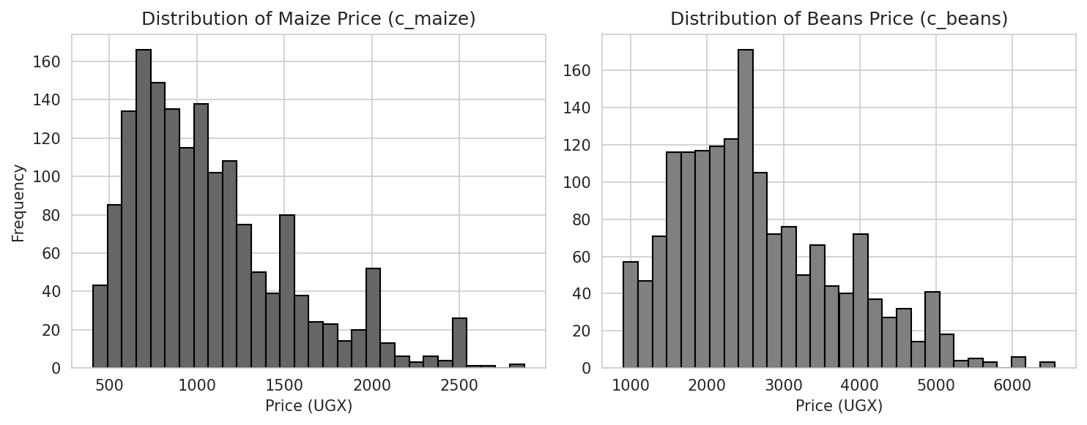
The histograms have a strong concentration at lower values and a tail toward higher values. The shape agrees with the positive skewness values.
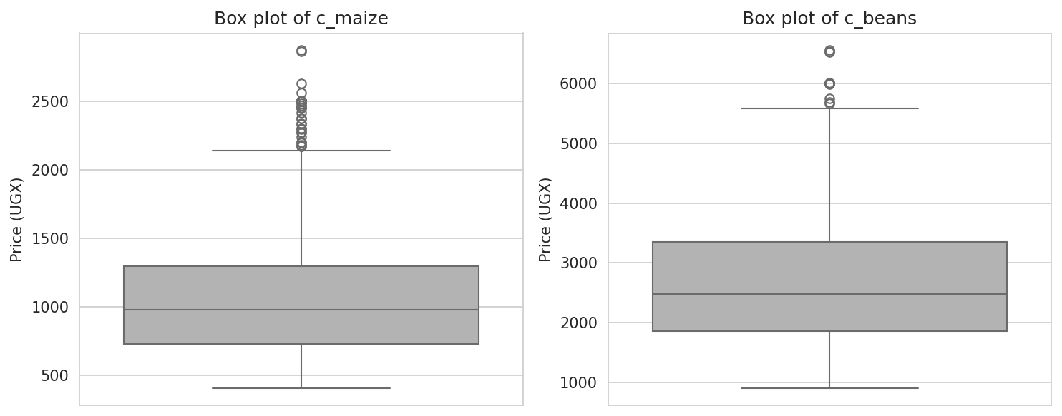
.
The box plots show several points outside the usual range. They should be investigated, but the earlier cleaning work treated them as possible real price spikes. Removing them without evidence could remove the behaviour that the forecasting model needs to learn.
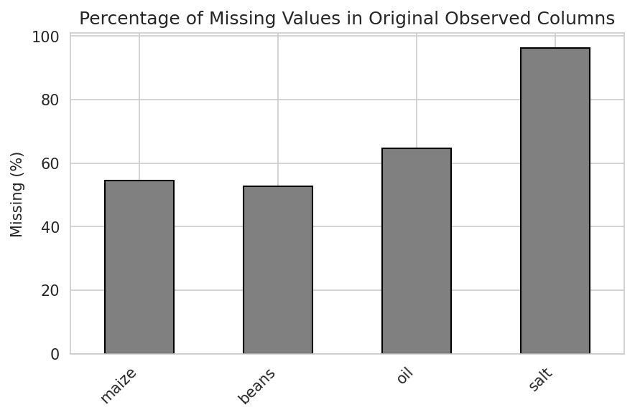

Original observed field | Missing values
maize | 54.5%
beans | 52.7%
oil | 64.7%
salt | 96.1%

The missingness chart is important. The original observed fields have many missing values, especially salt. Notebook 6 therefore uses cleaned c_ variables for the main EDA. The report should not describe the original observed fields as complete.

6. Relationships and Trends
Notebook 6 then studies relationships between variables. The heatmap gives a quick view of linear association. The scatter plot gives a direct view of the maize-beans relationship.
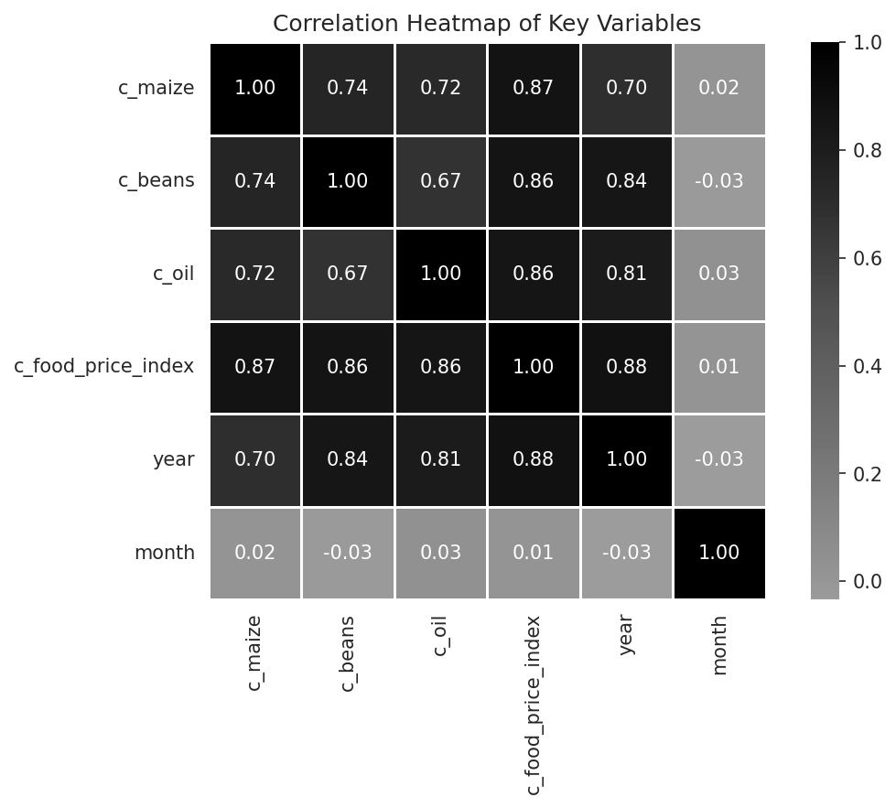

Pair | Pearson correlation
Maize and beans | 0.74
Maize and food-price index | 0.87
Beans and food-price index | 0.86
Maize and year | 0.70
Beans and year | 0.84

The maize and beans prices move together. The relationship is positive. This does not prove that one price causes the other. Both products may respond to common factors such as weather, transport costs, supply, demand, and general food-price pressure.
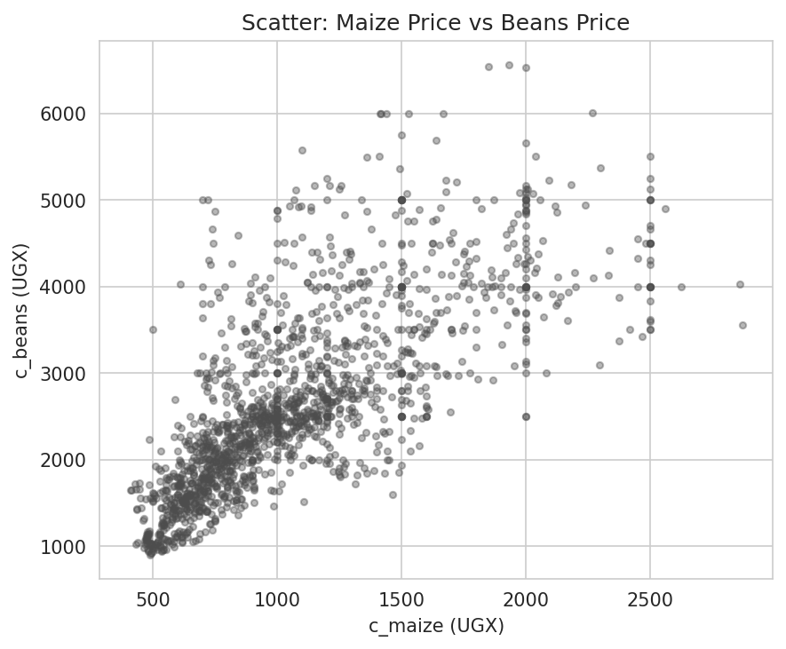
The scatter plot shows an upward band. The points are not perfectly close to one line, so maize price alone cannot explain every beans price. Market and time variables may add useful information.
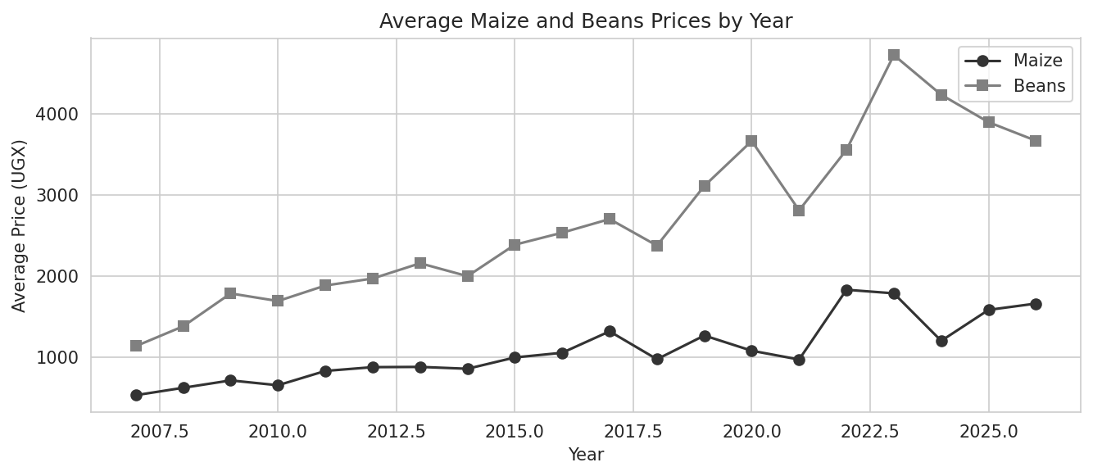
The yearly averages show a broad rise over the study period. There are also rises and falls within that direction. The annual chart hides monthly movements, so the model should keep the monthly detail.

7. What the EDA Means forr Modelling
Use time features. Year and month are important because the data changes over time.
Keep market identity. The seven market labels represent different locations and market conditions.
Test price relationships. Maize and beans move together, so lagged or current related-price features may help. The final modelling design must avoid data leakage.
Treat extreme values carefully. Large values may be real events. Compare them with the source fields, coverage, and trust fields before removal.
Check missingness before modelling. A missing value count is not enough. The pattern of missing values and the way they were filled should be recorded.
Compare simple baselines. A model should beat a last-value, seasonal, or market-average baseline before it is called useful.

8. Limitations
The EDA is descriptive. It does not prove causes.
The selected file contains a field called Market Average alongside named markets. This average should be handled carefully because it is derived from market information and can create leakage if used incorrectly.
The data ends in 2026 in the project files. The last period may have different coverage from older periods.
High missingness in original observed fields means that cleaned fields need clear documentation.
The report does not claim that a high correlation guarantees good forecasts.

9. Conclusion
Notebook 6 gives a clear first view of the price data. It finds right-skewed price distributions, high-price months, a positive maize-beans relationship, missing original observations, and a broad rise in yearly averages. These findings support the next modelling stages, but they also set conditions for them. The model must respect time order, market differences, missing values, and genuine price spikes.
In simple terms, the data contains a pattern, but it is not simple. Prices rise over the long term, move together, and sometimes jump. A useful forecasting model should learn all three facts.

10. Sources
Project sources reviewed:
Notebook files in the notebooks folder, including Notebook 6 and the earlier cleaning, feature, split, and model notebooks.
uganda_maize_beans_selected_markets.csv in the data folder.
Figures 1 to 6 in the figures folder.
BCS3101_Assignment2_Group_Report.docx and mercy.docx in the report folder.
Web sources used for background:
Food and Agriculture Organization of the United Nations. FAO Food Price Index and World Food Situation. https://www.fao.org/worldfoodsituation/foodpricesindex/en/
Uganda Bureau of Statistics. Official statistics portal and key statistics pages. https://www.ubos.org/
Web pages accessed: 1 October 2026. The web sources provide context only. The numerical results in this report come from the project files.

