Notebook 2: Data cleaning
Projet:
Student: KUKUNDAKWE SAVIOUS

1. Purpose
Notebook 2 checks missing values, duplicate rows and unusual prices. It records what we found and explains which data we keep for the later analysis.

2. Dataset
The notebook starts with the selected-markets file prepred in Notebook 1. It contains 1,652 rows and 102 columns. The seven markets are Busia, Gulu, Hoima, Jinja, Lira, Mbarara and Market Average. Each market has 236 monthly records.
The target columns are c_maize and c_beans. The World Bank descirbes the Uganda Real-Time Food Prices data as a mixture of direct price measurements and machine-learning estimates. The completed c_ series should therefore not be described as fully observed prices. Some values are estimates, and that uncertainty carries into any model trained on them [1].

3. Missing Values
Notebook 2 counted the missing values in every column. The main results are below.
Column | Missing rows | Missing (%) | Decision
maize (observed) | 900 | 54.48% | Keep for comparison; do not use as a model feature.
beans (observed) | 871 | 52.72% | Keep for comparison; do not use as a model feature.
oil (observed) | 1,069 | 64.71% | Do not use the highly incomplete observed series as a feature.
salt (observed) | 1,588 | 96.13% | Leave out of later feature selection.
c_maize | 0 | 0% | Keep as the maize target.
c_beans | 0 | 0% | Keep as the beans target.

We did not fill the gaps in the original maize and beans columns with a mean or median. More than half of their entries are missing, so simple filling could add values that were not measured. The completed target series have no missing entries, so the notebook keeps them.
The missing-data matrix in Notebook 2 shows blocks of mising observations. This suggests the gaps are not simply scattered across the file. However, a plot alone cannot establish whether the gaps are MCAR, MAR or MNAR. Those labels describe why values are missing, and the cause needs further evidence [2].
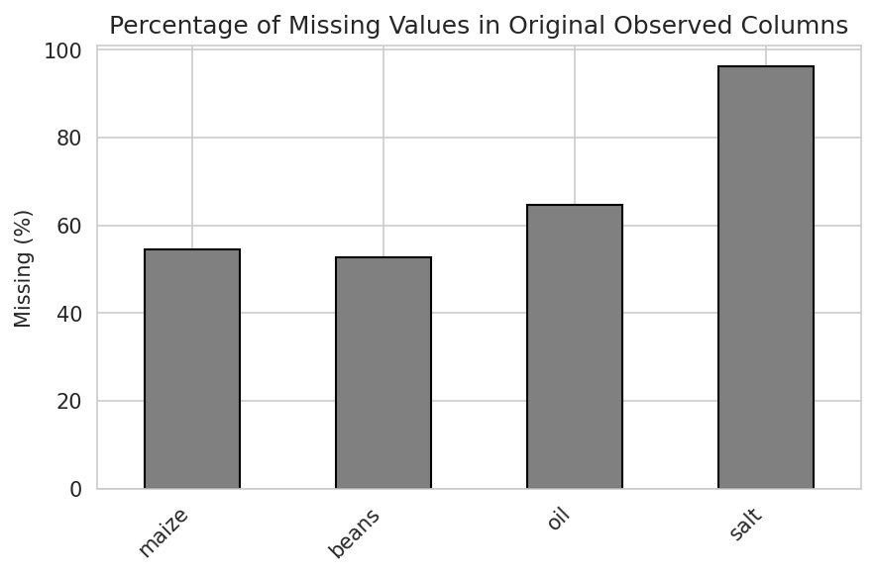
Figure 1. Missing values in the original observed price columns. This bar chart is from Notebook 6 and supports the missing-value counts used in Notebook 2.

4. Duplicate Records
The notebook found zero exact duplicate rows. No rows were removed. The cleaned file therefore keeps all 1,652 records.

5. Outlier Checks
Notebook 2 used the interquartile range (IQR) rule and the Z-score rule on each target. Under the IQR rule, a value is flagged when it is outside the fences Q? - 1.5 ? IQR and Q? + 1.5 ? IQR [3]. A flag is a prompt to investigate, not proof that the value is wrong.
Target | Q1 | Q3 | Lower fence | Upper fence | IQR flags | Z-score flags, |Z| > 3
c_maize | 729.53 | 1,300.00 | -126.18 | 2,155.70 | 48 | 30
c_beans | 1,855.69 | 3,350.00 | -385.77 | 5,591.46 | 12 | 9

The fences were calculated across all seven market series together. A pooled rule can flag a price because it is high compared with the combined data, even if it is less unusual for that particular market. Market-by-market checks could give different results.
The notebook keeps the flaged values. It does not delete or cap them. This is a reasonable choice for an initial analyis because a high price can be a real market event. Notebook 6 also found 70 maize values above 2,000 UGX across several years. That pattern support keeping the observetions for now, but it does not prove that every flagged value is correct. Checking the original survey records would be needed to confirm individual spikes.
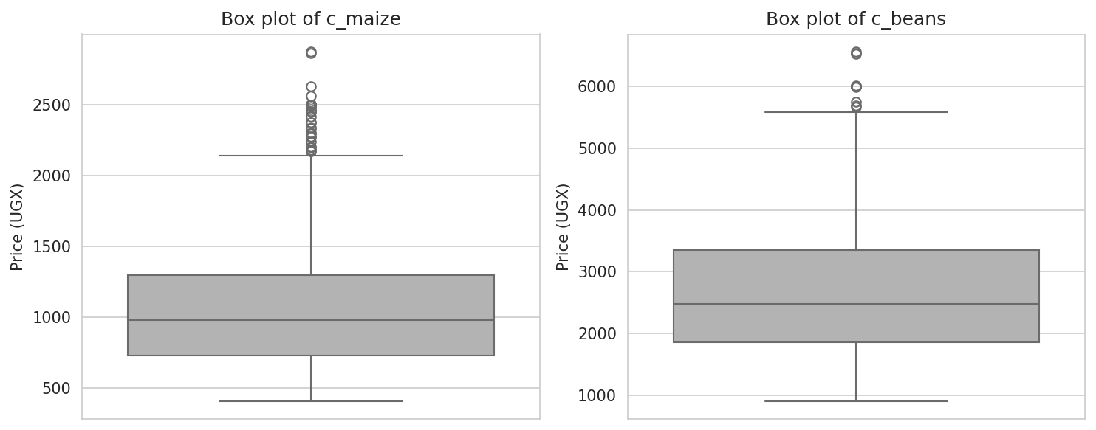
Figure 2. Box plots of the two completed target series. Points beyond the whiskers are potential outliers, not confirmed errors.

6. Cleaning Outcome
After the checks, the dataset still has 1,652 rows and 102 columns. Both targets have zero missing values. No duplicate rows or outlier observations were removed. Notebook 2 saves the result as uganda_maize_beans_cleaned.csv for the next stages.
This cleaning steep gives the later notebooks a consistent starting point. Notebook 3 uses one source file and marks data integration as not applicable. Later feature selection drops rows that are incomplete in the selected predictors, so the modelling table is smaller than the cleaned table.
References
1. World Bank Microdata Library. Monthly food price estimates by product and market: Uganda, 43 markets, 2007/01/01–2026/08/01, version 2026-08-24. Dataset record. The record states that the series uses direct measurements and machine-learning estimates for missing prices.
2. D. B. Rubin, “Inference and missing data,” Biometrika, vol. 63, no. 3, pp. 581–592, 1976. https://doi.org/10.1093/biomet/63.3.581.
3. National Institute of Standards and Technology. NIST/SEMATECH e-Handbook of Statistical Methods: Box Plot. NIST guidance.

