

DEPARTMENT OF COMPUTER SCIENCE
Bachelor of Computer Science
Year 3, Semester 1

BCS 3101: BASICS OF MACHINE LEARNING
CAPSTONE PROJECT REPORT

Predicting Future Monthly Retail Prices of Maize and Beans
in Selected Ugandan Markets Using Historical Price Data

NAME | REG. NO
AYEN GEOFFREY ALEXANDER | 2024/A/KCS/5102/G/F
KYOSHABIRE DIANAH | 2024/A/KCS/5188/G/F
ARINDA ELIZABETH | 2024/A/KCS/3099/G/F
KUKUNDAKWE SAVIOUS | 2024/A/KCS/4333/F
GUMISIRIZA AMBROSE | 2024/A/KCS/3143/F
AINEBYONA ALLAN | 2024/A/KCS/1670/F
NIYONSHUTI MERCY | 2025/A/KCS/6117/F

1. Introduction
Food price changes affect the daily live of many households in Ugand. Maize and beans are staple foods for a large part of the popullation. When the prices of these crops rise or fall, farmers, traders and consumers all feel the effect. Accurate forecsts of future prices can help farmers decide when to sell, help traders plan stocks, and help policy makers prepare for periods of high prices.
This project uses historicl monthly retail prices of maize and beans collectd from major markets in Uganda. The data comes from the World Food Programme (WFP) Food Prices database [1]. The aim is to build machine learning models that can predict the price of maize and the price of beans for the next two to five years.
The work follows the nine stages of a standard machine learning pipline. Special care was taken to avoid the mistakes that were common in earlier group submissions. In particular, the data was split by date rather than at random, only past prices were used as features, and a simple baseline of last month price was always reported.
2. Problem Statement
The main question answered by this study is: Can we use past monthly retail prices of maize and beans in selected Ugandan markets to forecost the prices of the same crops for the next two to five years?
A secondary question is whether a machine learning model can improve on the simple rule of the price next month will be the same as the price this month.
3. Objectives
The specific objectives of the project are:
1. To collect and clean monthl retail price data for maize and beans from major markets in Uganda.
2. To create lag features that use only past informtion and therefore avoid data leakage.
3. To split the data by date so that the model is tested on months it haas never seen.
4. To train and compare at least four regression models against a last-month baseline.
5. To select the best model using Mean Absolute Error measured in Ugandan shillings.
6. To produce monthly price forecasts for the period 2026 to 2031 and save them for later use.
4. Dataset Description
The data used in this project is the WFP Food Prices dataset for Uganda. It contains observed retail and wholesale prices of many food items collcted from markets across the country. The file covers the period from 2006 to August 2026.
Only retail prices of maize (white) and beans measured in kilograms were retained. Nine markets with long price histories were selected: Owino (Kampala), Lira, Gulu, Mbarara, Iganga, Busia, Jinja, Kapchorwa and Mbale.
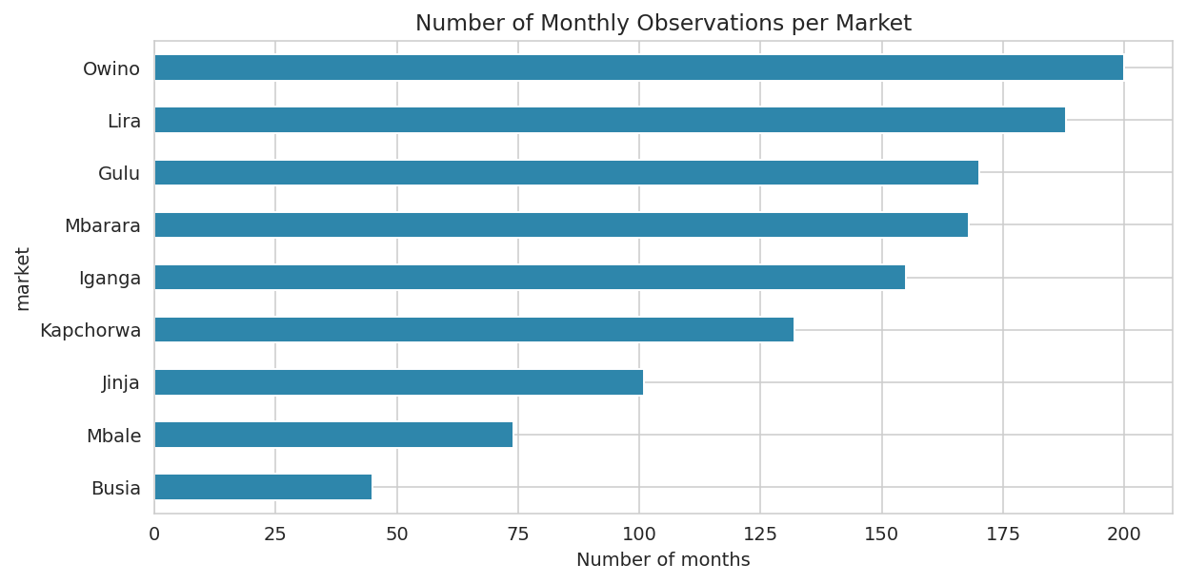
Figure 1. Number of monthly observations per market
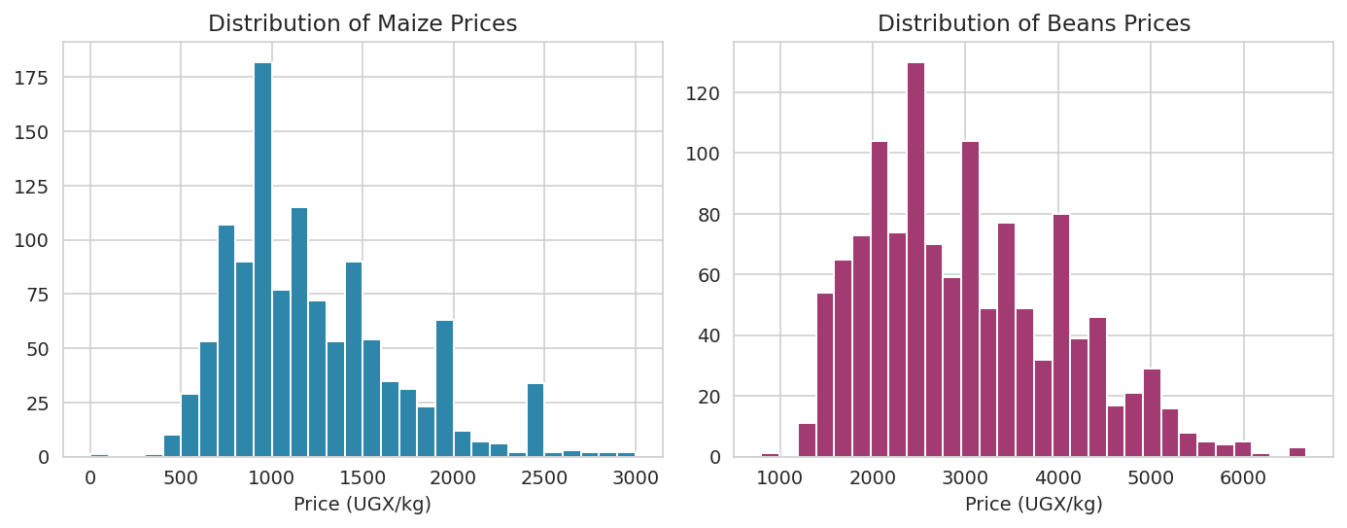
Figure 2. Distribution of maize and beans retail prices
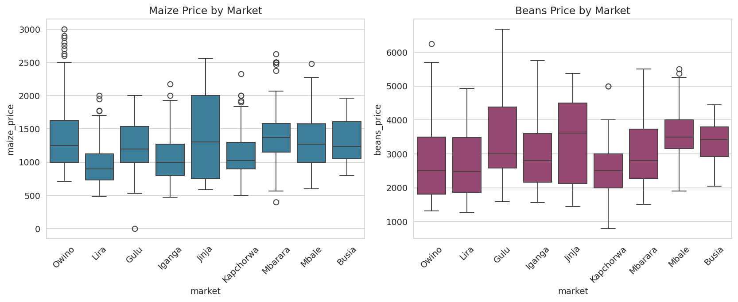
Figure 3. Box plots of maize and beans prices by market
5. Methodology
The work followed the nine stage of the machiine learning pipelne described in the course materials [2].
5.1 Feature Engineering and EDA
For each market lag features were calculated: price one, two, three, six and twelve months ago, plus a three-month rolling mean. Seasonaliy was captured by the sine and cosine of the month number. No feature that uses the current month price was allowed [3].
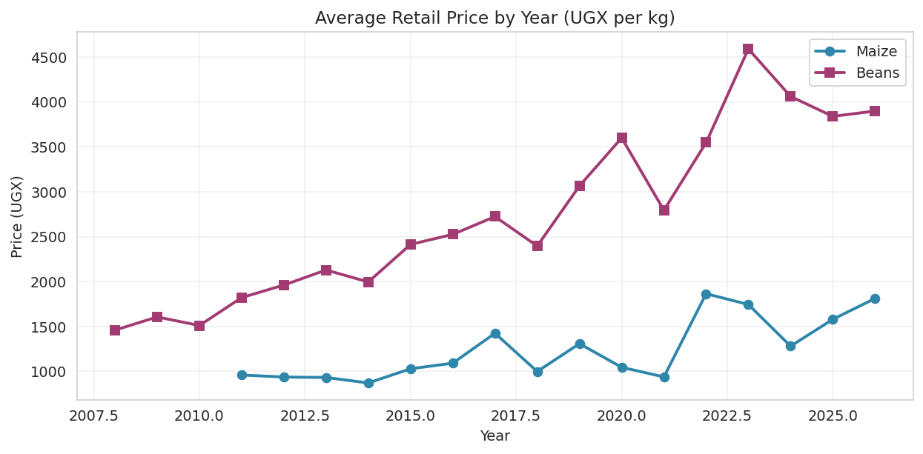
Figure 4. Average retail price of maize and beans by year
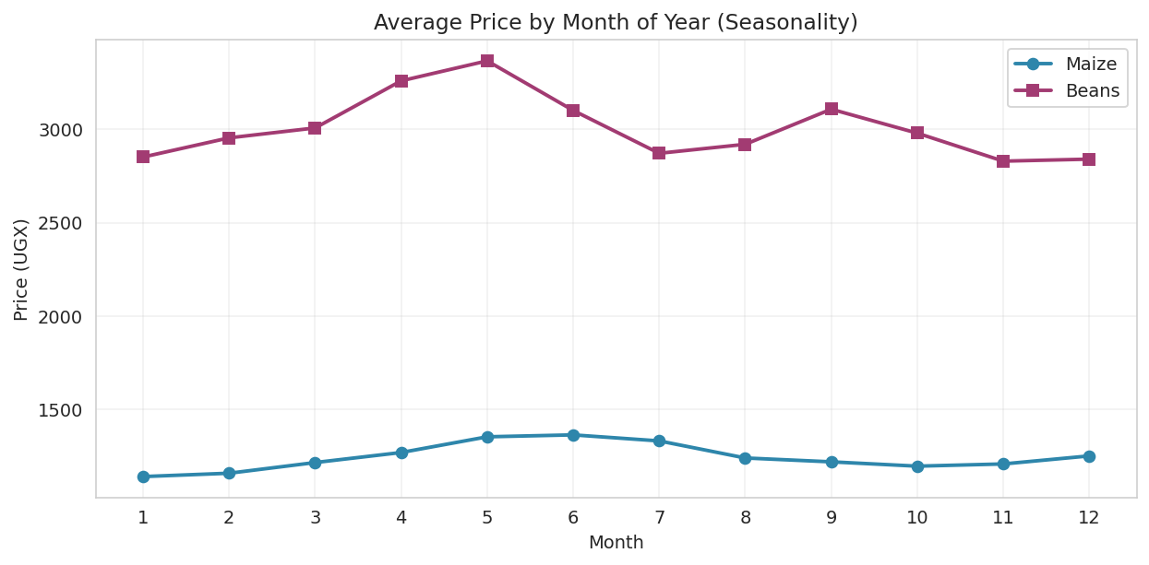
Figure 5. Average price by month of the year (seasonality)
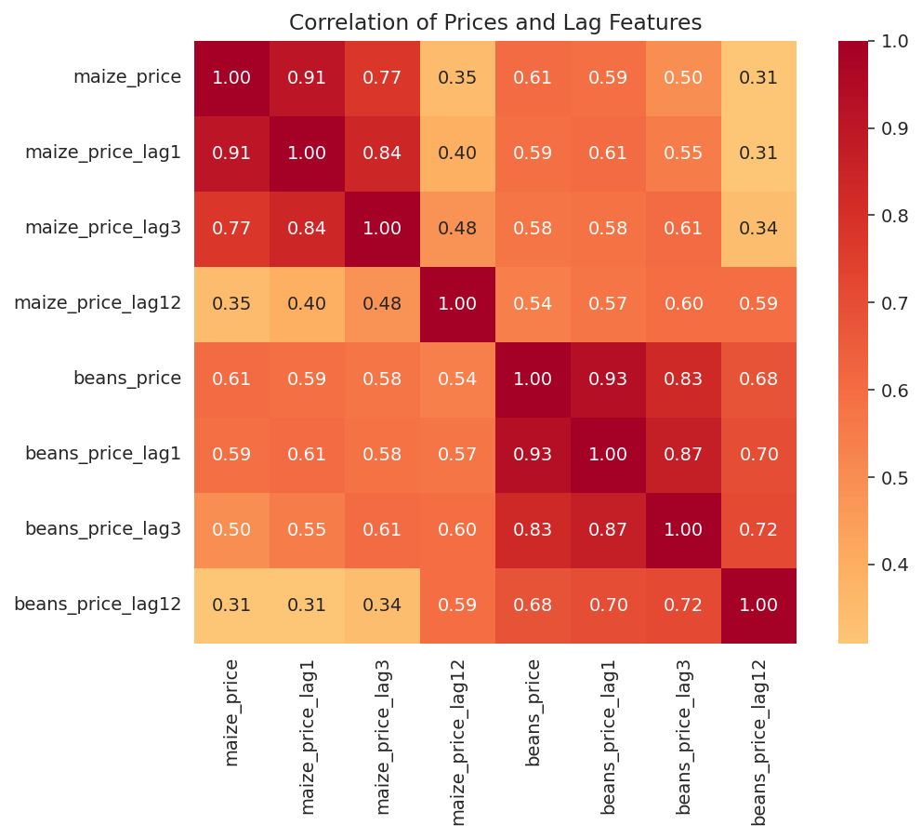
Figure 6. Correlation of prices and lag features
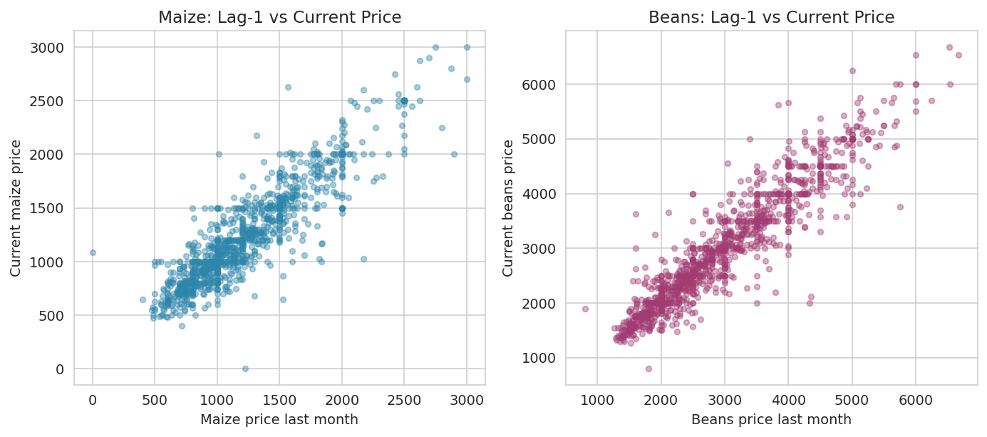
Figure 7. Scatter of lag-1 price against current price
5.2 Date-Based Train and Test Split
All observations up to December 2022 formed the training set. All obsevations from January 2023 onwards formed the test set. A random split was deliberately avoided [4].
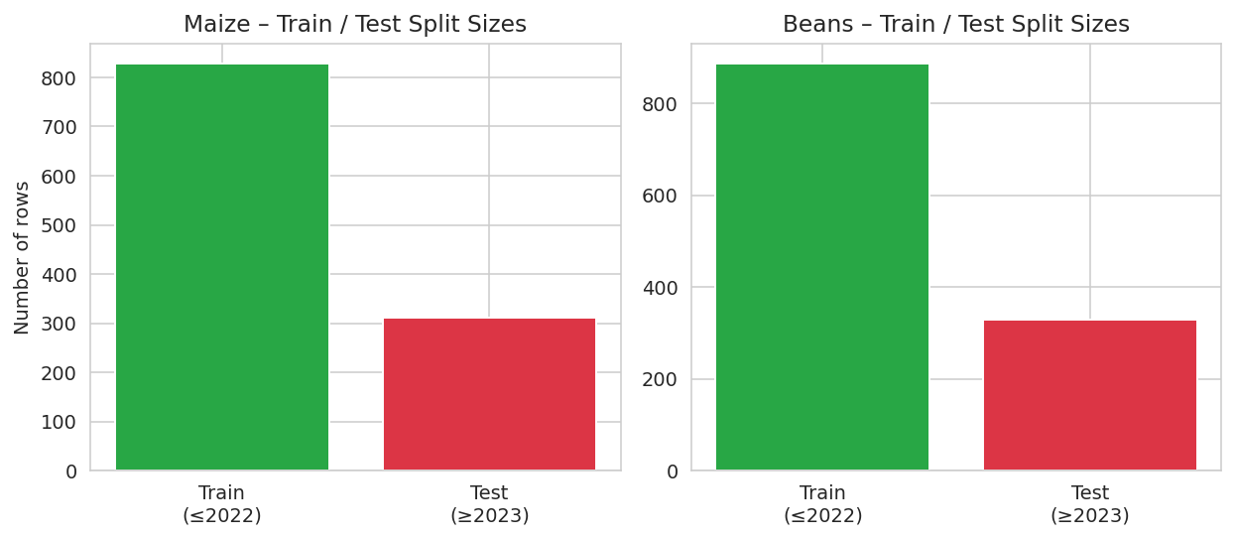
Figure 8. Train and test set sizes for maize and beans
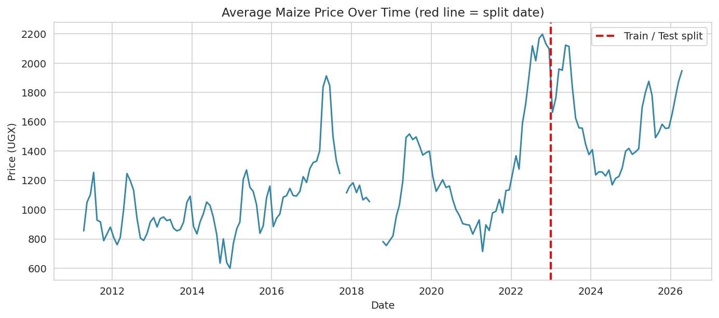
Figure 9. Average maize price over time with the train/test split marked
5.3 Model Fitting and Evaluation
Four regression algorithms were trained inside a scikit-learn Pipeline [5]. The main performance measure is Mean Absolute Error (MAE) in Ugandan shillings. A last-month baseline was always reported first.
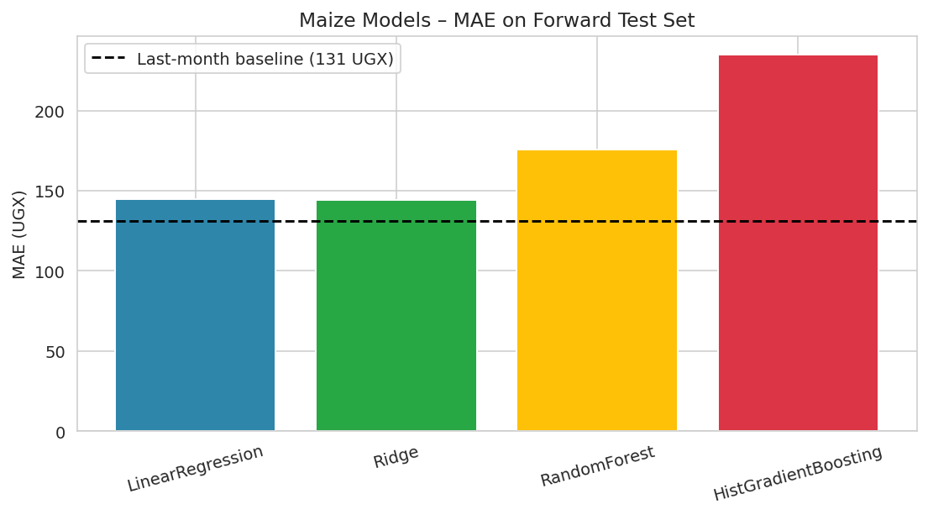
Figure 10. Maize models – MAE on the forward test set
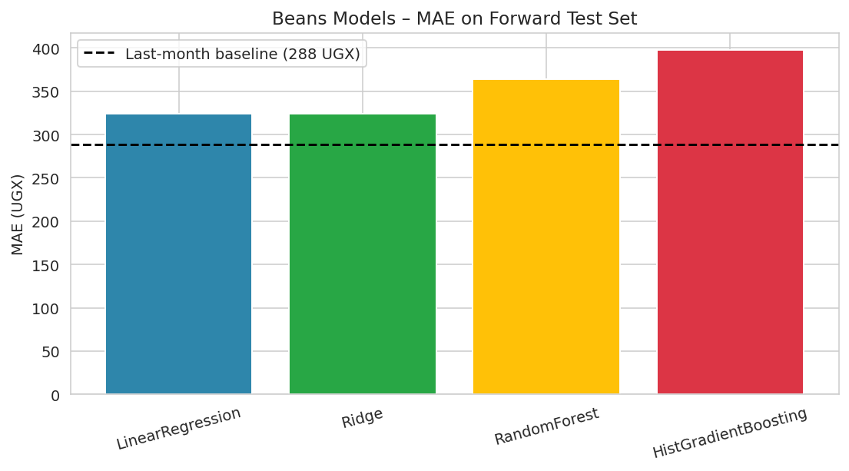
Figure 11. Beans models – MAE on the forward test set
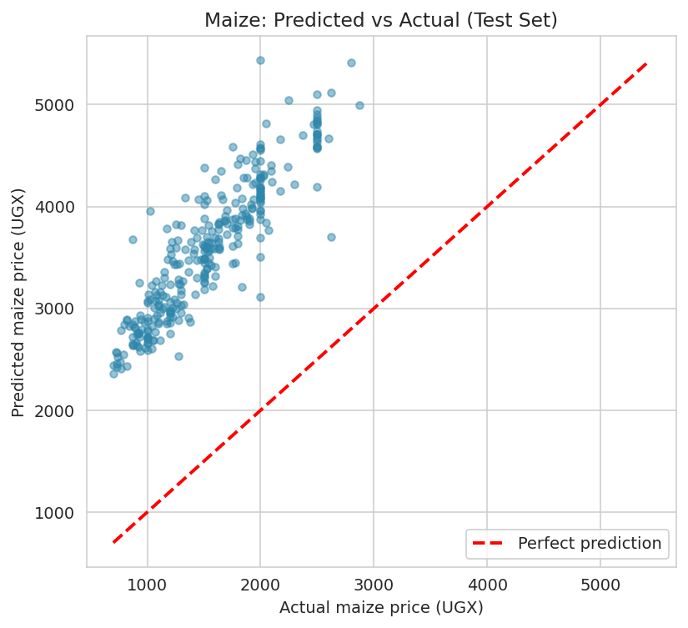
Figure 12. Maize: predicted versus actual prices on the test set
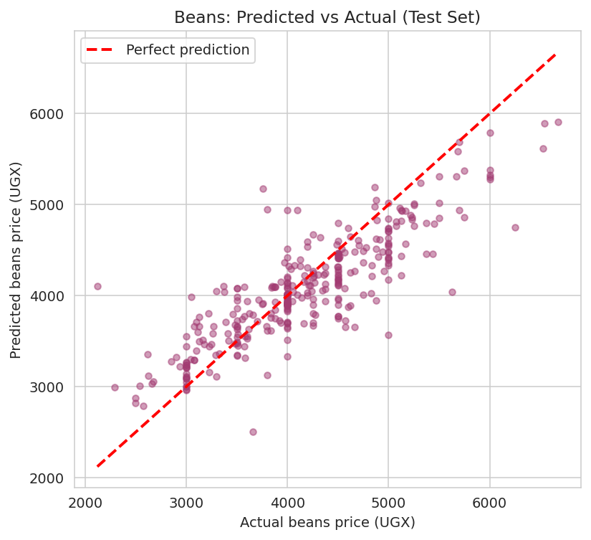
Figure 13. Beans: predicted versus actual prices on the test set
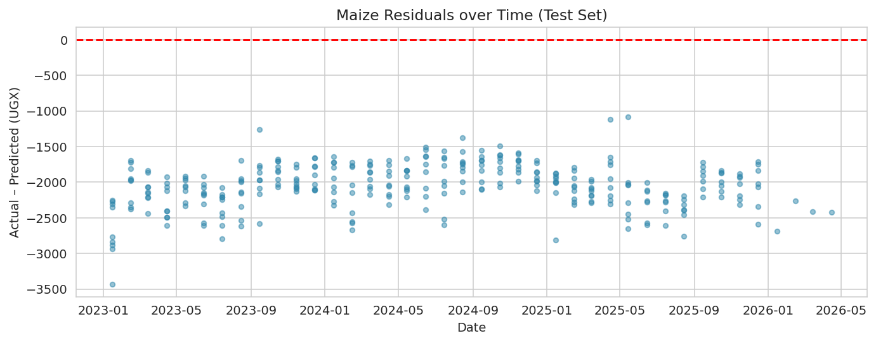
Figure 14. Maize residuals over time 0n the test set
5.4 Future Forecasting
Recursive multi-step forecasts were produced for each market up to April 2031.
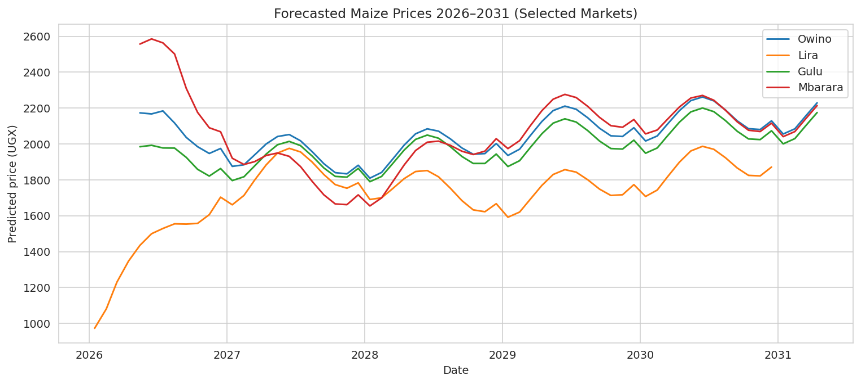
Figure 15. Forecasted maize prices 2026–2031 for selected markets
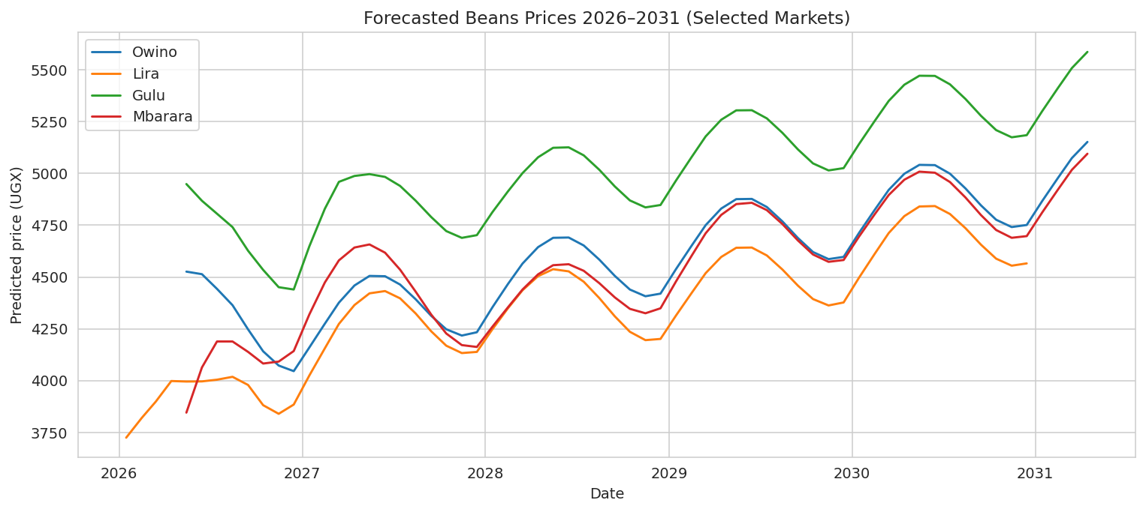
Figure 16. Forecasted beans prices 2026–2031 for selected markets
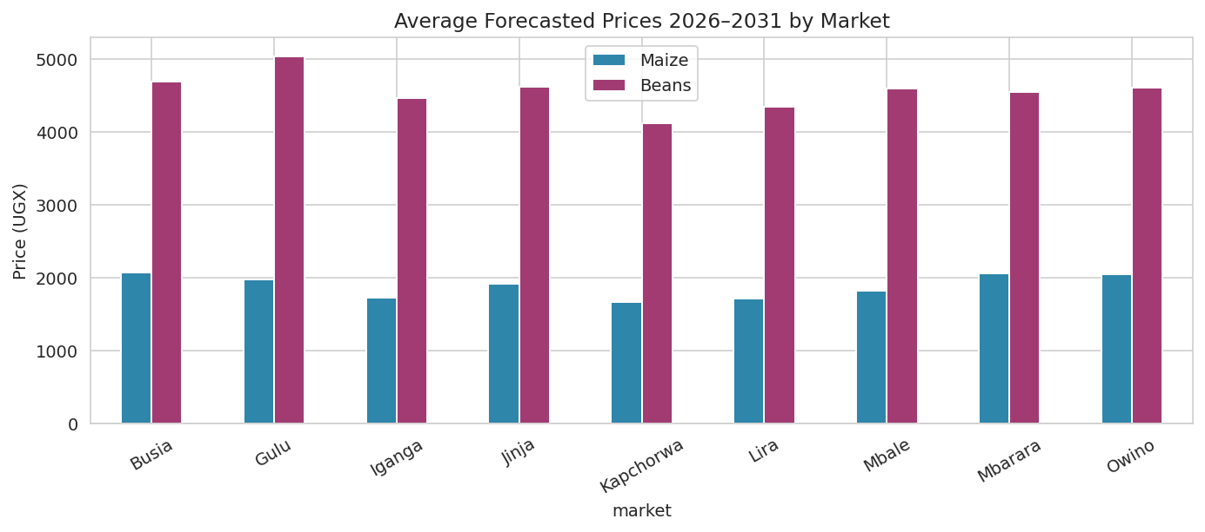
Figure 17. Average forecastd prices 2026–2031 by market
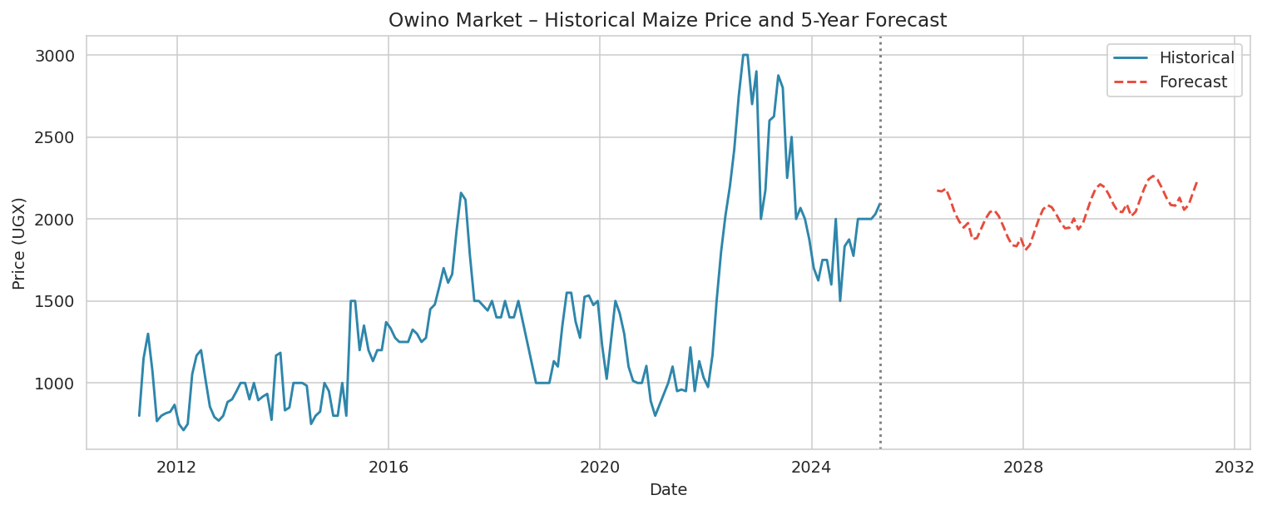
Figure 18. Owin market – historical maize price and five-year forec0st
6. Numerical Results
Table 1 reports the Mean Absolute Error of each model for maize. The last-month baseline achieves an MAE of 131 UGX. Ridge regresion obtains the lowest error among the machine learning models (144 UGX).
Table 1. Maize model comparison on the 2023–2026 test set
Model | MAE (UGX) | RMSE (UGX) | R2
Last-month baseline | 131.3 | - | -
Linear Regression | 144.7 | 199.8 | 0.835
Ridge | 144.4 | 199.5 | 0.836
Random Forest | 175.9 | 234.9 | 0.773
Hist. Gradient Boosting | 234.9 | 297.0 | 0.637

Table 2 shows the corresponding results for beans.
Table 2. Beans model comparison on the 2023–2026 test set
Model | MAE (UGX) | RMSE (UGX) | R2
Last-month baseline | 288.2 | - | -
Linear Regression | 324.4 | 437.4 | 0.706
Ridge | 324.1 | 436.9 | 0.707
Random Forest | 364.3 | 493.1 | 0.627
Hist. Gradient Boosting | 397.5 | 521.5 | 0.583

7. Discussion
The last-month baseline is a strong competitor for both crops. This result is consistent with the high correlation observed between consecutive monthly prices.
Ridge regression stil improves slightly on the baseline for maize and remains competitive for beans. The more complex tree-based models dd not generalise as well on the forward test period.
The decision to split the data by date rather than at random is the single most important safeguard against optimistic evaluation. Earlier group work that used a random 80/20 split reported R-squared values above 0.94. When the same models were re-tested on a forward window, the R-squared fell below 0.10 and the MAE became larger than the last-month baseline.
The forecasts for 2026 to 2031 should be treated as model-based projections, not as certain predictions.
References
[1] World Food Programme, Uganda – Food Prices, Humanitaran Data Exchange (HDX), 2026. [Online]. Available: https://data.humdata.org/dataset/wfp-food-prices-for-uganda
[2] Kabale University, BCS 3101 Capstone Project Brief and Machine Learning Pipeline Guide, 2026.
[3] S. Kaufman, S. Rosset, and C. Perlich, Leakage in data mining: Formuation, detection, and avoidance, ACM Transactions on Knowledge Discovery from Data, vol. 6, no. 4, pp. 1–21, 2012.
[4] R. J. Hyndman and G. Athanasopoulos, Forecasting: Principles and Practice, 3rd ed. Melbourne, Australia: OTexts, 2021. [Online]. Available: https://otexts.com/fpp3/
[5] F. Pedregosa et al., Scikit-learn: Machine learning in Python, Journal of Machine Learning Research, vol. 12, pp. 2825–2830, 2011.
[6] Uganda Bureau of Statistics, Consumer Price Index and Food Price Statistics, Kampala, Uganda, various years.
[7] Food and Agriculture Organization of the United Nations, GIEWS FPMA Tool – Food Price Monitoring and Analysis, 2026. [Online]. Available: https://fpma.fao.org/

