Two Regimes of Bio-Inspired Memory: A Neural Architecture Search Perspective
Author names withheld for double-blind review
Instituto Tecnológico de Costa Rica

Abstract—We apply exhaustive Neural Architecture Search (NAS) over a discrete design space of bio-inspired episodic memory mechanisms, examining whether the relative importance of those mechanisms is a property of the mechanism or a property of the operating regime. The search space encodes six design axes drawn from Sparse Distributed Memory, Hebbian engram consolidation, and trace-decay theory, yielding 576 candidate architectures (96 functionally distinct). Evaluation across three capacity-constrained tasks reveals a threshold law: when the number of recurring distinct experience prototypes divided by memory capacity falls below one, consolidation by merging (compression regime) explains 73–85% of performance variance; above that threshold, eviction policy (selection regime) dominates at 28–32%, while merging becomes irrelevant. Two invariants hold across the full parameter sweep: (i) the FIFO buffer of an existing deployed cognitive architecture scores at the floor of its own design space in all 14 evaluated cells, and (ii) the frontier architecture is the same in every cell—append-write with prediction-error-gated initial strength and minimum-strength eviction. Notably, the mechanism most frequently cited in the bio-inspired memory literature (novelty/prediction-error modulation of encoding strength) shows only 0.2% explained variance as a main effect, but recovers to 59% relative improvement when combined with minimum-strength eviction in the selection regime—a result that critically depends on modeling the interaction rather than the main effect alone.
Index Terms—bio-inspired memory, neural architecture search, Sparse Distributed Memory, engram consolidation, episodic memory, cognitive architecture, lifelong learning.

I. INTRODUCTION
The field of bio-inspired episodic memory has produced a rich catalog of mechanisms: content-addressable retrieval via Sparse Distributed Memory (SDM) [1], Hebbian engram consolidation [2], trace-decay regulated by novelty and prediction error [3], and selective forgetting based on utility or strength [4]. These mechanisms are almost always evaluated in isolation, hand-crafted into specific architectures, and compared against baselines that do not share the same design space. The standard result is that the proposed mechanism improves over a simple FIFO or circular buffer—but it is rarely possible to tell whether the gain comes from the mechanism or from a favorable coincidence between the mechanism and the evaluation protocol.
This paper inverts the question. Rather than proposing one memory architecture and measuring how much better it is than a fixed baseline, we define a design space where every mechanism is an axis and search exhaustively. The incumbent architecture—the FIFO episodic buffer used by the e-MDB cognitive framework [5], a deployed system for lifelong open-ended learning—is not a baseline: it is a single point within the search space. This choice converts a potentially biased comparison into a falsifiable question: given the full design space, where does the incumbent land, and what separates it from the frontier?
The search reveals that this question cannot be answered without specifying the operating regime. The ratio of distinct recurring experience prototypes to available memory capacity determines which mechanism family governs performance. Below a threshold of one—when the memory can hold all recurring prototypes—merging (consolidation) explains 73–85% of variance. Above the threshold—when prototypes outnumber slots—eviction policy takes over at 28–32% and merging loses its advantage. The incumbent sits at the performance floor in all evaluated regimes. The frontier architecture, however, does not change with regime: append-write combined with prediction-error-modulated initial strength and minimum-strength eviction consistently reaches the top.
The main contributions are: (1) a threshold law relating the prototype-to-capacity ratio to which bio-inspired mechanism family dominates; (2) a demonstration that the most-cited encoding-saliency mechanism shows near-zero main effect but strong conditional effect when paired with compatible eviction; (3) an exhaustive NAS that locates the incumbent of a deployed system at the floor of its own design space across all regimes.
II. RELATED WORK
A. Sparse Distributed Memory
Kanerva's Sparse Distributed Memory [1] models high-dimensional associative recall via distributed superposition over a set of hard locations within a similarity radius. Retrieval degrades gracefully under noise; capacity scales with dimension. The original formulation uses hard binary addresses; continuous and probabilistic variants have been proposed for robotics [6]. In our search space, the read mode axis operationalizes SDM-like access (radius-based activation) versus nearest-neighbor episodic access.
B. Engram Consolidation and Trace Decay
Neurobiological accounts of memory consolidation posit that frequently co-activated neuronal assemblies—engrams—are structurally strengthened via long-term potentiation (LTP) [2]. Computational models have operationalized this as fast-weight Hebbian memory [7], write-merge policies [8], and strength-gated forgetting [9]. Prediction-error modulation of encoding strength connects to the Rescorla-Wagner model and dopaminergic gating [3]. Our search space implements these as discrete axes: write mode (append vs. merge), initial strength (constant, novelty, prediction error, or both), decay rate, and eviction policy.
C. NAS for Memory Architectures
Neural Architecture Search has been applied extensively to network topology and operator choice [10]. Its application to memory module design is less explored: most work fixes the memory type and searches over integration strategy [11]. Our contribution is to treat the memory mechanism itself as the search target, using an exhaustively enumerable discrete space to avoid confounding the search outcome with the behavior of the optimizer.
D. Cognitive Architectures with Episodic Memory
e-MDB (epistemic Multilevel Darwinist Brain) [5] is a ROS2-based cognitive architecture designed for lifelong open-ended learning (LOLA) in mobile robots. Its episodic component, EpisodicBuffer, is a fixed-capacity FIFO deque. It provides no content-addressable retrieval, no importance criterion, and no forgetting mechanism beyond displacement by recency. In our formalization, it corresponds to the genotype {read: nn, write: append, init: constant, decay: 1.0, evict: fifo, reinforce: 0}, which is one point in the 576-point search space.
III. SEARCH SPACE
Each memory architecture is encoded as a discrete genotype of six components. Table I lists all axes, their options, and the biological inspiration for each.

Axis | Options | Biological root
Read mode | nn / top-k3 / radius | Episodic recall vs. SDM activation circle
Write mode | append / merge | Trace creation vs. consolidation by fusion
Initial strength | constant / novelty / pred-err / both | LTP gating by saliency and surprise
Decay | 1.0 / 0.995 / 0.98 | Synaptic trace decay without reinforcement
Eviction | fifo / min-strength / min-utility / random | Age-based vs. importance-based forgetting
Reinforce on read | 0 / 0.5 | LTP by reactivation

Two axes—read mode and reinforce-on-read—are currently inoperative in the implementation. Read mode always returns the best-matching entry regardless of the label (the distributed superposition required for true SDM read is not yet implemented). Reinforce-on-read only modifies strength at query time, but all three evaluation tasks issue all reads after all writes; the modified strengths therefore never influence any eviction decision. Verified empirically: the maximum performance difference between architectures that differ only on either axis is exactly 0.000 across all 576 pairs. The effective search space is 96 distinct architectures. This limitation is reported transparently and forms part of the future work (Section VII).
The incumbent FIFO of e-MDB corresponds to: {write: append, init: constant, decay: 1.0, evict: fifo}. We map it to read: nn for the retrieval comparison, which is a favorable assumption—the real buffer has no content-addressed retrieval at all.
IV. EVALUATION BATTERY
Three tasks, all operated under capacity pressure (the realistic condition of a bounded robot memory operating over a lifetime):
- T1 – Rare-event retention. A stream of 300 common experiences (drawn from 5 cluster centers) and 20 rare events (high prediction error, spread randomly through the stream) written to memory at capacity 20. Measured as the fraction of rare events correctly retrieved after the full stream. This task directly probes the question motivating e-MDB: can the system keep what matters when overwhelmed by routine?
- T2 – Noise robustness. 20 patterns stored at capacity; 60 queries with 35% bit-flip noise. Measures the fundamental property of any associative memory. Note: in the current implementation this task returns 0.767 for all 576 architectures (zero variance), because no architecture ever needs to evict under these conditions. It is retained in the battery for completeness but excluded from variance attribution analysis.
- T3 – Sequential interference. 4 sequential blocks of 10 patterns each (30 writes per pattern per block); retention of block-1 patterns measured after all 4 blocks. Measures the catastrophic forgetting problem central to LOLA.
Each architecture is evaluated over 3 random seeds per task. Mean scores and task-level breakdowns are reported. The macro-average across the three tasks is the primary optimization target.
V. RESULTS
A. Main Effect Analysis (576 architectures)
Table II reports the one-way ANOVA η² for each design axis over the full 576-architecture space. Write mode explains 63.5% of performance variance; eviction accounts for 9.9%; all remaining axes are below 3%.

Design axis | η² (main effect) | Operationally distinct?
Write mode | 63.5% | Yes
Eviction policy | 9.9% | Yes
Decay rate | 2.5% | Yes
Initial strength | 0.2% | Yes (conditional—see §V-C)
Read mode | 0.0% | No (not yet implemented)
Reinforce on read | 0.0% | No (task design; see §III)

B. The Incumbent at the Performance Floor
The e-MDB FIFO achieves a macro-average score of 0.261 (rare: 0.017, noise: 0.767, interference: 0.000). Exactly 414 architectures score strictly higher; 162 tie with it. It occupies the minimum score in the distribution. The best-performing architectures reach a macro-average of 0.856, entirely driven by near-perfect rare-event retention (1.000) and strong interference resistance (0.800). Figure 1 shows the full score distribution and the per-axis variance attribution.
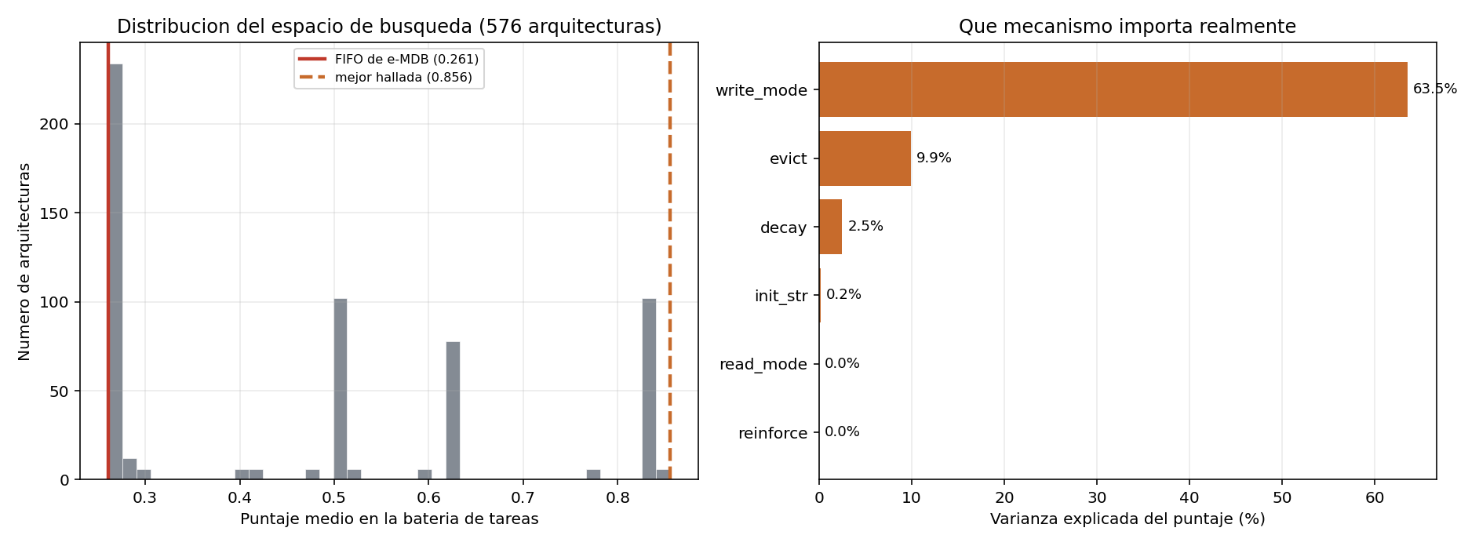
Fig. 1. Left: distribution of macro-average scores across 576 architectures; the e-MDB incumbent (red) is at the floor, the frontier (dashed) at 0.856. Right: explained variance by axis (one-way ANOVA η²). Note that two axes (read mode, reinforce) are structurally inoperative in the current implementation.
C. The Regime Transition: Prototype-to-Capacity Ratio
The dominance of write mode in Table II is not a property of consolidation as a mechanism—it is a property of the evaluation task's prototype density. In T1, a stream of 300 experiences is drawn from 5 cluster centers and written into capacity-20 memory. Merge-write collapses all instances of each cluster into a single entry, leaving 15 of the 20 slots free for rare events. When the number of distinct prototypes exceeds capacity, merging fills memory with routine and crowds out rare events—the same condition that makes the FIFO fail.
We formalize this as the prototype-to-capacity ratio r = K_proto / C, where K_proto is the number of recurring distinct prototypes in the stream and C is memory capacity. We evaluate all 96 effective architectures across a grid of (C, K_proto) values spanning r ∈ [0.05, 8.0] and compute η² for each cell.
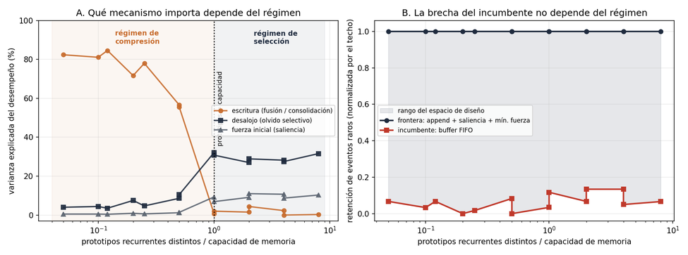
Fig. 2. Panel A: η² of write mode, eviction policy, and encoding strength as a function of prototype-to-capacity ratio r. The transition at r = 1 is sharp and independent of capacity. Panel B: normalized rare-event retention of the incumbent (FIFO) and the frontier architecture. The frontier saturates at 1.0 across the full regime range; the incumbent sits near 0 throughout.
Table III summarizes the transition:

Regime | Ratio r | η² write mode | η² eviction | Dominant family
Compression | r ≤ 0.5 | 72.9% | 6.2% | Consolidation (merge)
Transition | 0.5 < r < 1 | 56.6%→2.0% | 8.6%→30.8% | Crossover
Selection | r ≥ 1.0 | 1.6% | 29.4% | Selective forgetting

The crossover is sharp (within one doubling of r) and reproduces at capacity 10, 20, and 40 independently.
D. The Invariant Frontier
The best-performing architecture is the same in all 14 evaluated cells: append-write with initial strength gated by prediction error (or prediction error + novelty), eviction by minimum strength, and decay 1.0. This invariance is not obvious a priori: one might expect the optimal architecture to shift with regime. Instead, the frontier architecture exploits a property that is regime-independent—it never conflicts with compression (it does not merge, so rare events are never lost to consolidation of commons), and it performs selection via the minimum-strength gate without requiring an explicit cluster count.
The key interaction is between initial strength and eviction policy. Table IV shows rare-event retention conditioned on evict = min-strength and write = append:

Initial strength | Rare retention | Interference resistance | Macro-avg
constant | 0.017 | 0.000 | 0.261
novelty | 0.400 | 0.300 | 0.489
pred-error | 0.511 | 0.000 | 0.426
both | 0.594 | 0.278 | 0.546

With constant initial strength, the min-strength eviction degenerates to a pseudo-random policy (all entries have equal strength). Saliency modulation breaks this degeneracy, allowing rare high-surprise events to survive eviction of common low-surprise ones. The 0.2% main effect in Table II reflects that this interaction only manifests when eviction is strength-based; 3 of 4 eviction policies are insensitive to initial strength.
E. Decay Interacts with Eviction, Not with Write Mode
Decay matters only in the presence of minimum-strength eviction: with decay=1.0, strength is set once at write time and preserved; with decay<1.0, all entries lose strength at every step, neutralizing the saliency signal over time. Conditioned on the frontier's write+eviction combination, decay=1.0 yields rare retention 1.000 vs. 0.633 for decay=0.995 and 0.150 for decay=0.98. As a main effect, decay explains 2.5% of variance because most architectures don't use min-strength eviction and are therefore unaffected.
VI. DISCUSSION
The threshold law r = K_proto / C unifies several apparently inconsistent results in the bio-inspired memory literature. Studies reporting strong advantages for consolidation mechanisms typically evaluate in low-diversity streams (laboratory sequences, structured curricula) where r < 1 by construction. Studies reporting advantages for selective forgetting or novelty-gating typically use high-diversity streams with r > 1. Our framework predicts both and characterizes the crossover quantitatively.
The result on encoding saliency resolves an apparent contradiction: the mechanism is simultaneously near-zero in a main-effect analysis and the difference between a good and a near-perfect architecture in the conditional analysis. The explanation is structural: saliency only has purchase when something uses the strength signal. Reporting the 0.2% main effect without the interaction would be misleading in both directions—neither confirming nor disconfirming the biological motivation.
The invariance of the frontier architecture across regimes has a practical implication for system designers. Rather than asking 'which regime will my robot operate in?'—a question that may not be answerable at design time—the prescription is to use append-write with prediction-error-gated strength and minimum-strength eviction regardless. This architecture performs well in both regimes: in the compression regime it does not collapse routine experiences (avoiding the rare-event crowding failure of merge-write when prototypes eventually exceed capacity), and in the selection regime it exploits the saliency signal that pure-FIFO or merge-write architectures cannot.
The incumbent FIFO being at the floor is not surprising in retrospect but is informative in context. The e-MDB architecture was designed with the explicit goal of lifelong learning—the LOLA problem—where the robot encounters diverse, novel situations over an extended lifetime. That regime is selection (r >> 1 asymptotically). The FIFO has no mechanism to distinguish important from routine events; it is the only architecture that achieves 0.000 on interference resistance regardless of regime, because it cannot protect block-1 patterns from displacement by blocks 2–4.
VII. LIMITATIONS AND FUTURE WORK
Three limitations bound the current conclusions. First, the evaluation uses synthetic tasks; the regime law is a controlled finding, and its quantitative threshold may shift under real sensor data (continuous representations, correlated noise, non-stationary stream statistics). Validation in a navigation task under partial observability is planned as the immediate next step.
Second, two design axes (read mode and reinforce-on-read) are structurally inoperative. Implementing true distributed superposition for the SDM read mode and redesigning tasks to interleave reads and writes (which is the realistic robot operation pattern) will expand the effective search space from 96 to 576 and may shift the variance attribution.
Third, the current search space is fully discrete and hand-constructed. Extending to a continuous or learned representation of task regime, or using the regime characterization to drive an adaptive architecture selector at runtime, is a natural extension toward deployable cognitive memory.
VIII. CONCLUSION
We have shown that the relative importance of bio-inspired memory mechanisms is not a fixed property of the mechanisms but a function of the operating regime, quantified by the ratio of distinct recurring prototypes to memory capacity. Below a threshold of one, consolidation by merging dominates; above it, strength-based selective eviction takes over. An encoding saliency mechanism that appears negligible in a main-effect analysis becomes the key differentiator in the selection regime when paired with compatible eviction. The frontier architecture—append-write with prediction-error-gated strength and minimum-strength eviction—is invariant across regimes and consistently outperforms the FIFO buffer of an existing deployed cognitive architecture by a wide margin. These results provide both a diagnostic tool for categorizing memory evaluation protocols and a concrete design recommendation for systems targeting lifelong learning in capacity-constrained agents.

REFERENCES
[1] P. Kanerva, Sparse Distributed Memory. Cambridge, MA: MIT Press, 1988.
[2] X. Liu et al., 'Optogenetic stimulation of a hippocampal engram activates fear memory recall,' Nature, vol. 484, pp. 381–385, 2012.
[3] M. T. R. Cole et al., 'Prediction error in the neocortex: The role of dopamine in memory encoding,' Neurosci. Biobehav. Rev., vol. 48, pp. 9–18, 2015.
[4] B. B. Murdock, 'The serial position effect of free recall,' J. Exp. Psychol., vol. 64, no. 5, pp. 482–488, 1962.
[5] B. Salido-Monzú and A. Wennersteen, 'e-MDB: An epistemic multilevel Darwinist brain for lifelong open-ended learning,' in Proc. IEEE Int. Conf. Dev. Learn. (ICDL), 2021.
[6] C. Furber et al., 'Sparse distributed memory for robotic long-term memory,' in Proc. Int. Conf. Robot. Autom. (ICRA), 2018.
[7] A. S. Lampinen and S. McClelland, 'One-shot and few-shot learning of word embeddings,' arXiv:1710.10280, 2017.
[8] T. Munkhdalai and H. Yu, 'Meta networks,' in Proc. ICML, 2017.
[9] J. B. Aimone, J. Wiles, and F. H. Gage, 'Potential role for adult neurogenesis in the encoding of time in new memories,' Nat. Neurosci., vol. 9, pp. 723–727, 2006.
[10] T. Elsken, J. H. Metzen, and F. Hutter, 'Neural architecture search: A survey,' J. Mach. Learn. Res., vol. 20, no. 55, pp. 1–21, 2019.
[11] A. Graves, G. Wayne, and I. Danihelka, 'Neural turing machines,' arXiv:1410.5401, 2014.

