AI-DRIVEN ANALYSIS OF PILGRIM EXPERIENCES: ENHANCING HAJJ AND UMRAH SERVICES THROUGH SMART DATA INSIGHTS

Your Name
Student ID
Name of institution
Submission Date

Contents
Abstract 4
INTRODUCTION 5
Background and Overview 5
Motivation 6
Problem statement 6
Objectives of Project 7
Significance and Beneficiaries 8
Research Questions 8
An Overview of Scope and Study Methodology 9
Definitions of Terms 10
LITERATURE REVIEW 11
METHODOLOGY 14
Methods and Materials 14
Data Description 15
Data Understanding: Statistical Description 16
Data Pre-Processing 20
a. Translation 20
b. Normalization 21
c. Tokenization 21
d. Lemmatization 21
e. Parts of Speech Tagging (POS) 22
f. Stop words removal 22
g. Vectorization 23
h. Thematic Extraction 24
Feature Engineering and Analysis 26
Modelling 28
Environment Configuration and Tech Stacks 30
FINDINGS 31
CONCLUSION AND FUTURE DIRECTIONS 44
REFERENCES 45
Appendix 48
Chart 1: Formulas and Meaning of Abbreviations in Descriptive Statistics 48

Abstract
The Hajj and Umrah pilgrimage sectors struggle to process and extract valuable insights from the vast amount of feedback they receive—around 30 million comments each year in more than 27 languages. The high volume and linguistic diversity of these reviews make it challenging for authorities to sort and address recurring concerns systematically. This project aims to introduce an AI-powered solution using pre-trained transformer models to analyze pilgrim feedback efficiently. The system categorizes comments into key service areas, including immigration, accommodation, transportation, and public services, while also assessing sentiment to determine overall satisfaction levels. Furthermore, the AI model’s performance is measured using accuracy, precision, recall, and F1-score metrics to ensure its reliability. By adopting this approach, authorities can obtain data-driven insights to enhance the pilgrimage experience, improve service quality, and make more informed decisions.

INTRODUCTION

Background and Overview
Customer service analysis, CSA, is fast gaining momentum in industries (Bohn, 2018). CSA significantly empowers industries and service agents to understand data, providing personalized responses to customers’ needs and preferences quickly, accurately, and driving growth. It relies on statistical methods and data to provide data-driven actionable insights. The insights significantly help in service provision, promoting growth, and fostering data-driven decisions. According to a report from the State of Service agency (Amanah et al., 2021), 90 percent of service providers and 85 percent of data analysts hold CSA extremely valuable in improving customer interaction, brand loyalty, and service delivery (Amanah et al., 2021; Bohn, 2018).
The efficiency and effectiveness of CSA rely on the nature and amount of data. Big data, compared to small data, presents analytical challenges and opportunities in CSA. In this regard, the internet, the internet of things (IoT), technological advancements, and cloud computing have revolutionized the nature of data. For instance, service agents in Hajj and Umrah receive extremely big, unstructured, diverse, and multilingual data (Bala, 2022). They receive big data at speeds and forms that require more advanced ways of monetizing, analyzing, organizing, and processing the data. These methods differ from traditional methods of data analysis, for they enhance timely, accurate, real-time, complete, relevant, and precise big data analysis.
Artificial intelligence, AI, is the powerhouse behind current advanced analytical models and methods. Putri & Puteri (2024) defines AI as processes and efforts of simulating human processes like reasoning, decision-making, learning, and thinking using computers and computerized systems. AI encompasses an umbrella of different disciplines, including machine learning, deep learning, natural language processing, neural networks, and big data analysis. The use of AI and natural language processing, particularly sentiment analysis and text classification, in customer service analysis is dominant and central (Kaplan, 2020). This study aims to use Python and pretrained models like BERT and GPT to create an AI-powered system to improve the analysis of pilgrims' experiences.

Motivation
Driving this project is the desire to improve pilgrimage experiences at Hajj and Umrah. Visiting the of Hajj and Umrah are one of the most significant Islamic rituals. Bearing this importance, millions of Muslims and visitors want to have the best spiritual experience. However, the quality and accessibility of services like transportation, food, drinks, and accommodation provided influence visitors' spiritual experience at Mecca. Umrah and Hajj pilgrimage, at Mecca, receive millions of travelers globally (Ali & Alalmi, 2020). The improvement and understanding of these services rely on customer service analysis. The data retrieved from customer feedback and sentiments can help relevant authorities and the government of Saudi Arabia enhance services provided to pilgrims at Hajj and Umrah, but only if processed and analyzed effectively and accurately.

Problem statement
Statistically, Umrah and Hajj receive an average of 2-3 million visitors every year (Putri & Puteri, 2024), with a highest record of 2 million in 2025 (Ali & Alalmi, 2020). Additionally, the Kingdom of Saudi Arabia targets to increase this number to 30 million by 2030 (Amanah et al., 2021). With these trends, there is an urgent need to enhance CSA services, driving to improve services and infrastructure to accommodate the rising surge of pilgrims. Without an automated AI-driven smart data insight provider, the sector will continue to experience challenges in analyzing feedback and sentiments from visitors. Currently, the Hajj and Umrah pilgrimage sectors struggle to process and extract valuable insights from the vast amount of feedback they receive—around 2-3 million comments each year, and projected to reach 30 million comments by 2030, in more than 27 languages. The high volume and linguistic diversity of these reviews make it challenging for authorities to sort and address recurring concerns systematically.

Objectives of Project
The primary objective is to leverage Natural Language Processing (NLP) and pre-trained transformer models like Bert and GPT to analyze text-based reviews and identify key areas that require service enhancements. The project builds a system that will:
- Leverage an AI-powered analytics system capable of processing and categorizing large-scale pilgrim feedback data.
- Use pre-trained transformer models to analyze pilgrim feedback efficiently.
- Generate graphs and visual representations to enhance data-driven insights and decision-making.
- Automatically categorizes comments into key service areas, including immigration, accommodation, transportation, and public services, while also assessing sentiment to determine overall satisfaction levels.
- Provide a confidence interval against each comment analyzed. The confidence interval builds into the credibility and accuracy of the text classified and sentiment analyzed, helping service agents and analysts make informed choices and decisions.
By adopting this approach, authorities can obtain data-driven insights to enhance the pilgrimage experience, improve service quality, and make more informed decisions.

Significance and Beneficiaries
The system is intended to enhance the extraction of insightful, valuable information from the big data comments received during the Umrah and Hajj pilgrimage. The insights significantly empower the authorities to address and systematically sort out recurring issues to evaluate satisfaction levels in service delivery. The key players targeted in the app are visitors and authorities in the Hajj and Umrah pilgrimage. The comments and feedback from guests and visitors will help authorities to analyze and leverage levels of service delivery and satisfaction using the system. The following participants are the main beneficiaries of this project.
- Pilgrims – Improved services based on data-driven enhancements will lead to a more seamless and satisfactory pilgrimage experience.
- Ministry of Hajj and Umrah – Access to AI-generated insights will allow for informed decision-making and targeted service improvements.
- Service Providers – Hotels, transportation companies, and healthcare services can refine their offerings based on real-time feedback analysis.
- AI & Data Science Researchers – The project will provide a case study on applying AI to large-scale multilingual sentiment and topic classification.

Research Questions
The following research questions provide guidance and direction in addressing the research problem statement and objectives.
- How can pre-trained transformer models, like GPT, analyze reviews from pilgrims to identify the main challenges they face?
- How accurately can AI models classify pilgrims' comments as positive, neutral, or negative?
- What are the most common challenges pilgrims face based on AI-driven sentiment analysis, and which service areas require improvement?
- How do the findings from AI-based analyses compare with previous studies regarding model accuracy?

An Overview of Scope and Study Methodology
The focus of this study is on utilizing multilingual sentiments and comments data from pilgrimages. The data retrieved from the Ministry of Hajj and Umrah database will be used to train and fine-tune pretrained models, BERT and GPT. The model will generate classified texts based on service category and analyze the comments as either positive, neutral, or negative. The main form of data used in this study is textual unstructured data recorded in an Excel spreadsheet.
The main features of the system include:
- A demographic and cross-demographic analysis module
In this section, the user can get comprehensive and interactive insights into the demographics of Hajj and Umrah pilgrims. The key characteristics analyzed here include:
• Age Distribution: Interactive visualizations illustrating the range and concentration of pilgrims’ ages.
• Statistical Overview: Key metrics including minimum, maximum, mean, quartiles, and mode of pilgrim ages.
• Nationality & Gender Breakdown: Detailed analysis of visitor nationalities segmented by gender.
• Cross-Demographic Insights: Integrated visualizations combining age, gender, and nationality to highlight deeper demographic trends.

- Text and Sentimental Classification Analysis Module
This module allows authorities to input textual, API, URL, or file data for sentimental and textual analysis. The texts are classified as their positive, neutral, or negative with their corresponding confidence level, purposely to enhance the evaluation of service delivery and satisfaction levels in their respective categories.
- Additionally, there is a documentation where users can read the manuals to understand how to use and navigate through the system.
Upon successful completion of the project, the following items will be submitted:
- An AI-powered solution system deployed in Streamlit.
- A Git repository containing files and images of the project
- A Word document report
- PowerPoint slide presentation about the project

Definitions of Terms
- Customer service analysis, CSA, refers to the use of statistical methods or models to extract valuable insights from statistical data retrieved from customer feedback and sentiments (Kaplan, 2020).
- Statistical methods or models refer to a group of processes and methods for collecting, organizing, analyzing, and interpreting data to make informed decisions or understand a phenomenon (Amanah et al., 2021).
- Data means information in the form of facts or numbers (Bohn, 2018).
- Big Data refers to a massive data generated at high velocity, and is highly diverse, valuable, and possesses big veracity (Putri & Puteri, 2024).
- GPT refers to Generative Pre-trained Transformer (Almutaibi, 2024)
- BERT refers to Bidirectional Encoder Representations from Transformers (Almutaibi, 2024)
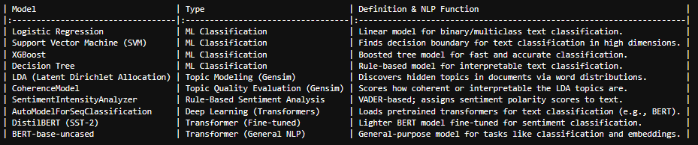
List of Trained Models, Definitions, and Functions

The rest of this report is organized and developed into a literature review section discussing previous publications about AI, CSA, and NLP; study methodology, which highlights the stacks, approaches, and methods used in this project; results sections discussing the main findings of the project and in relation to previous studies; a conclusion; an appendix; and a bibliography section.

LITERATURE REVIEW
Studies by Ahmadi and Sudahri (2025) and Firdos and Dermawan (2023) recommend employing digital technology to analyze and improve customer experience. Through a qualitative study of 15 publications, the authors argue that the Hajj and Umrah sector can improve customer experience by employing modern technology to analyze data. They explain that by employing more data-driven smart technologies, the sector with improve its credibility, promote visitor engagement, leverage on perception, and build on trust (Firdos & Dermawan, 2023). The authors further established that real-time, fast, and effective analysis can enhance visitor experience in the Hajj and Umrah sector. They concluded that “Hajj and Umrah industry need to optimize interactive and transparent smart analysis using tools like AI chatbots, real-time engagement, dashboards, andfeedback analytics to strengthen trust and service credibility” (Firdos & Dermawan, 2023, p.24).
This study was purely theoretical, and no project was conducted to validate the proposals (Ahmadi & Sudahri, 2025). Furthermore, the authors proposed data analytical tools that are featured in this study. Their study provides foundations for this project, for this study intends to develop a smart AI-based technology to analyze feedback from Umrah and Hajj. The study intends to contribute to studies by Ahmadi, Sudahri, Firdos, and Dermawan towards establishing how accurate AI-powered models can classify and analyze feedback texts.
Contributing to the studies by Ahmadi and Sudahri (2025) and Firdos and Dermawan (2023), is a study by Subhan et al. (2023). Subhan and friends investigated the effects of improving service quality at Hajj and Umrah from Indonesia using SmartPLS3.2.9 and SEM-PLS applications to analyze customer experience. The authors establish that feedback analysis is significant for establishing visitors’ worship and comfort (Subhan et al., 2023). However, the study faced several drawbacks and challenges in its sentimental analysis. For instance, their applications being naïve could not accurately process, classify, and analyze big data. The applications did not perform well in establishing areas that need improvement. Accordingly, Subhan et al. (2023) recommended future studies to apply more advanced models in text classification and sentiment analysis. This study intends to bridge the gaps in the study by Subhan et al. (2023) by using pre-trained models to address challenges faced in analyzing pilgrimage sentiments in Umrah and Hajj in Saudi Arabia. Saudi Arabia is a perfect choice for this study due to the large number of visitors allowing for the collection of big data.
Almutaibi (2024) provides good insights about NLP, AI, and pretrained models in text classification and sentiment analysis. He examined the effectiveness of transformer-based models, as an advancement of NLP, in interpreting, producing, and understanding human language. He argues that “transformer models, GPT and BERT, use transformer architecture that leverages self-attention mechanisms to process text effectively and efficiently” (Almutaibi, 2024). In differentiating the two models, the author explains that GPT is best with content generation and ideal for generating contextual and coherent text, while BERT is best for language understanding, especially in deep language learning and comprehension (Almutaibi, 2024). He adds that GPT is fine-tune for text generation while BERT is fine-tuned for sentiment analysis, text classification, and NLP-related tasks like answering questions. Accordingly, the study by Almutaibi (2024) provides foundational and theoretical knowledge akin to this research's objectives and problem statement.
In similar studies, although conducted in Turkey to examine sentiments in the Turkish language, Salıcı & Ölçer (2024) show the limitations of transformer models in NLP. According to the author, these models perform poorly in some languages, particularly low-resource languages like Turkish. Salıcı and Ölçer claim that they observed these models facing challenges in languages with agglutinative and autoregressive structures (Salıcı & Ölçer, 2024). The studies suggest the challenges rise from “the structural features of the language and the limitations of the datasets” (Salıcı & Ölçer, 2024, p.34). Accordingly, this study aims to investigate the accuracy and challenges faced when using transformer models for NLP, sentiment analysis, and text classification. It advances the studies by Salıcı and Ölçer by using multilingual languages from Umrah and Hajj pilgrimages to analyze the performance of transformer models compared to previous studies regarding model accuracy. By focusing on the existing research gaps, limitations, and recommendations, this study will provide answers to the established research questions.
Previous research has contributed to a better understanding of the use of AI, transformer models, in NLP, in improving the experience of pilgrimages. However, the studies fall short in real-time sentiment analysis and text classification of pilgrimage comments and feedback. This study and the system developed bridge current gaps in research by introducing an NLP deep learning and transformer text classification and sentiment analysis AI-powered driven system, classifying and analyzing real-time, multi-lingual comments. By introducing a service categorizer, the approach enhances comment analysis and data-driven decisions to improve service delivery in Umrah and Hajj. The proposed system leverages big data and the transformer model, BERT, to improve pilgrim service evaluation, support, monitoring, and real-time data analysis. The section that follows discusses the research approach and methodology used in the study.

METHODOLOGY

Methods and Materials
This section discusses in detail the structure, technology stacks, and methods used to design the analysis platform to improve pilgrimage experiences and service delivery. The main components of the platform include demographic and cross-demographic and text-classifier analytics, providing a comprehensive data-driven solution that leverages machine learning and deep learning for smart comment analysis and classification. This study used a similar structure used in the system developed by Chelloug et al. (2025), Shah (2024), and Alquayt et al. (2025), with slight modifications in data collections, feature engineering, and the machine learning model. Figure 1 shows the general structure used to design the platform.
The system uses deep learning, neural networks, and machine learning to categorize services into the following departments: Transport and Travel, Staff Attitude and Support, General Services, Accommodation & Facilities, Food Quality and Dining, Service Efficiency & Time Management, Hotel Room Conditions & Cleanliness, and Event and Program Organization. The processes used to develop the analysis module include comments acquisition from the pilgrimage database, data preprocessing, feature extraction, and analysis. The text-sentiment analysis involves the use of training, validating, and testing data using deep learning and classification-sentimental modules.
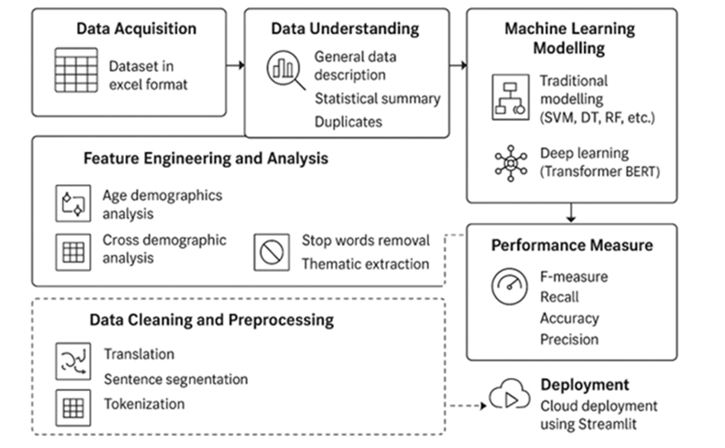
FIGURE 1: Structural Design of the AI-Driven Smart Sentiment Analyzer System

Data Description
The data used in this study is derived from the Ministry of Hajj and Umrah database retrieved from https://www.haj.gov.sa/Home. The dataset used in this study comprises of comments on the Umrah and Hajj pilgrimage. The data contains important aspects like age, nationality, gender, and comments on the pilgrimages. The data is textual in nature with numerical and categorical entries where appropriate. The entries were appropriate for both analysis and modelling. A full description of the variables in the dataset is provided in Table 1. The dataset contained five columns and 10500 observations. Only one column had numerical values, int64, with the rest of the columns containing categorical values. The total memory usage of the dataset was 410.3+ KB. Accordingly, this allowed the handling of the dataset using pandas and Scikit-learn, for education and demonstration purposes (Ali & Alalmi, 2020; Almutaibi, 2024; Alquayt et al., 2025). The dataset does not include any sensitive or personal information to ensure confidentiality, data ethics, security, and sound methodological research.
TABLE 1: Data Description

Column Name Description

Nationality Country of origin
Language Native language of visitor
Gender Sexual orientation of visitor
Age lifetime; age of visitors
Comments sentiments giving feedback of service provided

Data Understanding: Statistical Description
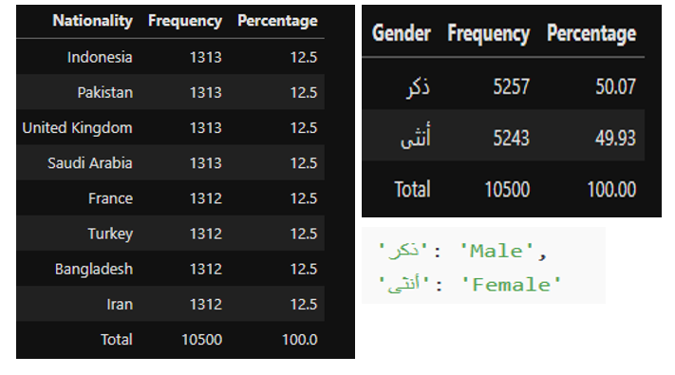
The understanding of the data used in this study helped establish possible effects of the distribution of variables on the comments. Data understanding is purposed to examine measures of central tendency, data distribution, and measures of dispersion using formulas displayed in chart 1 in the Appendix. Data understanding focused on analyzing the frequencies of nationality, gender, age, and other variables, as well as their distributions. The frequency distribution of nationality and gender variables is shown in Tables 4 and 5.
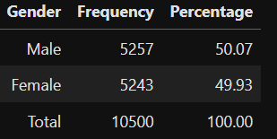

From left to Right: TABLE 4 showing the frequency distribution table of the Nationality variable and TABLE 5 showing the frequency distribution table for the Gender variable.

These distributions were visualized using a bar graph because they are categorical, to understand their nature of the distributions. The frequency distribution bar graph of the nationality variable, Graph 3, showed that the distribution is symmetrical and lacks skewness. The distribution is flat with values being extremely close together, indicating that the nationality variable lacks variability. The data also showed that individuals from the countries observed have similar frequencies of visiting the pilgrim. The amount of dispersion is small because the values are close together. The lack of spread or dispersion in this variable shows free nationality bias in the influence of an individual’s nationality on the comments given. Visitors' comments are fair with no biases or influence from the country of origin a person comes from. This observation confirmed that the comments are credible for use in this project.
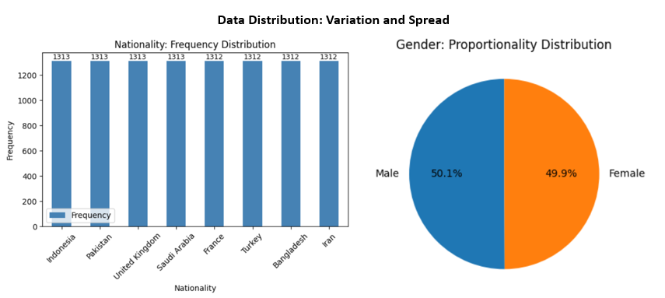
Similarly, the distribution or proportionality of the male and female individuals was equally similar, pie chart 4. The gender distribution has a range of 14, showing extremely little variation of negligible effects on the comments. In interpretation, the very close proportionality of the gender variable shows that the comments are free of gender bias, because both genders are equally represented in the sampled comments.
Graph 3, left, shows the frequency distribution of Nationality, and Graph 4, right, shows the Gender proportionality and distribution in the dataset.

The data understanding of the variable age was detailed. The variable was discrete in scale, allowing for detailed descriptions in terms of measures of central tendency, dispersion, and consequently data distribution as shown in Graph 5 histogram, Graph 6 boxplot, and Table 6 statistical summary Table.
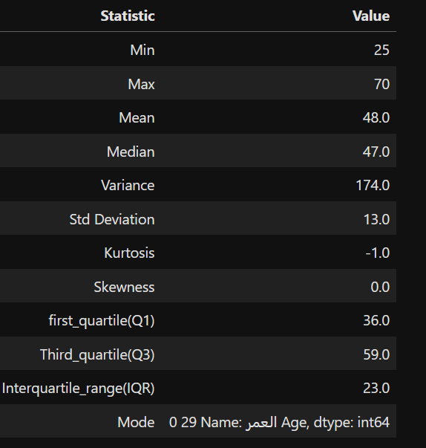
The tabulated statistical summary showed the least age of individuals sampled was 25 years, the maximum 70 years, giving a range of 45 years. While this range is large, most individuals are evenly clustered around 48 years. The median age is 47 years, and the most frequent age is 29 years. The slight variations in the mean, median, and mode age suggest slight variations in the dataset. This variation is confirmed with calculations of the variance, standard deviation, kurtosis, and skewness. The high variance suggests that individual ages are dispersed relative to the scatter of the values about their mean (Firdos & Dermawan, 2023)). This variation is supported by a standard deviation of 13.0, confirming that the ages of individuals are dispersed in the dataset.

TABLE 6 shows Age Statistical Summary Table

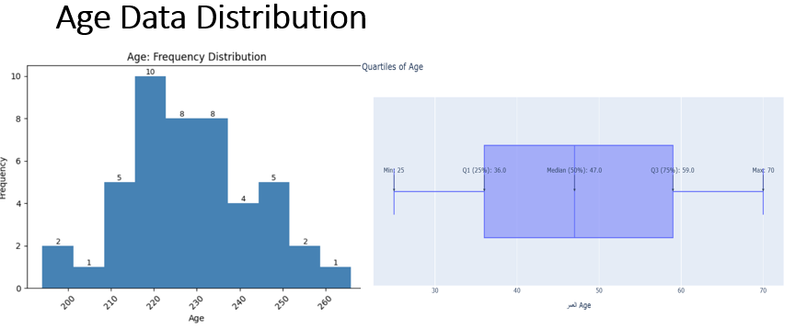
Further analysis of this variation was observed in the age variable using kurtosis and skewness. The age distribution is almost symmetrical, and the skewness is equal to zero, see graph 5. This distribution suggests that the ages provided in the sample data are evenly distributed about the mean, lack skewness, and are evenly clustered near the median, see boxplot graph 6. This show that the comments fairly represented individuals visiting the pilgrimage of ages 14-70. Additionally, the results of kurtosis (negative value) show that the peak of the age distribution is flat or platykurtic. The kurtosis and skewness in relation akin the other measures of dispersion suggest light variations and age-independence of the comment’s variable. This again confirms the credibility of the comments for use in this project, for it is bias-free of individuals' age.
Left, Graph 5 showing symmetrical age distribution of ages, and Right, Graph 6 showing a boxplot representing the age distribution of the age variation about the quartiles

Data Pre-Processing
The data collected was unstructured as it was multilingual and textual in nature. As thus, preprocessing was done to generate quality and appropriate data for the project statement. The Excel data was loaded in pandas, and preprocessing was done using Python. Non-English comments were translated using Google Translate, imported from Deep translator. The preprocessing step was necessary because it enhanced subsequent preprocessing procedures. Data preparation and preprocessing followed the order of: translation, normalization, tokenization, Punctuation removal, lemmatization, parts of speech tagging, stop word removal, and vectorization.

Translation
Translation involved converting the textual data in different languages into English. This transformation was necessary to allow for further preprocessing of the data. The dataset, particularly variable comments and gender, expressed in different languages, was transformed to English using a deep translator. The translator model, the Google Translator imported from the Deep Translator library, was used for textual conversion. All the non-English texts were converted to English, and the English texts were retained to ensure uniformity of language.

Normalization
Normalization included segmenting the data into individual sentences to improve readability. Sentence segmentation facilitated cleaning the data to remove capitalization and punctuation. For example, before normalization: Sometimes, transportation is late! After normalization, sometimes transportation is late. Cleaning the data to remove punctuations facilitated data refinery
and removal of special characters.

Tokenization
The sentences were then segmented into their respective individual words, tokens, using a word tokenizer. For example, before tokenization, sometime transportation is late. After extraction: “sometimes”, “transportation”, “is”, “late”. Tokenization is significant to enhance data processing, understanding, and further analysis (Alquayt et al., 2025). It builds on thematic extraction, text classification, retrieval of information, and text classification in NLP (Amanah et al., 2021).

Lemmatization
Lemmatization involves converting textual data into its basic form, mostly dictionary form (Ahmadi & Sudari, 2025). The column comments were lemmatized using the Spacy library. The words in each comment were transformed using the en_core_web_sm pipeline downloaded from Spacy to preserve data contextually, enhance uniformity, and cohesion. en_core_web_sm is an optimized pre-trained CPU-based model for NLP core functionalities (Subhan et al., 2023). This pipeline provides reliable, credible, and more accurate processing of textual data in NLP. For example, the comment transportation is sometimes late when it is converted with sometimes transportation is late after lemmatization.

Parts of Speech Tagging (POS)
POS refers to the process of labeling words in a text into their basic linguistic form, parts of speech (Almutaibi, 2024). The comments after lemmatization were linguistically labeled. POS significantly improved subtleties in the comment data enhancing comprehension of data. This process was done using en_core_web_sm downloaded from spacy library. In this process, for instance, the lemmatized comment sometimes transportation be late was preprocessed to [(sometimes, sometimes, ADV), (transportation, NOUN), (be, be, AUX)].

Stop words removal
Stop words are words with no to little meaning in NLP (Alquayt et al., 2025). They occur with high frequency, adding bulk to language, yet when removed, the sentences will still be contextually meaningful. For example, the, and, of, is, a, and in. The removal of stop words enhances language clarity and helps reduce noise in data (Alquayt et al., 2025). Stop words were removed in the data was removed using the stop words, punkt, and library imported from NLTK. However, stop words that communicated negative sentiments like haven’t, wouldn’t, didn’t were retained to maintain authenticity and contextual meaning in sentiments. The tokens generated after removing stop words were straightforward. Consequently, the study did not use n-gram computation due to the nature and sufficiency of the data generated after removing stop words.

Vectorization
Vectorization is a process in NLP involving converting textual data into numerical data that a computer can easily understand and interpret (Salıcı & Ölçer, 2024). In this case, the comments in textual form could be understood by the different algorithms because computers use binary data. The comments after POS tagging were vectorized using TfidfVectorizer (TF-IDF) imported from sklearn. Additionally, the different parts of speech were categorized into segments of N-grams. The process of categorizing the words into N-grams involved computing the textual comments into trigrams, unigrams, and bigrams. The categorization enhanced the preprocessing processes by matching and combining words for more accurate outcomes. Vectorization was also important to enhance thematic categorization of comments into their respective services categories and departments. The top 30 outputs of words are shown in Figure 2.

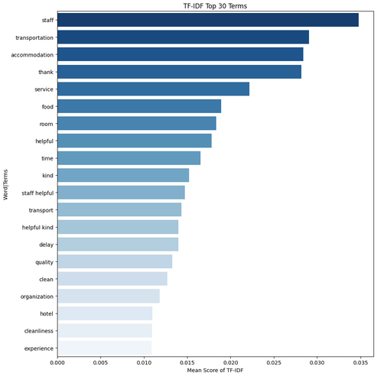

FIGURE 2 shows outcome of the TF-IDF Output Terms

Thematic Extraction
The platform analyzes comments and categorizes them in their respective service departments. Accordingly, the comments dataset was used to extract departments based on commented services. The module Genism was used to import a coherence model for thematic extractions. In this case, the themes represented departments and categories for classifying comment services. The LdaModel from genism supplemented the thematic extraction. Additionally, a word frequency analysis was done to further help analyze the frequencies of tokens in the comment variable. Using a compare and contrasting approach of the outputs from LdaModel, coherence model, and word frequency analysis, the following departments, themes, were extracted, see table 2.
The thematic extraction helped to further classify the comments into predetermined categories and classes. The classification and sorting are relevant to enable the text classification model to categorize the posts and comments into their respective department or groups.
TABLE 2: Themes and Departments

Departments Frequency Counts

Transport & Travel 3079
Staff Attitude & Support 2209
General Services 1739
Accommodation & Facilities 979
Food Quality & Dining 885
Service Efficiency & Time Management 850
Hotel Room Conditions & Cleanliness 476
Event & Program Organization 283

Name: count, dtype: int64

Table 2 shows frequency counts of categories or departments. It provides insights about the various service categories related to the comments provided. A dictionary of themes and topics was created to generate an algorithm that would analyze keywords and linguistic characteristics of comments and later classify them into their respective categories.
The process of thematic extraction was necessary to provide a dataset that would train the transformer text classifier to categorize unseen data into their respective categories. The model, after learning, classifies comments contextually and by their content. After a series of validations and classifications, it is empowered to automatically sort and classify comments into the identified categories.
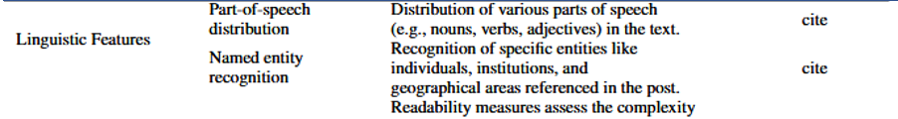
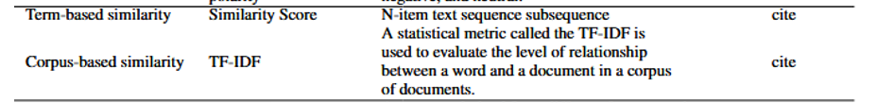
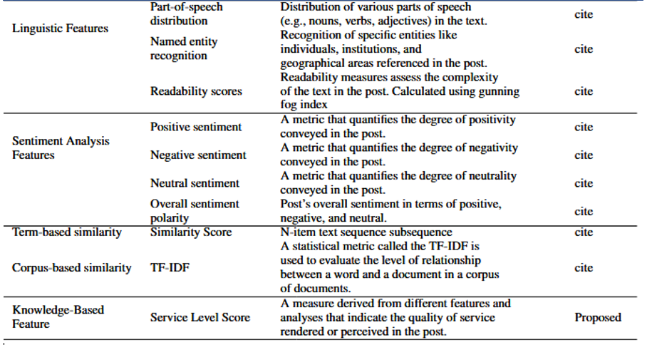
Because this study is built upon previous studies from Almutaibi (2024), Salıcı & Ölçer (2024), Ahmadi and Sudahri (2025), and Firdos and Dermawan (2023) the studies borrowed similar key features from these studies to build a model that classifies and analyzes comments based on these features, Table 7.

Subhan et al. (2023), Ahmadi and Sudahri (2025), and Firdos and Dermawan (2023)

Feature Engineering and Analysis
Feature engineering isolate variables and generates a new dataset with the variables of interest (Alquayt et al., 2025). Feature engineering significantly enhances the analysis of demographics and cross-demographic data. For instance, the age variable was separated, and the data was used to visualize statistical age descriptions and the distribution of the visitors. The characteristics of age, nationality, and gender were also isolated and visualized using interactive plotly graphs, as shown in the following subplots.
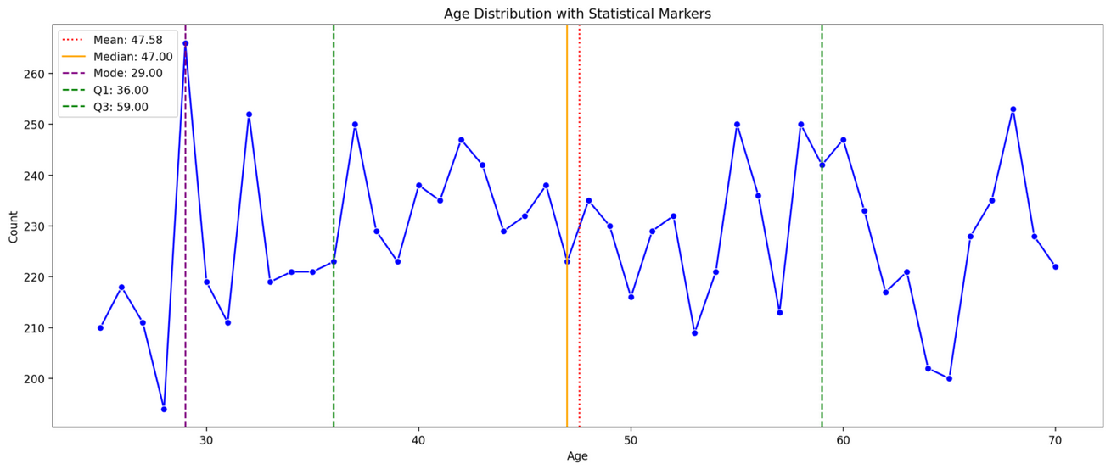

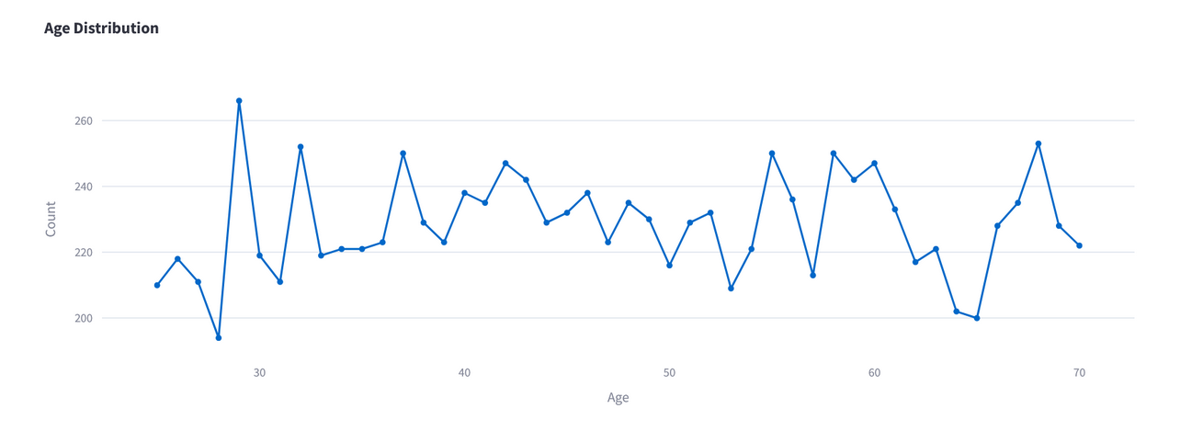

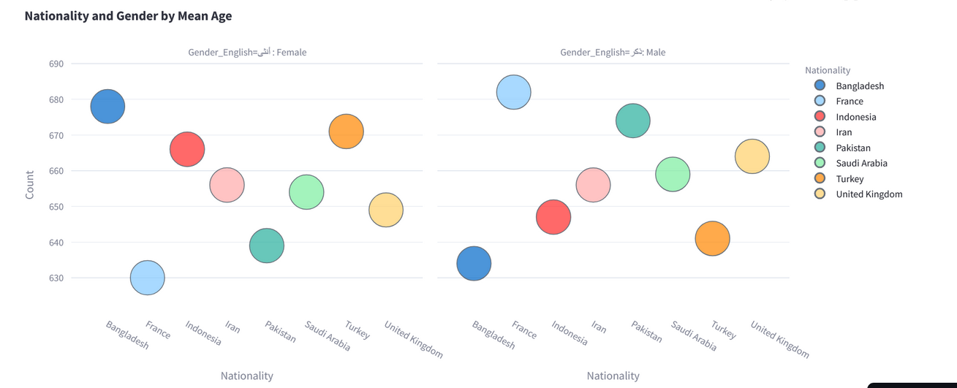

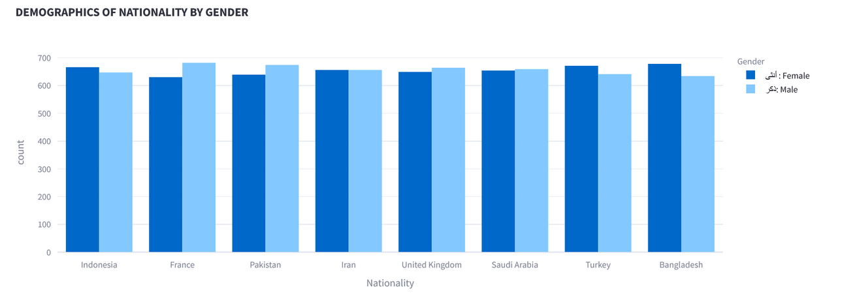

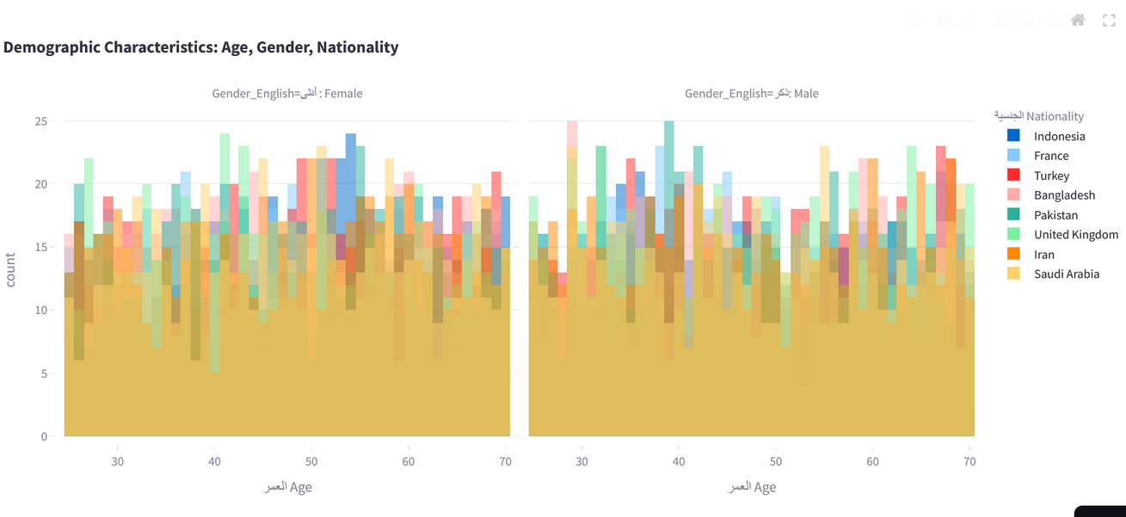

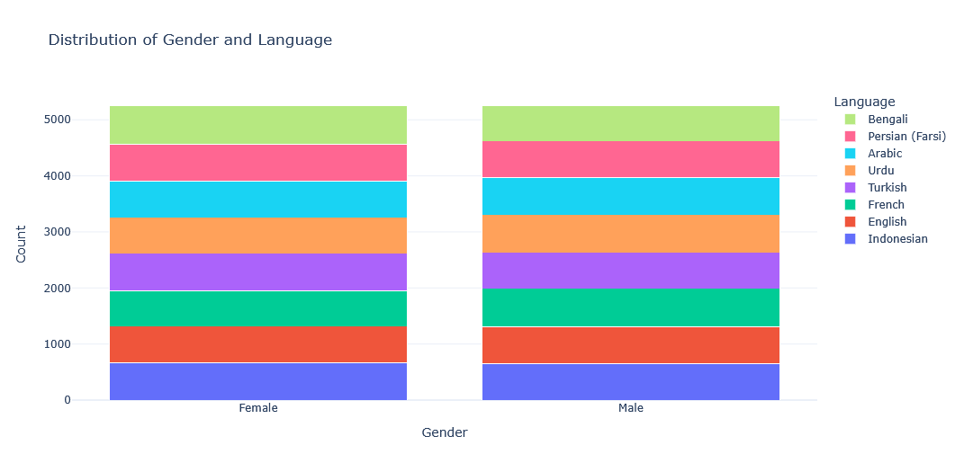

Modelling
Modelling focused on training, testing, and evaluating a sentiment and text classifier model for the comment category. Modelling involved implementing a number of machine learning algorithms for sentiment analysis and text classification. The objective is to critically evaluate the accuracy, performance, and efficiency of machine learning classifiers in analyzing sentiments and categorizing them into appropriate categories. The models implemented included Support Vector Machine (SVM), Logistic Regression, XGBoost, Decision Tree, DistilBERT, and Bert transformer.
The dataset was divided into 20 percent test data (2100 observations) and 80 percent training data (8400 observations). The train-test-split ratio is commonly used in most machine learning methods with small data sets (Bala, 2022) and where a test data set is missing (Alquayt et al., 2025). The model was trained and tested to classify test into three labels: positive, negative, or neutral comments. The training and testing were conducted systematically to prevent overfitting and enhance model performance. The evaluation of the model performance was akin to studies by Ahmadi & Sudahri (2025), where “Performance metrics for each classifier are calculated by comparing the number of correctly classified instances to the total number of classifications made by that classifier” (Ahmadi & Sudahri, 2025, p.35). Modelling involves the use of naïve machine learning algorithms like SVM, Decision Tree, logistic regression, XGBoost, and NLP Hugging Face transformers and AutoModelForSequenceClassification machine learning algorithms, including distilbert-base-uncased, distilbert/distilbert-base-uncased-finetuned-sst-2-english, and bert-base-uncased sentimental analysis. A sentimental Intensity Analyzer was used to label sentiments. The models used supervised learning, learning from labeled data, and classified and analyzed sentiments on new data. The models are evaluated using Recall, Precision, Accuracy, confusion matrix, and F-scores (Shah, 2024).
The optimization of the model was done manually. Manual optimization includes resetting candidates of deep neural networks (DNN) and running them iteratively until the highest performance is achieved (Ahmadi & Sudahri, 2025). The value of the cross-entropy loss function, L, provides a guide to the threshold of an optimized model.
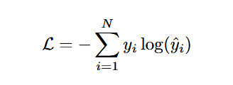
In this case
Yi= actual class label
Ӳ = predicted class label
N = total training samples

Mathematical expression of L, cross-entropy function (Shah, 2024; Bala, 2022; Kaplan, 2020). The parameter of learning rate, per device train batch size, per device evaluation batch size, number of training epochs, and weight decay were adjusted frequently until generalization, reliability, model accuracy, and optimal weight configurations were reached. The optimization was established at a maximum number of iterations of 2, a phase where the model's accuracy stabilized and started to reduce in the subsequent iterations.

Environment Configuration and Tech Stacks
The libraries used to develop the platform are summarized in table 3. The main language used is python v3.1 for development and deployment. Jupyter notebook supported the integration of cloud computing, facilitating data visualization, processing, coding, analysis, writing, and machine learning.

TABLE 3: The Main Tools Used to Develop the System

Programming Python 3.10
Data Processing Scikit-Learn, Pandas, Numpy,
Visualization Seaborn, Matplotlib, Plotly
Machine Learning Scikit-Learn
Deep Learning Hugging Face Transformer
Model Evaluation scikit-Learn, Torch
Text Analysis and Translation Nltk, Deep Translator, Gensim, Collections
Deployment Streamlit Cloud Community
Collaboration Git Bash and Git Hub
Further Analysis Pivotal Table in Excel Spreadsheet

FINDINGS
The results section presents findings of evaluation metrics of the proposes models and explores answers addressing the research questions. The evaluation metrics show recall, precision, F1-score, accuracy, and confusion matrices of 6 specific models used in this project. The modelling utilized the comments feature as a decision feature to analyze sentiments and classify them appropriately in their correct service categories. In this experiment, the base model was the logistic regression upon which other traditional machine learning algorithms were built in before advancing to more sophisticated deep neural networks algorithms. Graph 7 shows the performance of the models in order of their evaluation metrics.
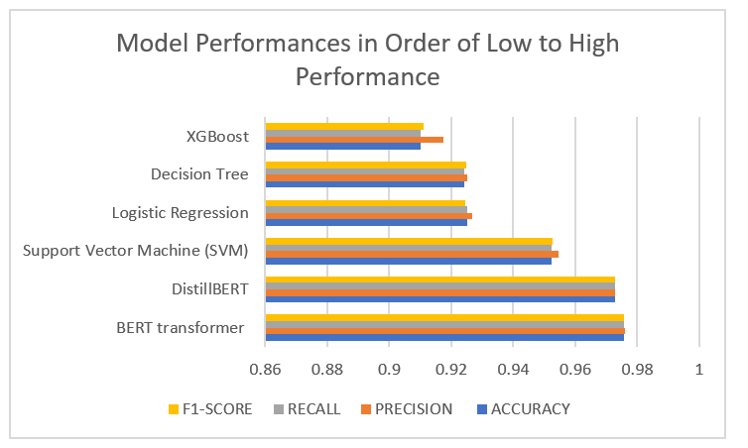

GRAPH 7: Model performance results in ascending order

The graph shows that all models scored at least 90% in the respective evaluated metrics. The hugging face pretrained transformers of BERT and Distill BERT scored highly, exceeding 97% accuracies, surpassing the accuracy of traditional machine learning models, including XGBoost, Decision tree, logistic regression, and SVM, which had 91%, 92%, 92%, and 95%. The evaluation metrics of all models are impressive, all above 90%. The use of POS and lemmatization increased the efficiency and effectiveness of testing and training the models by improving the accuracy of contextual word normalization (Almutaibi, 2024). The graph supports this observation, showing a precision of at least 91%. The exact precision of each model, XGBoost, Decision tree, logistic regression, SVM, DistillBert, and BERT model is 91%, 92%, 92%, 95%, 97%, and 97% respectively.
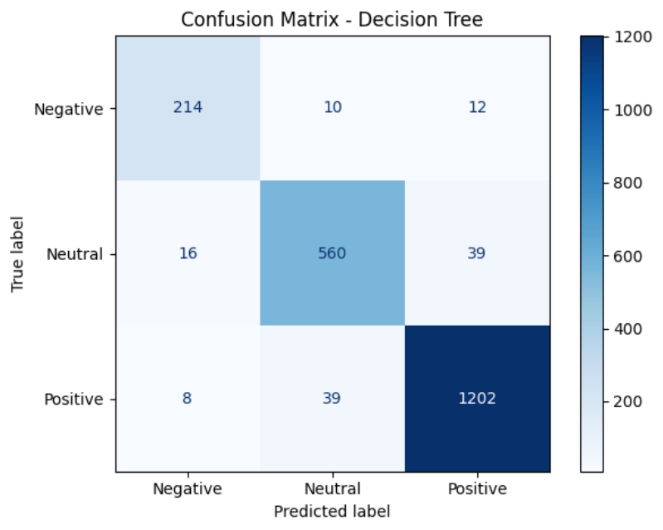
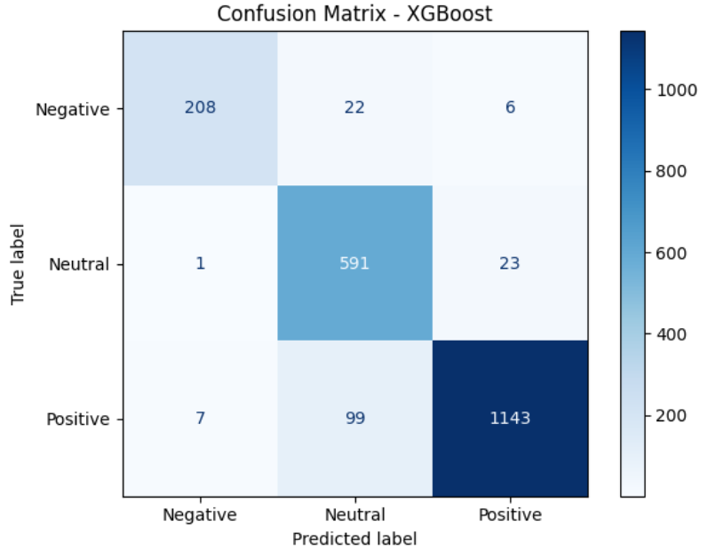
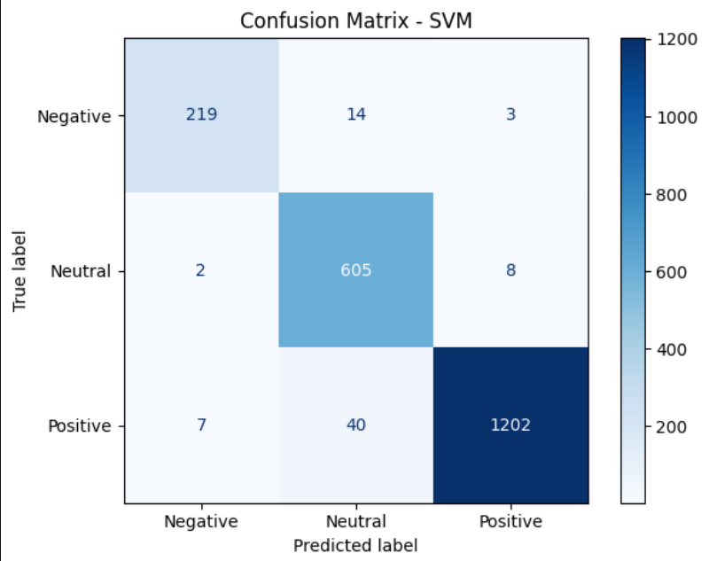
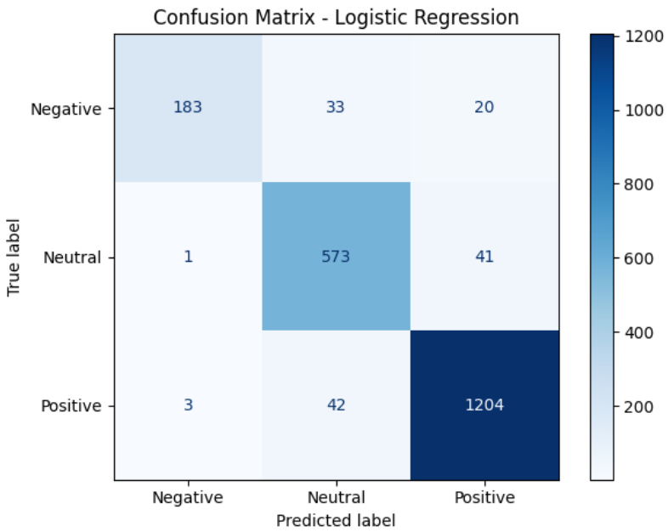
The efficiency of the model’s performance was evaluated using a confusion matrix. The confusion matrix shows the number of predicted values against actual values of positive, negative, and neutral comments. The figures below show the results of each model's confusion matrix.

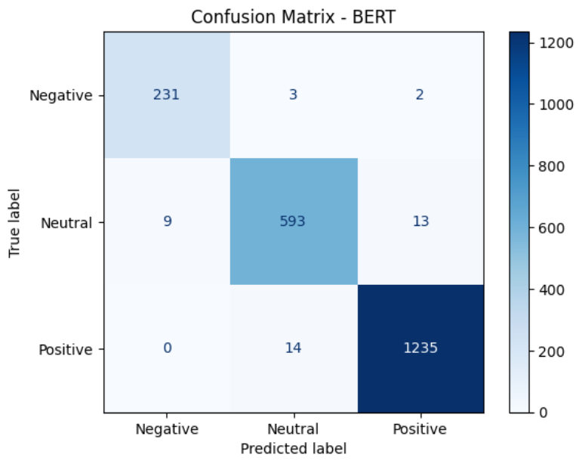
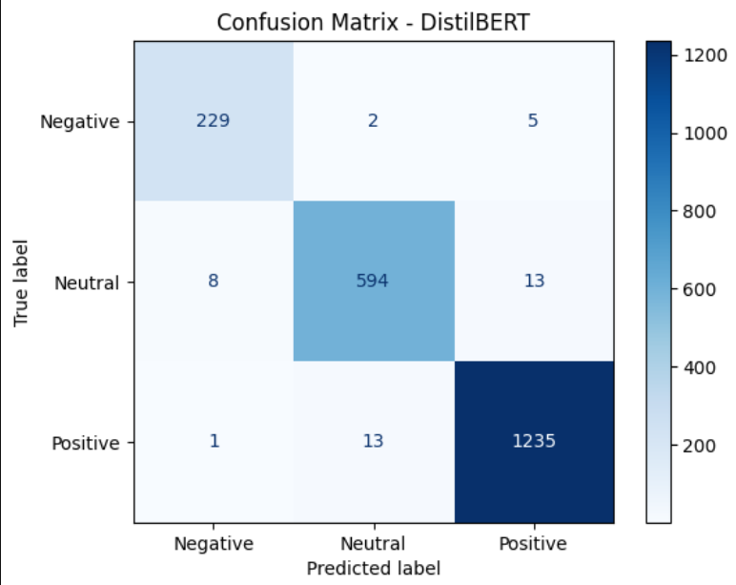
Figures showing confusion matrix of the respective models.

A comprehensive result of the model’s accuracy, precision, recall, and F1-score are shown in Table 8. The table highlights the distinct exceptional metric performance of XGBoost and the support vector machine. The accuracy, recall, F1-score, and precision of XGBoost and SVM shows XGBoost performed poorly while SVM performed exceptionally high. The performance is expected because XGBoost works well with large datasets characterized by heavy feature engineering and multiple structured variables (Ahmadi & Sudahri, 2025). SVM performs best with a small dataset and easily interpretable data. This data contained 10500 observations with only 4 variables or inputs, which facilitates the low performance of XGBoost and the high performance of SVM. On the other hand, the other models performed as expected, with performances enhanced by parts of speech tagging and lemmatization. Logistics regression and decision tree work with small datasets and distillBERT and BERT are generally good with sentiment analysis and text classification (Subhan et al., 2023).

MODEL | ACCURACY | PRECISION | RECALL | F1-SCORE
XGBoost | 91.00 | 91.75 | 91.00 | 91.12
Decision Tree | 92.42 | 92.52 | 92.43 | 92.47
Logistic Regression | 92.52 | 92.69 | 92.52 | 92.45
(SVM) Support Vector Machine | 95.24 | 95.45 | 95.24 | 95.27
DistillBERT | 97.29 | 97.28 | 97.29 | 97.28
BERT transformer | 97.58 | 97.60 | 97.57 | 97.58
TABLE 8 shows model’s accuracy, precision, recall, and F1-score
For robustness, versatility, and more enhanced performance, DistillBERT and BERT transformers were selected. These models are powerful and are designed for natural language processing. The models are pretrained models from hugging face transformers and are effective for contextual text classification and sentimental analysis tasks. These models are bidirectional and learns contextually, making them better for this task (Almutaibi, 2024). BERT builds upon DistillBERT transformer with more enhanced features like handling complex large dataset, reduced computational cost, improved dependency, and effective in NLP tasks, resulting to increased performance. However, other pretrained models like GPT, initially intended to be used in this mode, were not used because it is limited in NLP tasks. GPTs work best in content generation tasks and not in sentiment analysis and classification tasks.
Out of the trained and tested models, BERT and DistillBERT transformers performed at optimum with accuracies, precision, recall, and F1- score of at least 97%. However, BERT had much higher scores in all metrices and was therefore proposed as the final model. In comparison, DistillBERT had 97.29%, 97.28%, 97.29%, and 97.28% and BERT had 97.58%, 97.60%, 97.57%, and 97.58% for accuracy, precision, recall, and F1- score. This comparison is shown in Graph 8. The graph and result show how the proposed model are highly efficient in processing the comments.

Graph 8 showing evaluation metric and performance scores of DistillBERT and BERT transformer.
In comparing and contrasting BERT and DistillBERT transformers, the base model is distilbert-base-uncased transformer model since the second model Robust Model Bert-Base-Uncased is built upon it. The results displayed below show that model 1 and model 2 were accurate at epoch 2 and 3. Both models had an accuracy of at least 96% accuracy at epoch 2, with a minimal difference in validation and training loss. Accordingly, the training of each model was set at an epoch in the subsequent training sessions.
Model 1: DistillBERT
Epoch | Training Loss | Validation Loss | Accuracy | F1 | Precision | Recall
1 | 18.40 | 15.94 | 94.95 | 94.96 | 95.07 | 94.95
2 | 06.43 | 12.88 | 97.30 | 97.29 | 97.29 | 97.29
3 | 04.34 | 14.07 | 96.90 | 96.93 | 97.00 | 96.90

Model 2: BERT
Epoch | Training Loss | Validation Loss | Accuracy | F1 | Precision | Recall
1 | 15.92 | 17.51 | 95.71 | 95.73 | 95.75 | 95.71
2 | 08.41 | 13.94 | 96.95 | 96.96 | 96.96 | 96.95
3 | 04.33 | 13.03 | 97.57 | 97.58 | 97.60 | 97.57

In comparison, the second model performed better in both training and test sets. For instance, the first model had an optimum F1-score of 97.29 percent on both the train and test sets compared to 97.58 percent for the second model. In terms of learning and prediction, model 1 even it had at least 90 percent in learning, recalling, and prediction, the model still performed poorly compared to model 2. The overall accuracy of model 1 in both the training and test sets was 97.30 percent. In comparison, model 2 had a 97.57 percent accuracy on training and test data.
Bert transformers are pre-trained transformers (Bohn, 2018). These transformers are “bidirectional contextual learning, classifier, and sentimental analysis models” (Bala, 2022, p.43). Distilbert-base is a baseline model, and Bert-base model builds upon distilbert (Firdos & Dermawan, 2023) by refining learning approaches, leveraging big data, and improving text classification and sentiment analysis. Bert-base has an improved computational cost, increased accuracy, and performance, evidently seen in the 97.57 percent accuracy and f1-scores of at least 97 percent. Accordingly, the Bert-base model was selected for deployment using Streamlit due to its analysis performance, efficiency in class balancing, and interpretability.
Generally, the model was determined as optimal because of a low training loss, balanced F1-scores, an acceptable recall. When deployed and tested, the Bert-base performed as expected, as seen in the image below.
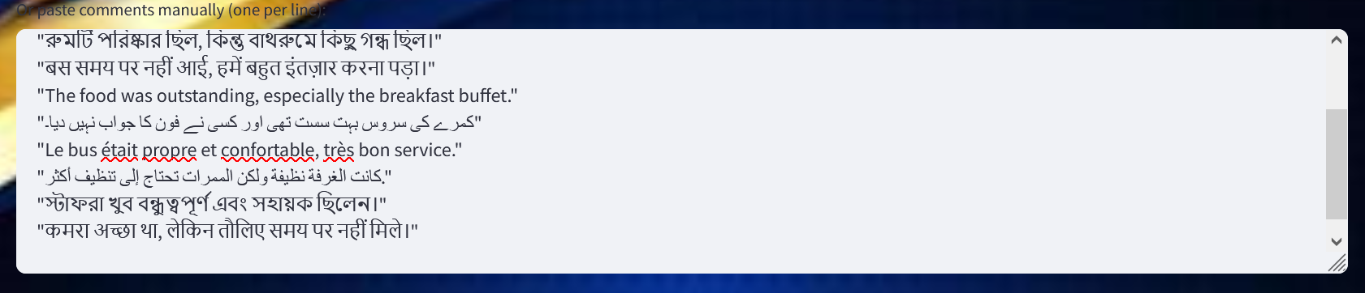
Comments Analyzed

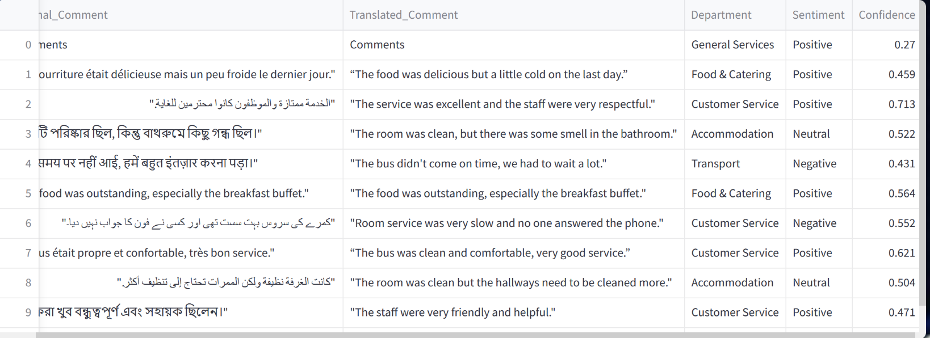

IMAGE 1: Image shows output of sentimental analysis and text classification.
In analysis, the results address the problem statement in this study by providing insights into the two research questions. For instance, the results show that pre-trained transformers like BERT can be used to accurately predict and review the sentiments of pilgrims. An accuracy score of 97.57 percent and average f1-scores of 97.58 percent is credible, reliable, and persuasive. The scores suggest the models can identify challenges faced by pilgrims through analyzing the sentiments and using the output to address challenges in their respective categories, particularly categorized as negative. The analysis and classification are significant to quickly and accurately address pilgrims’ concerns, issues, and challenges faced in providing services in their predefined departments. The model also generates a dataset that can be downloaded for further analysis, including common challenges faced.
In providing insights into how accurately an AI model can classify sentiments, the confidence of the model in its prediction was determined. Graph 1, shown below, shows that confidence of the model is clustered around 80 to 100 percent, with all being above 50 percent. The clustering confirms that AI is good at accurate classification and sentimental analysis. From the counts, most counts or the highest count classification frequency (in the x-axis) have confidence counts clustered the highest to 1. Again, this is a good indication that AI, generally, is accurate in classifying sentiments as positive, neutral, or negative.

GRAPH 1: (Left) Counts of Confidence Interval and (Right) Sentiments by Counts
This project is also set to generate a model that provides a real-time dataset of sentiments classified. The dataset is significant in examining common challenges by department or service facing the Umrah and Hajj pilgrims. An analysis of the dataset generated after sentimental and text classification showed that, from the highest to least, the following departments are affected mostly: Transport and travel, food quality and dining, accommodation and facilities, general services, Hotel room conditions and cleanliness, staff attitude and support. The indication of the common challenges is shown by the length of the bars showing negative sentiments by departments, as shown in Graph 2. The authorities can then filter out the sentiments based on the department and negative sentiments to observe the precise challenges faced for improvements.
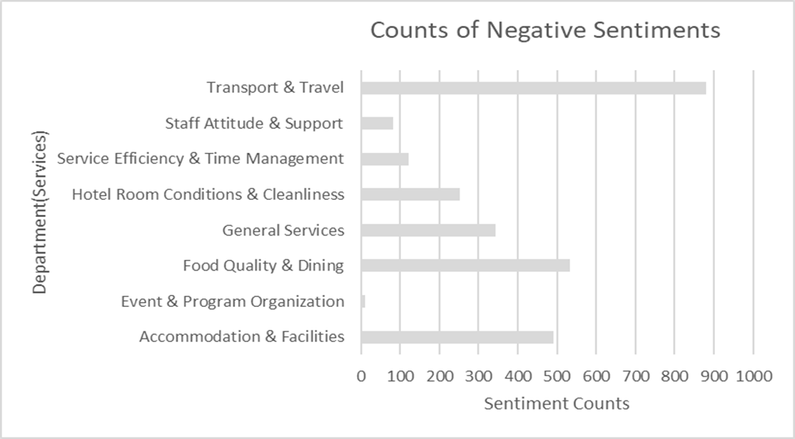
GRAPH 2: Counts of Sentiments by Classification analysis

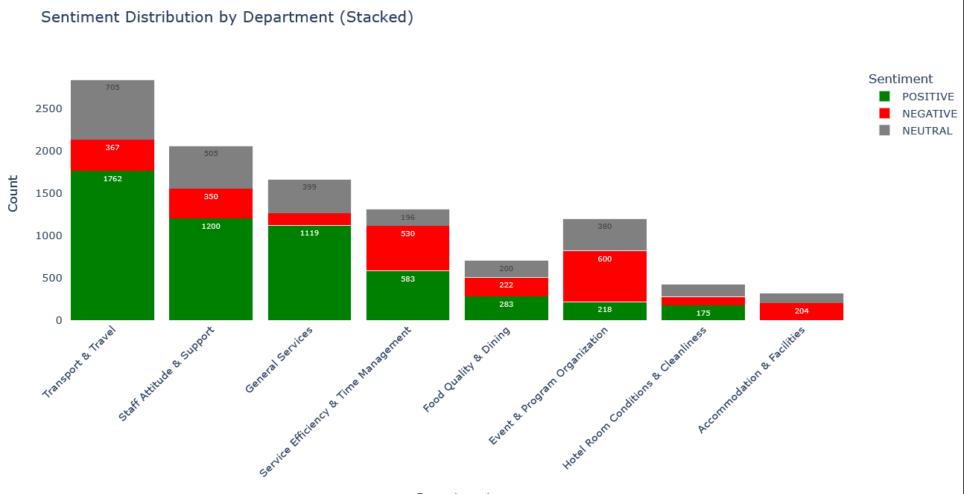
The proposed system classifies and analyzes sentiments by categories. These categories explore the various service departments, each named after the services provided within them. The classification and analysis significantly tell the strengths and weaknesses of the departments. The positive sentiments highlight the strengths of the departments and suggest a satisfactory customer experience with the services offered. The negative sentiments portray dissatisfactory service delivery, and therefore, a weakness in a department’s service delivery. On the other hand, neutral sentiments suggest mixed reactions about the services provided. The model shows that most sentiments are positive, followed by neutral sentiments and negative sentiments. The classification and analysis demonstrate that AI-powered models can potentially enhance customer service analysis in the Hajj and Umrah pilgrimages. This is shown in the bar graph below.
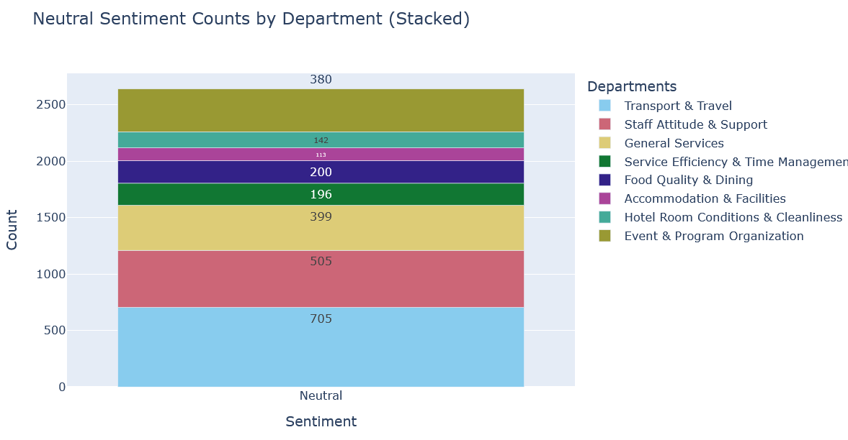
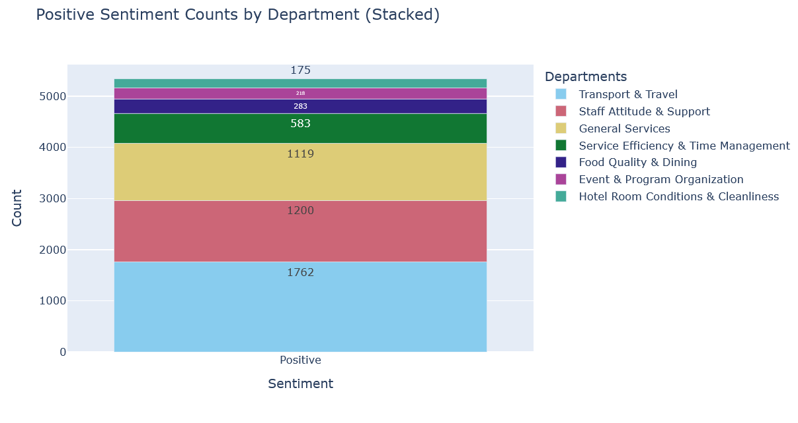
In analysis, the proposed model shows that customers express high levels to low levels of satisfaction in the order of transport and travel, staff attitude and support, general services, service efficiency and time management, food quality and dining, event and program organization, and hotel room conditions and cleanliness. With these analyses, the ministry can make efforts to improve on poorly provided services while enhancing more on the best provided services. Customers provided neutral sentiments in the following departments and services, in order of high to low: transport and travel, staff attitude and support, general services, event and program organization, food quality and dining, service efficiency and time management, and hotel room conditions and cleanliness. In regard to the negative sentiment, event and program organization, service efficiency and time management, transport and travel, and staff attitude and support had the most negative sentiments. However, a majority of pilgrims gave positive feedback, followed by neutral feedback, in all services reported negatively. The analysis demonstrated the effectiveness of AI-driven sentiment analysis in identifying and responding to common challenges pilgrims face based on service delivery. The findings reported above are represented in the graphs shown below.

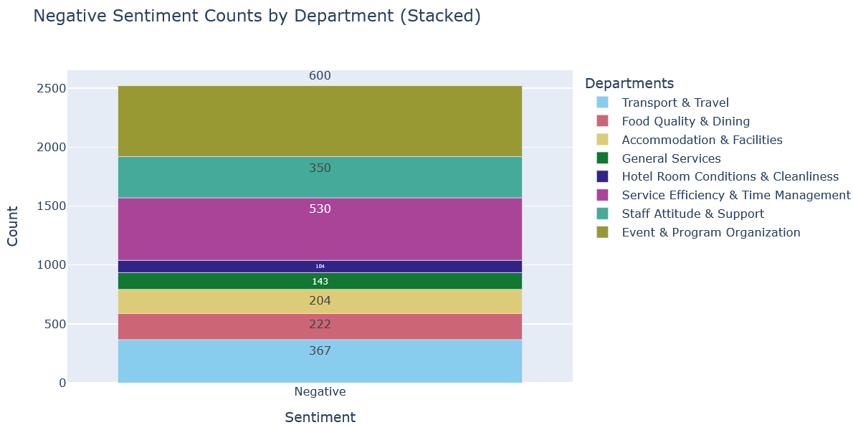

In discussion, the findings of this study are akin, and similar to studies done on AI models and accuracy. These studies involve the evaluation of different models, most of which have been used in study in sentiment analysis and classification tasks. The nature of the studies is theoretical focusing on reviewing documentation and publication on AI models to qualitatively analyze functions, architecture, and performance of the models. Accordingly, and similar to studies by Chelloug et al. (2025) and Firdos & Dermawan (2023), the accuracy of the model developed in this project showed that modern and robust models are accurate, precise, and efficient in text classification and sentiment tasks. However, the accuracy depends on the size of the data, tasks, and optimization of parameters (Shah, 2024; Subhan et al., 2023; Amanah et al., 2021). For instance, this study established that GPTs are better at generating content than at sentiment analysis. On the other hand, while transformers like BERT are accurate on sentiment and text analysis, the accuracy of the models improves with model complexity. In this case, bert-base was more accurate than distilbert-case due to reasons tabulated below. These findings resonate with studies by Bohn (2018) and Bala (2022).
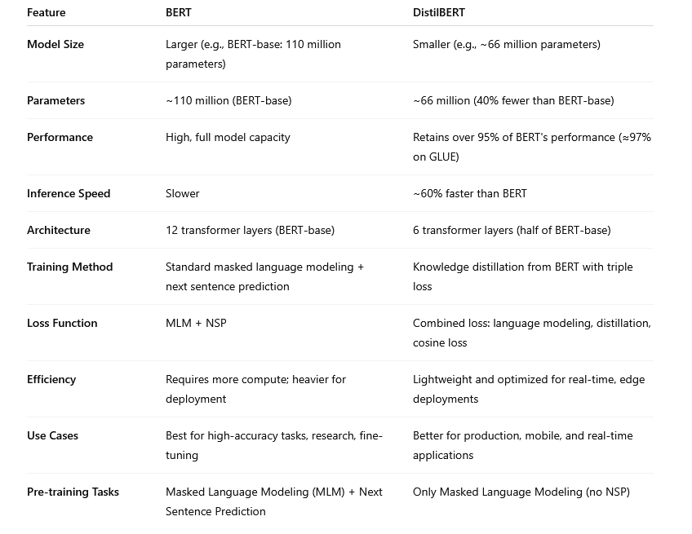
Additionally, this research establishes a correlation between expert analysis and the accuracy of AI models. The tasks of analyzing sentiments and categorizing the sentiments in their respective service areas require expertise (Amanah et al., 2021; Putri & Puteri, 2024; Shah, 2024). Otherwise, tasks like thematic analysis, tokenization, and categorizing comments by departments by AI would be less accurate. In similar findings to a study by Chelloug et al. (2025), this study established a marginal alignment between AI-based analyses and expert analysis. In sum, the accuracy of an AI-based analysis improves with more updates “to enhance its accuracy and consistency with expert evaluations” (Ahmadi & Sudahri, 2025, p.45).

CONCLUSION AND FUTURE DIRECTIONS
In today’s world, customer sentiments and feedback provide valuable insights to improve services, identify challenges, and address customer experience. This study introduced an AI-driven smart text and sentiment analyzer that evaluates sentiments from pilgrims, classifies them in their correct service category, and marks the comment either as positive, neutral, or negative. The platform builds on deep neural networks, machine learning, and NLP. The relevance and quality of the sentiments are quantified using Google Translate and a thematic extractor. The platform is important for service agents and authorities in Umrah and Hajj guiding, informing, and providing insights that enhance decision-making and pilgrim management. The dataset used in this training of the model was complex, with language semantics and structures from multiple languages, to ensure validation and generalizability of the model. The bert-base model recommended in this study performed best with f1-score, precision, recall, and accuracy of over 90 percent in both training and testing sets.
However, this study faced several limitations. Firstly, the platform’s ability to provide real-time analysis and classification is limited. There is a need to incorporate and address computational complexities to allow real-time analysis. Secondly, the model was trained using small data, and its application to big data may be challenging. Thirdly, the platform is limited to diverse validation because it relies on restricted data only applicable to the platform. Lastly, the classification and analysis are based on two classes only, positive, neutral, or negative, and therefore, analyzing comments that are neutral is a challenge. This study recommends future projects to consider addressing issues of scalability by utilizing more advanced mechanisms and domain-specific embeddings (Ahmadi & Sudahri, 2025). It is recommended that future projects integrate real-time analysis and use pretrained models like GPT, which this study failed to use.

REFERENCES
Ahmadi, E. S., & Sudahri. (2025). Analysis of communication strategies of Hajj and Umrah travel agencies in building pilgrims' trust through digital media: A case study of PT. Assunniyah al-jauhari. Ilomata International Journal of Social Science, 6(2), 642-668. https://doi.org/10.61194/ijss.v6i2.1710
Ali, A. A., & Alalmi, A. (2020). Role of Hajj and Umrah (Pilgrimage tourism) in Saudi Arabian economy. International Journal of Mechanical and Production Engineering Research and Development, 10(5), 669-674. https://doi.org/10.24247/ijmperdoct202066
Almutaibi, D. A. (2024). GPT vs. BERT: A technical deep dive | Al Rafay global. Al Rafay Consulting. https://alrafayglobal.com/gpt-vs-bert/
Alquayt, A., Aljuhani, O., Alharthi, A. F., Alqahtani, R., Khan, A., Al-jedai, A., Almoeen, A., Alshennawi, M., Badreldin, H. A., Aljouie, A., Alnasser, L. A., Alshehri, A. M., Alzahrani, M. Y., Alhaidal, H. A., Alhajaji, R., Alotaibi, S., Redhwan, E. Z., Alharthi, F., Alghamdi, B. G., … Al Sulaiman, K. (2025). AI-driven healthcare innovations for enhancing clinical services during mass gatherings (Hajj): Task force insights and future directions. BMC Health Services Research, 25(1). https://doi.org/10.1186/s12913-025-13045-5
Amanah, D., Hurriyati, R., Disman, .., Gaffar, V., & Ansari Harahap, D. (2021). Service quality towards Lazada's customer satisfaction based on importance performance analysis methods and customer satisfaction index. Proceedings of the 4th Sriwijaya Economics, Accounting, and Business Conference, 4(6), 152-160. https://doi.org/10.5220/0008437801520160
Bala, P. (2022). Introduction of big data with analytics of big data. Research Anthology on Big Data Analytics, Architectures, and Applications, 4(2), 54-66. https://doi.org/10.4018/978-1-6684-3662-2.ch003
Bohn, J. (2018). Analysis of self-efficacy as a contributor to customer and managerial perceptions in customer service rep performance. Journal of Customer Service in Marketing and Management, 5(2), 71-87. https://doi.org/10.1300/j127v05n02_05
Chelloug, S. A., Muthanna, M. S., Jamil, F., Al-Gaashani, M. S., Alhelaly, S., Aziz, A., & Muthanna, A. (2025). Enhancing Hajj and Umrah services through predictive social media classification. IEEE Access, 13(10), 67220-67238. https://doi.org/10.1109/access.2025.3559204
Firdos, E., & Dermawan, A. (2023). Building company image and trust of prospective Hajj and umrah pilgrims through public relations strategies. Multazam : Jurnal Manajemen Haji dan Umrah, 3(2), 45. https://doi.org/10.32332/multazam.v3i2.8121
Kaplan, J. (2020). The impact of artificial intelligence on human labor. Artificial Intelligence, 2(1), 37. https://doi.org/10.1093/wentk/9780190602383.003.0006
Putri, F. E., & Puteri, H. E. (2024). Analyzing the effect of prime services provided by Hajj and Umrah organizing section at the ministry of religion office in Pariaman municipality on prospective Hajj pilgrim’s satisfaction. Munazzama: Journal of Islamic Management and Pilgrimage, 4(1), 57-73. https://doi.org/10.21580/mz.v4i1.17216
Salıcı, M., & Ölçer, Ü. E. (2024). Impact of transformer-based models in NLP: An in-depth study on BERT and GPT. International Artificial Intelligence and Data Processing Symposium (IDAP), 4(12), 1-6. https://doi.org/10.1109/idap64064.2024.10710796
Shah, A. A. (2024). Enhancing Hajj and Umrah rituals and crowd management through AI technologies: A comprehensive survey of applications and future directions. IEEE Access, 12(10), 161820-161841. https://doi.org/10.1109/access.2024.3487923
Subhan, A., Firdaus, A. F., & Najib, M. (2023). The influence of Islamic service quality and trust on customer satisfaction and intention in reusing the services in the implementation of Umrah and special Hajj pilgrimage. Jurnal Ekonomi Syariah Teori dan Terapan, 10(3), 275-289. https://doi.org/10.20473/vol10iss20233pp275-289

Appendix

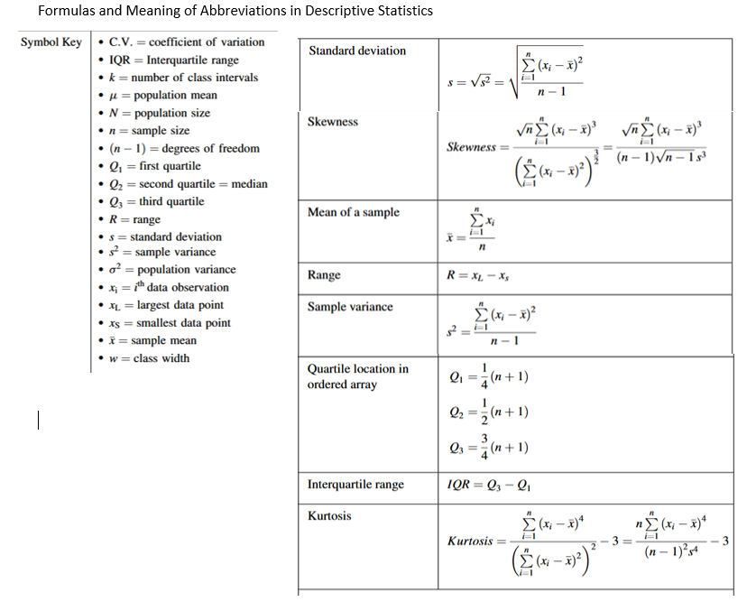
Chart 1: Formulas and Meaning of Abbreviations in Descriptive Statistics

