Mandat Lauren
Portfolio monitoring and review — 2026
Private wealth · €100m · preserve purchasing power under a 15% maximum-loss constraint
Period: 1 January → 29 October 2026 (year-to-date). As of 29 October 2026.

What this note measures
The portfolio was finalised on 24/09/2026. A “since 1 January” track is therefore not a realised gain, but an analysis of what the selection would have done over 2026: how it behaved, why, and what that says about the thesis.
Portfolio figures are computed in euros, dividends reinvested. The two directly-held bond sleeves are represented by maturity-matched ETFs. Market reference points (ECB, inflation, indices, yields) are facts as of October 2026. Full method at the end.

1. Summary
Over the first ten months of 2026, the portfolio rose +6.0% in euros — +2.7 pts more than the inflation objective (4%/yr, i.e. +3.3% pro-rated). Over the same period its worst drawdown from peak was held to −3.6%, 11.4 points away from the mandate's loss limit (−15%).
In short, the year made the portfolio work exactly as designed: an equity engine that is enough to beat inflation, and a bond base that holds the loss. Equities (30% of the portfolio) added +6.86 pts; the bond sleeve (66%), built to protect rather than earn, cost −0.78 pts in a year of rising yields; gold (3%), −0.05 pts.
Yet 2026 was not an easy year: an energy shock brought inflation back, pushed the ECB to raise rates and sent bonds lower. The portfolio came through because its equity selection was on the right side of that shock — energy, utilities, healthcare, banks — and because it has no exposure to the two big European losers of the year, autos and luxury. The rest of this note traces that chain, from the macro backdrop down to each holding.

2. The 2026 macro backdrop
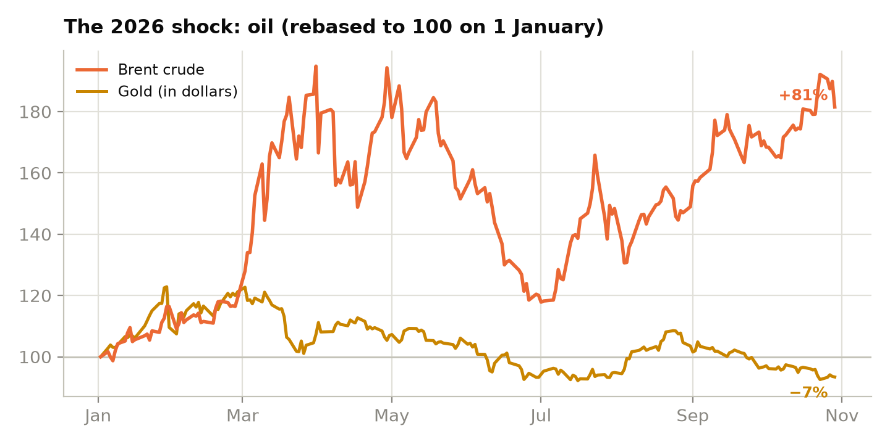
Brent crude and gold (in dollars), rebased to 100 on 1 January 2026. Oil is the year's through-line.
It all starts with energy. A Middle East conflict from late February sent oil surging: Brent ends the period up 81%, after a peak near 95% in late March. This is the dominant shock of 2026, and it feeds everything else.
Inflation came back. Driven by energy, euro-area inflation rose to 3.3% in August (energy alone up more than 14% year-on-year). Purchasing power is the live issue again — precisely the risk the mandate was calibrated against.
The ECB raised rates. Against the easing cycle expected early in the year, the central bank held in Q1, then hiked in June and again in September, taking the deposit rate to 2.50%. 2026 is therefore a year of tightening, not easing.
Bonds sold off. Long yields rose accordingly: the German 10-year Bund hit 15-year highs over the summer (around 3.3-3.6%) before easing back toward 3.35% in late October. Stress concentrated on France, where the yield gap to Germany widened to around 170 basis points, the most since the debt crisis — a watch point for any government-bond sleeve.
Equities, though, held up well. Despite that backdrop, the Stoxx 600 gained roughly 9-10% and set records in August. But the rise was very uneven: semiconductors (ASML to the fore, +60% and more) and banks (+22%, lifted by consolidation) led; autos (−16%) and luxury (soft Chinese demand) were the big laggards.
Two currency effects, finally. Despite the ECB's hikes, the euro weakened (−5.1% against the dollar) — an energy importer's currency suffers in an oil shock; conversely the oil-linked Norwegian krone strengthened. And gold, the safe haven, spiked early in the year (peak +23% in dollars in late January) before fading: it ends −6.6% in dollars, but only −1.6% in euros, the weak euro having cushioned the fall.

3. How the portfolio moved, month by month
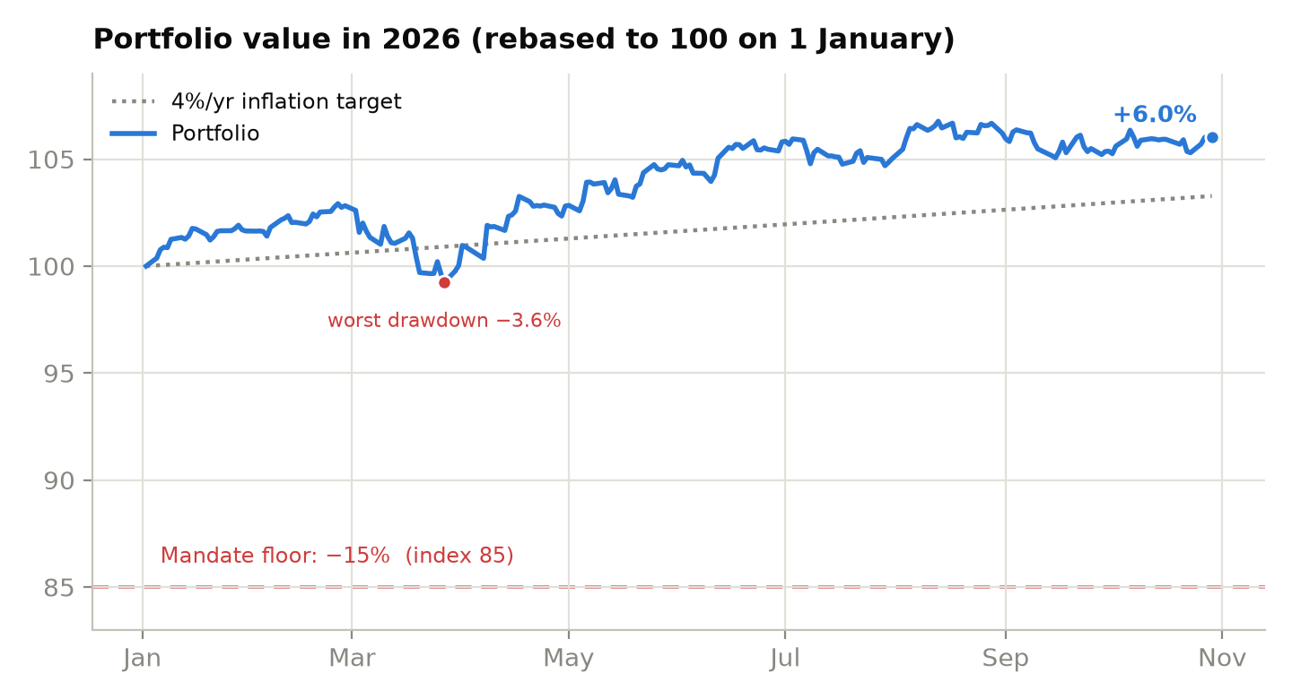
Portfolio value rebased to 100, in euros, against the inflation target and the mandate's loss floor.
January-February: a quiet climb. The portfolio appreciates gently, carried by still-calm equities, while gold already plays safe haven at the first signs of tension.
Late February-March: the only real air pocket. The oil shock and the jump in yields push equities down; the year's low is reached on 27 March, at −3.6% from the peak. This is the telling moment: bonds do not play their usual shock-absorber role, because yields rise at the same time as equities fall. And yet the loss stays contained at 3.6% — more than 11 points from the limit. Diversification did not need bonds that day: the equity sleeve's own moderation was enough.
April to summer: the rebuild, then the records. Once the shock is digested, equities turn up and keep going: semiconductors, energy, banks and utilities drag the European index to new highs in August, and the portfolio with it. Most of the +6% is built over this stretch.
Autumn: consolidation. Since September the portfolio has hovered around its +6% level, bonds still weighing slightly while equities hold their gains. Nothing spectacular — which, for a defensive mandate, is good news.

4. By asset category
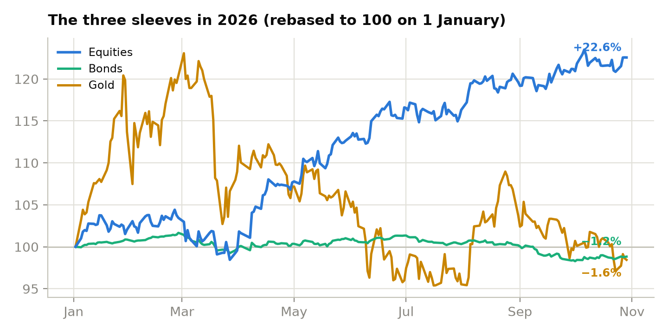
Each sleeve rebased to 100 on 1 January. Equities rise, bonds stay flat, gold round-trips.
Sleeve | Weight | Performance | Contribution
Equities | 30.4% | +22.6% | +6.86 pts
Bonds | 66.3% | −1.2% | −0.78 pts
Gold | 3.3% | −1.6% | −0.05 pts

Equities (30.4%) are the engine. They gained +22.6% over the year and delivered almost all of the performance. Notably, they clearly beat the broad European index (around +9-10%), thanks to selection — detailed in the sector and stock sections below.
Bonds (66.3%) are the base, and they did their job. They fell only 1.2% in a year of sharply rising yields. The breakdown is instructive:
Sub-sleeve | Weight | Performance | Contribution
Govt 2-10y (3-7y proxy) | 41.3% | −2.1% | −0.88 pts
AAA 6-24m ladder (1-3y proxy) | 10.0% | +0.3% | ≈ 0
Inflation-linked (IBCI) | 15.0% | +0.5% | ≈ 0

All of the loss comes from the long government sleeve (−2.1%): the most sensitive to rising yields. Against it, the short AAA ladder — where the €10m to be withdrawn sits — and the inflation-linked bonds stayed positive (+0.3% and +0.5%). The short end protected the liquidity, and linkers protected against inflation: both sleeves worked in exactly the year they were meant for.
Gold (3.3%) round-tripped. A sought-after haven early in the year, it then faded to finish −1.6% in euros. Insurance that, this year, cost almost nothing (−0.05 pts).

5. By sector (the European equity basket)
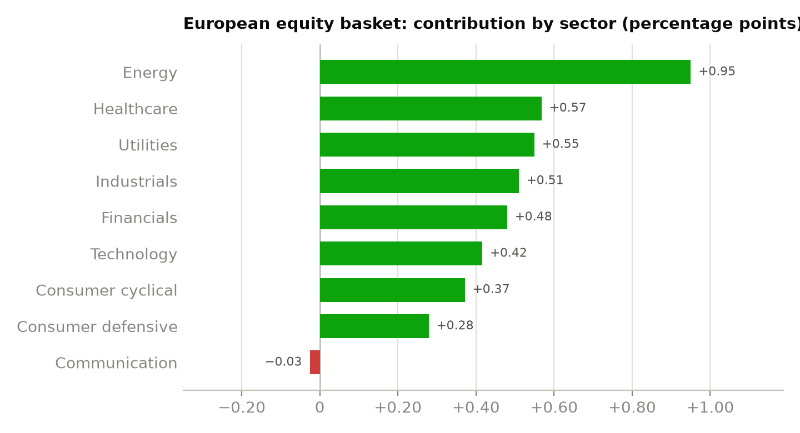
Each sector's contribution within the 15-stock European basket to total performance, in percentage points.
The European equity basket benefited very broadly from the macro backdrop. Eight of nine sectors are positive, and the only flat one (communication) stays so by a whisker.
Energy dominates (+0.95 pts, +117.1% performance): a single holding, Vår Energi, lifted by the oil shock. Next come healthcare (+0.57 pts), driven by Orion, utilities (+0.55 pts) — Iberian names directly sensitive to energy prices — industrials (+0.51 pts) and financials (+0.48 pts), at the heart of the re-rating of European banks and insurers.
Technology (+0.42 pts, +51.3%) is “only” sixth by contribution despite ASML's very large rise, because it is a single holding. Consumer (cyclical +0.37 pts and defensive +0.28 pts) rounds out the picture. Only communication (−0.03 pts) is neutral: Airtel Africa's fall cancels Publicis's gain.
The takeaway is twofold. First, performance is broad, not a concentrated sector bet. Second — and at least as important — the basket holds no autos and no luxury, the two sectors that lost money in Europe this year. What is absent matters as much as what is present.

6. By holding
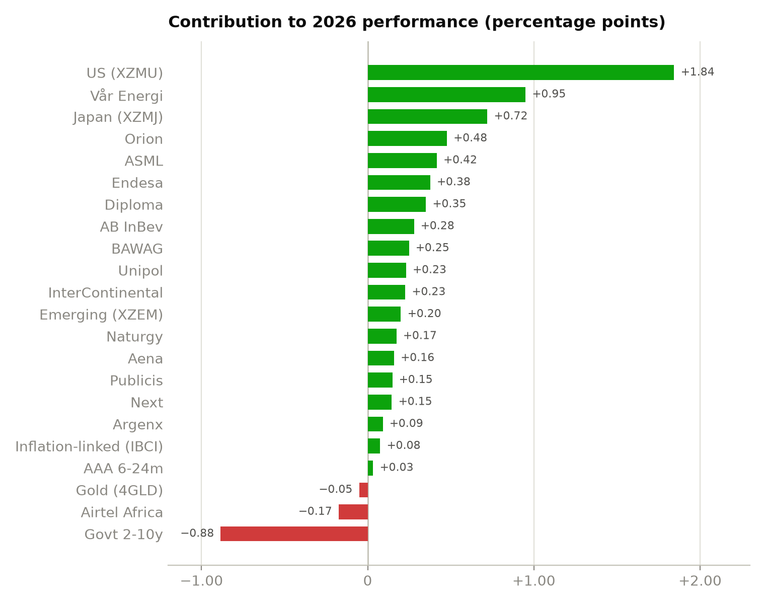
Each holding's contribution to 2026 performance, in percentage points. Green: positive; red: negative.
The locomotives. Vår Energi (+117.1% in euros) posts the largest rise: solid production and dividends, high oil prices, and a Norwegian krone that adds to the euro gain. Orion (+58.8%) benefits from the ramp-up of its prostate-cancer treatment (Nubeqa, with Bayer). ASML (+51.3%), the world's only maker of EUV lithography machines, remains the thoroughbred of the semiconductor cycle. Behind them, Endesa (+46.4%) and Naturgy (+21.3%) — Iberian utilities — , Diploma (+43.2%), AB InBev (+34.4%), BAWAG (+30.6%), Unipol (+28.5%) and InterContinental (+27.9%) line up gains of 25 to 50%.
The pack. Aena (+19.6%), Publicis (+18.3%), Next (+17.9%) and Argenx (+11.2%) rose more modestly, between 11 and 20% — respectable gains that, without making headlines, add to the whole.
The only loser. Airtel Africa fell 21.5%, hit by rotation out of emerging-market-exposed names and by African currencies, despite good operating results. But since each stock carries the same weight (about 0.8% of wealth), the impact is limited to −0.17 pts: equal-weighting turned bad news into a footnote. The same mechanism stops Vår Energi, at the other extreme, from turning the portfolio into an energy bet.
Finally, the three geographies complement the European equities:
Region (ETF) | 2026 performance | Contribution
Japan (XZMJ) | +23.7% | +0.72 pts
United States (XZMU) | +17.3% | +1.84 pts
Emerging (XZEM) | +4.4% | +0.20 pts

Japan (+23.7%) and the United States (+17.3%, helped by a firmer dollar) contributed well; emerging markets (+4.4%) stayed quieter.

7. Does the thesis hold?
The mandate's defensive thesis holds both ways:
- The floor held comfortably. The year's worst drawdown (−3.6%) stays more than 11 points from the −15% limit, even though bonds were not playing their usual shock-absorber role. The portfolio never put the client at risk.
- The engine was enough. +6.0%, i.e. +2.7 pts above the inflation to beat. In a year when inflation did come back, the core objective — preserving purchasing power — is met.
- Selection paid off. Beating the European index by more than ten points is no accident: it is the result of a well-positioned basket (energy, healthcare, utilities, banks) and, above all, one cleared of the year's losing sectors. Geographic diversification and equal-weighting did the rest.

8. Rebalancing and watch points
- Weight drift. Equities (+22.6%) rose far faster than the rest; their actual share has drifted above the 30.4% target. The monthly rebalancing set out in the mandate trims equities back toward bonds — this is the move that re-arms protection after a rally.
- Bonds now pay more. Rising yields cost this year, but they improve the government sleeve's expected return going forward: reinvestment happens at higher rates, and the protection cushion is thicker than at the start of the year.
- Vår Energi has become, by far, the largest holding in the basket after its +117.1%. The sole energy exposure, volatile and oil-price-driven: one to watch, and the basket's rebalancing brings it back to size.
- France. The OAT-Bund spread at its widest since the debt crisis warrants keeping an eye on the government sleeve's composition and avoiding an overweight to French paper.
- AAA 6-24m ladder (the €10m of liquidity). +0.3% on the year: consistent with its role — preserving the sum to be withdrawn, not making it work.

9. Method and limits
- Window: 02/01/2026 → 29/10/2026 (300 days). Daily prices, dividends reinvested, everything converted to euros (FX for London- and Oslo-listed names).
- Construction: buy-and-hold at target weights since 1 January, with no rebalancing inside the calculation — weights drift with prices, as they do in reality between two rebalancings.
- Direct bonds → maturity-matched ETF proxies: 2-10y government bonds represented by a euro-area 3-7y government ETF; the 6-24m AAA ladder by a 1-3y ETF. The proxy reproduces the sleeve's behaviour, not the exact price of the holdings.
- Macro references: oil (Brent) and gold in dollars; ECB, inflation, index and yield figures taken from public sources in October 2026. These are dated facts, not continuously recomputed.
- Worst drawdown measured daily over this year only: it lights up recent behaviour but does not replace the mandate's 2006-2026 test (−14.0% at worst), which remains the reference for the −15% limit.
- Reminder: YTD ≠ realised gain — the mandate dates from 24/09. These figures describe the selection over the year, not an account statement.

