Name: Allan Duldulao
Date: November 15, 2025
Course: Foundations of Databases & SQL Programming
Github Link: AllanDuldulao/DBFoundations

Assignment 06 – Views

Introduction
In this module we will learn about Views. SQL Views are virtual tables that display data from one or more underlying tables without storing it physically. It simplifies complex queries, enhance security by restricting access to specific columns or rows and provide consistent interface for users. Views also support schema binding to prevent unintended changes to base tables.
Use SQL View when?
You would use SQL Views when you need to simplify complex queries by encapsulating frequently used JOINs, filters, or calculations, into reusable virtual table. They are ideal for enhancing security by allowing users to access only specific columns or rows without exposing the underlying tables. Views also help standardize data presentation across applications or reports, ensuring consistency even if the base schema changes. Additionally, they improve performance and maintainability by centralizing business logic in one place.
Differences and Similarities between a View, a Function and Stored Procedure
Similarities of View, Function, and Stored Procedure, all three are stored, named database objects that can be use multiple times, so they share the common advantage of avoiding code duplication and centralizing logic in the database. A View is essentially a stored SELECT query that behaves like a virtual table and is always read-only. You cannot pass parameters to a standard view and you cannot use DML statements inside it that effect multiple base tables directly. Whereas both Functions and Stored Procedures can contain complex procedural logic (loops, variables, conditional statements, DML, DDL, etc.). A Function must always return exactly one value and can be used directly inside a SELECT, WHERE, or JOIN clause, while VIEWS return a result set like a table and Stored Procedures return nothing by rule, though they can output multiple result sets or output parameters. Functions have strict limitations on side effects, most database engines forbid a function from modifying data (no INSERT/UPDATE/DELETE/ in regular scalar functions) or changing the database state, but Stored Procedures are explicitly designed for side effects and can freely modify data, commit or rollback transactions, and perform administrative tasks. Views and table-valued functions can be indexed views in SQL server to improve performance, whereas Stored Procedures can never be indexed themselves, but they can contain logic that takes parameters and therefore produce different execution plans dynamically, something standards Views cannot do. Below is table 1 for comparison.
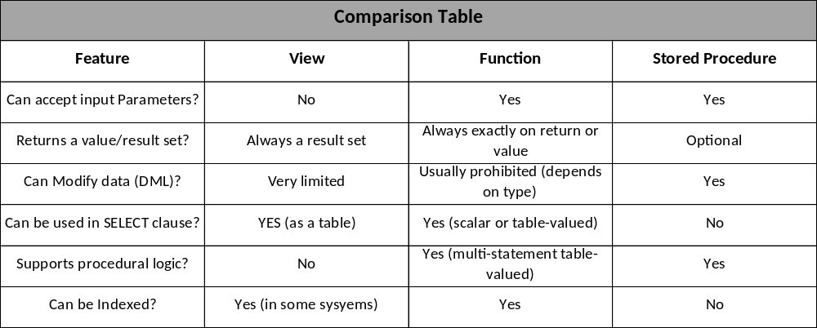
Table 1. Comparison Table

Summary
In short, use SQL Views for reusable, parameter-less queries and security/encapsulation. Use Function when you need to return a value and embed logic inside queries. Use Stored Procedure when you need full procedural power, parameters and side effects.

