CARDS FOR PRINTING

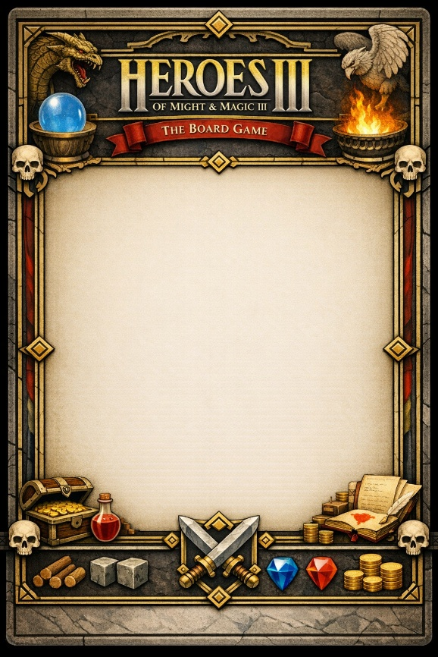



Permanent bonus
You may give an ally a Moral token at any time. The token can only be used in the round in which it was given.
Permanent bonus
Every round you may at any time choose an ally who receives an additional Movement point.





Permanent bonus
Your hero gains an expert point which any ally can spend with your permission at any time once every round.
Permanent bonus
Once per round a  unit of choice from the Inferno player’s army may be gated in at the beginning of a combat round. If defeated the gated unit must be recruited again by the Inferno player.



